./

Learning Report – MBSE

Course Code: <CODE>



Version Number:

Team Members :

Team No:

Module: Model Based System Engineering

|  |  |  |  |  |  |
| --- | --- | --- | --- | --- | --- |
| **Ver. Rel. No.** | **Release Date** | **Prepared. By** | **Reviewed By** | **Approved By** | **Remarks/Revision Details** |
| 1. | 15-03-21 | Ujjawal Kumar  99003745 |  |  |  |
|  |  |  |  |  |  |
|  |  |  |  |  |  |
|  |  |  |  |  |  |
|  |  |  |  |  |  |

**Document History**

# 

Contents

Team Work 3

**Activity 1** – Differential Model of fuel injector solenoid 4

**Activity 2** –Difference Equation 5

**Activity 3** – Explore the below resources and share learning and critical comments on the same 4

**Activity 4** – Complete Matlab Onramp 5

**Activity 5** – Complete Simulink Onramp 5

# Team Work

## **ACTIVITY 1 – Differential Model of Fuel Injector**

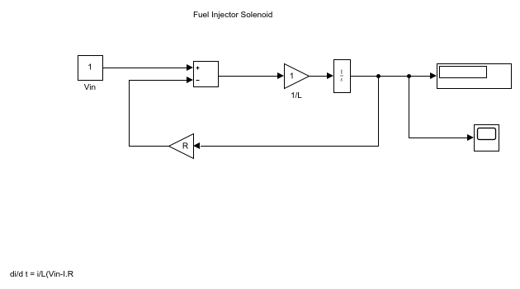

. 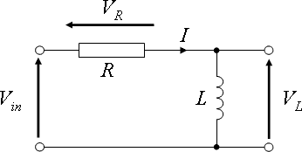

Circuit Diagram

Equation: di/dt=1/L⋅(Vin–I⋅R)

**ACTIVITY 2 – Difference Equation vehicle velocity**

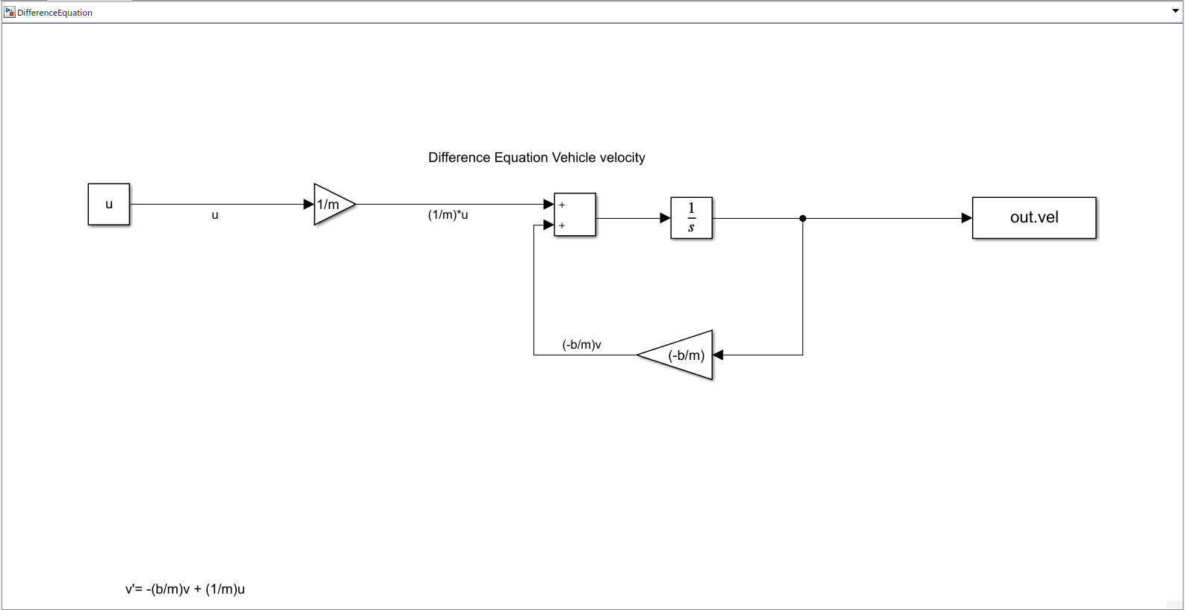

**Equation: v'= -(b/m)v + (1/m)u**

**ACTIVITY 3 – MATLAB Onramp Certification**

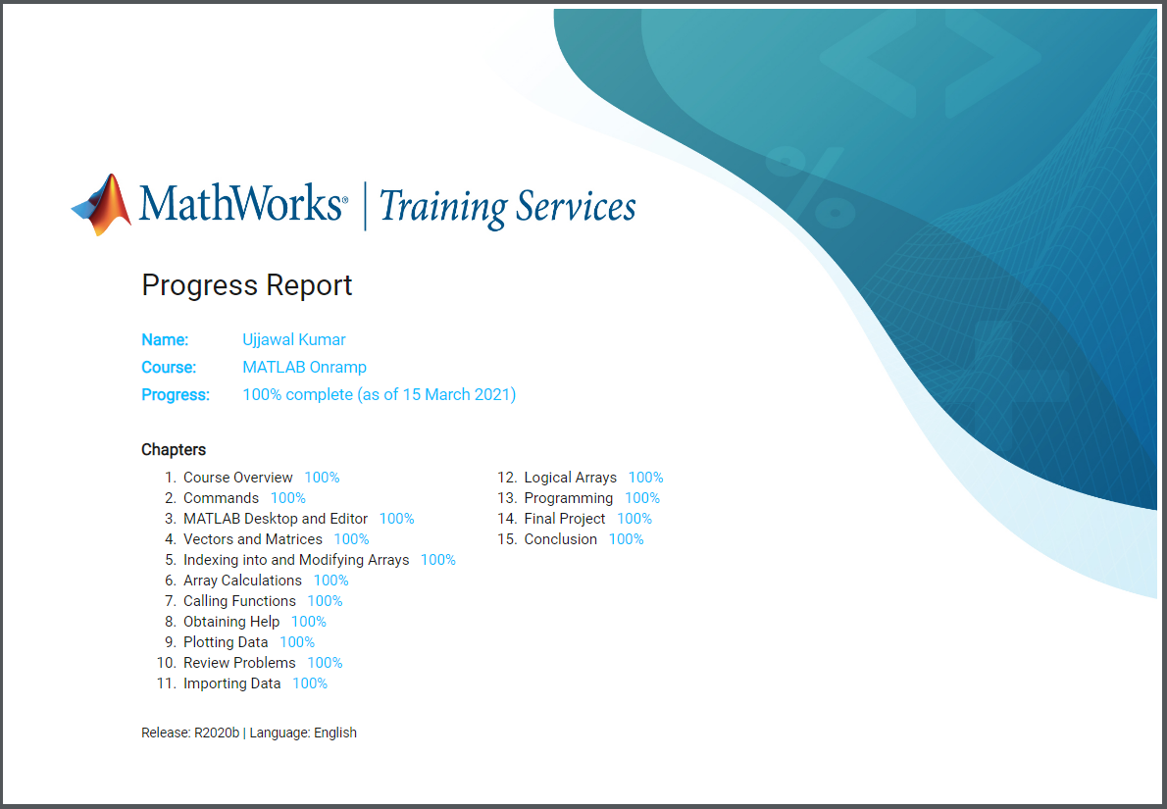

**ACTIVITY 4 – Simulink Onramp Certification**

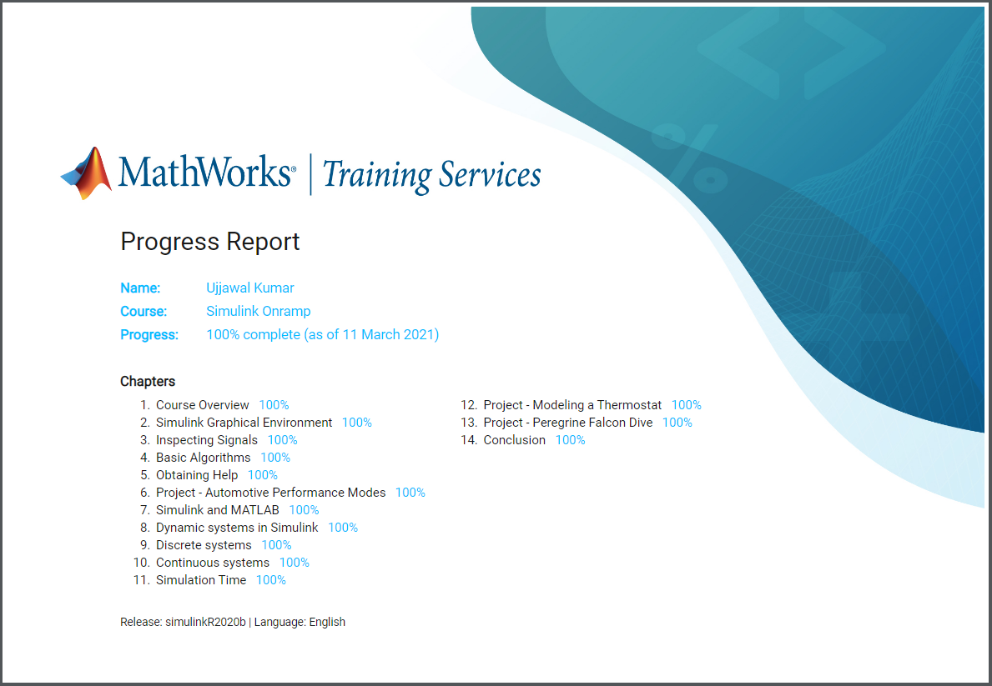

**ACTIVITY 5 – Stateflow Onramp Certification**

