Title:Control System-Second Order System:open loop with different values 1
This Document has equation for DC Motor 1
Math analysis 1
IVT 1
Analysis: 5
Control System-Second Order System:varying zeta value open system 5
Analysis 14
This Document has movement of poles for Second Order System 14
Analysis 16
This Document has movement of poles for Second Order System 16
Negtaive Feedback 19
Positive Feedback 23
Analysis 28
Analysis 34

Title:Control System-Second Order System:open loop with different values
%Author:Ravikumar M Pise
%PS No:99003747
%Date:7/04/2021
%Version:1.0

This Document has equation for DC Motor
%Equation:Ldi/dt+Ri+Kw=V
% Jdw/dt+bw=Ki
%T(s)=(K/LJ)/(s^2+((b/J)+(R/L)s+(R*b)/(L*J)+(K*K)/(L*J)

Math analysis
%dependent variables:w
%independent variables:t
%constant:K,R,L,J,b
%Roots:0.5*(-(b/J)-(R/L))+sqrt((((b*b)/(J*J))+((R*R)/(L*L))-((2*R*b)/(L*J))-((4*K*K)/(L*J)))
% 0.5*(-(b/J)-(R/L))-sqrt((((b*b)/(J*J))+((R*R)/(L*L))-((2*R*b)/(L*J))-((4*K*K)/(L*J)))

IVT
%for impulse is 0
%for step is 0
%%FVT
%for impulse is K/((b*L)+(R*J))=0.1667
%for step is K/((R*b)+(K*K))=0.0999001
J = 0.01;
b = 0.1;
K = 1;
R = 1;
L = 0.5;
%TF=tf([K/(J*L)],[1,((b/J)+(R/L)),(((K*K)+(R*b))/(L*J))]);
sys = tf([K/(J*L)],[1,((b/J)+(R/L)),(((K*K)+(R*b))/(L*J))])
subplot(3,3,1)
step(sys)
subplot(3,3,2)
impulse(sys)
subplot(3,3,3)
%S = stepinfo(sys)
[z,p,k]= tf2zp([K/(J*L)],[1,((b/J)+(R/L)),(((K*K)+(R*b))/(L*J))])
zplane(z,p)
S = stepinfo(sys)
J = 0.1;
b = 1;
K = 0.1;
R = 10;
L = 5;
%TF=tf([K/(J*L)],[1,((b/J)+(R/L)),(((K*K)+(R*b))/(L*J))]);
sys = tf([K/(J*L)],[1,((b/J)+(R/L)),(((K*K)+(R*b))/(L*J))])
subplot(3,3,4)
step(sys)
subplot(3,3,5)
impulse(sys)
subplot(3,3,6)
%S = stepinfo(sys)
[z2,p2,k2]= tf2zp([K/(J*L)],[1,((b/J)+(R/L)),(((K*K)+(R*b))/(L*J))])
zplane(z2,p2)
S = stepinfo(sys)
J = 0.01;
b = 0.01;
K = 0.1;
R = 0.1;
L = 0.05;
%TF=tf([K/(J*L)],[1,((b/J)+(R/L)),(((K*K)+(R*b))/(L*J))]);
sys = tf([K/(J*L)],[1,((b/J)+(R/L)),(((K*K)+(R*b))/(L*J))])
subplot(3,3,7)
step(sys)
subplot(3,3,8)
impulse(sys)
subplot(3,3,9)
%S = stepinfo(sys)
[z1,p1,k1]= tf2zp([K/(J*L)],[1,((b/J)+(R/L)),(((K*K)+(R*b))/(L*J))])
zplane(z1,p1)
S = stepinfo(sys)
sys =
200
----------------
s^2 + 12 s + 220
Continuous-time transfer function.
z =
0×1 empty double column vector
p =
-6.0000 +13.5647i
-6.0000 -13.5647i
k =
200
S =
struct with fields:
RiseTime: 0.0993
SettlingTime: 0.5669
SettlingMin: 0.8527
SettlingMax: 1.1356
Overshoot: 24.9123
Undershoot: 0
Peak: 1.1356
PeakTime: 0.2303
sys =
0.2
------------------
s^2 + 12 s + 20.02
Continuous-time transfer function.
z2 =
0×1 empty double column vector
p2 =
-9.9975
-2.0025
k2 =
0.2000
S =
struct with fields:
RiseTime: 1.1351
SettlingTime: 2.0652
SettlingMin: 0.0090
SettlingMax: 0.0100
Overshoot: 0
Undershoot: 0
Peak: 0.0100
PeakTime: 3.6758
sys =
200
--------------
s^2 + 3 s + 22
Continuous-time transfer function.
z1 =
0×1 empty double column vector
p1 =
-1.5000 + 4.4441i
-1.5000 - 4.4441i
k1 =
200
S =
struct with fields:
RiseTime: 0.2882
SettlingTime: 2.3810
SettlingMin: 8.0006
SettlingMax: 12.2393
Overshoot: 34.6325
Undershoot: 0
Peak: 12.2393
PeakTime: 0.7061
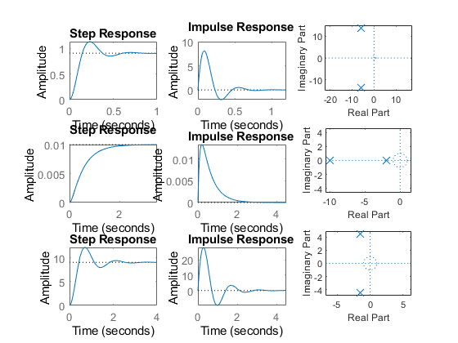

Analysis:
1.1st response of system is accurate because settling time is less 2.1st response speed is high because rise time is less 3.2nd response is more stable because overshoot is zero

Control System-Second Order System:varying zeta value open system
This Document has equation for Second Order System
%w=1
jeta=1;
TF=tf([1],[1,(2*jeta),1])
sys = tf([1],[1,(2*jeta),1])
figure
subplot(2,3,1)
S = stepinfo(sys)
[z,p,k]= tf2zp([1],[1,(2*jeta),1])
zplane(z,p)
jeta=0.7;
TF=tf([1],[1,(2*jeta),1])
sys = tf([1],[1,(2*jeta),1])
%hold on
subplot(2,3,2)
S = stepinfo(sys)
[z,p,k]= tf2zp([1],[1,(2*jeta),1])
zplane(z,p)
jeta=1.5;
TF=tf([1],[1,(2*jeta),1])
sys = tf([1],[1,(2*jeta),1])
subplot(2,3,3)
S = stepinfo(sys)
[z,p,k]= tf2zp([1],[1,(2*jeta),1])
zplane(z,p)
jeta=-1;
TF=tf([1],[1,(2*jeta),1])
sys = tf([1],[1,(2*jeta),1])
subplot(2,3,4)
S = stepinfo(sys)
[z,p,k]= tf2zp([1],[1,(2*jeta),1])
zplane(z,p)
jeta=-0.5;
TF=tf([1],[1,(2*jeta),1])
sys = tf([1],[1,(2*jeta),1])
subplot(2,3,5)
S = stepinfo(sys)
[z,p,k]= tf2zp([1],[1,(2*jeta),1])
zplane(z,p)
jeta=-1.5;
TF=tf([1],[1,(2*jeta),1])
sys = tf([1],[1,(2*jeta),1])
subplot(2,3,6)
S = stepinfo(sys)
[z,p,k]= tf2zp([1],[1,(2*jeta),1])
zplane(z,p)
figure
jeta=0;
TF=tf([1],[1,(2*jeta),1])
sys = tf([1],[1,(2*jeta),1])
S = stepinfo(sys)
[z,p,k]= tf2zp([1],[1,(2*jeta),1])
zplane(z,p)
TF =
1
-------------
s^2 + 2 s + 1
Continuous-time transfer function.
sys =
1
-------------
s^2 + 2 s + 1
Continuous-time transfer function.
S =
struct with fields:
RiseTime: 3.3579
SettlingTime: 5.8339
SettlingMin: 0.9000
SettlingMax: 0.9994
Overshoot: 0
Undershoot: 0
Peak: 0.9994
PeakTime: 9.7900
z =
0×1 empty double column vector
p =
-1
-1
k =
1
TF =
1
---------------
s^2 + 1.4 s + 1
Continuous-time transfer function.
sys =
1
---------------
s^2 + 1.4 s + 1
Continuous-time transfer function.
S =
struct with fields:
RiseTime: 2.1268
SettlingTime: 5.9789
SettlingMin: 0.9001
SettlingMax: 1.0460
Overshoot: 4.5986
Undershoot: 0
Peak: 1.0460
PeakTime: 4.4078
z =
0×1 empty double column vector
p =
-0.7000 + 0.7141i
-0.7000 - 0.7141i
k =
1
TF =
1
-------------
s^2 + 3 s + 1
Continuous-time transfer function.
sys =
1
-------------
s^2 + 3 s + 1
Continuous-time transfer function.
S =
struct with fields:
RiseTime: 5.8584
SettlingTime: 10.6547
SettlingMin: 0.9012
SettlingMax: 0.9999
Overshoot: 0
Undershoot: 0
Peak: 0.9999
PeakTime: 25.9983
z =
0×1 empty double column vector
p =
-2.6180
-0.3820
k =
1
TF =
1
-------------
s^2 - 2 s + 1
Continuous-time transfer function.
sys =
1
-------------
s^2 - 2 s + 1
Continuous-time transfer function.
S =
struct with fields:
RiseTime: NaN
SettlingTime: NaN
SettlingMin: NaN
SettlingMax: NaN
Overshoot: NaN
Undershoot: NaN
Peak: Inf
PeakTime: Inf
z =
0×1 empty double column vector
p =
1
1
k =
1
TF =
1
-----------
s^2 - s + 1
Continuous-time transfer function.
sys =
1
-----------
s^2 - s + 1
Continuous-time transfer function.
S =
struct with fields:
RiseTime: NaN
SettlingTime: NaN
SettlingMin: NaN
SettlingMax: NaN
Overshoot: NaN
Undershoot: NaN
Peak: Inf
PeakTime: Inf
z =
0×1 empty double column vector
p =
0.5000 + 0.8660i
0.5000 - 0.8660i
k =
1
TF =
1
-------------
s^2 - 3 s + 1
Continuous-time transfer function.
sys =
1
-------------
s^2 - 3 s + 1
Continuous-time transfer function.
S =
struct with fields:
RiseTime: NaN
SettlingTime: NaN
SettlingMin: NaN
SettlingMax: NaN
Overshoot: NaN
Undershoot: NaN
Peak: Inf
PeakTime: Inf
z =
0×1 empty double column vector
p =
2.6180
0.3820
k =
1
TF =
1
-------
s^2 + 1
Continuous-time transfer function.
sys =
1
-------
s^2 + 1
Continuous-time transfer function.
S =
struct with fields:
RiseTime: NaN
SettlingTime: NaN
SettlingMin: NaN
SettlingMax: NaN
Overshoot: NaN
Undershoot: NaN
Peak: Inf
PeakTime: Inf
z =
0×1 empty double column vector
p =
0.0000 + 1.0000i
0.0000 - 1.0000i
k =
1
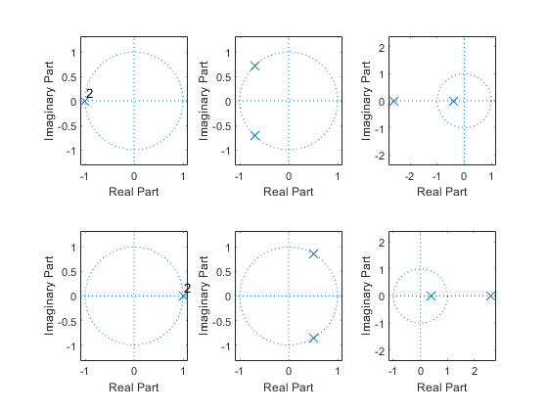
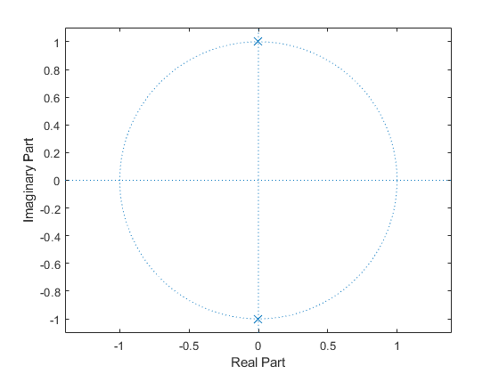

Analysis
To get stable system zeta value should be greater than zero
% if zeta value is between 0 to 1-->poles are conjugate
% if zeta is greater than 1-->poles are real stable
% if zeta is less then 1 -->Poles are real and unstable

This Document has movement of poles for Second Order System
zeros = 0;
poles = [-10+20i -10-20i];
gain = 1;
sys = zpk(zeros,poles,gain)
hold on
pzmap(sys)
zeros = 0;
poles = [-10+10i -10-10i];
gain = 1;
sys = zpk(zeros,poles,gain)
pzmap(sys)
zeros = 0;
poles = [-5+20i -5-20i];
gain = 1;
sys = zpk(zeros,poles,gain)
pzmap(sys)
zeros = 0;
poles = [-5+10i -5-10i];
gain = 1;
sys = zpk(zeros,poles,gain)
pzmap(sys)
sys =
s
-----------------
(s^2 + 20s + 500)
Continuous-time zero/pole/gain model.
sys =
s
-----------------
(s^2 + 20s + 200)
Continuous-time zero/pole/gain model.
sys =
s
-----------------
(s^2 + 10s + 425)
Continuous-time zero/pole/gain model.
sys =
s
-----------------
(s^2 + 10s + 125)
Continuous-time zero/pole/gain model.
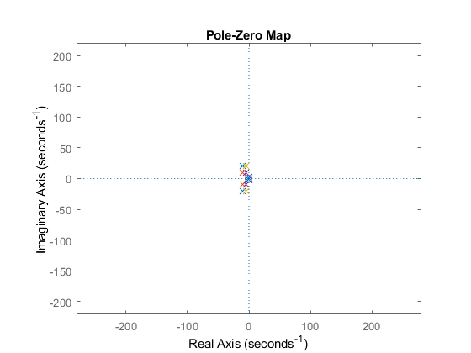

Analysis
% 1.when the pole is moving lef overshoot decreses,Frequency increses
% 2.zeta value is gettting incresed,means damping is less,systemwill be stable
% In Vertical Shifting
% 1.Overshoot increases,damping decreases
% diagonal Shifting
% Overshoot,Damping will be same
% Frequency Increases

This Document has movement of poles for Second Order System
zeros = 0;
poles = [-10 -5];
gain = 1;
sys = zpk(zeros,poles,gain)
hold on
pzmap(sys)
zeros = 0;
poles = [-9+5i -5+5i];
gain = 1;
sys = zpk(zeros,poles,gain)
hold on
pzmap(sys)
zeros = 0;
poles = [-15+2i -20+2i];
gain = 1;
sys = zpk(zeros,poles,gain)
hold on
pzmap(sys)
zeros = 0;
poles = [-15-2i -20-2i];
gain = 1;
sys = zpk(zeros,poles,gain)
hold on
pzmap(sys)
zeros = 0;
poles = [-15-2i -20-2i];
gain = 1;
sys = zpk(zeros,poles,gain)
hold on
pzmap(sys)
sys =
s
------------
(s+10) (s+5)
Continuous-time zero/pole/gain model.
Warning: This zpk model has a complex gain or some complex zeros or poles that
do not come in conjugate pairs.
sys =
s
---------------------
(s+(9-5i)) (s+(5-5i))
Continuous-time zero/pole/gain model.
Warning: This zpk model has a complex gain or some complex zeros or poles that
do not come in conjugate pairs.
sys =
s
-----------------------
(s+(15-2i)) (s+(20-2i))
Continuous-time zero/pole/gain model.
Warning: This zpk model has a complex gain or some complex zeros or poles that
do not come in conjugate pairs.
sys =
s
-----------------------
(s+(15+2i)) (s+(20+2i))
Continuous-time zero/pole/gain model.
Warning: This zpk model has a complex gain or some complex zeros or poles that
do not come in conjugate pairs.
sys =
s
-----------------------
(s+(15+2i)) (s+(20+2i))
Continuous-time zero/pole/gain model.
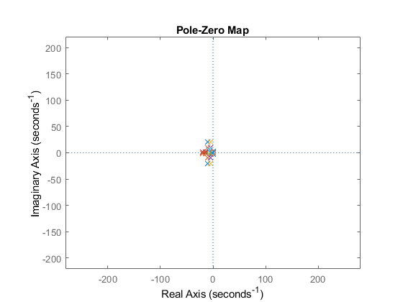

Negtaive Feedback
J = 0.01;
b = 0.1;
K = 1;
R = 1;
L = 0.5;
TF=tf([K/(J*L)],[1,((b/J)+(R/L)),(((K*K)+(R*b))/(L*J))]);
CF=10
sys = CF*TF
NCTF1=feedback(sys,1)
subplot(3,2,1)
step(NCTF1)
title("Step with negative")
subplot(3,2,2)
impulse(NCTF1)
title("impulse with negative")
S = stepinfo(NCTF1)
[wn,zeta]=damp(NCTF1)
J = 0.01;
b = 0.1;
K = 1;
R = 1;
L = 0.5;
TF=tf([K/(J*L)],[1,((b/J)+(R/L)),(((K*K)+(R*b))/(L*J))]);
CF=tf([1,0],[1])
sys = CF*TF
NCTF2=feedback(sys,1)
subplot(3,2,3)
step(NCTF2)
title("Step with diff")
subplot(3,2,4)
impulse(NCTF2)
title("impulse with diff")
S = stepinfo(NCTF2)
[wn,zeta]=damp(NCTF2)
J = 0.01;
b = 0.1;
K = 1;
R = 1;
L = 0.5;
TF=tf([K/(J*L)],[1,((b/J)+(R/L)),(((K*K)+(R*b))/(L*J))]);
CF=tf([1],[1,0])
sys = CF*TF
NCTF3=feedback(sys,1)
subplot(3,2,5)
step(NCTF3)
title("Step with integrator")
subplot(3,2,6)
impulse(NCTF3)
title("impulse with integrator")
S = stepinfo(NCTF3)
[wn,zeta]=damp(NCTF3)
CF =
10
sys =
2000
----------------
s^2 + 12 s + 220
Continuous-time transfer function.
NCTF1 =
2000
-----------------
s^2 + 12 s + 2220
Continuous-time transfer function.
S =
struct with fields:
RiseTime: 0.0245
SettlingTime: 0.6206
SettlingMin: 0.4993
SettlingMax: 1.5026
Overshoot: 66.7860
Undershoot: 0
Peak: 1.5026
PeakTime: 0.0667
wn =
47.1169
47.1169
zeta =
0.1273
0.1273
CF =
s
Continuous-time transfer function.
sys =
200 s
----------------
s^2 + 12 s + 220
Continuous-time transfer function.
NCTF2 =
200 s
-----------------
s^2 + 212 s + 220
Continuous-time transfer function.
S =
struct with fields:
RiseTime: 0
SettlingTime: 3.7813
SettlingMin: 6.5963e-04
SettlingMax: 0.9234
Overshoot: Inf
Undershoot: 0
Peak: 0.9234
PeakTime: 0.0253
wn =
1.0429
210.9571
zeta =
1
1
CF =
1
-
s
Continuous-time transfer function.
sys =
200
--------------------
s^3 + 12 s^2 + 220 s
Continuous-time transfer function.
NCTF3 =
200
--------------------------
s^3 + 12 s^2 + 220 s + 200
Continuous-time transfer function.
S =
struct with fields:
RiseTime: 2.2719
SettlingTime: 4.1463
SettlingMin: 0.9044
SettlingMax: 0.9993
Overshoot: 0
Undershoot: 0
Peak: 0.9993
PeakTime: 7.6683
wn =
0.9549
14.4725
14.4725
zeta =
1.0000
0.3816
0.3816

Positive Feedback
figure
J = 0.01;
b = 0.1;
K = 1;
R = 1;
L = 0.5;
TF=tf([K/(J*L)],[1,((b/J)+(R/L)),(((K*K)+(R*b))/(L*J))]);
CF=10
sys = CF*TF
PCTF1=feedback(sys,-1)
subplot(3,2,1)
step(PCTF1)
title("Step with positive")
subplot(3,2,2)
impulse(PCTF1)
title("impulse with positive")
S = stepinfo(PCTF1)
[wn,zeta]=damp(PCTF1)
J = 0.01;
b = 0.1;
K = 1;
R = 1;
L = 0.5;
TF=tf([K/(J*L)],[1,((b/J)+(R/L)),(((K*K)+(R*b))/(L*J))]);
CF=tf([1,0],[1])
sys = CF*TF
PCTF2=feedback(sys,-1)
subplot(3,2,3)
step(PCTF2)
title("Step with diff")
subplot(3,2,4)
impulse(PCTF2)
title("impulse with diff")
S = stepinfo(PCTF2)
[wn,zeta]=damp(PCTF2)
J = 0.01;
b = 0.1;
K = 1;
R = 1;
L = 0.5;
TF=tf([K/(J*L)],[1,((b/J)+(R/L)),(((K*K)+(R*b))/(L*J))]);
CF=tf([1],[1,0])
sys = CF*TF
PCTF3=feedback(sys,-1)
subplot(3,2,5)
step(PCTF3)
title("Step with integrator")
subplot(3,2,6)
impulse(PCTF3)
title("impulse with integrator")
S = stepinfo(PCTF3)
[wn,zeta]=damp(PCTF3)
CF =
10
sys =
2000
----------------
s^2 + 12 s + 220
Continuous-time transfer function.
PCTF1 =
2000
-----------------
s^2 + 12 s - 1780
Continuous-time transfer function.
S =
struct with fields:
RiseTime: NaN
SettlingTime: NaN
SettlingMin: NaN
SettlingMax: NaN
Overshoot: NaN
Undershoot: NaN
Peak: Inf
PeakTime: Inf
wn =
36.6146
48.6146
zeta =
-1
1
CF =
s
Continuous-time transfer function.
sys =
200 s
----------------
s^2 + 12 s + 220
Continuous-time transfer function.
PCTF2 =
200 s
-----------------
s^2 - 188 s + 220
Continuous-time transfer function.
S =
struct with fields:
RiseTime: NaN
SettlingTime: NaN
SettlingMin: NaN
SettlingMax: NaN
Overshoot: NaN
Undershoot: NaN
Peak: Inf
PeakTime: Inf
wn =
1.1776
186.8224
zeta =
-1
-1
CF =
1
-
s
Continuous-time transfer function.
sys =
200
--------------------
s^3 + 12 s^2 + 220 s
Continuous-time transfer function.
PCTF3 =
200
--------------------------
s^3 + 12 s^2 + 220 s - 200
Continuous-time transfer function.
S =
struct with fields:
RiseTime: NaN
SettlingTime: NaN
SettlingMin: NaN
SettlingMax: NaN
Overshoot: NaN
Undershoot: NaN
Peak: Inf
PeakTime: Inf
wn =
0.8653
15.2030
15.2030
zeta =
-1.0000
0.4231
0.4231
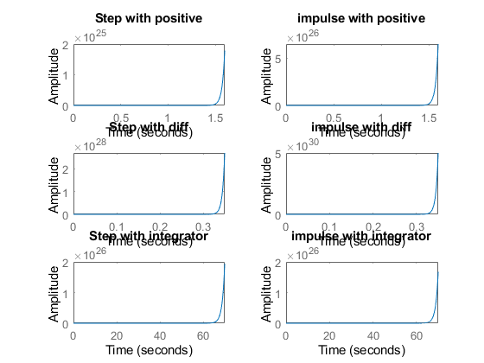
figure
hold on
pzmap(NCTF1)
pzmap(NCTF2)
pzmap(NCTF3)
pzmap(PCTF1)
pzmap(PCTF2)
pzmap(PCTF3)
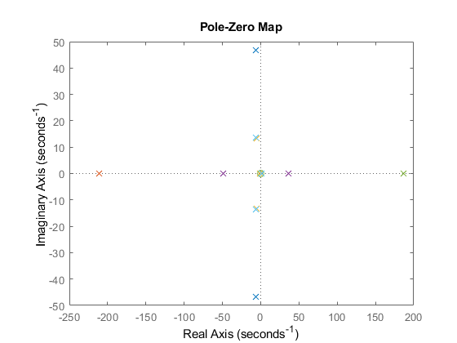

Analysis
by adding positive feedback with integrator damping will be less,so the system will be stable
% Overshooot is infinity,in differentiator closed loop, system is unstable
J = 0.01;
b = 0.1;
K = 1;
R = 1;
L = 0.5;
TF=tf([K/(J*L)],[1,((b/J)+(R/L)),(((K*K)+(R*b))/(L*J))]);
CF=1;
sys1 = CF*TF;
subplot(4,2,1)
step(sys1)
title("Step ")
subplot(4,2,2)
impulse(sys1)
title("Impulse")
S = stepinfo(sys1);
[wn,zeta]=damp(sys1)
p1=pole(sys1)
z1=zero(sys1)
J = 0.01;
b = 0.1;
K = 1;
R = 1;
L = 0.5;
TF=tf([K/(J*L)],[1,((b/J)+(R/L)),(((K*K)+(R*b))/(L*J))]);
CF=10;
sys2 = CF*TF;
subplot(4,2,3)
step(sys2)
title("Step with gain")
subplot(4,2,4)
impulse(sys2)
title("impulse with gain")
S = stepinfo(sys2)
[wn,zeta]=damp(sys2)
p2=pole(sys2)
z2=zero(sys2)
J = 0.01;
b = 0.1;
K = 1;
R = 1;
L = 0.5;
TF=tf([K/(J*L)],[1,((b/J)+(R/L)),(((K*K)+(R*b))/(L*J))]);
CF=tf([1,0],[1]);
sys3 = CF*TF;
subplot(4,2,5)
step(sys3)
title("Step with zero ")
subplot(4,2,6)
impulse(sys3)
title("impulse with zero ")
S = stepinfo(sys3)
[wn,zeta]=damp(sys3)
p3=pole(sys3)
z3=zero(sys3)
J = 0.01;
b = 0.1;
K = 1;
R = 1;
L = 0.5;
TF=tf([K/(J*L)],[1,((b/J)+(R/L)),(((K*K)+(R*b))/(L*J))]);
CF=tf([1],[1,0]);
sys4 = CF*TF;
subplot(4,2,7)
step(sys4)
title("Step with pole ")
subplot(4,2,8)
impulse(sys4)
title("impulse with pole ")
S = stepinfo(sys4)
[wn,zeta]=damp(sys4)
p4=pole(sys4)
z4=zero(sys4)
wn =
14.8324
14.8324
zeta =
0.4045
0.4045
p1 =
-6.0000 +13.5647i
-6.0000 -13.5647i
z1 =
0×1 empty double column vector
S =
struct with fields:
RiseTime: 0.0993
SettlingTime: 0.5669
SettlingMin: 8.5269
SettlingMax: 11.3557
Overshoot: 24.9123
Undershoot: 0
Peak: 11.3557
PeakTime: 0.2303
wn =
14.8324
14.8324
zeta =
0.4045
0.4045
p2 =
-6.0000 +13.5647i
-6.0000 -13.5647i
z2 =
0×1 empty double column vector
S =
struct with fields:
RiseTime: 0
SettlingTime: 0.6520
SettlingMin: -2.0155
SettlingMax: 8.0919
Overshoot: Inf
Undershoot: Inf
Peak: 8.0919
PeakTime: 0.0844
wn =
14.8324
14.8324
zeta =
0.4045
0.4045
p3 =
-6.0000 +13.5647i
-6.0000 -13.5647i
z3 =
0
S =
struct with fields:
RiseTime: NaN
SettlingTime: NaN
SettlingMin: NaN
SettlingMax: NaN
Overshoot: NaN
Undershoot: NaN
Peak: Inf
PeakTime: Inf
wn =
0
14.8324
14.8324
zeta =
-1.0000
0.4045
0.4045
p4 =
0.0000 + 0.0000i
-6.0000 +13.5647i
-6.0000 -13.5647i
z4 =
0×1 empty double column vector
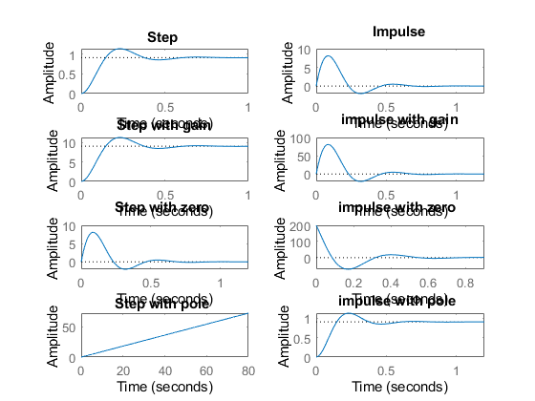
figure
hold on
pzmap(sys1)
pzmap(sys2)
pzmap(sys3)
pzmap(sys4)
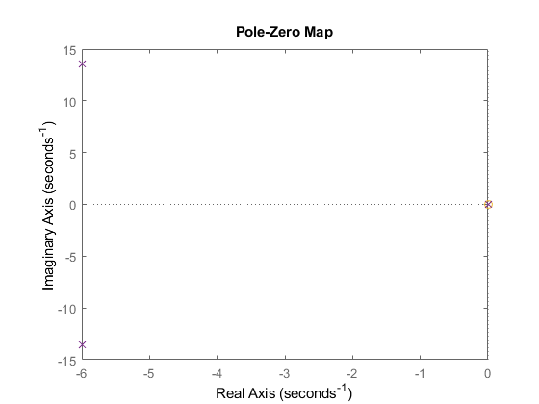

Analysis
without gain-->Complex conjugate poles
% when we add differentiator,with different constant values,the Transfer function is settling at zero in step response
% Poles are getting changed when we change constant values
% Pole Location is not getting changed irrespective of controller taken into consederation
% By adding defferential controller,IVT changes from 0 to some value.
% FVT remains same for impulse response.
% by adding integrator in step response the system is not settling.
Published with MATLAB® R2020b

