./

Learning Report –

MBD

Course Code: <CODE>



Version Number:

Team Members :

Team No:

Module: Model Based System Engineering

|  |  |  |  |  |  |
| --- | --- | --- | --- | --- | --- |
| **Ver. Rel. No.** | **Release Date** | **Prepared. By** | **Reviewed By** | **Approved By** | **Remarks/Revision Details** |
|  | 18-3-2021 | Nilanjana Das |  |  |  |
|  |  |  |  |  |  |
|  |  |  |  |  |  |
|  |  |  |  |  |  |
|  |  |  |  |  |  |

**Document History**

# 

Contents

1. REQUIREMENTS 4

1.1. INTRODUCTION: 4

**MANUAL WIPER CONTROL SYSTEM**

# REQUIREMENTS

## INTRODUCTION:

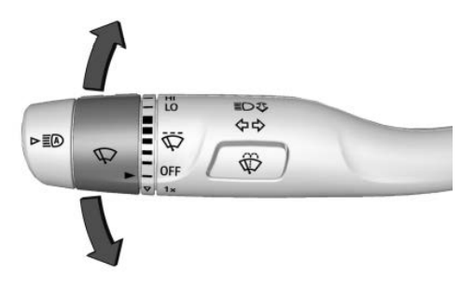

**Figure 1: Wiper system**

The main purpose of the wiper system is to clean the windscreen sufficiently to provide suitable visibility at all times. The wiper system must perform the following tasks.

(a) Efficient removal of dirt, water and snow.  
(b) Operation in the temperature range of 243 K to 353 K.  
(c) The ability to pass the stall and snow load test.  
(d) A service life of around 1500 000 wipe cycles,

(e) Resistance to corrosion from acid, alkalis and ozone.

For meeting the above requirements, proper design and manufacturing with good quality components are required for both the wiper and washer systems. The actual method of cleaning the screen by the blades can vary provided that the legally prescribed area of the screen is cleaned.

**SAE LEVELS OF WIPER CONTROL:**

**Manual wiper system**: The manual wiper system is activated by the driver through the wiper handle knob which activates the sensor in the electric control unit sending signal to the wiper motor to operate at desired speed which is chosen by the driver.

This manual wiper system in the car comes under **SAE level 1**.

Automatic wiper system:

Car used for reference: **GMC SIERRA 2020**

## RESEARCH:

**Wiper Motor Permanent-magnet Type.** The construction of a single speed motor is shown. The armature with 8-slots is mounted on self-lubricating sintered bushes. Two carbon brushes, set 180 degrees apart, rub on an 8-segment commutator generally installed at the driving end. Two strong permanent magnets are bonded to the steel yoke using an adhesive, which is sometimes coated externally with non-ferrous metal to protect it against corrosion. A steel worm, formed on the end of the armature, drives a plastic worm wheel at a speed of about l/10th the speed of the armature.

**Shunt Wound Motors.** These motors are rarely used nowadays due to the superiority of the permanent magnet type in respect of power, noise, efficiency, cost, reliability, and current consumption. Figure 30.6A shows the layout of a single speed motor using a shunt wound field.

**Self-parking Wipers.** On some vehicles the wiper blades are parked off the windscreen. To achieve this arrange­ment the circuit is switched-on so that the current through the armature is reversed after the motor has stopped. This change the polarity of the brush in the permanent magnet motor so that the armature rotates in the opposite direction. By arranging the gearbox linkage, the wiping stroke can be extended by the reverse motion, and this movement parks the wiper blades away from the glass screen.  
Overload Protection. During snow or ice conditions the load on the wiper motor increases heavily, which decreases motor speed and under extreme conditions stops it. The decrease in armature speed reduces back emf due to which is large current in the order of 11A flows through the motor leading to overheating and possible damage to the motor.

**Washers** As per the statutory regulations in some countries a screen washer must be installed to clean the driver’s side of the Windscreen. Most of the vehicles install an electrically operated pump to supply water or cleaning fluid in the form of two or more jets for spraying on the windscreen. On some vehicles an extra pump is used for a separate headlamp wash system, and some of these vehicles are also fitted with headlamp wipers.  
The small centrifugal pump is either fixed directly on to the water reservoir or fitted in the hydraulic line. A permanent magnet motor drives the pump and is controlled by a switch often operated from the wiper switch stalk on the steering column (Fig. 30.12). The pump is of self-priming type and a filter is installed at the inlet of the pump. Polythene tubing is used for the jets. A typical motor consumes about 3 A and supplies about 0.75 litre/min fluid at a pressure of 66 kPa. During winter period a small quantity of methylated spirit is added to the water to lower the freezing temperature.

**Wiper Blades.** Blades should be replaced when the rubber starts cracking, tearing or becomes hard and brittle. The metal portion of the blade should be perfect and the fixing to the arm must be proper. A wiper blade must not work on the dry screen as this overload the motor and also severely scratches the surface of the glass.

**Screen.** Methylated sprit maybe used to remove traffic film from the screen and wiper blades. The screen and blade surface should not be contaminated with polishes containing silicone and wax.

**Wiper Arms.** These arms should be inspected for the perfect condition of the spring to provide required force (about 350 grams) to the blade. The arm should not be bent as this can cause the blade to chatter during operation.

**MY FEATURES:**

Basic model of system:

The wipers combine two mechanical technologies to perform their task:

1. A combination **electric motor** and **worm gear** reduction provides power to the wipers.
2. A neat linkage converts the rotational output of the motor into the back-and-forth motion of the wipers.
3. Varying motor speeds:
4. Low speed
5. Medium speed
6. High speed
7. No of swipes: 1X = 1 swipe only, 2X = 2 swipes at a time
8. Washer liquid comes out on the wind screen when the user presses the button.

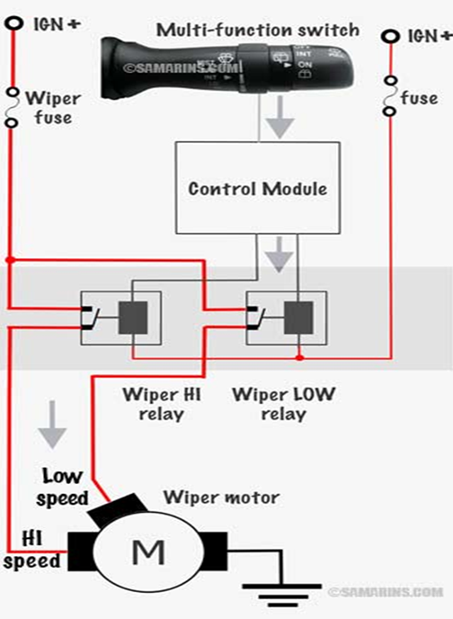

**Figure 1: Model diagram of wiper system**

**SWOT ANALYSIS:**

|  |  |
| --- | --- |
| **STRENGTHS**   * multi utility * user friendly * compact design * sturdy and * 2-speed | **WEAKNESS**   * Does not support automated wiping system. * Not an intelligent system |
| **OPPORTUNITIES**   * It can be converted to automatic wiper system integrated with rain sensor. | **THREATS**   * Leakage from the washer * Pump malfunction * Motor failure * Wiper failure due to excessive dust, snow |

**Table 1: SWOT Analysis of manual wiper system**

1. **DESIGN:** 
   1. **High Level Requirements (HLR):** 
      1. Handle Knob for Wiper speed and swipes
      2. Push button for water jet spray
   2. **Low level Requirements (LLR):**
      1. Wiper motor: **Gearmotor for windshield wipers MRT62-4**

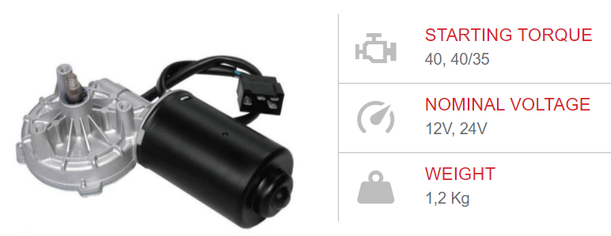

**Figure 2: Gearmotor for wiper**

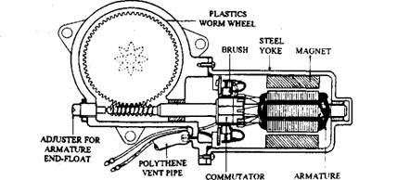

**Figure 3: Permanent Magnet Motor for wiper**

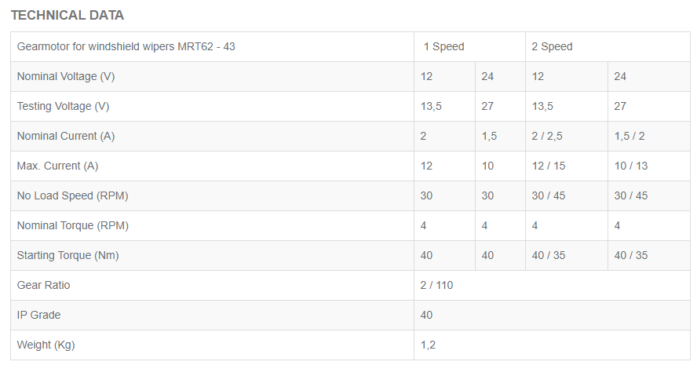

**Figure 4: Datasheet of Gearmotor for wiper**

Comparison table between different motor manufacturers:

|  |  |  |
| --- | --- | --- |
| SPECIFICATIONS | GEARMOTOR FOR WINDSHIELD WIPERS MRT62-43 | WIPER MOTOR -WD1160 |
| 1. Nominal voltage(V) | 12 | 12 |
| 1. Rated Current (amps) | 12/15 | 6.3 |
| 1. Nominal torque (Nm) | 4 | 5.2 |
| 1. Rated speed (RPM) | 30/45 | 40 |
| 1. Weight (Kg) |  | 2 |

**Table 2: comparison table for 2 types of motor**

* + 1. Relay: **1 FORM C AUTOMOTIVE SILENT RELAY**

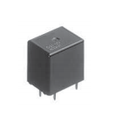

**Figure 5: Automotive Silent Relay**

Specifications of relay:

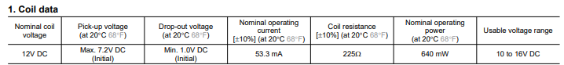

* + 1. Push button:

Specifications of Push button:

**Links for datasheets:**

1. Wiper motor: WM.pdf
2. Relay: relay wiper.pdf
3. Push Button: [Switch_Catalog.pdf (carlingtech.com)](https://www.carlingtech.com/sites/default/files/documents/Switch_Catalog.pdf)
4. **ALGORITHM**

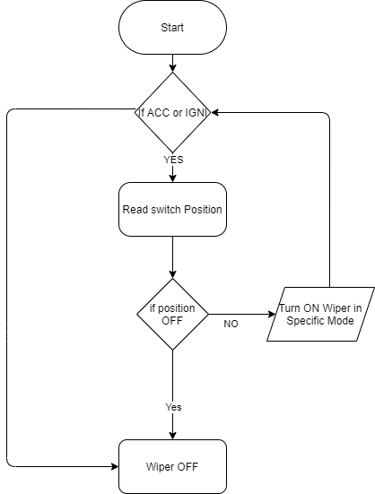

1. **TEST CASES**

**High level test plan:**

|  |  |  |  |  |  |
| --- | --- | --- | --- | --- | --- |
| **Test ID** | **Description** | **Expected input** | **Actual input** | **Expected output** | **Actual output** |
| Hl_EG_W | Ignition button is pressed | Button pressed | Button pressed | Engine turns on | Engine turns on |
| Hl_WB_W | Wiper button is pressed | Button Pressed | Button Pressed | Wiper turns on | Wiper turns on |

**Low level test plan:**

|  |  |  |  |  |  |
| --- | --- | --- | --- | --- | --- |
| **Test ID** | **Description** | **Expected input** | **Actual input** | **Expected output** | **Actual output** |
| LO_IWOF_W | Ignition and wiper off | Both button unpressed | Both button unpressed | Wiper not activated | Wiper not activated |
| LO_IOWOF_W | Ignition on wiper off | Ignition button pressed but wiper off | Ignition button pressed but wiper off | Wiper off | Wiper off |
| LO__W | Wiper speed set to low | Speed set to low | Speed set to low | Wipes in low speed | Wiper swipes in low speed |
|  |  |  |  |  |  |
|  |  |  |  |  |  |
|  |  |  |  |  |  |