./

Learning Report – MBSE

Course Code: <CODE>

The FlexRay communications bus is a deterministic, fault-tolerant and high-speed bus system developed in conjunction with automobile manufacturers and leading suppliers. FlexRay delivers the error tolerance and time-determinism performance requirements for x-by-wire applications (i.e. drive-by-wire, steer-by-wire, brake-by-wire, etc.).

A **FlexRay** signal **can** carry up to 30 times the data of a **CAN** message and has 3 CRC checks,

One of the things that distinguishes FlexRay, CAN and LIN from more traditional networks such as ethernet is its topology, or network layout. FlexRay supports simple multi-drop passive connections as well as active star connections for more complex networks. Depending a vehicle's layout and level of FlexRay usage, selecting the right topology helps designers optimize cost, performance, and reliability for a given design.

As with any multi-drop bus, only one node can electrically write data to the bus at a time.  If two nodes were to write at the same time, you end up with contention on the bus and data becomes corrupt.  There are a variety of schemes used to prevent contention on a bus. CAN, for example, used an arbitration scheme where nodes will yield to other nodes if they see a message with higher priority being sent on a bus.  While flexible and easy to expand, this technique does not allow for very high data rates and cannot guarantee timely delivery of data.   FlexRay manages multiple nodes with a **Time Division Multiple Access** or TDMA scheme. Every FlexRay node is synchronized to the same clock, and each nodes waits for its turn to write on the bus.  Because the timing is consistent in a TDMA scheme, FlexRay is able to guarantee **determinism** or the consistency of data deliver to nodes on the network. This provides many advantages for systems that depend on up-to-date data between nodes.

<https://www.ni.com/en-in/innovations/white-papers/06/flexray-automotive-communication-bus-overview.html>

<https://www.fujitsu.com/downloads/CN/fmc/lsi/FlexRay-EN.pdf>

### The Communication Cycle

The **FlexRay communication cycle** is the fundamental element of the media-access scheme within FlexRay. The duration of a cycle is fixed when the network is designed, but is typically around 1-5 ms.  There are four main parts to a communication cycle:

1. **Static Segment**  
   Reserved slots for deterministic data that arrives at a fixed period.
2. **Dynamic Segment**  
   The dynamic segment behaves in a fashion similar to CAN and is used for a wider variety of event-based data that does not require determinism.
3. **Symbol Window**  
   Typically used for network maintenance and signaling for starting the network.
4. **Network Idle Time**  
   A known "quiet" time used to maintain synchronization between node clocks.

The Header is 5 bytes (40 bits) long and includes the following fields:

1. Status Bits - 5 bits
2. Frame ID - 11 bits
3. Payload Length - 7 bits
4. Header CRC - 11 bits
5. Cycle Count - 6 bits

The Frame ID defines the slot in which the frame should be transmitted and is used for prioritizing event-triggered frames. The Payload Length contains the number of words which are transferred in the frame. The Header CRC is used to detect errors during the transfer. The Cycle Count contains the value of a counter that advances incrementally each time a Communication Cycle starts.

The payload contains the actual data transferred by the frame. The length of the FlexRay payload or data frame is up to 127 words (254 bytes), which is over 30 times greater compared to CAN.

The trailer contains three 8-bit CRCs to detect errors.

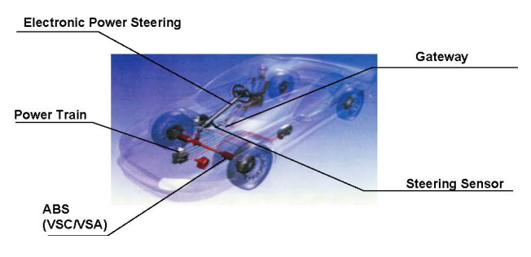

**https://www.fujitsu.com/downloads/CN/fmc/lsi/FlexRay-EN.pdf**

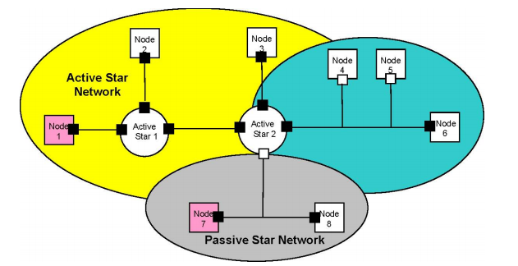

https://www.fujitsu.com/downloads/CN/fmc/lsi/FlexRay-EN.pdf

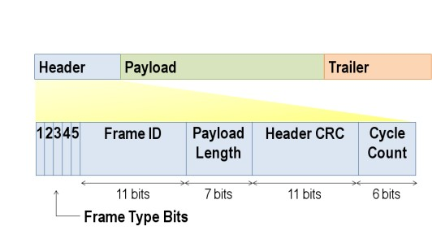

https://www.fujitsu.com/downloads/CN/fmc/lsi/FlexRay-EN.pdf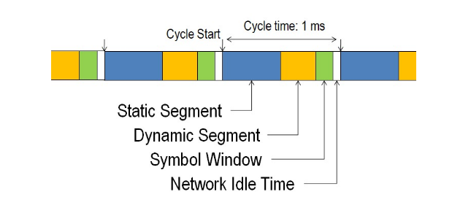

<https://www.fujitsu.com/downloads/CN/fmc/lsi/FlexRay-EN.pdf>

\

