./

Learning Report – Applied System Development Life Cycle and Software Testing



|  |  |  |  |  |  |
| --- | --- | --- | --- | --- | --- |
| **Ver. Rel. No.** | **Release Date** | **Prepared. By** | **Reviewed By** | **To be approved By** | **Remarks/Revision Details** |
| 1 |  | Name/PS No | Name/PS No | Module Owner Name | Comments |
| 2 | 15/02/21 | 99003753 |  |  |  |

**Document History**

Table of Contents

Table of Figures 3

Table of Tables 4

ACTIVITY 1: SYSTEM/ SOFTWARE DEVELOPMENT 4

**INTRODUCTION** 4

**MY PRODUCT: “Name ”** 6

**SWOT ANALYSIS** 7

**REQUIREMENTS** 7

**DESIGN** 8

HIGH LEVEL DESIGN 8

LOW LEVEL DESIGN 11

**TEST PLANS** 13

**REFERENCES** 15

ACTIVITY 2: AGILE METHODOLOGY 15

**THEME** 15

**EPIC** 15

**USER STORY** 16

**REFERENCES** 17

APPENDIX: 17

## Table of Figures

Figure 1 CLASS DIAGRAM(HIGH LEVEL) 10

Figure 2 USE CASE DIAGRAM (HIGH LEVEL) 11

Figure 3 ACTIVITY DIAGRAM (HIGH LEVEL) 12

Figure 4 USE CASE DIAGRAM (LOW LEVEL) 12

Figure 5 ACTVITY DIAGRAM (LOW LEVEL) 13

Figure 6 BLOCK DIAGRAM 13

Figure 7 COMPONENT DIAGRAM (HIGH LEVEL) 22

Figure 8 ACTIVITY DIAGRAM (high level) 23

[Figure 9 ACTIVITY DIAGRAM (LOW LEVEL) 24](https://lnttsgroup.sharepoint.com/sites/GEA/Global%20Engineering%20Academy/GEA%20Insights/Genesis/Shared%20Documents/Submission/MYSORE/2009MYSEMB/Foundation/Applied%20SDLC%20with%20Software%20Testing/99002439/FINAL.docx#_Toc52177322)

Figure 10- ACTIVITY DIAGRAM (LOW LEVEL) 24

Figure 11 TEST PLAN 25

Figure 12 GIT 27

Figure 13 GIT ISSUES 28

Figure 14 GIT COMMITS 1 28

Figure 15 GIT COMMIT 2 29

Figure 16 GIT 30

Figure 17 GIT MAKE 31

Figure 18 GIT MAKE 2 31

Figure 19 GIT BUILD 32

Figure 20 GIT CODE QUALITY 32

## Table of Tables

Table 1 AGING 6

Table 2 GRADING COST 6

Table 3 REQUIREMENTS 8

Table 4 HIGH LEVEL TEST PLAN 15

Table 5 LOW LEVEL TEST PLAN 16

Table 6 USER STORIES 17

Table 7 AGING 19

Table 8 GRADING COST 19

Table 9 REQUIREMENTS 21

Table 10 USER STORIES 27

**Introduction**

## Project Name – Calculator

Helps in computing trigonometric functions, binary conversions, Dimension conversions and basic calculator.

Features -

* Basic Calculation
* Binary Conversion
* Dimension Conversion
* Trigonometric Functions

### Arithmetic Conversions

* Addition
* Subtraction
* Multiplication
* Division
* modulus

# SWOT Analysis -

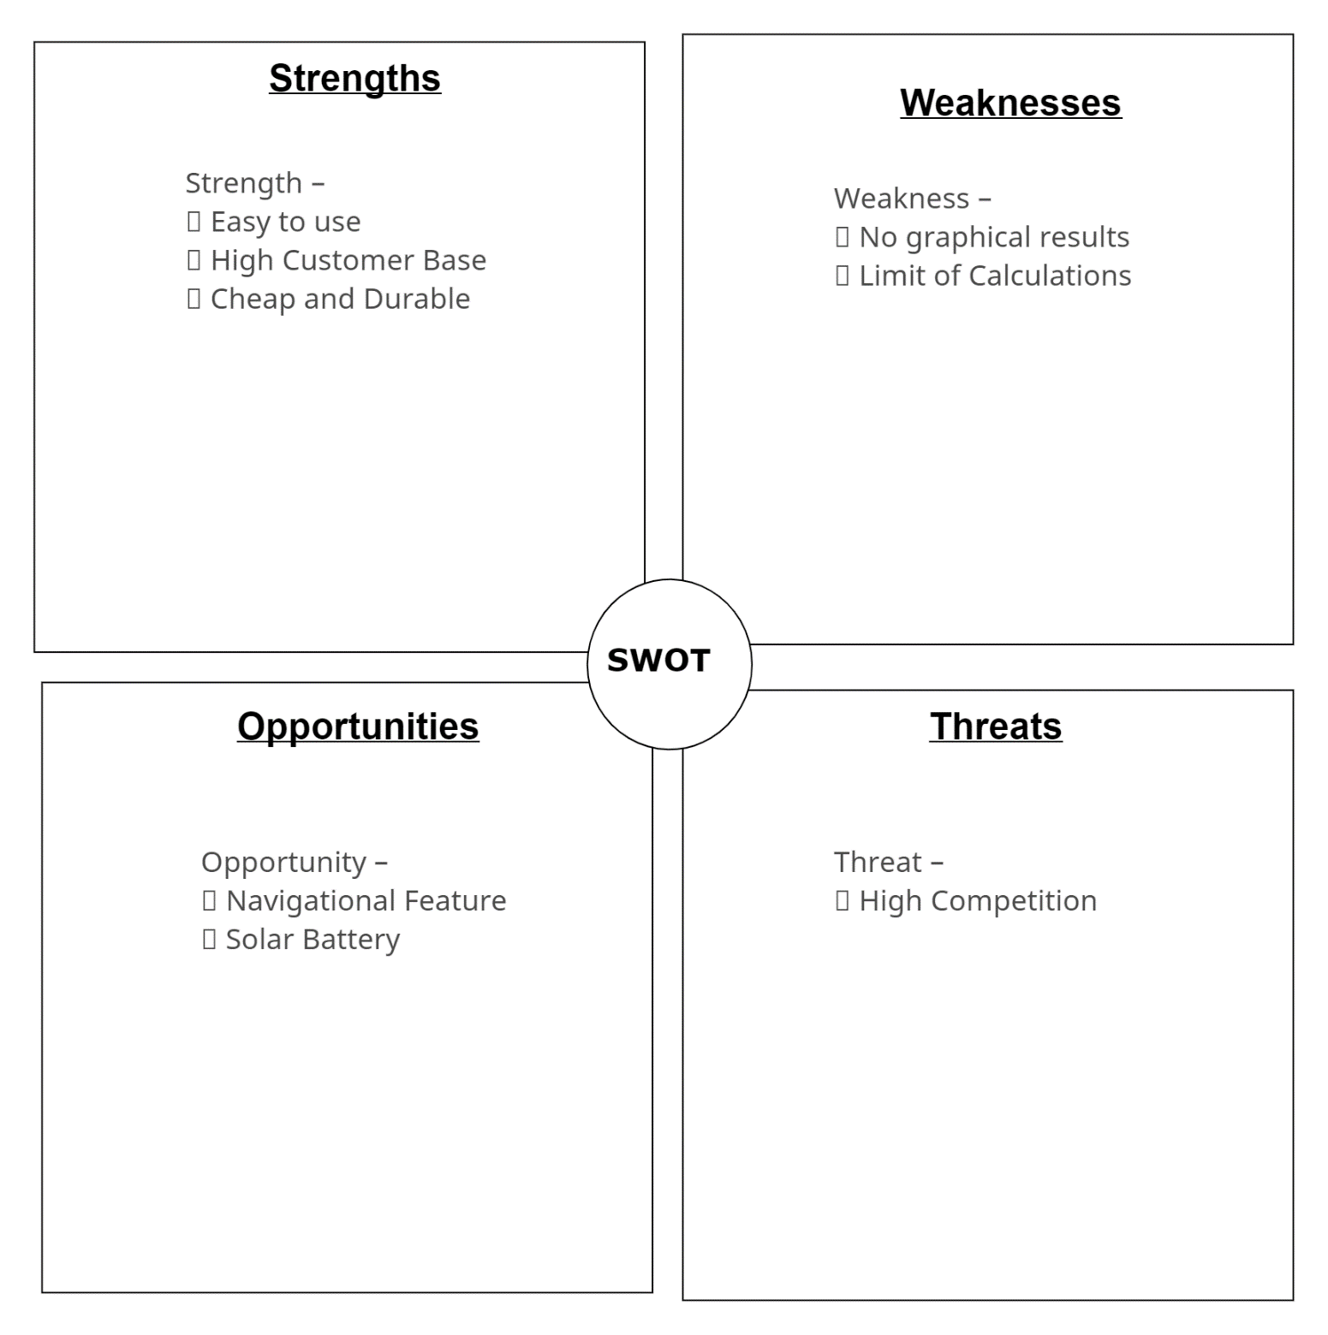

# Requirements

## High Level Requirements

* Basic Arithmetic Calculation
* Trigonometric Calculation
* Dimension Conversion
* Binary Conversion

## Low Level Requirements

### Arithmetic Conversions

* Addition
* Subtraction
* Multiplication
* Division
* modulus

### Trigonometric Conversions

* Sine, Cosine, Tan, Cot, Sec, Co-sec
* I/O type Floating Values

### Binary Conversion

* Binary to decimal and Hex
* Decimal to Hex and Binary
* Positive integer values allowed
* Conversion for Range of word size

### Dimension Conversion

* Length Conversions (centimeter/meter/km, inch/foot)
* Mass Conversions(g/kg/pounds)
* Temperature Conversions(Degree/Fahrenheit)
* Floating Values

Design

Low Level Design -

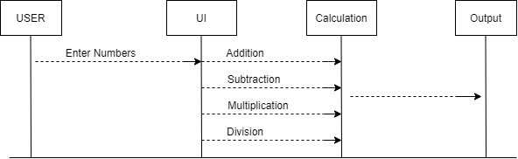

Low Level Design

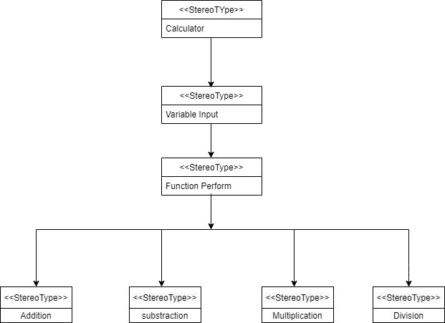

High Level Diagram

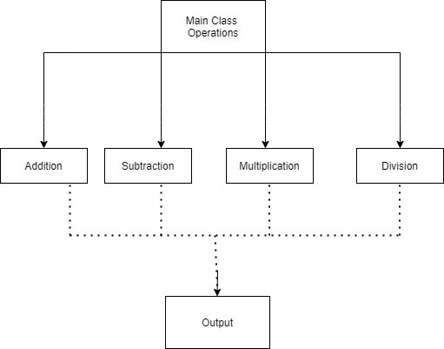

Object Diagram

Test Plan

**# Arithmetic Operations**

| Test Id | Input                | Expected Output | Actual Output |   Status   |

|---------|----------------------|-----------------|---------------|------------|

| T1      | Addition 2,3         | 5               |    5          |      pass      |

| T2      | Subtraction 5,1      | 4               |   4          |         pass   |

| T3      | Multiplication 2,5   | 10              |  10          |       pass     |

| T4      | Division 18,6        | 3               |   3         |       pass     |

| T5      | Addition -2,5        | 3               |   3          |       pass     |

| T6      | Subtraction -3,5     | -8              |  -8         |       pass     |

| T7      | Multiplication +5 ,-5| -25             |         -25   |       pass     |

| T8      | Division 15,0        | Error           |     Error     |    Pass        |

GIT Issues –

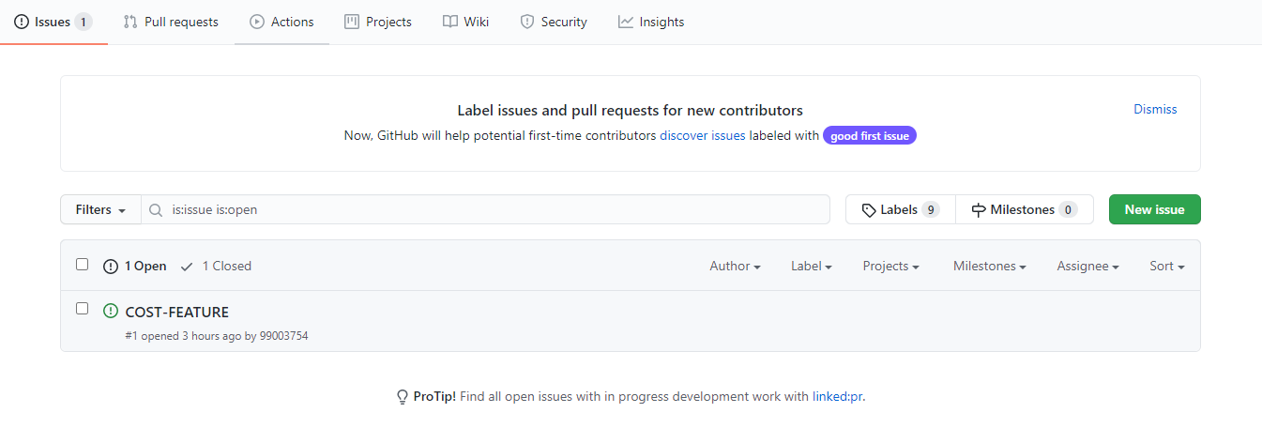

GIT Commits -

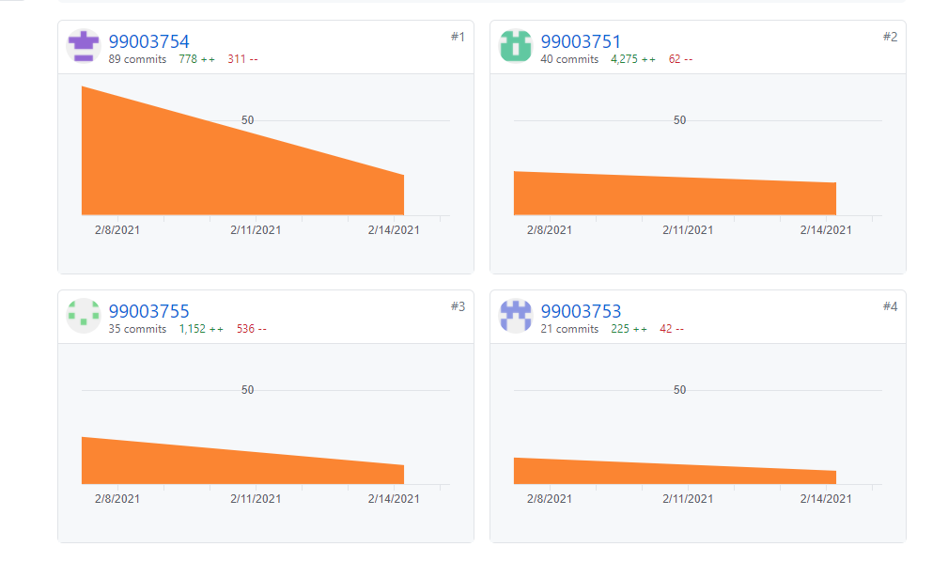

Cpp Check -

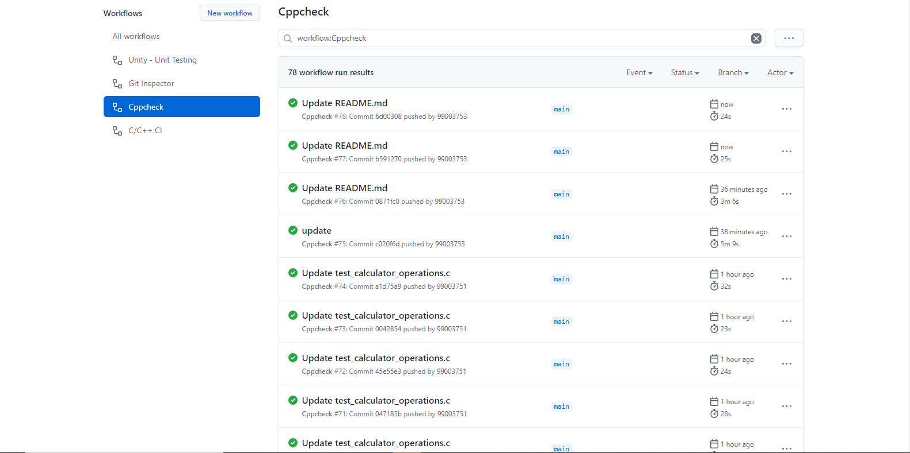

Agile Methodology

The **Agile software development** methodology is one of the simplest and effective processes to turn a vision for a business need into software solutions. Agile is a term used to describe software development approaches that employ continual planning, learning, improvement, team collaboration, evolutionary development, and early delivery. It encourages flexible responses to change.

Theme - Calculator

This Calculator helps in calculating basic calculation, conversion of dimensions, trigonometric functions and binary conversions.

Epic - The Calculator Is to perform basic arithmetic operation ,that is design by me.

Stories – Based on epic some are function given below –

1.Addition

2.Subtraction

3.Multipplication

4.Division

5.Remainder

Here is a graphical illustration of the Agile Model –

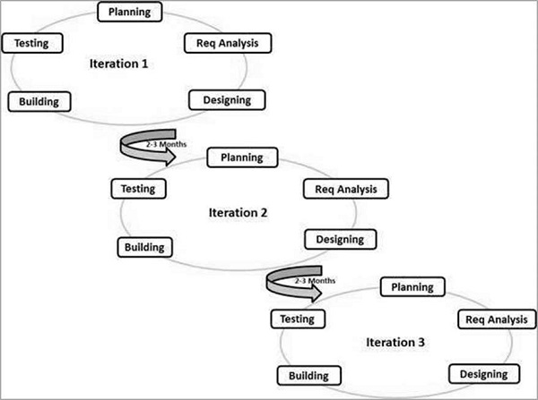

An iteration, in the context of an Agile project, is a during which development takes place, the duration of which:

* may vary from project to project, usually between 1 and 4 weeks
* is in most cases fixed for the duration of a given project