./

Learning Report

Automotive System overview



Team 1

|  |  |  |  |  |  |
| --- | --- | --- | --- | --- | --- |
| **Ver. Rel. No.** | **Release Date** | **Prepared. By** | **Reviewed By** | **Approved By** | **Remarks/Revision Details** |
| 1 | 19-3-2021 | Arpita A Kulkarni  99003757 |  |  |  |
| 2 | 22-03-2021 | Arpita A Kulkarni  99003757 |  |  |  |
|  |  |  |  |  |  |
|  |  |  |  |  |  |
|  |  |  |  |  |  |

**Document History**

# 

Contents

Introduction 4

Research: 5

My features 16

Requirements 17

High Level Requirements 17

Low Level Requirements 17

SWOT Analysis 17

Design 19

Test Plan 20

# Introduction

* Power assisted door glass is defined as automobile window which can be raised and lowered by depressing a button or switch as opposed to using a hand-turned crank handle. This system is also coined as power window in automotive industry. The power window of a vehicle door window is a device installed between the vehicle door panels and has a simple top level functional requirement.
* The first power windows were introduced in cars in 1940 by Packard using a hydro-electric system, and since the 1970's the operational design has not changed significantly. In a basic system, power is run to the motor as switches are activated based on the user input. In some cars though, the power does not go through the switches directly and instead connects to a microcontroller which monitors the state of the switches and if the switch status is changed, the microcontroller closes a relay to provide power to the window motor. The driver is able to control other windows by sending data on a communication bus to tell the controller to open/close other windows. Most power window systems consist of 4 basic components: the battery, a switch, a motor, and gears. The gears are connected to linkages that attach to the bottom of the window.
* The window follows a track in the door to allow for smooth operation of the window's motion. The DC motor works in a 2 to 5amp current range and is controlled through a relay. The basic motor operation is accomplished by reversing the polarity of the motor to make the window move up or down. The motor is able to tell when the window is closed by using a thermal sensor. The motor lifts the window until the glass is fully up, when this happens the motor will still be trying to push the window up, but the glass has nowhere to go so it creates resistance and heat in the motor. The sensor detects the change and turns the motor off.

# Research:

How does Power window work?

The power is directed to the ignition; so that when you turn on the vehicle the windows will be in operation. From the ignition, a wire runs to the fuse box before leading on to the window switch, this is essential in the case of a fault. The fuse will burn out therefore preventing any major costly repairs to larger components.  
  
The switch works by closing and opening two different sets of wire circuits, and then the wires are redirected to the power windows motor. When you push the switch one way, one set closes and another open. If you push the switch the other way the opposite sets open and close. This is necessary in determining which way the motor should run.  
The majority of power windows work in the same way by having an automatic down feature on the driver side window; if you hold the switch down the window will lower until you release the switch, but if you just tap the switch, the window will open fully. Most power windows however, don’t have an automatic up feature due to the danger of something or someone becoming trapped. There is normally a circuit which determines the speed of the motor, if the motor slows down before the window is closed, it will stop and reverse the opposite way therefore opening the window again.

The [power window motor](https://www.carjunky.com/products/Power-Window-motor) is a small motor that has an attached worm gear. This worm gear is a length of metal with a spiral on one end, similar to that of a screw.  
The worm is attached to a gear; this circular gear has teeth around the outside. We can all picture this as a form of cog. As the worm turns it moves the gear by linking the teeth inside the spiral; the gear is then linked to several spur gears. Spur gears are used to create gear reductions in machines with motors.  
  
The worm is fixed at a specific angle to the gear, which allows the worm to turn the gear, but prevents the gear from turning the worm. The motion of the worm and gears create a gear reduction which gives enough force to turn or rotate things, this is called torque.  
  
There are supporting bars below each electric window and attached to each bar is an arm. This arm slides along the bars as the window rises and falls. The other end of the arm has a plate with teeth that slot into the teeth of the gears; as the gears turn so does the arm and in turn raises or lowers the window glass. On the opposite side of the bars is a counter arm that counteracts the weight of the window, so if the main arm is raised on the right side of the window the counter arm will be raised on the left, ensuring that the glass rises and falls evenly and level.  
  
The mechanisms are very similar in manual windows as that of power windows, but instead of the motor turning the gears the crank handle does the work.

|  |
| --- |
|  |

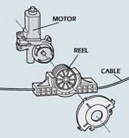

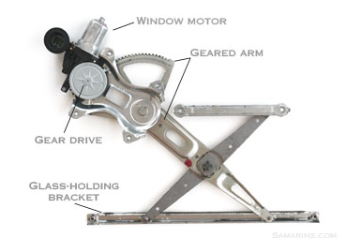

Anti-Pinch Operation:

* The anti-trapping function is adopted.
* The power window timer function is adopted.
* The power window lock switch is adopted.
* When the window reaches the obstruction, it can cause bodily harm or the window can shatter if the obstruction is hard. To add a safety device to the express-up feature, car makers use an anti-pinch device. The window motor has a pressure sensor that detects window motor movement when the glass has stopped moving, even minutely. If this occurs, the window reverses direction and moves downward.
* The anti-pinch feature is controlled by a small module which is now often integrated into the power window switches on the driver’s door. If the vehicle loses battery power or the power windows require a repair, the power windows will not know their upper and lower limits. The window motor will need to be re-trained so it can learn the window travel limits.

Reed Sensor:

Features

•The reed switch used in the Reed Sensor is hermetically sealed and is therefore not sensitive rough wet environments

• The reed sensors reliably operate between - 50˚C to 150˚C

• Magnet and Reed Sensor are isolated and have no physical contact by typically having the magnet mounted on the motor and the Reed Sensors mounted and positioned to accurately detect the motor rotation

• The magnet is not affected by its environment

• Tens of millions of reliable operations

• Surface mount and through hole packages available

• Cylindrical hole and screw fastening mounting

• Contacts dynamically tested



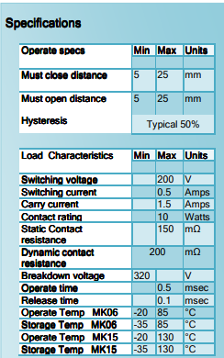

Hall effect Sensor:

Hall Effect Sensors are devices which are activated by an external magnetic field. We know that a magnetic field has two important characteristics flux density, (B) and polarity (North and South Poles). The output signal from a Hall effect sensor is the function of magnetic field density around the device. When the magnetic flux density around the sensor exceeds a certain pre-set threshold, the sensor detects it and generates an output voltage called the Hall Voltage, VH.

The output voltage, called the Hall voltage, (VH) of the basic Hall Element is directly proportional to the strength of the magnetic field passing through the semiconductor material (output ∝ H). This output voltage can be quite small, only a few microvolts even when subjected to strong magnetic fields so most commercially available Hall effect devices are manufactured with built-in DC amplifiers, logic switching circuits and voltage regulators to improve the sensors sensitivity, hysteresis and output voltage. This also allows the Hall effect sensor to operate over a wider range of power supplies and magnetic field conditions.

Hall Effect Sensors are available with either linear or digital outputs. The output signal for linear (analogue) sensors is taken directly from the output of the operational amplifier with the output voltage being directly proportional to the magnetic field passing through the Hall sensor.

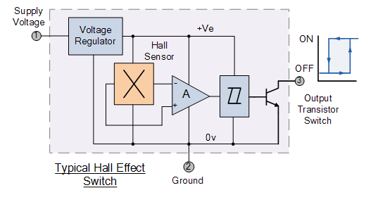

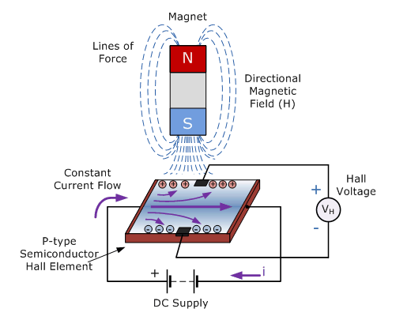

Current Sensor:

Current flowing through a conductor causes a voltage drop. The relation between current and voltage is given by Ohm’s law. In electronic devices, an increase in the amount of current above its requirement leads to overload and can damage the device.

Measurement of current is necessary for the proper working of devices. Measurement of voltage is Passive task and it can be done without affecting the system. Whereas measurement of current is an Intrusive task which cannot be detected directly as voltage.

ACS712

For measuring current in a circuit, a sensor is required. ACS712 Current Sensor is the sensor that can be used to measure and calculate the amount of current applied to the conductor without affecting the performance of the system.

ACS712 Current Sensor is a fully integrated, Hall-effect based linear sensor IC. This IC has a 2.1kV RMS voltage isolation along with a low resistance current conductor.

Working Principle

Current Sensor detects the current in a wire or conductor and generates a signal proportional to the detected current either in the form of analog voltage or digital output.

[Current Sensing](https://www.elprocus.com/current-sensor/) is done in two ways – Direct sensing and Indirect Sensing. In Direct sensing, to detect current, Ohm’s law is used to measure the voltage drop occurred in a wire when current flows through it.

A current-carrying conductor also gives rise to a magnetic field in its surrounding. In Indirect Sensing, the current is measured by calculating this magnetic field by applying either [Faraday’s law](https://www.elprocus.com/electromagnetic-induction-and-laws/) or Ampere law. Here either a [Transformer](https://www.elprocus.com/various-types-of-transformers-applications/) or [Hall effect sensor](https://www.elprocus.com/hall-effect-sensor-working-principle-and-applications/) or fiber optic current sensor are used to sense the magnetic field.

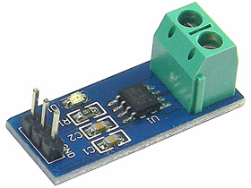

Interface:

Driver side: Master Switch

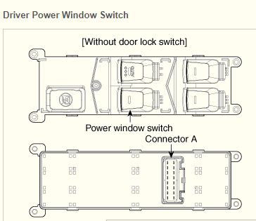

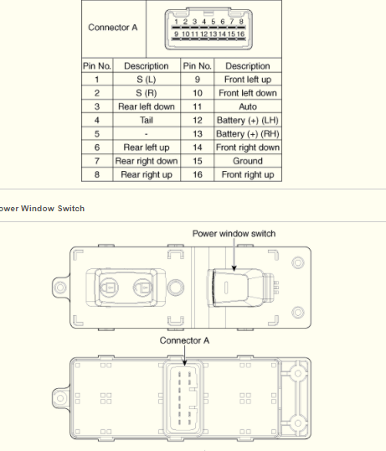

Passenger side:



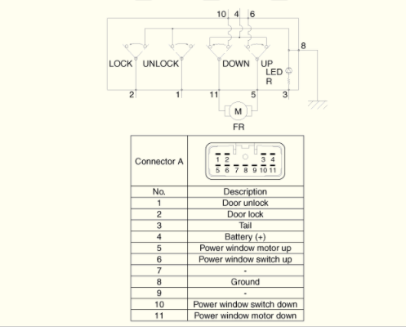

Classification:

Input:

Master switch:4 driver control switches + lock or unlock switch

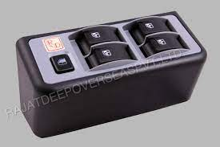

Switch:3 passenger switch

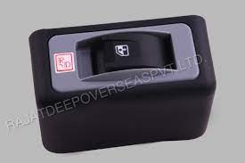

Sensors: Current Sensor to measure the resistance on motor, to detect the presence of object.

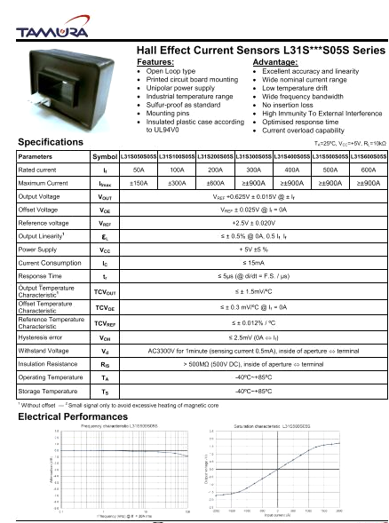

Figure :Hall effect datasheet

|  |  |  |  |
| --- | --- | --- | --- |
| Sensor name | Hall effect sensor | MK15 Series Reed Sensor | ACS712 Current Sensor |
| Operating |  |  |  |
| Characteristics |  |  |  |
| Scale Factor |  |  |  |
|  |  |  |  |
|  |  |  |  |

Motor:

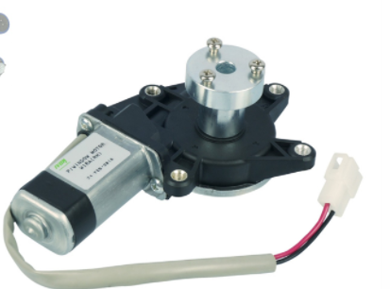

* Voltage Rating: 12VDC
* No load Speed:  85 ± 15RPM

## My features

* Anti-Pinch operation.
* Express Mode.

# Requirements

## High Level Requirements

|  |  |
| --- | --- |
| Id | Description |
| BCM_PW_HL_1 | Express Mode of Operation |
| BCM_PW_HL_2 | Anti-Pinch Operation |
| BCM_PW_HL_3 | User input |

## Low Level Requirements

|  |  |
| --- | --- |
| Id | Description |
| BCM_PW_LL_1 | Express mode up by pulling up the switch for 50 sec. |
| BCM_PW_LL_2 | Express mode down by pressing down the switch for 50 sec. |
| BCM_PW_LL_3 | Resistance on motor to detect the presence of object. |
| BCM_PW_LL_4 | Driver Command is prioritized over Passenger input when both gives command at same time. |
| BCM_PW_LL_5 | User Input==UP, window goes Up by 25% every 1 sec. |
| BCM_PW_LL_6 | User Input==DOWN, window goes Down by 25% every 1 sec. |
| BCM_PW_LL_7 | In express mode up, check for armature current of motor. If object present current decreases then open the window fully. |
|  |  |
|  |  |

## SWOT Analysis

|  |  |
| --- | --- |
| Strengths   * It allows the driver to control the windows with just the touch of his fingers. * It allows people with hand injuries or other physical complications to easily operate the windows. * Drivers can easily control the windows even while driving. * The master power panel in the front also allows the driver to operate all the windows simultaneously, without leaving his seat. This feature is very helpful in case there are children in the back seat. | Weakness   * Many a times, the window regulator also known as the window track, might stop functioning. This causes a power window failure. * Power windows might also stop working because of a broken motor, a broken cable pulley, or a broken switch. * If fails to detect object presence, it may lead to hazard. |
| Opportunities   * Power Windows can be used in any all the modern vehicle. | Threats   * Every Day New feature are getting added. |

# Design

High Level Design

Low level Design

# Test Plan

|  |  |  |  |  |  |  |  |
| --- | --- | --- | --- | --- | --- | --- | --- |
| Test Id | Description | Actual Input | Excepted Input | Excepted Output | Actual Output | Categories | Validation Time span |
| 1 |  |  |  |  |  |  |  |
| 2 |  |  |  |  |  |  |  |
| 3 |  |  |  |  |  |  |  |
| 4 |  |  |  |  |  |  |  |