./

Learning Report – Applied System Development Life Cycle and Software Testing



|  |  |  |  |  |  |
| --- | --- | --- | --- | --- | --- |
| **Ver. Rel. No.** | **Release Date** | **Prepared. By** | **Reviewed By** | **To be approved By** | **Remarks/Revision Details** |
| 1 |  | Name/PS No | Name/PS No | Module Owner Name | Comments |
| 2 |  | Ajit Bijapur/  99003736 |  |  |  |
| 3 |  |  |  |  |  |
|  |  |  |  |  |  |
|  |  |  |  |  |  |

**Document History**

Table of Contents

1.INTRODUCTION: - 4

2.RESEARCH: - 4

3.features: 8

4. Detailed features: - 9

**5 . IMPLEMENTATION: -13**

6.Flow chart…………………………………………………………………………………………………………………………………………………….….15

7.REFERENCES: - 16

## **Table of Figures**

**Figure 1 CLASS DIAGRAM(HIGH LEVEL) 10**

**Figure 2 USE CASE DIAGRAM (HIGH LEVEL) 11**

**Figure 3 ACTIVITY DIAGRAM (HIGH LEVEL) 12**

**Figure 4 USE CASE DIAGRAM (LOW LEVEL) 12**

**Figure 5 ACTVITY DIAGRAM (LOW LEVEL) 13**

**Figure 6 BLOCK DIAGRAM 13**

**Figure 7 COMPONENT DIAGRAM (HIGH LEVEL) 22**

**Figure 8 ACTIVITY DIAGRAM (high level) 23**

[**Figure 9 ACTIVITY DIAGRAM (LOW LEVEL) 24**](https://lnttsgroup.sharepoint.com/sites/GEA/Global%20Engineering%20Academy/GEA%20Insights/Genesis/Shared%20Documents/Submission/MYSORE/2009MYSEMB/Foundation/Applied%20SDLC%20with%20Software%20Testing/99002439/FINAL.docx#_Toc52177322)

**Figure 10- ACTIVITY DIAGRAM (LOW LEVEL) 24**

**Figure 11 TEST PLAN 25**

**Figure 12 GIT 27**

**Figure 13 GIT ISSUES 28**

**Figure 14 GIT COMMITS 1 28**

**Figure 15 GIT COMMIT 2 29**

**Figure 16 GIT 30**

**Figure 17 GIT MAKE 31**

**Figure 18 GIT MAKE 2 31**

**Figure 19 GIT BUILD 32**

**Figure 20 GIT CODE QUALITY 32**

## **Table of Tables**

**Table 1 AGING 6**

**Table 2 GRADING COST 6**

**Table 3 REQUIREMENTS 8**

**Table 4 HIGH LEVEL TEST PLAN 15**

**Table 5 LOW LEVEL TEST PLAN 16**

**Table 6 USER STORIES 17**

**Table 7 AGING 19**

**Table 8 GRADING COST 19**

**Table 9 REQUIREMENTS 21**

**Table 10 USER STORIES 27**

**ACTIVITY 1: SYSTEM/ SOFTWARE DEVELOPMENT**

Introduction:

**1.Power door lock system**: -

Power door locks are also sometimes referred to as central-locking or electric door locks. These types of locks allow you or the passenger to unlock or lock all of the doors in the vehicle simultaneously by simply flipping a switch or pressing a button in the vehicle. The control panel that allows you to control all of the vehicle's locks is typically situated on the inside of the driver's side of the vehicle. This type of system is available in 2-door models, as well as [4-door car](http://www.kbb.com/what-is/4-door-car/) models.

The first power door locks were presented in 1914 on the Scripps-Booth. Power door locks did not become a common inclusion on luxury vehicles until 1956 when they were introduced once again by Packard. Almost all of today's [new car](http://www.kbb.com/what-is/new-car/) models offer power door locks. The earliest power-locking systems were capable of only locking and unlocking the doors on the vehicle. Many vehicles today include a power-lock system that can also unlock other areas of the vehicle, such as the fuel door or the trunk. With this option, the cover on the fuel cap can be released with the activation of a button or switch. Many vehicles today will also automatically activate the power door locks when the vehicle attains a specific speed.

2.Interior lights: -

Most vehicles have interior lights that are also called dome lights or courtesy lights. These can be located on the ceiling of the vehicle and illuminate when people enter or exit the car. The lighting normally stays lit until the vehicle is turned on so the passengers can safely fasten their seat belt.

Research:

1. **Door lock system:**

**WHAT HAPPENS INSIDE THE CAR DOOR?**

A power door lock actuator is typically positioned somewhere below the latch. A connecting rod attaches to the actuator and another one connects the latch to the manual knob that sticks out the top of the door. The mechanism allows for the rods to work in conjunction to power the actuator. Within the actuator, a tiny electrical motor turns a series of gears that drive a rack and pinion gear set that attaches to the actuator rod. The rotational motion of the motor is converted into linear motion, and the lock is opened. A centrifugal clutch prevents the process from happening in reverse.

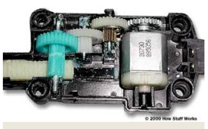

**Fig 1. Inside the power-door-lock actuator**

This system is quite simple. A small [electric motor](https://electronics.howstuffworks.com/motor.htm) turns a series of [spur gears](https://auto.howstuffworks.com/gear2.htm) that serve as a [gear reduction](https://auto.howstuffworks.com/gear-ratio.htm). The last gear drives a [rack-and-pinion gear set](https://auto.howstuffworks.com/gear6.htm) that is connected to the actuator rod. The rack converts the rotational motion of the motor into the linear motion needed to move the lock [2].

Wiring diagram for Door system:

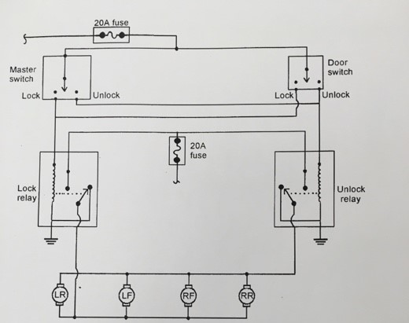

Fig 2.Wiring diagram of Door system

**2.Interior lights: -**

Most of the modern cars are equipped with circuitry which switches on the Car's room lamp when a door is opened and switches off the lamp in fading manner when the door is closed.

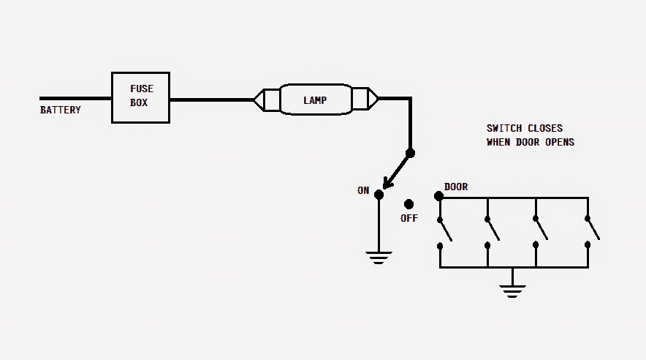

Fig 3.interior lighting

The lamp is connected to the battery's positive thru a fuse. The other end of the lamp is connected to a single-pole-3-throw switch.

When this switch is positioned at ON, the other end of the lamp gets connected to ground i.e. the negative terminal of the battery hence, the lamp gets illuminated [1].

In OFF position, the lamp remains disconnected from the ground. In DOOR position, the lamp gets connected to the ground via door switches (in parallel). When a door is opened, the corresponding door switch is closed.

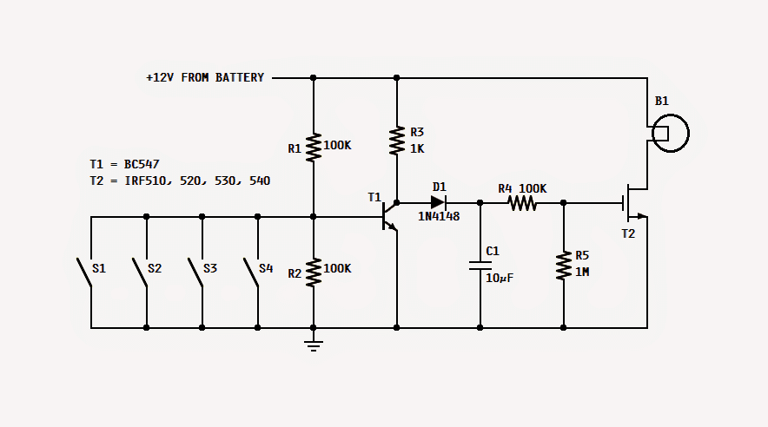

Fig 4. Interior lighting switch

How it Works?

* Referring to the proposed car interior light fader circuit, when any of the door is opened, its switch is closed hence, the base of T1 gets connected to ground and thus stop conducting. In this state, C1 gets charged rapidly via R3 and D1.
* As soon as C1 is charged, the Mosfet is fed with the gate voltage thru R4 and thus it starts conducting and consequently the lamp is illuminated.
* Now, when that door is closed, its switch gets open. The base of T1 gets disconnected from the ground and is held at a voltage delivered by the R1/R2 voltage divider.
* This action switches on T1, and the voltage coming from R3 finds it way to ground thru emitter of T1.
* The switching on of T1 deprives C1 of its charging current and thus C1 starts discharging slowly thru R4 and R5. The gate voltage of T2 reduces as C1 discharges.
* With this reduction in the gate voltage the intensity of the lamp is also reduced. Finally, when the gate voltage goes below the threshold voltage the lamp switches off

**1.Reed Switch**: -

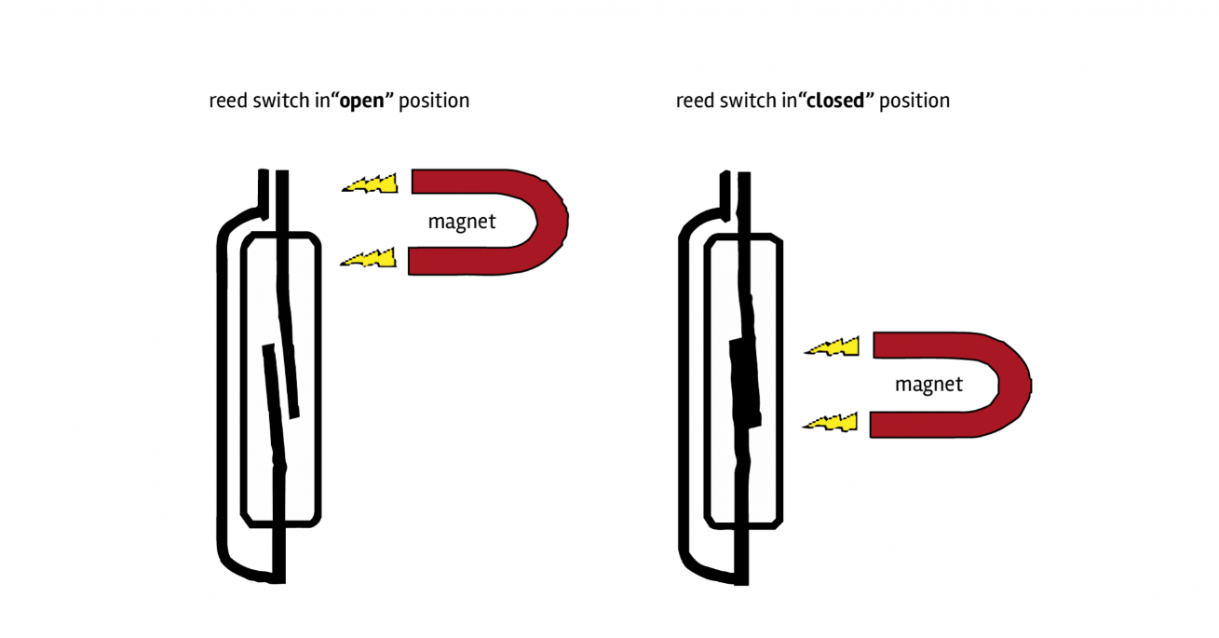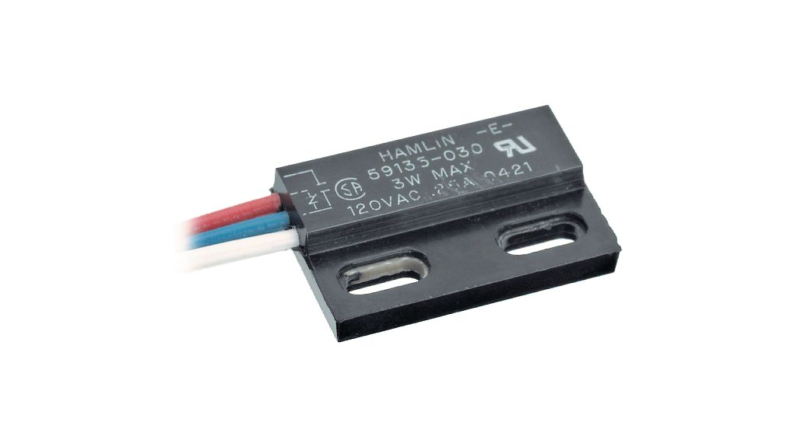

Fig 5. Reed switches

Features

* The reed sensors reliably operate between - 50˚C to 150˚C
* Magnet and Reed Sensor are isolated and have no physical contact by typically having the magnet mounted on the handle and the Reed Sensors mounted and positioned to accurately pick up the handle motion
* The reed switch used in the Reed Sensor is hermetically sealed and is therefore not sensitive to rough, wet environments
* The magnet is not affected by its environment
* Tens of millions of reliable operations
* Surface mount and through hole packages available
* Cylindrical hole and screw fastening mounting
* Contacts dynamically tested
* Rated voltage: 200 VDC max
* Distance: 15mm max
* Dimensions:
  + Box size (each side): 29mm x 14mm x 9mm / 1.1" x 0.6" x 0.4"
  + Cable Length: 305mm ± 12mm / 12" ± 0.5"
  + Weight (per side): 5.4g

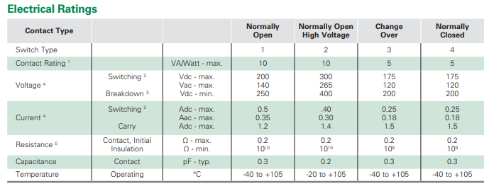

Table 1. electrical rating of Reed switch



# Fig 6.Reed switch in Door Lock Detection

How Reed Switch work?

* the Magnet and the Reed Switch will always be near and the Reed Switch will be in closed state (since my Reed Switch is a Normally Open type).
* When the door is opened, the magnet moves away from the Reed Switch along with the door and the switch moves back to Open state[8].

**Characteristics of reed switches:-**

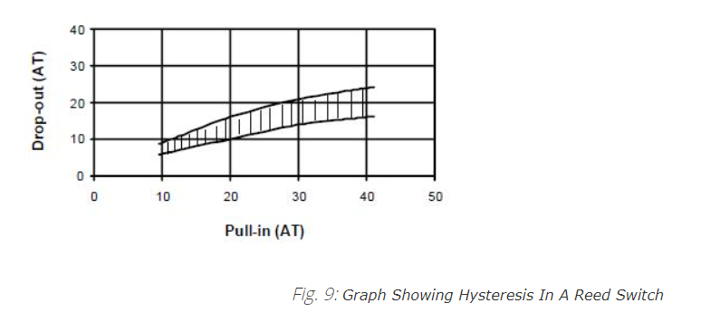

Hysteresis Graph

The above plot shows that that variation in hysteresis is for low ampere turns (AT) is very small and increases with higher AT. For a low hysteresis operation of the Reed Switch the magnetic influence on the switch should be kept low

2.Dc motor:

* Specification: Rated voltage 12V DC; Operate smoothly on 8-16V DC
* Size Info: Shaft: 2mm diameter x 22mm length; Canister: 3.2 x 2.5 x 1.7cm/1.25'' x 0.98'' x 0.67(L x W x H)
* [Aftermarket Replacement Part]: Replaceable OE number for reference: FC-280SC-20150
* [High Rotation Speed]: This car door lock motor rotates and works accurately, low noise; The speed reaches up to 11800 rpm
* [Widely Application]: This 22mm flat shaft motor is widely used for cars with appropriate voltage and rotational speed in a same shape

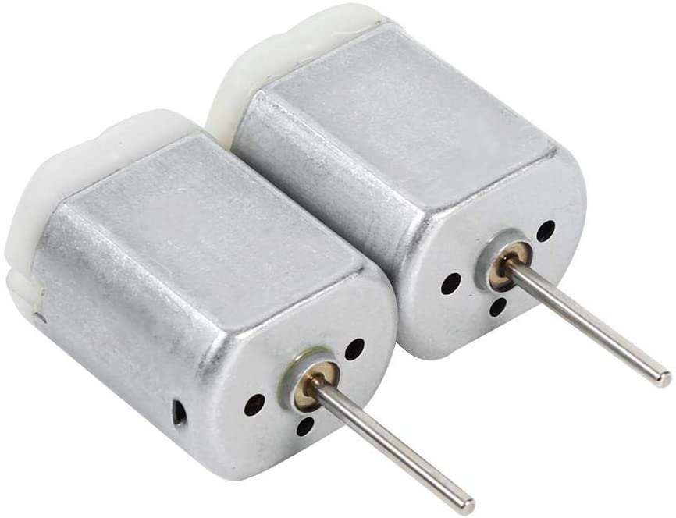

Fig 7.DC motors

# 3.Linear Actuator:

Description:

This is a Linear Actuator - Power Door Lock Mechanism for Electronics Circuit. This motor driven actuator can be installed to add power door lock systems to most vehicles. Simple two wire hook-up for easy installation. Usable with remote control and alarm system.

* Supply voltage: DC 12V
* Current consumption: 0.15A-2.0A
* Movement: Linear
* Movement distance: 20mm.

# Fig 8.Linear Actuators- RS010

Electromagnetic actuators rely on solenoids which lock or unlock doors using current going in both directions (open/closed) through an electric module. On this kind of system two types of arrangements are in use. First one uses separate relays for each of action taking by the system. One dedicated to open and another one to close the door. Both of them are controlled by a transistor switching the circuit operated by the capacitor (storage for energy necessary to operate system) which is releasing current necessary to activate the locks. Another type uses two capacitors and two relays working as a tandem. One pair is responsible for locking and another for unlocking. When the circuit is closed a current is discharged from the capacitor and the lock is either opened or closed.

4.Relay:-

**Characteristics of relay switch: -**

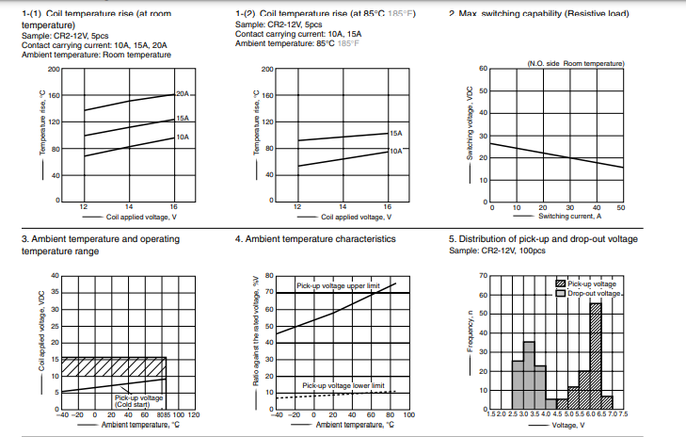

Interior Light: -

1.Resistors

2.Capacitors

3.Switches

4.LED bulb -12V

5.1N41418 Diode specification: -

|  |  |
| --- | --- |
| Diode Type | Small Signal |
| Forward Current If(AV) | 150mA |
| Repetitive Reverse Voltage Vrm Max | 100V |
| Forward Voltage VF Max | 1V |
| Reverse Recovery Time trr Max | 4ns |
| Forward Surge Current Max | 2A |
| Operating Temperature Range | -65°C to +200°C |
| Diode Case Style | DO-35 |
| No. of Pins | 2 |

SWOT Analysis

|  |  |
| --- | --- |
| *Strength*   * User friendly * Easy application * Fast operation | *Weakness*   * User interface is required * Poor intelligent |
| *Opportunities*   * Automatic door lock is possible. * Keyless door lock | *Threat*   * Motor malfunction * failure of door lock actuators * Blown fuse |

Features:-

**1.Requirements of the Door lock :-**

I. Locking the Doors: -

* Press the lock switch on the door interior trim panel. You can no longer release the doors using the exterior door handle switches.

II.Unlocking the Doors: -

* Press the unlock switch on the door interior trim panel. You can release the doors using the exterior door handle switches.

**2.Requirements of the interior lights**: -

* Whenever the door is open the interior lights has to be glow and when the door is closed the interior light has to be off and manual switch is also there for on and off the lamp

**Requirements:**

|  |  |
| --- | --- |
| ID | Description |
| DC_HL1 | Central locking system |
| DC_HL2 | Automatic locking system |
| DC_HL3 | Passenger door lock |
| DC_HL4 | Interior lighting control |

Table 2. High level requirement

|  |  |
| --- | --- |
| ID | Description |
| DC_LL1 | Driver as the access to lock or unlock all the door |
| DC_LL2 | Once the vehicle as started the door as to be locked automatically |
| DC_LL3 | Passengers should have access to lock and unlock the doors |
| DC_LL4 | Light should be on when the any one of the doors or all the door is opened |
| DC_LL5 | Light should be off all the door is opened |

Table 3. Low level requirement

**Design:**

Fig 9.High level Model

Fig 10.Low level Model

**Test plan:**

|  |  |  |  |  |
| --- | --- | --- | --- | --- |
| **Case ID** | **Description** | **Input** | **Expected o/p** | **Actual o/p** |
| HL_DC_1 | Central locking system | Driver press the central locking system switch | It should lock/unlock all the doors including passengers’ doors | It should lock all the doors including passengers’ doors |
| HL_DC_2 | Automatic locking | Ignition should be on | All the doors should be lock including driver door | All the doors should be lock including driver door |
| HL_DC_3 | Passenger door lock | Passenger door lock button | Unlock /lock the doors of passengers | Unlock /lock the doors of passengers |
| HL_DC_4 | Interior lighting control | Doors of the vehicle | Light should be on any one of the doors is opened | Light should be on any one of the doors is opened |
| DC_LL1 | Driver as the access to lock or unlock all the door | Driver side central locking button | All the 4 doors should be close | All the 4 doors should be close |
| DC_LL2 | Light should be off all the door is opened | Should check whether doors are closed or not | Light should be off | Light should be off |

Table 4. Test cases

**Flow chart:**

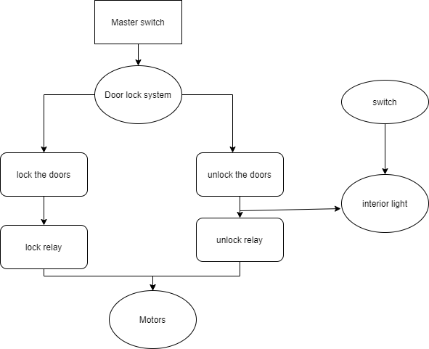

Reference**:**

1. **Working of Door lock system:-**<https://www.ukessays.com/essays/engineering/components-features-central-locking-1083.php>
2. <https://auto.howstuffworks.com/power-door-lock3.html>
3. **More detail on Door lock system**:-<http://what-when-how.com/automobile/window-winding-and-central-door-locking-automobile/>
4. **About Interior light**:- <https://circuits-diy.com/led-car-doom-or-interior-light-using-lm2940-ic/>
5. **About Interior light**:- <https://www.homemade-circuits.com/car-interior-light-fader-circuit/>
6. **Power door lock system**:- <http://surpasspowerwindow.com/how-do-vehicle-power-door-locks-work/>
7. <https://standexelectronics.com/applications-markets/door-lock/>
8. **How car door works in Ford:-**<http://www.fordservicecontent.com/Ford_Content/vdirsnet/OwnerManual/Home/Content?bookCode=O109200&countryCode=USA&languageCode=EN&marketCode=US&viewTech=IE&chapterTitleSelected=G1806601&subTitleSelected=G1890941&topicHRef=G1890942&div=l&variantid=7105&vFilteringEnabled=False&userMarket=USA>
9. **Linear Actuators**: -<https://rees52.com/mechanical/553-linear-actuator-power-door-lock-mechanism-for-electronics-circuit-rs010>
10. **About reed switches**: -https://www.engineersgarage.com/article_page/reed-switch-understanding-specifications/