./

Control Systems – Team Analysis Report



Version Number: 1.4

Team Number: 2

Team members: Pushkar Antony, Rama Subba Reddy, Amit Kumar, Amiya Panda

Module: Control Systems

|  |  |  |  |  |  |
| --- | --- | --- | --- | --- | --- |
| **Ver. Rel. No.** | **Release Date** | **Prepared. By** | **Reviewed By** | **Approved By** | **Remarks/Revision Details** |
| 1.0 | 14/04/2021 | Pushkar Antony | Rama Subba Reddy | Dr.Prithvi Sekhar | Addition of System without controller and lag lead controller |
| 1.1 | 14/04/2021 | Rama Subba Reddy | Pushkar Antony | Dr.Prithvi Sekhar | Addition of Stanley Controller |
| 1.2 | 14/04/2021 | Amit Kumar | Pushkar Antony | Dr.Prithvi Sekhar | Addition of On-Off Controller |
| 1.3 | 14/04/2021 | Amiya Panda | Amiya Panda | Dr.Prithvi Sekhar | Addition of PID Controller |
| 1.4 | 15/04/2021 | Pushkar Antony | Amit Kumar | Dr.Prithvi Sekhar | Final checks and Alignments |

**Document History**

Contents

1) Lateral Dynamics Control- Open Loop without controller 4

Plant Description 4

Open Loop Control 4

Math Analysis: 8

Comparison Analysis: 8

2) Lateral Dynamics Control- Closed Loop with Lag-Lead Controller 9

Plant Description 9

Closed Loop (negative feedback) without Controller :- 9

Closed Loop (negative feedback) with Controller:- 10

Math Analysis: 11

Comparison Analysis: 13

3) Lateral Dynamics Control- Closed Loop with Stanley Controller 14

4) Lateral Dynamics Control- Closed Loop with On-Off Controller 15

5) Lateral Dynamics Control- Closed Loop with PID Controller 20

Control System - Lateral Control - Second Order System 20

Plant Description 20

Math analysis 21

Tool Analysis 21

Comparison Analysis 26

# Lateral Dynamics Control- Open Loop without controller

## Plant Description

Vertical dynamics, or ride dynamics, basically refers to the vertical response of the vehicle to road disturbances. Longitudinal dynamics involves the straight-line acceleration and braking of the vehicle. Lateral dynamics is concerned with the vehicle's turning behavior.

%--------------------------------------------------------------------------  
% Equation1: Ybeta*Beta + Yr*r + Ydelta*delta + Fya + m*g*theta =  
% m*V*d(Beta)/dt + m*V*r  
% Equation2: Nbeta*Beta + Nr*r + Ndelta*delta - (c-a)*Fya = Izz*dr/dt  
%--------------------------------------------------------------------------  
% Variables:  
% Ybeta = Cf+Cr --> Damping - in - Sideslip  
% Yr = (aCf - bCr)/V --> Lateral Force/Yaw Coupling  
% Ydelta = ~Cf --> Control Force  
% Nbeta = a*Cf - b*Cr --> Directional Stability  
% Nr = (a^2)Cf + (b^2)Cr --> Yaw Damping  
% Ndelta = -aCf --> Control Moment  
%--------------------------------------------------------------------------  
% Values: Ydelta = 2461; m = 1775; V = 100; Nr = -67.06; Ndelta = 2803.079;  
% Yr = 0.46384; Izz = 1960; Ybeta = -4772; Nbeta = 46.38; V1=50;  
% Yr1 = 0.92768; Nr1 = -134.12;

## Open Loop Control

System with Velocity of 100km/hr:-

clc;  
Ydelta = 2461;  
m = 1775;  
V = 100;  
Nr = -67.06;  
Ndelta = 2803.079;  
Yr = 0.46384;  
Izz = 1960;  
Ybeta = -4772;  
Nbeta = 46.38;  
sys = tf([((Ydelta)/(m*V)),-((Nr*Ydelta)+(Ndelta*((m*V)-Yr)))/...  
 (Izz*m*V)],[1,(-(Nr/Izz)-(Ybeta/(m*V))),((Nr*Ybeta)+...  
 (Nbeta*((m*V)-Yr)))/(Izz*m*V)])  
figure(1);  
subplot(2,2,1);  
impulse(sys);  
title('Impulse Input for k');  
subplot(2,2,2);  
step(sys);  
title('Step Input for k');  
subplot(2,2,3);  
[z,p,k]= tf2zp([((Ydelta)/(m*V)),-((Nr*Ydelta)+(Ndelta*((m*V)-Yr)))/...  
 (Izz*m*V)],[1,(-(Nr/Izz)-(Ybeta/(m*V))),((Nr*Ybeta)+...  
 (Nbeta*((m*V)-Yr)))/(Izz*m*V)])  
pzmap(sys)  
hold on;  
S = stepinfo(sys)  
%--------------------------------------------------------------------------  
% System with velocity of 50km/hr:-  
V1 = 50;  
Yr1 = 0.92768;  
Nr1 = -134.12;  
sys = tf([((Ydelta)/(m*V1)),-((Nr1*Ydelta)+(Ndelta*((m*V1)-Yr1)))/...  
 (Izz*m*V1)],[1,(-(Nr1/Izz)-(Ybeta/(m*V1))),((Nr1*Ybeta)+...  
 (Nbeta*((m*V1)-Yr1)))/(Izz*m*V1)])  
figure(2);  
subplot(2,2,1);  
impulse(sys);  
title('Impulse Input for k');  
subplot(2,2,2);  
step(sys);  
title('Step Input for k');  
subplot(2,2,3);  
[z,p,k]= tf2zp([((Ydelta)/(m*V1)),-((Nr*Ydelta)+(Ndelta*((m*V1)-Yr)))/...  
 (Izz*m*V1)],[1,(-(Nr/Izz)-(Ybeta/(m*V1))),((Nr*Ybeta)+...  
 (Nbeta*((m*V1)-Yr)))/(Izz*m*V1)])  
pzmap(sys)  
hold on;  
S = stepinfo(sys)

sys =  
   
 0.01386 s - 1.43  
 ------------------------  
 s^2 + 0.0611 s + 0.02458  
   
Continuous-time transfer function.  
  
  
z =  
  
 103.1148  
  
  
p =  
  
 -0.0305 + 0.1538i  
 -0.0305 - 0.1538i  
  
  
k =  
  
 0.0139  
  
  
S =   
  
 struct with fields:  
  
 RiseTime: 7.6539  
 SettlingTime: 126.2645  
 SettlingMin: -89.1467  
 SettlingMax: -41.4693  
 Overshoot: 53.2876  
 Undershoot: 0  
 Peak: 89.1467  
 PeakTime: 21.1043  
  
  
sys =  
   
 0.02773 s - 1.428  
 ------------------------  
 s^2 + 0.1222 s + 0.02734  
   
Continuous-time transfer function.  
  
  
z =  
  
 51.5401  
  
  
p =  
  
 -0.0440 + 0.1535i  
 -0.0440 - 0.1535i  
  
  
k =  
  
 0.0277  
  
  
S =   
  
 struct with fields:  
  
 RiseTime: 8.5851  
 SettlingTime: 64.9768  
 SettlingMin: -67.2096  
 SettlingMax: -47.9433  
 Overshoot: 28.6676  
 Undershoot: 0  
 Peak: 67.2096  
 PeakTime: 20.3506

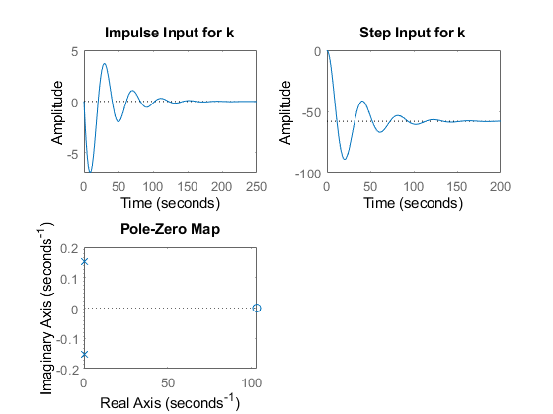

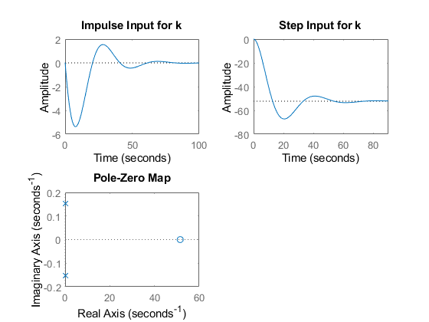

## Math Analysis:

Independent: Time(t) Dependent: Vehicle side slip angle (Beta), Front Steer angle (Delta) Constant: Damping in Sideslip (Ybeta), Lateral Force/Yaw Coupling(Yr), Control Force (Ydelta), Directional Stability (Nbeta), Yaw Damping (Nr), Control Moment(Ndelta).

%--------------------------------------------------------------------------  
% Roots:  
% System with V = 100km/hr:  
% 1) Zero = 103.1148  
% 2) Pole = -0.0305+0.1538i, -0.0305-0.1538i  
% System with V = 50m/s:  
% 1) Zero = 51.5401  
% 2) Pole = -0.0440+0.1535i, -0.0440-0.1535i  
%--------------------------------------------------------------------------  
% Time Response Analysis:  
% 1)System with V = 100km/hr:  
% RiseTime: 7.6539  
% SettlingTime: 126.2645  
% SettlingMin: -89.1467  
% SettlingMax: -41.4693  
% Overshoot: 53.2876  
% Undershoot: 0  
% Peak: 89.1467  
% PeakTime: 21.1043  
% 2)System with V = 50m/s:  
% RiseTime: 8.5851  
% SettlingTime: 64.9768  
% SettlingMin: -67.2096  
% SettlingMax: -47.9433  
% Overshoot: 28.6676  
% Undershoot: 0  
% Peak: 67.2096  
% PeakTime: 20.3506

## Comparison Analysis:

1) The order of the system is 2nd order. When the Velocity of the system is changed, we can get to see some changes.

2) The system with higher velocity has the highest rise time and reaches the peak the fastest.

3) That is, the system with the higher velocity is the fastest.

4) The system with lesser velocity has the lower settling time, denoting that it is more accurate.

5) The system with lesser velocity has lower overshoot percentages.

6) The system with higher velocity has the highest peak.

# Lateral Dynamics Control- Closed Loop with Lag-Lead Controller

## Plant Description

Introduction: Vertical dynamics, or ride dynamics, basically refers to the vertical response of the vehicle to road disturbances. Longitudinal dynamics involves the straight-line acceleration and braking of the vehicle. Lateral dynamics is concerned with the vehicle's turning behavior.

%--------------------------------------------------------------------------  
% Equation1: Ybeta*Beta + Yr*r + Ydelta*delta + Fya + m*g*theta =  
% m*V*d(Beta)/dt + m*V*r  
% Equation2: Nbeta*Beta + Nr*r + Ndelta*delta - (c-a)*Fya = Izz*dr/dt  
%--------------------------------------------------------------------------  
% Variables:  
% Ybeta = Cf+Cr --> Damping - in - Sideslip  
% Yr = (aCf - bCr)/V --> Lateral Force/Yaw Coupling  
% Ydelta = ~Cf --> Control Force  
% Nbeta = a*Cf - b*Cr --> Directional Stability  
% Nr = (a^2)Cf + (b^2)Cr --> Yaw Damping  
% Ndelta = -aCf --> Control Moment  
%--------------------------------------------------------------------------  
% Values: Ydelta = 2461; m = 1775; V = 100; Nr = -67.06; Ndelta = 2803.079;  
% Yr = 0.46384; Izz = 1960; Ybeta = -4772; Nbeta = 46.38; V1=50;  
% Yr1 = 0.92768; Nr1 = -134.12;

## Closed Loop (negative feedback) without Controller :-

clc;  
transfn = tf([0.01386,-1.43],[1,0.07496,-1.40542])  
figure(1);  
subplot(2,2,1);  
impulse(transfn);  
title('Impulse Input without controller');  
subplot(2,2,2);  
step(transfn);  
title('Step Input without controller');  
subplot(2,2,3);  
[z,p,k]= tf2zp([0.01386,-1.43],[1,0.07496,-1.40542])  
pzmap(transfn)  
title('pz map without controller');  
subplot(2,2,4);  
bode(transfn)  
[Gm,Pm,Wcg,Wcp] = margin(lag)  
title('Bode plot without controller');  
hold on;  
S = stepinfo(transfn)

transfn =  
   
 0.01386 s - 1.43  
 -----------------------  
 s^2 + 0.07496 s - 1.405  
   
Continuous-time transfer function.  
  
  
z =  
  
 103.1746  
  
  
p =  
  
 -1.2236  
 1.1486  
  
  
k =  
  
 0.0139

Unrecognized function or variable 'lag'.  
  
Error in ClosedLoop_LagLead_Controller (line 46)  
[Gm,Pm,Wcg,Wcp] = margin(lag)

## Closed Loop (negative feedback) with Controller:-

System with lag-controller/compensator:-

sys = tf([0.01386,-1.43],[1,0.0611,0.02458])  
sys2 = tf([1,0.05],[1,0.95])  
lag = sys*sys2  
figure(2);  
subplot(2,2,1);  
impulse(lag);  
title('Impulse Input for k');  
subplot(2,2,2);  
step(lag);  
title('Step Input for k');  
subplot(2,2,3);  
[z,p,k]= tf2zp([0.01386,-1.42,-0.0715],[1,1.011,0.08263,0.02335])  
pzmap(lag)  
subplot(2,2,4);  
bode(lag)  
[Gm,Pm,Wcg,Wcp] = margin(lag)  
hold on;  
S = stepinfo(lag)  
%--------------------------------------------------------------------------  
% System with lead-controller/compensator:-  
sys = tf([0.01386,-1.43],[1,0.0611,0.02458])  
sys2 = tf([1,0.95],[1,0.05])  
lag = sys*sys2  
figure(3);  
subplot(2,2,1);  
impulse(lag);  
title('Impulse Input for k');  
subplot(2,2,2);  
step(lag);  
title('Step Input for k');  
subplot(2,2,3);  
[z,p,k]= tf2zp([0.01386,-1.417,-1.358],[1,0.1111,0.02763,0.001229])  
pzmap(lag)  
subplot(2,2,4);  
bode(lag)  
[Gm,Pm,Wcg,Wcp] = margin(lag)  
hold on;  
S = stepinfo(lag)  
%--------------------------------------------------------------------------  
% System with lag-lead controller/compensator:-  
sys = tf([0.01386,-1.43],[1,0.0611,0.02458])  
sys2 = tf([1,0.95],[1,0.05])  
sys3 = tf([1,0.25],[1,0.85])  
lag = sys*sys2*sys3  
figure(4);  
subplot(2,2,1);  
impulse(lag);  
title('Impulse Input for k');  
subplot(2,2,2);  
step(lag);  
title('Step Input for k');  
subplot(2,2,3);  
[z,p,k]= tf2zp([0.01386,-1.413,-1.713,-0.3396],[1,0.9611,0.1221,0.02472,0.001045])  
pzmap(lag)  
subplot(2,2,4);  
bode(lag)  
[Gm,Pm,Wcg,Wcp] = margin(lag)  
hold on;  
S = stepinfo(lag)

## Math Analysis:

Independent: Time(t) Dependent: Vehicle side slip angle (Beta), Front Steer angle (Delta) Constant: Damping in Sideslip (Ybeta), Lateral Force/Yaw Coupling(Yr), Control Force (Ydelta), Directional Stability (Nbeta), Yaw Damping (Nr), Control Moment(Ndelta).

%--------------------------------------------------------------------------  
% Roots:  
% 1) Closed Loop without controller:  
% 1) Zero = 103.1148  
% 2) Poles = -1.2236, 1.1486  
% 2) Closed Loop with Lag Controller:  
% 1) Zeros = 102.5034, -0.0503  
% 2) Poles = -0.9499 + 0.0000i, -0.0306 + 0.1538i, -0.0306 - 0.1538i  
% 3) Closed Loop with Lead Controller:  
% 1) Zeros = 103.186, -0.9495  
% 2) Poles = -0.0305 + 0.1538i, -0.0305 - 0.1538i, -0.0500 + 0.0000i  
% 4) Closed Loop with Lag-lead Controller:  
% 1) Zeros = 103.1486, -0.9506, -0.2499  
% 2) Poles = {-0.8500 + 0.0000i, -0.0306 + 0.1538i,  
% -0.0306 - 0.1538i, -0.0500 + 0.0000i}  
%--------------------------------------------------------------------------  
% Time Response Analysis:  
% 1) Closed Loop without Controller:  
% RiseTime: NaN  
% SettlingTime: Nan  
% SettlingMin: NaN  
% SettlingMax: NaN  
% Overshoot: NaN  
% Undershoot: Nan  
% Peak: Inf  
% PeakTime: Inf  
% 2) Closed Loop with Lag Controller:  
% RiseTime: 2.1472  
% SettlingTime: 138.4252  
% SettlingMin: -9.7437  
% SettlingMax: 0.5176  
% Overshoot: 218.2161  
% Undershoot: 16.9030  
% Peak: 9.7437  
% PeakTime: 12.1189  
% 3) Closed Loop with Lead Controller:  
% RiseTime: 20.8356  
% SettlingTime: 96.3507  
% SettlingMin: -1.1153e+03  
% SettlingMax: -929.8799  
% Overshoot: 0.8998  
% Undershoot: 0  
% Peak: 1.1153e+03  
% PeakTime: 70.8488  
% 4) Closed Loop with Lag-Lead Controller:  
% RiseTime: 17.9517  
% SettlingTime: 94.2687  
% SettlingMin: -330.5149  
% SettlingMax: -270.3005  
% Overshoot: 1.6628  
% Undershoot: 0  
% Peak: 330.5149  
% PeakTime: 67.8339  
%--------------------------------------------------------------------------  
% Frequency Response Analysis:  
% 1) Closed Loop without controller:  
% Gm = 0.0031  
% Pm = 170.0613  
% 2) Closed Loop with Lag Controller:  
% Gm = 0.3266  
% Pm = -137.446  
% 3) Closed Loop with lead Controller:  
% Gm = 0.00090467  
% Pm = 148.5963  
% 4) Closed Loop with Lag-Lead Controller:  
% Gm = 0.0031  
% Pm = 170.0613

## Comparison Analysis:

1) On giving -ve feedback without any controller, the system goes unstable.

2) On adding a controller/compensator the system goes from unstable to stable.

3) This happens because the controller adds poles/zeros making the system reach stability.

4) On adding a Lag Compensator, the rise time is least and settling time is highest comparing to the same system in other 2 controllers.

5) The Lag Controller, adds a zero and a pole to the system.

6) The lag Controller, has a +ve Gm proving its stability.

7) The lag controller also has the highest overshoot percentage.

8) On adding a Lead Compensator, the rise time and settling time is in-between comparing to the same system with other 2 controllers.

9) The Lead Controller, adds a zero and a pole to the system.

10) The lead Controller, has a +ve Gm proving its stability.

11) The lead controller provides the minimum overshoot percentage compared to the other 2 controllers.

12) On adding a Lag-Lead Compensator, the rise time is in-between and the settling time is lowest comparing to the same system in other controllers.

13) The Lag-Lead Controller, adds a zero and a pole to the system.

14) The Lag-Lead Controller, has a +ve Gm indicating its stability.

15) The Lag-Lead Controller provides the second best overshoot percentage compared to the other 2 controllers.

16) Overall, the lag-lead controller provides the best of all worlds and is the best controller to use.

# Lateral Dynamics Control- Closed Loop with Stanley Controller

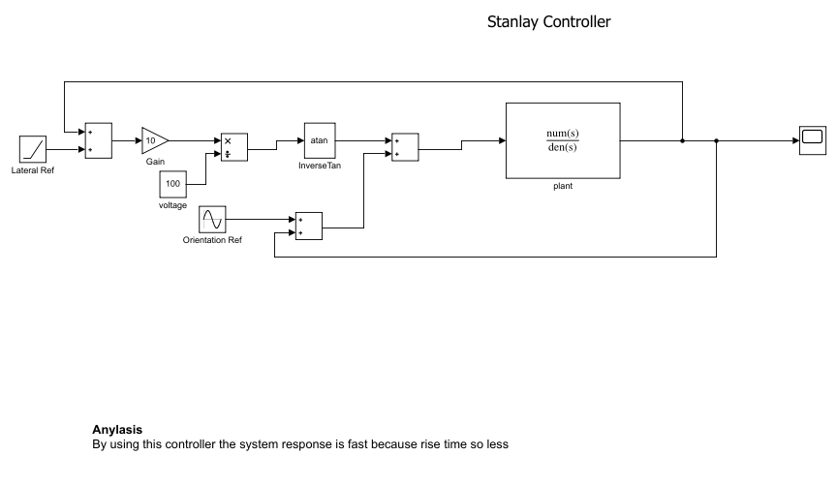

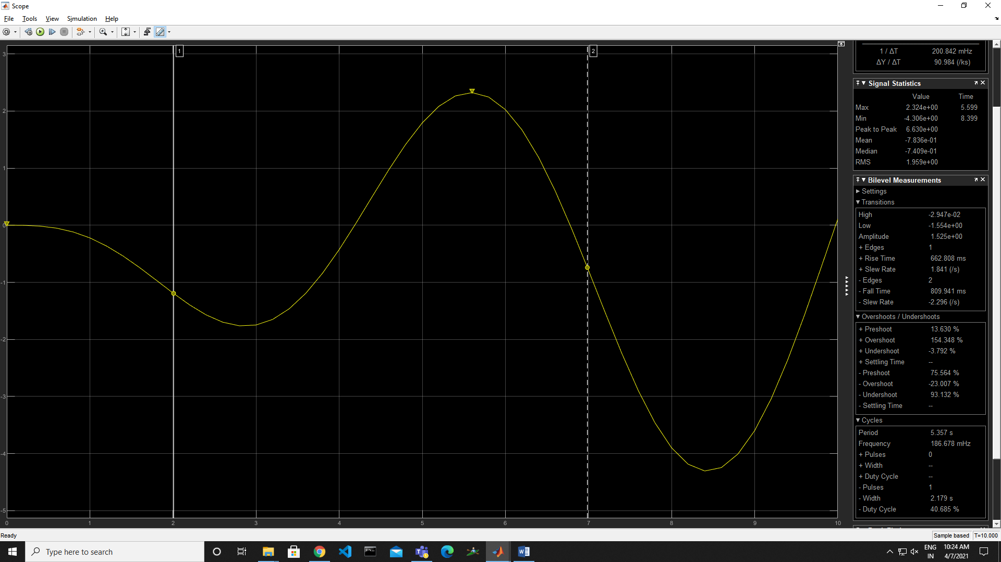

# Lateral Dynamics Control- Closed Loop with On-Off Controller

%%Indiviual work  
%Title:Control System -Lateral control -Second Order System  
%Author:Amit Kumar  
%Ps No: 99003775  
%Date:14/04/2021  
%Version 1.0  
  
%%Transfer function for On_off or Bang-bang,or Two-Step Controller=H(s)=(K/T.s+1)*e^-r.s  
%Variable description for Control Transfer Function  
%Where r for tau value k is gain and T is time constant  
%The time constant is a measure of the capacitance of the system. The higher the time constant,  
%the longer it takes for the system to react to changing inputs or disturbances.  
%In most of the control systems with feedback loop, the system can not respond instantly  
%to any disturbance and it takes time (delay) until the controller output has any effect on  
%the measured (plant) output. This time delay is know as dead time.  
  
  
%Implementations  
%Ideal Equation  
% Equation1 = m*V*(d(beta)/dt) + m*V_r = Y_beta * beta + Y_r * r + Y_delta * delta + F_ya + m*g*theta  
% Equation2 = I_zz * ((dr)/(dt)) = N_beta *beta + N_r * r + N_delta *Delta - (c-a) * F_ya

%Roots:  
%Roots for On-Off Controller is  
%pole=-1/T;  
%Zero=-1/r;  
  
% System with V = 100km/hr:  
% 1) Zero = 103.1148  
% 2) Pole = -0.0305+0.1538i, -0.0305-0.1538i  
  
% System with V = 50km/hr:  
% 1) Zero = 51.5401  
% 2) Pole = -0.0440+0.1535i, -0.0440-0.1535i  
  
%%Variable Description  
%Variable Description  
%m - Total Vehicle mass(kg)  
%V - Magnitude of vehicle velocity (v)  
%Y_delta - Control force derivative (Newton/rad)  
%N_r - Yaw damping derivative (Newton-metre-s/rad)  
%N_delta - Control Moment Derivative (Newton-metre/rad)  
%r - Yaw velocity (rad/sec)  
%Vr - Velocity of the rear tire (metre/sec)  
%theta - Road side Slope (rad)  
%g - Acceleration due to gravity (metre/s^2)  
%c - Distance from front axle to aerodynamics side force (metre)  
%a - Distance from mass center to front axle (metre)  
%I_zz - Total vehicle yaw mass moment of inertia (kg-metre^2)  
%Y-r - Lateral force yaw coupling derivative (Newton-sec/rad)  
%Y-beta - Damping in sideslip derivative (Newton/rad)  
%beta - Vehicle side slip angle (rad)  
%F_ya - Aerodynamics side force disturbance (Newton)  
%N_beta - Directional stability derivative (Newton-metre/rad)  
  
%%Math Analysis  
%Independend: Time(t)  
%Dependend:Vehicle side slip angle (Beta), Front Steer angle (Delta)  
%Constant: Damping in Sideslip (Ybeta), Lateral Force/Yaw Coupling(Yr)  
% Control Force (Ydelta), Directional Stability (Nbeta),  
% Yaw Damping (Nr), Control Moment(Ndelta).  
  
%%Plant Descripation  
%Implementaions1  
%This Plant is valid for any type of Vehicle  
%The on-off control is the simplest form of a controller,  
%which switches ON when the error is positive and switches OFF  
%when the error is zero or negative. An on-off controller doesn’t  
%have intermediate states but only fully ON or fully OFF states.  
%Due to the switching logic, an on-off controller is often called a bang-bang controller or a two-step controller.  
clc;  
K=0.8;  
T=0.60;  
r=3;  
M=K*exp(-r);  
D=T+1;  
Ydelta = 2461;  
m = 1775;  
V = 100;  
Nr = -67.06;  
Ndelta = 2803.079;  
Yr = 0.46384;  
Izz = 1960;  
Ybeta = -4772;  
Nbeta = 46.38;  
sys1 = tf([((M*(Ydelta)/(m*V))),M*(-((Nr*Ydelta)+(Ndelta*((m*V)-Yr))))/...  
 (Izz*m*V)],[1*D,(-(Nr/Izz)-(Ybeta/(m*V)))*D,((Nr*Ybeta)+...  
 (Nbeta*((m*V)-Yr)))*D/(Izz*m*V)])  
figure(1);  
subplot(2,2,1);  
impulse(sys1);  
title('Impulse Input for k');  
subplot(2,2,2);  
step(sys1);  
title('Step Input for k');  
subplot(2,2,3);  
[z,p,k]=tf2zp([((M*(Ydelta)/(m*V))),M*(-((Nr*Ydelta)+(Ndelta*((m*V)-Yr))))/...  
 (Izz*m*V)],[1*D,(-(Nr/Izz)-(Ybeta/(m*V)))*D,((Nr*Ybeta)+...  
 (Nbeta*((m*V)-Yr)))*D/(Izz*m*V)])  
pzmap(sys1)  
subplot(2,2,4);  
bode(sys1)  
hold on;  
S = stepinfo(sys1)  
  
  
V1 = 50;  
  
sys2 = tf([((M*(Ydelta)/(m*V1))),M*(-((Nr*Ydelta)+(Ndelta*((m*V1)-Yr))))/...  
 (Izz*m*V1)],[1*D,(-(Nr/Izz)-(Ybeta/(m*V1)))*D,((Nr*Ybeta)+...  
 (Nbeta*((m*V1)-Yr)))*D/(Izz*m*V1)])  
  
figure(2);  
subplot(2,2,1);  
impulse(sys2);  
title('Impulse Input for k');  
subplot(2,2,2);  
step(sys2);  
title('Step Input for k');  
subplot(2,2,3);  
[z,p,k]=tf2zp([((M*(Ydelta)/(m*V1))),M*(-((Nr*Ydelta)+(Ndelta*((m*V1)-Yr))))/...  
 (Izz*m*V1)],[1*D,(-(Nr/Izz)-(Ybeta/(m*V1)))*D,((Nr*Ybeta)+...  
 (Nbeta*((m*V1)-Yr)))*D/(Izz*m*V1)])  
pzmap(sys2)  
subplot(2,2,4);  
bode(sys2)  
hold on;  
S = stepinfo(sys2)  
  
%%Analysis  
%If we take Gain value and Time constant value as zero we get values of  
%Rise time,Overshoot and peak time zero  
%Not changes in UnderShoot  
%If Velocity decrease Frequency Increases  
%poles are complex cojugate at origin due to that system is  
%marginal stable  
%When velocity is more RiseTime is less and vise versa  
%when Velocity of vehicle is less Settling time is less  
%Undershoot is independent to vehicle speed  
%If velocity is larger peaktime is more

sys1 =  
   
 0.0005522 s - 0.05694  
 -----------------------------  
 1.6 s^2 + 0.09776 s + 0.03933  
   
Continuous-time transfer function.  
  
  
z =  
  
 103.1148  
  
  
p =  
  
 -0.0305 + 0.1538i  
 -0.0305 - 0.1538i  
  
  
k =  
  
 3.4514e-04  
  
  
S =   
  
 struct with fields:  
  
 RiseTime: 7.6539  
 SettlingTime: 126.2645  
 SettlingMin: -2.2192  
 SettlingMax: -1.0323  
 Overshoot: 53.2876  
 Undershoot: 0  
 Peak: 2.2192  
 PeakTime: 21.1043  
  
  
sys2 =  
   
 0.001104 s - 0.05692  
 ---------------------------  
 1.6 s^2 + 0.1408 s + 0.0408  
   
Continuous-time transfer function.  
  
  
z =  
  
 51.5401  
  
  
p =  
  
 -0.0440 + 0.1535i  
 -0.0440 - 0.1535i  
  
  
k =  
  
 6.9029e-04  
  
  
S =   
  
 struct with fields:  
  
 RiseTime: 8.1126  
 SettlingTime: 86.9226  
 SettlingMin: -1.9606  
 SettlingMax: -1.1646  
 Overshoot: 40.5421  
 Undershoot: 0  
 Peak: 1.9606  
 PeakTime: 20.9366

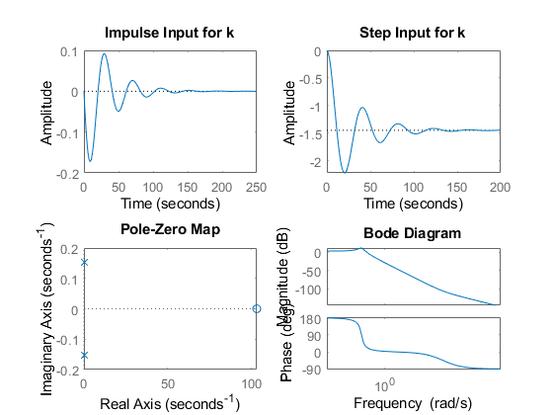

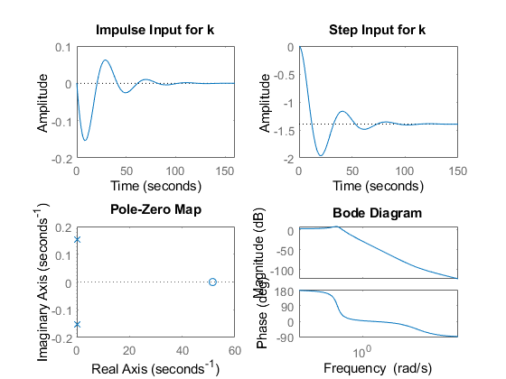

# Lateral Dynamics Control- Closed Loop with PID Controller

## Control System - Lateral Control - Second Order System

%Name - Amiya Kumar Panda  
%PS No - 99003783  
%Date - 14/04/2021  
%Version - 1.1.1

## Plant Description

%This plant has been modeled for lateral contol of any vehicle.  
%In this model two different values of velocity has been taken to get the better result analysis.  
  
% Implementation  
% Ideal Equation-  
% Equation1 = m*V*(d(beta)/dt) + m*V_r = Y_beta * beta + Y_r * r + Y_delta * delta + F_ya + m*g*theta  
% Equation2 = I_zz * ((dr)/(dt)) = N_beta *beta + N_r * r + N_delta *Delta - (c-a) * F_ya  
  
%Variable Description  
%m - Total Vehicle mass(kg)  
%V - Magnitude of vehicle velocity (v)  
%Y_delta - Control force derivative (Newton/rad)  
%N_r - Yaw damping derivative (Newton-metre-s/rad)  
%N_delta - Control Moment Derivative (Newton-metre/rad)  
%r - Yaw velocity (rad/sec)  
%Vr - Velocity of the rear tire (metre/sec)  
%theta - Road side Slope (rad)  
%g - Acceleration due to gravity (metre/s^2)  
%c - Distance from front axle to aerodynamics side force (metre)  
%a - Distance from mass center to front axle (metre)  
%I_zz - Total vehicle yaw mass moment of inertia (kg-metre^2)  
%Y-r - Lateral force yaw coupling derivative (Newton-sec/rad)  
%Y-beta - Damping in sideslip derivative (Newton/rad)  
%beta - Vehicle side slip angle (rad)  
%F_ya - Aerodynamics side force disturbance (Newton)  
%N_beta - Directional stability derivative (Newton-metre/rad)

## Math analysis

% Independent: Time(t)  
% Dependent: Vehicle side slip angle (Beta), Front Steer angle (Delta)  
% Constant: Damping in Sideslip (Ybeta), Lateral Force/Yaw Coupling(Yr),Control Force (Ydelta), Directional Stability (Nbeta),Yaw Damping (Nr), Control Moment(Ndelta).

## Tool Analysis

clear all;  
close all;  
clc;  
Ydelta = 2461;  
m = 1775;  
V = 100;  
Nr = -67.06;  
Ndelta = 2803.079;  
Yr = 0.46384;  
Izz = 1960;  
Ybeta = -4772;  
Nbeta = 46.38;  
  
sys = tf([((Ydelta)/(m*V)),-((Nr*Ydelta)+(Ndelta*((m*V)-Yr)))/(Izz*m*V)],[1,(-(Nr/Izz)-(Ybeta/(m*V))),((Nr*Ybeta) + (Nbeta*((m*V)-Yr)))/(Izz*m*V)])  
sys_N1=feedback(sys,1)  
 [GC_PID,info_PI] = pidtune(sys,'PID');  
 sys_N1_PID = feedback(sys * GC_PID,1);  
figure(1);  
subplot(2,2,1);  
impulse(sys_N1_PID);  
title('Impulse Input for k');  
subplot(2,2,2);  
step(sys_N1_PID);  
title('Step Input for k');  
subplot(2,2,3);  
[z,p,k]= tf2zp([((Ydelta)/(m*V)),-((Nr*Ydelta)+(Ndelta*((m*V)-Yr)))/(Izz*m*V)],[1,(-(Nr/Izz)-(Ybeta/(m*V))),((Nr*Ybeta) + (Nbeta*((m*V)-Yr)))/(Izz*m*V)])  
pzmap(sys_N1_PID)  
subplot(2,2,4);  
bode(sys_N1_PID)  
hold on;  
S = stepinfo(sys_N1_PID)  
  
  
V1 = 50;  
sys1 = tf([((Ydelta)/(m*V1)),-((Nr*Ydelta)+(Ndelta*((m*V1)-Yr)))/(Izz*m*V1)],[1,(-(Nr/Izz)-(Ybeta/(m*V1))),((Nr*Ybeta) + (Nbeta*((m*V1)-Yr)))/(Izz*m*V1)])  
sys_N2=feedback(sys1,1)  
[GC_PID,info_PI] = pidtune(sys1,'PID');  
 sys_N2_PID = feedback(sys1 * GC_PID,1);  
figure(2);  
subplot(2,2,1);  
impulse(sys_N2_PID);  
title('Impulse Input for k');  
subplot(2,2,2);  
step(sys_N2_PID);  
title('Step Input for k');  
subplot(2,2,3);  
[z,p,k]= tf2zp([((Ydelta)/(m*V1)),-((Nr*Ydelta)+(Ndelta*((m*V1)-Yr)))/(Izz*m*V1)],[1,(-(Nr/Izz)-(Ybeta/(m*V1))),((Nr*Ybeta) + (Nbeta*((m*V1)-Yr)))/(Izz*m*V1)])  
pzmap(sys_N2_PID)  
subplot(2,2,4);  
bode(sys_N2_PID)  
hold on;  
S = stepinfo(sys_N2_PID)

sys =  
   
 0.01386 s - 1.43  
 ------------------------  
 s^2 + 0.0611 s + 0.02458  
   
Continuous-time transfer function.  
  
  
sys_N1 =  
   
 0.01386 s - 1.43  
 -----------------------  
 s^2 + 0.07496 s - 1.405  
   
Continuous-time transfer function.  
  
  
z =  
  
 103.1148  
  
  
p =  
  
 -0.0305 + 0.1538i  
 -0.0305 - 0.1538i  
  
  
k =  
  
 0.0139  
  
  
S =   
  
 struct with fields:  
  
 RiseTime: 46.8233  
 SettlingTime: 114.3984  
 SettlingMin: 0.8746  
 SettlingMax: 0.9999  
 Overshoot: 0  
 Undershoot: 0.0250  
 Peak: 0.9999  
 PeakTime: 228.4047  
  
  
sys1 =  
   
 0.02773 s - 1.429  
 ------------------------  
 s^2 + 0.08798 s + 0.0255  
   
Continuous-time transfer function.  
  
  
sys_N2 =  
   
 0.02773 s - 1.429  
 ----------------------  
 s^2 + 0.1157 s - 1.404  
   
Continuous-time transfer function.  
  
  
z =  
  
 51.5401  
  
  
p =  
  
 -0.0440 + 0.1535i  
 -0.0440 - 0.1535i  
  
  
k =  
  
 0.0277  
  
  
S =   
  
 struct with fields:  
  
 RiseTime: 3.5091  
 SettlingTime: 35.6672  
 SettlingMin: 0.8867  
 SettlingMax: 1.0787  
 Overshoot: 7.8736  
 Undershoot: 0.6738  
 Peak: 1.0787  
 PeakTime: 7.1842

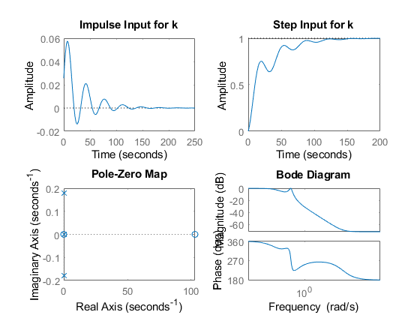

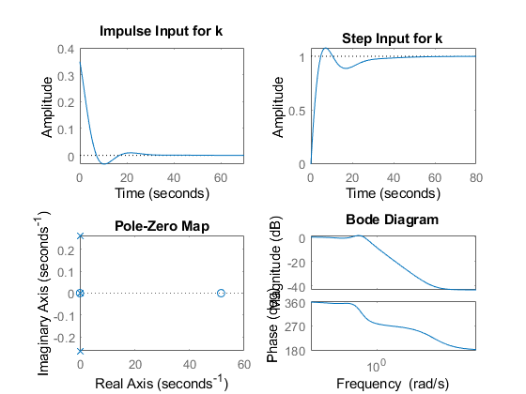

## Comparison Analysis

%Speed  
% As the rising time is less in the system 2 (V=50). So, we can conclude  
% that less the velocity of the system response will be fast.  
  
%Accuracy  
% As the settlimng time is less for the system 2 as compare to the system1.  
% Here, we can concluded that less the velocity the response settles very fast.  
  
% Stablity  
%As the poles are complex conjugate for both the system and the poles are  
%left side of the s-plane. The system is stable.  
% As the no. of zeros are also less than the no. of poles the system gets stable.