./

Learning Report – Control systems

Course Code: <CODE>



Version Number:

Team Members :

Team No:

Module: Model Based System Engineering

|  |  |  |  |  |  |
| --- | --- | --- | --- | --- | --- |
| **Ver. Rel. No.** | **Release Date** | **Prepared. By** | **Reviewed By** | **Approved By** | **Remarks/Revision Details** |
| 1 | 15/04/2021 | Katherapalle Rama Subba Reddy |  |  |  |

**Document History**

# 

Contents

Control system - RL circuit - First Order System 5

Plant Description 6

Math analysis 6

Roots calculation 6

Time Response 6

Tool Analysis 6

Comparision Analysis 6

Control system - RL circuit - First Order System 5

Plant Description 5

Math analysis 5

Roots calculation 5

Tool Analysis 5

Comparison Analysis 19

Control system - RL circuit - First Order System With controllers 20

Tool Analysis 20

Comparison Analysis 36

Control system - RLC circuit - Second Order System 37

plant description 37

Math analysis 37

Tool Analysis 37

Comparison Analysis 41

Control system - RLC circuit - Second Order System 42

Plant Description 42

Math analysis 42

Roots calculation 42

Tool Analysis 42

Comparison Analysis 54

Control system - RLC circuit - Second Order System with controlers 55

Plant Description 55

Math analysis 55

Roots calculation 55

Tool analysis 55

Comparison Analysis 75

Control system - RLC circuit - Second Order System with controlers 76

Plant Description 76

Math analysis 76

Tool analysis 76

Control system - RLC circuit - Second Order System 78

Plant Description 78

Tool analysis 78

comparison anyalsis 80

Control system - Mixing Process circuit - First Order System 81

Plant Description 81

Math analysis 81

Roots calculation 81

Tool anyalasis 81

Comparison Analysis 99

# Control system - RL circuit - First Order System

## Plant Description

implementation

%This plant has a model for RL circuit.  
%The 3 different values of R, L and C are analyzed  
  
% equation- V(t)= I(t)R + L{dI(t)/dt} //V(t) = I(t)R + L{\frac{dI(t)}{dt}}

## Math analysis

I- t D- V,I C- R,L

## Roots calculation

s = -R/L;

% IVT FVT  
% Impulse- 1/L 0  
% % Step - 0 1/R

## Time Response

Sys1 Sys2 Sys3 RiseTime: 1.0985e-05 RiseTime: 2.1970e-05 RiseTime: 1.0985e-04 SettlingTime: 1.9560e-05 SettlingTime: 3.9121e-05 SettlingTime: 1.9560e-04 SettlingMin: 0.9045 SettlingMin: 0.9045 SettlingMin: 0.9000 SettlingMax: 1.0000 SettlingMax: 1.0000 SettlingMax: 1.0000 Overshoot: 0 Overshoot: 0 Overshoot: 0 Undershoot: 0 Undershoot: 0 Undershoot: 0 Peak: 1.0000 Peak: 1.0000 Peak: 1.0000 PeakTime: 5.2729e-05 PeakTime: 1.0546e-04 PeakTime: 5.2729e-04

## Tool Analysis

%R = ([10e3 1e3 0.1e3]);  
%L = ([50e-3 10e-3 5e-3]);  
R = ([100 100e-3 0.32e-3 -100e-3]);  
L = ([5 25e-3 2e-3 25e-3]);  
  
for i=1:3  
 Tau = L(i)/R(i);  
 Lf = tf([0 (1/R(i))],[Tau 1])  
 figure(1);  
 subplot(2,3,i);  
 impulse(Lf);  
 title('Impulse Input');  
 subplot(2,3,i+3);  
 step(Lf);  
 title('Step Input');  
 hold on;  
 [z,p,k]= tf2zp([0 (1/R(i))],[Tau 1])  
 figure(2);  
 zplane(z,p);  
% xlim([-4*1e5 2*1e5]);  
% ylim([-4*1e5 2*1e5]);  
 xlim([-30 30]);  
 ylim([-30 30]);  
 hold on;  
 stepinfo(Lf)  
end  
hold off;

Lf =  
   
 0.01  
 ----------  
 0.05 s + 1  
   
Continuous-time transfer function.  
  
  
z =  
  
 0×1 empty double column vector  
  
  
p =  
  
 -20  
  
  
k =  
  
 0.2000  
  
  
ans =   
  
 struct with fields:  
  
 RiseTime: 0.1099  
 SettlingTime: 0.1956  
 SettlingMin: 0.0090  
 SettlingMax: 0.0100  
 Overshoot: 0  
 Undershoot: 0  
 Peak: 0.0100  
 PeakTime: 0.5273  
  
  
Lf =  
   
 10  
 ----------  
 0.25 s + 1  
   
Continuous-time transfer function.  
  
  
z =  
  
 0×1 empty double column vector  
  
  
p =  
  
 -4  
  
  
k =  
  
 40  
  
  
ans =   
  
 struct with fields:  
  
 RiseTime: 0.5493  
 SettlingTime: 0.9780  
 SettlingMin: 9.0450  
 SettlingMax: 9.9997  
 Overshoot: 0  
 Undershoot: 0  
 Peak: 9.9997  
 PeakTime: 2.6365  
  
  
Lf =  
   
 3125  
 ----------  
 6.25 s + 1  
   
Continuous-time transfer function.  
  
  
z =  
  
 0×1 empty double column vector  
  
  
p =  
  
 -0.1600  
  
  
k =  
  
 500.0000  
  
  
ans =   
  
 struct with fields:  
  
 RiseTime: 13.7313  
 SettlingTime: 24.4505  
 SettlingMin: 2.8266e+03  
 SettlingMax: 3.1249e+03  
 Overshoot: 0  
 Undershoot: 0  
 Peak: 3.1249e+03  
 PeakTime: 65.9115

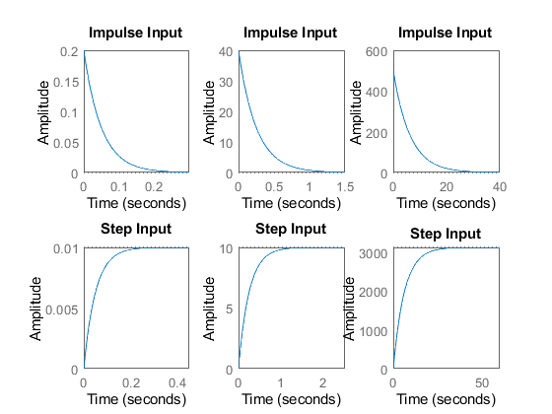

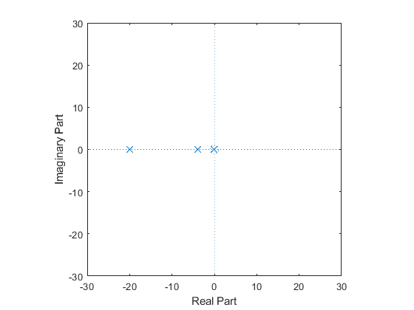

## Comparision Analysis

%first order open loop  
% Speed  
% Has the poles of the transfor function moves away from the origin  
% The rise time is decreasing so the response of the system is speed  
%Accuracy  
% Has the poles of the transfor function moves away from the origin  
% The settling time is decreasing so the accuracy is more  
%Stability  
% For the transfor functions above the poles negative side so they are stable

# Control system - RL circuit - First Order System

## Plant Description

implementation

%This plant has a model for RL circuit.  
%The 3 different values of R, L are analyzed  
  
% equation- V(t)= I(t)R + L{dI(t)/dt}

## Math analysis

I- t D- V,I C- R,L

## Roots calculation

s = -R/L;

## Tool Analysis

R = ([100 100e-3 0.32e-3 -100e-3]);  
L = ([5 25e-3 2e-3 25e-3]);  
K = ([10 1000 0.1 100]);  
  
% Positive Feedback  
for i=1:4  
 Tau = L(i)/R(i);  
 Lf = (tf([(1/R(i))],[Tau (1-(1/R(i)))]))  
 figure(1);  
 subplot(2,4,i);  
 impulse(Lf);  
 title('Impulse Input');  
 subplot(2,4,i+4);  
 step(Lf);  
 title('Step Input');  
 hold on;  
 [z,p,k]= tf2zp([(1/R(i))],[Tau (1-(1/R(i)))])  
 figure(2);  
 zplane(z,p);  
 xlim([-30 600]);  
 ylim([-100 100]);  
 hold on;  
 stepinfo(Lf)  
end  
hold off;  
  
%Negative Feedback with and without PID  
  
% R = ([10e3 1e3 0.1e3]);  
% L = ([50e-3 10e-3 5e-3]);  
  
for i = 1:3  
 Tau = L(i)/R(i);  
 sys_ol = tf([0 1],[Tau 1])  
 sys_cl = feedback(sys_ol,1)  
 stepinfo(sys_ol)  
  
 [GC_PI,info_PI] = pidtune(sys_ol,'PI');  
 sys_cl_PI = feedback(sys_ol * GC_PI,1);  
 stepinfo(sys_cl_PI)  
  
 [GC_PD,info_PD] = pidtune(sys_ol,'PD');  
 sys_cl_PD = feedback(sys_ol * GC_PD,1);  
 stepinfo(sys_cl_PD)  
  
 [GC_PID,info_PID] = pidtune(sys_ol,'PID');  
 sys_cl_PID = feedback(sys_ol * GC_PID,1);  
 stepinfo(sys_cl_PID)  
  
% input response plots  
 figure(3);  
 subplot(4,3,i);  
 step(sys_ol);  
 title(['Step of ', num2str(i) ,'th OL TF']);  
  
 subplot(4,3,i+3);  
 impulse(sys_ol);  
 title(['impulse of ', num2str(i) ,'th OL TF']);  
  
 subplot(4,3,i+6);  
 step(sys_cl);  
 title(['Step of ', num2str(i) ,'th CL TF']);  
  
 subplot(4,3,i+9);  
 impulse(sys_cl);  
 title(['impulse of ', num2str(i) ,'th CL TF']);  
  
% controller plots  
 figure(4);  
 subplot(4,3,i);  
 step(sys_cl)  
 title(['CL Uncontrolled response of ', num2str(i) ,'th TF']);  
  
 subplot(4,3,i+3);  
 step(sys_cl_PI)  
 title(['CL PI controlled response of ', num2str(i) ,'th TF']);  
  
 subplot(4,3,i+6);  
 step(sys_cl_PD)  
 title(['CL PD controlled response of ', num2str(i) ,'th TF']);  
  
 subplot(4,3,i+9);  
 step(sys_cl_PID)  
 title(['CL PID controlled response of ', num2str(i) ,'th TF']);  
  
% Bode plots  
 figure(5);  
 subplot(3,3,i);  
 bode(sys_ol)  
 title(['OL of ',num2str(i),'th TF']);  
  
 subplot(3,3,i+3);  
 bode(sys_cl)  
 title(['CL uncontrolled ',num2str(i),'th TF']);  
  
 subplot(3,3,i+6);  
 bode(sys_cl_PID)  
 title(['CL PID controlled ',num2str(i),'th TF']);  
  
end

Lf =  
   
 0.01  
 -------------  
 0.05 s + 0.99  
   
Continuous-time transfer function.  
  
  
z =  
  
 0×1 empty double column vector  
  
  
p =  
  
 -19.8000  
  
  
k =  
  
 0.2000  
  
  
ans =   
  
 struct with fields:  
  
 RiseTime: 0.1110  
 SettlingTime: 0.1976  
 SettlingMin: 0.0091  
 SettlingMax: 0.0101  
 Overshoot: 0  
 Undershoot: 0  
 Peak: 0.0101  
 PeakTime: 0.5326  
  
  
Lf =  
   
 10  
 ----------  
 0.25 s - 9  
   
Continuous-time transfer function.  
  
  
z =  
  
 0×1 empty double column vector  
  
  
p =  
  
 36  
  
  
k =  
  
 40  
  
  
ans =   
  
 struct with fields:  
  
 RiseTime: NaN  
 SettlingTime: NaN  
 SettlingMin: NaN  
 SettlingMax: NaN  
 Overshoot: NaN  
 Undershoot: NaN  
 Peak: Inf  
 PeakTime: Inf  
  
  
Lf =  
   
 3125  
 -------------  
 6.25 s - 3124  
   
Continuous-time transfer function.  
  
  
z =  
  
 0×1 empty double column vector  
  
  
p =  
  
 499.8400  
  
  
k =  
  
 500.0000  
  
  
ans =   
  
 struct with fields:  
  
 RiseTime: NaN  
 SettlingTime: NaN  
 SettlingMin: NaN  
 SettlingMax: NaN  
 Overshoot: NaN  
 Undershoot: NaN  
 Peak: Inf  
 PeakTime: Inf  
  
  
Lf =  
   
 10  
 -----------  
 0.25 s - 11  
   
Continuous-time transfer function.  
  
  
z =  
  
 0×1 empty double column vector  
  
  
p =  
  
 44  
  
  
k =  
  
 40  
  
  
ans =   
  
 struct with fields:  
  
 RiseTime: NaN  
 SettlingTime: NaN  
 SettlingMin: NaN  
 SettlingMax: NaN  
 Overshoot: NaN  
 Undershoot: NaN  
 Peak: Inf  
 PeakTime: Inf  
  
  
sys_ol =  
   
 1  
 ----------  
 0.05 s + 1  
   
Continuous-time transfer function.  
  
  
sys_cl =  
   
 1  
 ----------  
 0.05 s + 2  
   
Continuous-time transfer function.  
  
  
ans =   
  
 struct with fields:  
  
 RiseTime: 0.1099  
 SettlingTime: 0.1956  
 SettlingMin: 0.9045  
 SettlingMax: 1.0000  
 Overshoot: 0  
 Undershoot: 0  
 Peak: 1.0000  
 PeakTime: 0.5273  
  
  
ans =   
  
 struct with fields:  
  
 RiseTime: 0.0405  
 SettlingTime: 0.1480  
 SettlingMin: 0.9001  
 SettlingMax: 1.1382  
 Overshoot: 13.8188  
 Undershoot: 0  
 Peak: 1.1382  
 PeakTime: 0.0879  
  
  
ans =   
  
 struct with fields:  
  
 RiseTime: 0.0015  
 SettlingTime: 0.0027  
 SettlingMin: 0.8875  
 SettlingMax: 0.9861  
 Overshoot: 0  
 Undershoot: 0  
 Peak: 0.9861  
 PeakTime: 0.0073  
  
  
ans =   
  
 struct with fields:  
  
 RiseTime: 0.0456  
 SettlingTime: 0.1583  
 SettlingMin: 0.9005  
 SettlingMax: 1.0608  
 Overshoot: 6.0819  
 Undershoot: 0  
 Peak: 1.0608  
 PeakTime: 0.0985  
  
  
sys_ol =  
   
 1  
 ----------  
 0.25 s + 1  
   
Continuous-time transfer function.  
  
  
sys_cl =  
   
 1  
 ----------  
 0.25 s + 2  
   
Continuous-time transfer function.  
  
  
ans =   
  
 struct with fields:  
  
 RiseTime: 0.5493  
 SettlingTime: 0.9780  
 SettlingMin: 0.9045  
 SettlingMax: 1.0000  
 Overshoot: 0  
 Undershoot: 0  
 Peak: 1.0000  
 PeakTime: 2.6365  
  
  
ans =   
  
 struct with fields:  
  
 RiseTime: 0.2023  
 SettlingTime: 0.7400  
 SettlingMin: 0.9001  
 SettlingMax: 1.1382  
 Overshoot: 13.8188  
 Undershoot: 0  
 Peak: 1.1382  
 PeakTime: 0.4397  
  
  
ans =   
  
 struct with fields:  
  
 RiseTime: 0.0076  
 SettlingTime: 0.0136  
 SettlingMin: 0.8919  
 SettlingMax: 0.9861  
 Overshoot: 0  
 Undershoot: 0  
 Peak: 0.9861  
 PeakTime: 0.0367  
  
  
ans =   
  
 struct with fields:  
  
 RiseTime: 0.2280  
 SettlingTime: 0.7913  
 SettlingMin: 0.9005  
 SettlingMax: 1.0608  
 Overshoot: 6.0819  
 Undershoot: 0  
 Peak: 1.0608  
 PeakTime: 0.4924  
  
  
sys_ol =  
   
 1  
 ----------  
 6.25 s + 1  
   
Continuous-time transfer function.  
  
  
sys_cl =  
   
 1  
 ----------  
 6.25 s + 2  
   
Continuous-time transfer function.  
  
  
ans =   
  
 struct with fields:  
  
 RiseTime: 13.7313  
 SettlingTime: 24.4505  
 SettlingMin: 0.9045  
 SettlingMax: 1.0000  
 Overshoot: 0  
 Undershoot: 0  
 Peak: 1.0000  
 PeakTime: 65.9115  
  
  
ans =   
  
 struct with fields:  
  
 RiseTime: 5.0582  
 SettlingTime: 18.5005  
 SettlingMin: 0.9001  
 SettlingMax: 1.1382  
 Overshoot: 13.8188  
 Undershoot: 0  
 Peak: 1.1382  
 PeakTime: 10.9920  
  
  
ans =   
  
 struct with fields:  
  
 RiseTime: 0.1909  
 SettlingTime: 0.3400  
 SettlingMin: 0.8919  
 SettlingMax: 0.9861  
 Overshoot: 0  
 Undershoot: 0  
 Peak: 0.9861  
 PeakTime: 0.9166  
  
  
ans =   
  
 struct with fields:  
  
 RiseTime: 5.7008  
 SettlingTime: 19.7837  
 SettlingMin: 0.9005  
 SettlingMax: 1.0608  
 Overshoot: 6.0819  
 Undershoot: 0  
 Peak: 1.0608  
 PeakTime: 12.3104

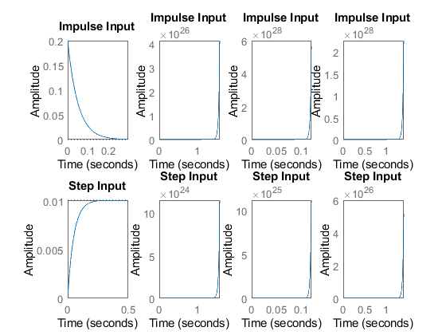

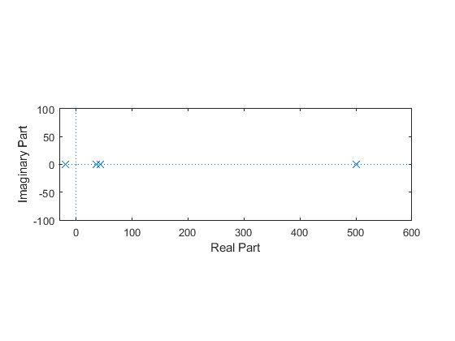

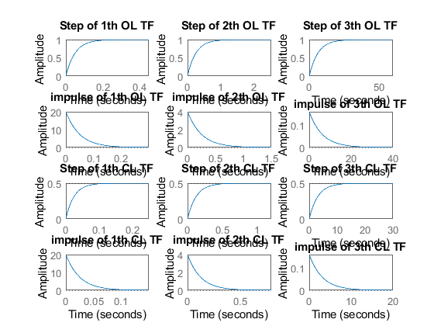

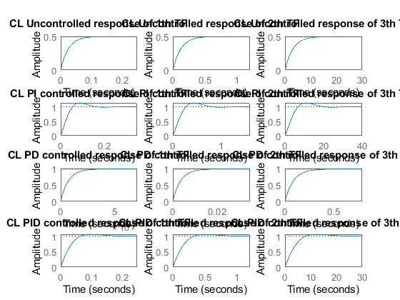

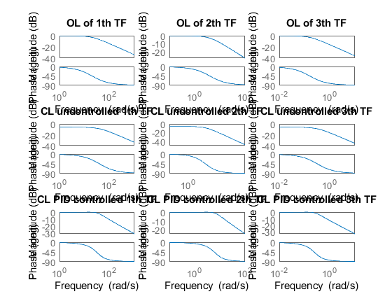

## Comparison Analysis

First order system of closed loop

%positive feed postive feed back  
%in this the is unstable for positive feedback  
  
%Negative feedback  
%In this speed of the system increases as poles goes away from origin  
%In this Settling time also decreases as poles goes away from origin  
%In this system peak value is same for all poles  
  
%PI controller  
%Rise time decreases so the speed of the system  
%Settling time also decreased so more accurate  
%peak cvalue is increased  
  
%PD controller  
%Rise time decreased in this system so it more speed  
%Settling time also decreased  
%Peak values also decreased  
  
%PID controller  
%Rise time decreases so some what speed  
%Settling time also slightly decreases  
%peak value also decreases

# Control system - RL circuit - First Order System With controllers

## Tool Analysis

R = ([100 100e-3 0.32e-3 -100e-3]);  
L = ([5 25e-3 2e-3 25e-3]);  
K = ([10 1000 0.1 100]);  
  
% P  
for i=1:4  
  
 Tau = L(i)/R(i);  
 Lf = K(i)*(tf([0 (1/R(i))],[Tau 1]))  
 figure(1);  
 subplot(2,4,i);  
 impulse(Lf);  
 title('Impulse Input');  
 subplot(2,4,i+4);  
 step(Lf);  
 title('Step Input');  
 hold on;  
 [z,p,k]= tf2zp([0 (1/R(i))],[Tau 1])  
 figure(2);  
 zplane(z,p);  
 xlim([-25 10]);  
 ylim([-10 10]);  
 hold on;  
 stepinfo(Lf)  
end  
hold off;  
  
% I  
for i=1:4  
  
 Tau = L(i)/R(i);  
 Lf = (tf([0 (1/R(i))],[Tau 1 0]))  
 figure(3);  
 subplot(2,4,i);  
 impulse(Lf);  
 title('Impulse Input');  
 subplot(2,4,i+4);  
 step(Lf);  
 title('Step Input');  
 hold on;  
 [z,p,k]= tf2zp([0 (1/R(i))],[Tau 1 0])  
 figure(4);  
 zplane(z,p);  
 pzmap(Lf);  
 xlim([-40 40]);  
 ylim([-40 40]);  
 hold on;  
 stepinfo(Lf)  
end  
hold off;  
  
% D  
for i=1:4  
 Tau = L(i)/R(i);  
 Lf = (tf([(1/R(i)) 0],[Tau 1]))  
 figure(5);  
 subplot(2,4,i);  
 impulse(Lf);  
 title('Impulse Input');  
 subplot(2,4,i+4);  
 step(Lf);  
 title('Step Input');  
 hold on;  
 [z,p,k]= tf2zp([(1/R(i)) 0],[Tau 1])  
 figure(6);  
 zplane(z,p);  
 pzmap(Lf);  
 xlim([-40 40]);  
 ylim([-40 40]);  
 hold on;  
 stepinfo(Lf)  
end  
hold off;

Lf =  
   
 0.1  
 ----------  
 0.05 s + 1  
   
Continuous-time transfer function.  
  
  
z =  
  
 0×1 empty double column vector  
  
  
p =  
  
 -20  
  
  
k =  
  
 0.2000  
  
  
ans =   
  
 struct with fields:  
  
 RiseTime: 0.1099  
 SettlingTime: 0.1956  
 SettlingMin: 0.0905  
 SettlingMax: 0.1000  
 Overshoot: 0  
 Undershoot: 0  
 Peak: 0.1000  
 PeakTime: 0.5273  
  
  
Lf =  
   
 10000  
 ----------  
 0.25 s + 1  
   
Continuous-time transfer function.  
  
  
z =  
  
 0×1 empty double column vector  
  
  
p =  
  
 -4  
  
  
k =  
  
 40  
  
  
ans =   
  
 struct with fields:  
  
 RiseTime: 0.5493  
 SettlingTime: 0.9780  
 SettlingMin: 9.0450e+03  
 SettlingMax: 9.9997e+03  
 Overshoot: 0  
 Undershoot: 0  
 Peak: 9.9997e+03  
 PeakTime: 2.6365  
  
  
Lf =  
   
 312.5  
 ----------  
 6.25 s + 1  
   
Continuous-time transfer function.  
  
  
z =  
  
 0×1 empty double column vector  
  
  
p =  
  
 -0.1600  
  
  
k =  
  
 500.0000  
  
  
ans =   
  
 struct with fields:  
  
 RiseTime: 13.7313  
 SettlingTime: 24.4505  
 SettlingMin: 282.6565  
 SettlingMax: 312.4918  
 Overshoot: 0  
 Undershoot: 0  
 Peak: 312.4918  
 PeakTime: 65.9115  
  
  
Lf =  
   
 1000  
 ----------  
 0.25 s - 1  
   
Continuous-time transfer function.  
  
  
z =  
  
 0×1 empty double column vector  
  
  
p =  
  
 4  
  
  
k =  
  
 40  
  
  
ans =   
  
 struct with fields:  
  
 RiseTime: NaN  
 SettlingTime: NaN  
 SettlingMin: NaN  
 SettlingMax: NaN  
 Overshoot: NaN  
 Undershoot: NaN  
 Peak: Inf  
 PeakTime: Inf  
  
  
Lf =  
   
 0.01  
 ------------  
 0.05 s^2 + s  
   
Continuous-time transfer function.  
  
  
z =  
  
 0×1 empty double column vector  
  
  
p =  
  
 0  
 -20  
  
  
k =  
  
 0.2000  
  
  
ans =   
  
 struct with fields:  
  
 RiseTime: NaN  
 SettlingTime: NaN  
 SettlingMin: NaN  
 SettlingMax: NaN  
 Overshoot: NaN  
 Undershoot: NaN  
 Peak: Inf  
 PeakTime: Inf  
  
  
Lf =  
   
 10  
 ------------  
 0.25 s^2 + s  
   
Continuous-time transfer function.  
  
  
z =  
  
 0×1 empty double column vector  
  
  
p =  
  
 0  
 -4  
  
  
k =  
  
 40  
  
  
ans =   
  
 struct with fields:  
  
 RiseTime: NaN  
 SettlingTime: NaN  
 SettlingMin: NaN  
 SettlingMax: NaN  
 Overshoot: NaN  
 Undershoot: NaN  
 Peak: Inf  
 PeakTime: Inf  
  
  
Lf =  
   
 3125  
 ------------  
 6.25 s^2 + s  
   
Continuous-time transfer function.  
  
  
z =  
  
 0×1 empty double column vector  
  
  
p =  
  
 0  
 -0.1600  
  
  
k =  
  
 500.0000  
  
  
ans =   
  
 struct with fields:  
  
 RiseTime: NaN  
 SettlingTime: NaN  
 SettlingMin: NaN  
 SettlingMax: NaN  
 Overshoot: NaN  
 Undershoot: NaN  
 Peak: Inf  
 PeakTime: Inf  
  
  
Lf =  
   
 10  
 ------------  
 0.25 s^2 - s  
   
Continuous-time transfer function.  
  
  
z =  
  
 0×1 empty double column vector  
  
  
p =  
  
 0  
 4  
  
  
k =  
  
 40  
  
  
ans =   
  
 struct with fields:  
  
 RiseTime: NaN  
 SettlingTime: NaN  
 SettlingMin: NaN  
 SettlingMax: NaN  
 Overshoot: NaN  
 Undershoot: NaN  
 Peak: Inf  
 PeakTime: Inf  
  
  
Lf =  
   
 0.01 s  
 ----------  
 0.05 s + 1  
   
Continuous-time transfer function.  
  
  
z =  
  
 0  
  
  
p =  
  
 -20  
  
  
k =  
  
 0.2000  
  
  
ans =   
  
 struct with fields:  
  
 RiseTime: 0.1099  
 SettlingTime: 0.1956  
 SettlingMin: 5.2605e-06  
 SettlingMax: 0.0191  
 Overshoot: Inf  
 Undershoot: 0  
 Peak: 0.2000  
 PeakTime: 0  
  
  
Lf =  
   
 10 s  
 ----------  
 0.25 s + 1  
   
Continuous-time transfer function.  
  
  
z =  
  
 0  
  
  
p =  
  
 -4  
  
  
k =  
  
 40  
  
  
ans =   
  
 struct with fields:  
  
 RiseTime: 0.5493  
 SettlingTime: 0.9780  
 SettlingMin: 0.0011  
 SettlingMax: 3.8200  
 Overshoot: Inf  
 Undershoot: 0  
 Peak: 40  
 PeakTime: 0  
  
  
Lf =  
   
 3125 s  
 ----------  
 6.25 s + 1  
   
Continuous-time transfer function.  
  
  
z =  
  
 0  
  
  
p =  
  
 -0.1600  
  
  
k =  
  
 500.0000  
  
  
ans =   
  
 struct with fields:  
  
 RiseTime: 13.7313  
 SettlingTime: 24.4505  
 SettlingMin: 0.0132  
 SettlingMax: 47.7496  
 Overshoot: 8.7961e+17  
 Undershoot: 0  
 Peak: 500.0000  
 PeakTime: 0  
  
  
Lf =  
   
 10 s  
 ----------  
 0.25 s - 1  
   
Continuous-time transfer function.  
  
  
z =  
  
 0  
  
  
p =  
  
 4  
  
  
k =  
  
 40  
  
  
ans =   
  
 struct with fields:  
  
 RiseTime: NaN  
 SettlingTime: NaN  
 SettlingMin: NaN  
 SettlingMax: NaN  
 Overshoot: NaN  
 Undershoot: NaN  
 Peak: Inf  
 PeakTime: Inf

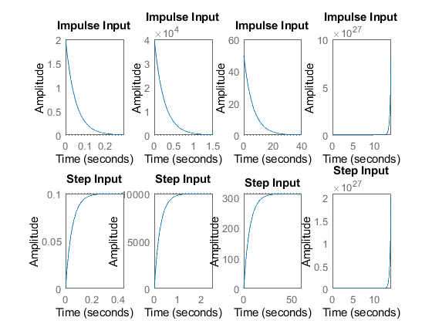

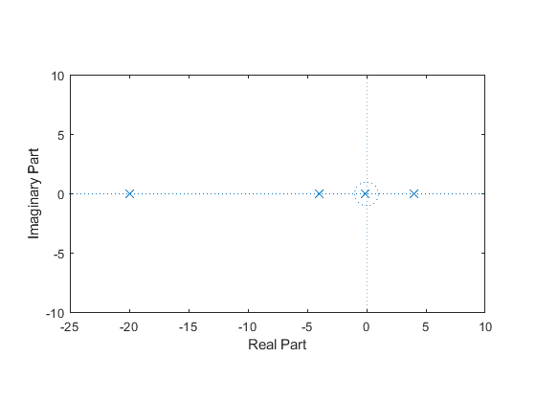

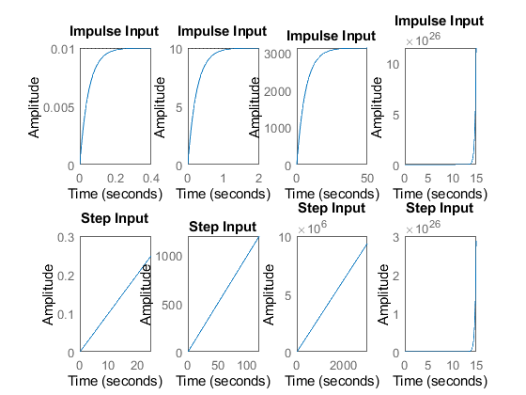

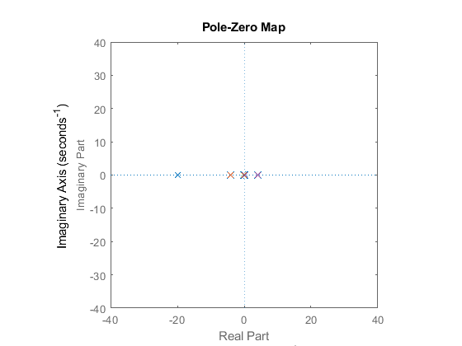

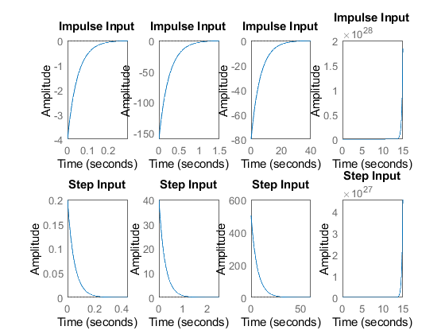

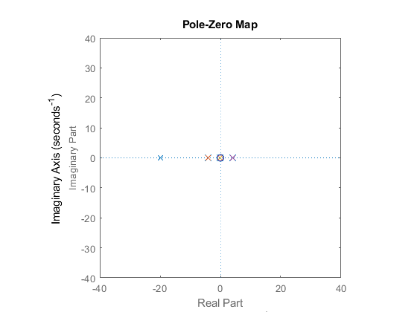

## Comparison Analysis

%P controller  
%Speed  
%Has the poles of the transfor function moves away from the origin  
%The rise time is decreasing so the response of the system is speed  
%Accuracy  
% Has the poles of the transfor function moves away from the origin  
% The settling time is decreasing so the accuracy is more  
%Stability  
% For the transfor functions above the poles negative side so they are stable  
% In this p controller only the peak value of the system increases  
  
% I controller  
%In this I controller the system become unstable  
%beacause the poles of the system are in positive side  
% It is also marginarlly stable pole located in origin  
  
  
% D controoler  
% In this controller rise time and settling time is same as before  
%But overshoot is increased and peak value also increases

# Control system - RLC circuit - Second Order System

Name - Katherapalle rama subba reddy PS No - 99003759 Date - 07/04/2021 Version - 2.0

plant description 1

Math analysis 1

Tool Analysis 1

Comparision Analysis 4

## plant description

implementation

%This plant has a model for RLC circuit.  
%The 3 different values of R, L and C are analyzed  
  
% Equation = V(t) = I(t)R + L{dI(t)/dt} + {1/C}{int(I(t)dt)}  
% V(t) = I(t)R + L{\frac{dI(t)}{dt}} + \frac{1}{C} \int I(t)dt

## Math analysis

I- Time D- V,I C- R,L,C

%roots = −(ξ∗Wn)±√(ξ^2−1) << $-(\xi*W_n) \pm \sqrt{(\xi^2 - 1)}$ >>

## Tool Analysis

R = [10 20 30];  
L = [1.7e-3 2.1e-3 4.9e-3];  
C = [1e-6 2e-6 3e-6];  
  
for i = 1:3  
 tau = L(i)/R(i);  
 T_F = tf([1/(L(i)*C(i))],[1,(1/tau),(1/(L(i)*C(i)))])  
  
 figure(1);  
 subplot(2,3,i);  
 title('Step');  
 step(T_F);  
  
 subplot(2,3,i+3);  
 title('impulse');  
 impulse(T_F);  
  
 [z,p,k]= tf2zp([1/(L(i)*C(i))],[1,(1/tau),(1/(L(i)*C(i)))]);  
 S = stepinfo(T_F)  
 figure(2);  
 zplane(z,p);  
 xlim([-30000 30000]);  
 ylim([-30000 30000]);  
 hold on;  
 zeta = (R(i)/2)*(sqrt(C(i)/L(i)));  
 w_n = (1/(sqrt(L(i)*C(i))));  
end

T_F =  
   
 5.882e08  
 -----------------------  
 s^2 + 5882 s + 5.882e08  
   
Continuous-time transfer function.  
  
  
S =   
  
 struct with fields:  
  
 RiseTime: 4.7299e-05  
 SettlingTime: 0.0013  
 SettlingMin: 0.5364  
 SettlingMax: 1.6811  
 Overshoot: 68.1077  
 Undershoot: 0  
 Peak: 1.6811  
 PeakTime: 1.2953e-04  
  
  
T_F =  
   
 2.381e08  
 -----------------------  
 s^2 + 9524 s + 2.381e08  
   
Continuous-time transfer function.  
  
  
S =   
  
 struct with fields:  
  
 RiseTime: 8.6542e-05  
 SettlingTime: 7.2631e-04  
 SettlingMin: 0.8699  
 SettlingMax: 1.3608  
 Overshoot: 36.0788  
 Undershoot: 0  
 Peak: 1.3608  
 PeakTime: 2.1276e-04  
  
  
T_F =  
   
 6.803e07  
 -----------------------  
 s^2 + 6122 s + 6.803e07  
   
Continuous-time transfer function.  
  
  
S =   
  
 struct with fields:  
  
 RiseTime: 1.7243e-04  
 SettlingTime: 0.0013  
 SettlingMin: 0.9190  
 SettlingMax: 1.2847  
 Overshoot: 28.4716  
 Undershoot: 0  
 Peak: 1.2847  
 PeakTime: 4.0618e-04

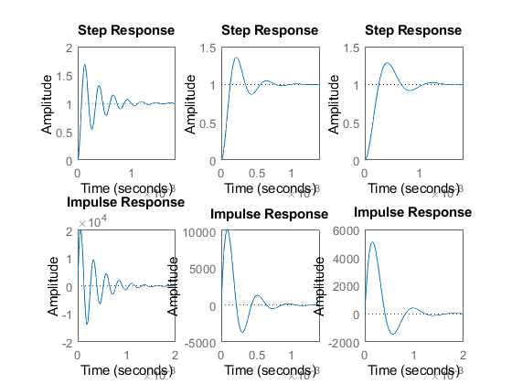

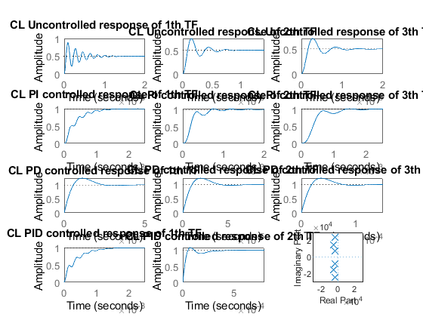

## Comparison Analysis

Speed Has the poles of the transfer function moves away from the origin The rise time is decreasing so the response of the system is speed

%Accuracy  
% Has the poles of the transfor function moves away from the origin  
% The settling time is decreasing so the accuracy is more  
%Stability  
% For the transfor functions above the poles negative side so they are stable

# Control system - RLC circuit - Second Order System

## Plant Description

implementation

%This plant has a model for RL circuit.  
%The 3 different values of R, L and C are analyzed  
  
% equation- V(t)= I(t)R + L{dI(t)/dt} + (1/c)(integ(Idt);

## Math analysis

I- t D- V,I C- R,L,C

## Roots calculation

Wn = 1/sqrt(LC); eta = R/2(sqrt(C/L)); S= -eta*Wn+Wn*sqrt(eta^2-1); S= -eta*Wn+Wn*sqrt(eta^2-1); -0.2941 + 2.4075i, -0.2941 - 2.4075i -0.4762 + 1.4677i, -0.4762 - 1.4677i -3.0612 + 7.6587i, -3.0612 - 7.6587i

## Tool Analysis

R = [10 20 30];  
L = [1.7e-3 2.1e-3 4.9e-3];  
C = [1e-6 2e-6 3e-6];  
  
for i = 1:3  
 tau = L(i)/R(i);  
 sys_ol = tf([1/(L(i)*C(i))],[1,(1/tau),(1/(L(i)*C(i)))])  
 [z p k] = tf2zp([1/(L(i)*C(i))],[1,(1/tau),(1/(L(i)*C(i)))])  
 stepinfo(sys_ol)  
 sys_cl = feedback(sys_ol,1)  
 stepinfo(sys_cl)  
  
 [GC_PI,info_PI] = pidtune(sys_ol,'PI');  
 sys_cl_PI = feedback(sys_ol * GC_PI,1)  
 stepinfo(sys_cl_PI)  
  
 [GC_PD,info_PD] = pidtune(sys_ol,'PD')  
 sys_cl_PD = feedback(sys_ol * GC_PD,1)  
  
 stepinfo(sys_cl_PD);  
 [GC_PID,info_PID] = pidtune(sys_ol,'PID');  
 sys_cl_PID = feedback(sys_ol * GC_PID,1)  
 stepinfo(sys_cl_PID)  
  
% input response plots  
 figure(1);  
 subplot(4,3,i);  
 step(sys_ol);  
 title(['Step of ', num2str(i) ,'th OL TF']);  
  
 subplot(4,3,i+3);  
 impulse(sys_ol);  
 title(['impulse of ', num2str(i) ,'th OL TF']);  
  
 subplot(4,3,i+6);  
 step(sys_cl);  
 title(['Step of ', num2str(i) ,'th CL TF']);  
  
 subplot(4,3,i+9);  
 impulse(sys_cl);  
 title(['impulse of ', num2str(i) ,'th CL TF']);  
  
% controller plots  
 figure(2);  
 subplot(4,3,i);  
 step(sys_cl)  
 title(['CL Uncontrolled response of ', num2str(i) ,'th TF']);  
  
 subplot(4,3,i+3);  
 step(sys_cl_PI)  
 title(['CL PI controlled response of ', num2str(i) ,'th TF']);  
  
 subplot(4,3,i+6);  
 step(sys_cl_PD)  
 title(['CL PD controlled response of ', num2str(i) ,'th TF']);  
  
 subplot(4,3,i+9);  
 step(sys_cl_PID);  
 title(['CL PID controlled response of ', num2str(i) ,'th TF']);  
  
% Bode plots  
 figure(3);  
 subplot(3,3,i);  
 bode(sys_ol)  
 title(['OL of ',num2str(i),'th TF']);  
  
 subplot(3,3,i+3);  
 bode(sys_cl)  
 title(['CL uncontrolled ',num2str(i),'th TF']);  
  
 subplot(3,3,i+6);  
 bode(sys_cl_PID)  
 title(['CL PID controlled ',num2str(i),'th TF']);  
  
end

sys_ol =  
   
 5.882e08  
 -----------------------  
 s^2 + 5882 s + 5.882e08  
   
Continuous-time transfer function.  
  
  
z =  
  
 0×1 empty double column vector  
  
  
p =  
  
 1.0e+04 *  
  
 -0.2941 + 2.4075i  
 -0.2941 - 2.4075i  
  
  
k =  
  
 5.8824e+08  
  
  
ans =   
  
 struct with fields:  
  
 RiseTime: 4.7299e-05  
 SettlingTime: 0.0013  
 SettlingMin: 0.5364  
 SettlingMax: 1.6811  
 Overshoot: 68.1077  
 Undershoot: 0  
 Peak: 1.6811  
 PeakTime: 1.2953e-04  
  
  
sys_cl =  
   
 5.882e08  
 -----------------------  
 s^2 + 5882 s + 1.176e09  
   
Continuous-time transfer function.  
  
  
ans =   
  
 struct with fields:  
  
 RiseTime: 3.2489e-05  
 SettlingTime: 0.0013  
 SettlingMin: 0.2089  
 SettlingMax: 0.8815  
 Overshoot: 76.3034  
 Undershoot: 0  
 Peak: 0.8815  
 PeakTime: 9.1592e-05  
  
  
sys_cl_PI =  
   
 1.573e12  
 --------------------------------------  
 s^3 + 5882 s^2 + 5.882e08 s + 1.573e12  
   
Continuous-time transfer function.  
  
  
ans =   
  
 struct with fields:  
  
 RiseTime: 8.1675e-04  
 SettlingTime: 0.0016  
 SettlingMin: 0.9029  
 SettlingMax: 1.0010  
 Overshoot: 0.0983  
 Undershoot: 0  
 Peak: 1.0010  
 PeakTime: 0.0025  
  
  
GC_PD =  
   
   
 Kp + Kd * s  
   
  
 with Kp = 71.5, Kd = 0.000413  
   
Continuous-time PD controller in parallel form.  
  
  
info_PD =   
  
 struct with fields:  
  
 Stable: 1  
 CrossoverFrequency: 2.8596e+05  
 PhaseMargin: 60.0000  
  
  
sys_cl_PD =  
   
 2.429e05 s + 4.205e10  
 ---------------------------  
 s^2 + 2.488e05 s + 4.264e10  
   
Continuous-time transfer function.  
  
  
sys_cl_PID =  
   
 1285 s^2 + 9.206e07 s + 1.649e12  
 --------------------------------------  
 s^3 + 7167 s^2 + 6.803e08 s + 1.649e12  
   
Continuous-time transfer function.  
  
  
ans =   
  
 struct with fields:  
  
 RiseTime: 7.9689e-04  
 SettlingTime: 0.0015  
 SettlingMin: 0.9030  
 SettlingMax: 0.9992  
 Overshoot: 0  
 Undershoot: 0  
 Peak: 0.9992  
 PeakTime: 0.0028  
  
  
sys_ol =  
   
 2.381e08  
 -----------------------  
 s^2 + 9524 s + 2.381e08  
   
Continuous-time transfer function.  
  
  
z =  
  
 0×1 empty double column vector  
  
  
p =  
  
 1.0e+04 *  
  
 -0.4762 + 1.4677i  
 -0.4762 - 1.4677i  
  
  
k =  
  
 2.3810e+08  
  
  
ans =   
  
 struct with fields:  
  
 RiseTime: 8.6542e-05  
 SettlingTime: 7.2631e-04  
 SettlingMin: 0.8699  
 SettlingMax: 1.3608  
 Overshoot: 36.0788  
 Undershoot: 0  
 Peak: 1.3608  
 PeakTime: 2.1276e-04  
  
  
sys_cl =  
   
 2.381e08  
 -----------------------  
 s^2 + 9524 s + 4.762e08  
   
Continuous-time transfer function.  
  
  
ans =   
  
 struct with fields:  
  
 RiseTime: 5.6327e-05  
 SettlingTime: 7.7837e-04  
 SettlingMin: 0.3780  
 SettlingMax: 0.7473  
 Overshoot: 49.4636  
 Undershoot: 0  
 Peak: 0.7473  
 PeakTime: 1.4506e-04  
  
  
sys_cl_PI =  
   
 1.011e12  
 --------------------------------------  
 s^3 + 9524 s^2 + 2.381e08 s + 1.011e12  
   
Continuous-time transfer function.  
  
  
ans =   
  
 struct with fields:  
  
 RiseTime: 2.0739e-04  
 SettlingTime: 0.0010  
 SettlingMin: 0.8246  
 SettlingMax: 1.0235  
 Overshoot: 2.3482  
 Undershoot: 0  
 Peak: 1.0235  
 PeakTime: 7.6279e-04  
  
  
GC_PD =  
   
   
 Kp + Kd * s  
   
  
 with Kp = 60.5, Kd = 0.000565  
   
Continuous-time PD controller in parallel form.  
  
  
info_PD =   
  
 struct with fields:  
  
 Stable: 1  
 CrossoverFrequency: 1.6244e+05  
 PhaseMargin: 60.0000  
  
  
sys_cl_PD =  
   
 1.346e05 s + 1.441e10  
 ---------------------------  
 s^2 + 1.442e05 s + 1.465e10  
   
Continuous-time transfer function.  
  
  
sys_cl_PID =  
   
 3.166e04 s^2 + 9.59e08 s + 6.782e12  
 ------------------------------------------  
 s^3 + 4.118e04 s^2 + 1.197e09 s + 6.782e12  
   
Continuous-time transfer function.  
  
  
ans =   
  
 struct with fields:  
  
 RiseTime: 3.7548e-05  
 SettlingTime: 3.6748e-04  
 SettlingMin: 0.8901  
 SettlingMax: 1.0771  
 Overshoot: 7.7107  
 Undershoot: 0  
 Peak: 1.0771  
 PeakTime: 7.5668e-05  
  
  
sys_ol =  
   
 6.803e07  
 -----------------------  
 s^2 + 6122 s + 6.803e07  
   
Continuous-time transfer function.  
  
  
z =  
  
 0×1 empty double column vector  
  
  
p =  
  
 1.0e+03 *  
  
 -3.0612 + 7.6587i  
 -3.0612 - 7.6587i  
  
  
k =  
  
 6.8027e+07  
  
  
ans =   
  
 struct with fields:  
  
 RiseTime: 1.7243e-04  
 SettlingTime: 0.0013  
 SettlingMin: 0.9190  
 SettlingMax: 1.2847  
 Overshoot: 28.4716  
 Undershoot: 0  
 Peak: 1.2847  
 PeakTime: 4.0618e-04  
  
  
sys_cl =  
   
 6.803e07  
 -----------------------  
 s^2 + 6122 s + 1.361e08  
   
Continuous-time transfer function.  
  
  
ans =   
  
 struct with fields:  
  
 RiseTime: 1.0983e-04  
 SettlingTime: 0.0012  
 SettlingMin: 0.4095  
 SettlingMax: 0.7121  
 Overshoot: 42.4234  
 Undershoot: 0  
 Peak: 0.7121  
 PeakTime: 2.8583e-04  
  
  
sys_cl_PI =  
   
 1.602e11  
 --------------------------------------  
 s^3 + 6122 s^2 + 6.803e07 s + 1.602e11  
   
Continuous-time transfer function.  
  
  
ans =   
  
 struct with fields:  
  
 RiseTime: 3.9362e-04  
 SettlingTime: 0.0019  
 SettlingMin: 0.8714  
 SettlingMax: 1.0117  
 Overshoot: 1.1698  
 Undershoot: 0  
 Peak: 1.0117  
 PeakTime: 0.0015  
  
  
GC_PD =  
   
   
 Kp + Kd * s  
   
  
 with Kp = 63.3, Kd = 0.00107  
   
Continuous-time PD controller in parallel form.  
  
  
info_PD =   
  
 struct with fields:  
  
 Stable: 1  
 CrossoverFrequency: 8.8034e+04  
 PhaseMargin: 60.0000  
  
  
sys_cl_PD =  
   
 7.251e04 s + 4.308e09  
 ---------------------------  
 s^2 + 7.863e04 s + 4.376e09  
   
Continuous-time transfer function.  
  
  
sys_cl_PID =  
   
 7874 s^2 + 1.373e08 s + 5.985e11  
 ----------------------------------------  
 s^3 + 1.4e04 s^2 + 2.053e08 s + 5.985e11  
   
Continuous-time transfer function.  
  
  
ans =   
  
 struct with fields:  
  
 RiseTime: 1.2439e-04  
 SettlingTime: 7.0435e-04  
 SettlingMin: 0.8598  
 SettlingMax: 1.0193  
 Overshoot: 1.9326  
 Undershoot: 0  
 Peak: 1.0193  
 PeakTime: 2.0704e-04

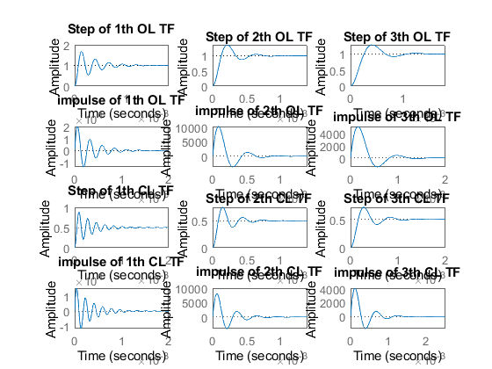

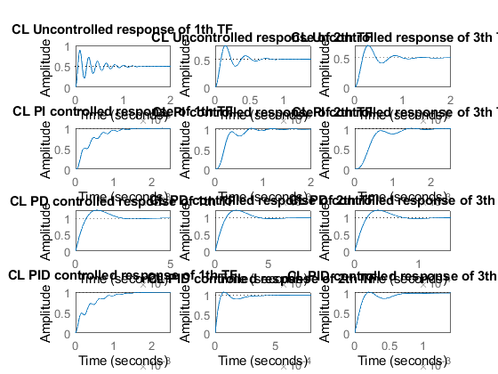

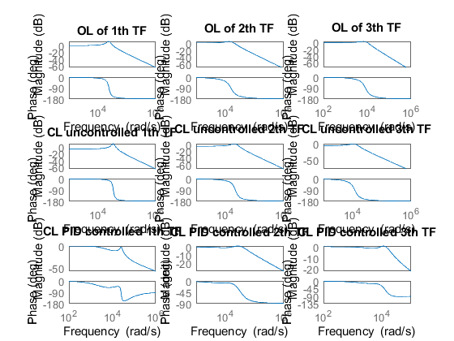

## Comparison Analysis

%Second order closed loop with unity feed back  
%In this the speed is also slightly decreased  
%Settling time does not effect in this unity feedback  
  
%second order with controllers  
%PI controller  
%In this system speed is decreased so respose is some slow  
%In this system settling time is slightly differed  
%Peak valve of the system also decreases  
  
%PD  
%In this system speed increased  
%In this system settling time is also decreases  
%peak value also decreases  
  
%PID  
%In this system speed of the system decrease  
%In this system settling time also varies  
%peak value also decreases

# Control system - RLC circuit - Second Order System with controlers

## Plant Description

implementation

%This plant has a model for RL circuit.  
%The 3 different values of R, L and C are analyzed  
  
% equation- V(t)= I(t)R + L{dI(t)/dt} + (1/c)(integ(Idt);

## Math analysis

I- t D- V,I C- R,L,C

## Roots calculation

Wn = 1/sqrt(LC); eta = R/2(sqrt(C/L)); S= -eta*Wn+Wn*sqrt(eta^2-1); S= -eta*Wn+Wn*sqrt(eta^2-1);

## Tool analysis

R = [10 20 30 -20];  
L = [1.7e-3 2.1e-3 4.9e-3 2.1e-3];  
C = [1e-6 2e-6 3e-6 2e-6];  
K = ([10 1000 0.1 100 1000]);  
  
%P  
for i = 1:4  
 tau = L(i)/R(i);  
 T_F = (tf([K(i)/(L(i)*C(i))],[1,(1/tau),(1/(L(i)*C(i)))]))  
  
 figure(1);  
 subplot(2,4,i);  
 title('Step');  
 step(T_F);  
  
 subplot(2,4,i+4);  
 title('impulse');  
 impulse(T_F);  
  
 [z,p,k]= tf2zp([K(i)/(L(i)*C(i))],[1,(1/tau),(1/(L(i)*C(i)))])  
 S = stepinfo(T_F)  
 figure(2);  
 zplane(z,p);  
 xlim([-30000 30000]);  
 ylim([-30000 30000]);  
 hold on;  
 zeta = (R(i)/2)*(sqrt(C(i)/L(i)))  
 w_n = (1/(sqrt(L(i)*C(i))))  
  
end  
hold off;  
  
% I  
for i = 1:4  
 tau = L(i)/R(i);  
 T_F = (tf([1/(L(i)*C(i))],[1,(1/tau),(1/(L(i)*C(i))),0]))  
  
 figure(3);  
 subplot(2,4,i);  
 title('Step');  
 step(T_F);  
  
 subplot(2,4,i+4);  
 title('impulse');  
 impulse(T_F);  
  
 [z,p,k]= tf2zp([1/(L(i)*C(i))],[1,(1/tau),(1/(L(i)*C(i))),0])  
 S = stepinfo(T_F)  
 figure(4);  
 zplane(z,p);  
 xlim([-30000 30000]);  
 ylim([-30000 30000]);  
 hold on;  
 zeta = (R(i)/2)*(sqrt(C(i)/L(i)))  
 w_n = (1/(sqrt(L(i)*C(i))))  
  
end  
hold off;  
  
% D  
for i = 1:4  
 tau = L(i)/R(i);  
 T_F = (tf([1/(L(i)*C(i)),0],[1,(1/tau),(1/(L(i)*C(i)))]))  
  
 figure(5);  
 subplot(2,4,i);  
 title('Step');  
 step(T_F);  
  
 subplot(2,4,i+4);  
 title('impulse');  
 impulse(T_F);  
  
 [z,p,k]= tf2zp([1/(L(i)*C(i)),0],[1,(1/tau),(1/(L(i)*C(i)))])  
 S = stepinfo(T_F)  
 figure(6);  
 zplane(z,p);  
 xlim([-30000 30000]);  
 ylim([-30000 30000]);  
 hold on;  
 zeta = (R(i)/2)*(sqrt(C(i)/L(i)))  
 w_n = (1/(sqrt(L(i)*C(i))))  
  
end  
hold off;

T_F =  
   
 5.882e09  
 -----------------------  
 s^2 + 5882 s + 5.882e08  
   
Continuous-time transfer function.  
  
  
z =  
  
 0×1 empty double column vector  
  
  
p =  
  
 1.0e+04 *  
  
 -0.2941 + 2.4075i  
 -0.2941 - 2.4075i  
  
  
k =  
  
 5.8824e+09  
  
  
S =   
  
 struct with fields:  
  
 RiseTime: 4.7299e-05  
 SettlingTime: 0.0013  
 SettlingMin: 5.3639  
 SettlingMax: 16.8108  
 Overshoot: 68.1077  
 Undershoot: 0  
 Peak: 16.8108  
 PeakTime: 1.2953e-04  
  
  
zeta =  
  
 0.1213  
  
  
w_n =  
  
 2.4254e+04  
  
  
T_F =  
   
 2.381e11  
 -----------------------  
 s^2 + 9524 s + 2.381e08  
   
Continuous-time transfer function.  
  
  
z =  
  
 0×1 empty double column vector  
  
  
p =  
  
 1.0e+04 *  
  
 -0.4762 + 1.4677i  
 -0.4762 - 1.4677i  
  
  
k =  
  
 2.3810e+11  
  
  
S =   
  
 struct with fields:  
  
 RiseTime: 8.6542e-05  
 SettlingTime: 7.2631e-04  
 SettlingMin: 869.8842  
 SettlingMax: 1.3608e+03  
 Overshoot: 36.0788  
 Undershoot: 0  
 Peak: 1.3608e+03  
 PeakTime: 2.1276e-04  
  
  
zeta =  
  
 0.3086  
  
  
w_n =  
  
 1.5430e+04  
  
  
T_F =  
   
 6.803e06  
 -----------------------  
 s^2 + 6122 s + 6.803e07  
   
Continuous-time transfer function.  
  
  
z =  
  
 0×1 empty double column vector  
  
  
p =  
  
 1.0e+03 *  
  
 -3.0612 + 7.6587i  
 -3.0612 - 7.6587i  
  
  
k =  
  
 6.8027e+06  
  
  
S =   
  
 struct with fields:  
  
 RiseTime: 1.7243e-04  
 SettlingTime: 0.0013  
 SettlingMin: 0.0919  
 SettlingMax: 0.1285  
 Overshoot: 28.4716  
 Undershoot: 0  
 Peak: 0.1285  
 PeakTime: 4.0618e-04  
  
  
zeta =  
  
 0.3712  
  
  
w_n =  
  
 8.2479e+03  
  
  
T_F =  
   
 2.381e10  
 -----------------------  
 s^2 - 9524 s + 2.381e08  
   
Continuous-time transfer function.  
  
  
z =  
  
 0×1 empty double column vector  
  
  
p =  
  
 1.0e+04 *  
  
 0.4762 + 1.4677i  
 0.4762 - 1.4677i  
  
  
k =  
  
 2.3810e+10  
  
  
S =   
  
 struct with fields:  
  
 RiseTime: NaN  
 SettlingTime: NaN  
 SettlingMin: NaN  
 SettlingMax: NaN  
 Overshoot: NaN  
 Undershoot: NaN  
 Peak: Inf  
 PeakTime: Inf  
  
  
zeta =  
  
 -0.3086  
  
  
w_n =  
  
 1.5430e+04  
  
  
T_F =  
   
 5.882e08  
 ---------------------------  
 s^3 + 5882 s^2 + 5.882e08 s  
   
Continuous-time transfer function.  
  
  
z =  
  
 0×1 empty double column vector  
  
  
p =  
  
 1.0e+04 *  
  
 0.0000 + 0.0000i  
 -0.2941 + 2.4075i  
 -0.2941 - 2.4075i  
  
  
k =  
  
 5.8824e+08  
  
  
S =   
  
 struct with fields:  
  
 RiseTime: NaN  
 SettlingTime: NaN  
 SettlingMin: NaN  
 SettlingMax: NaN  
 Overshoot: NaN  
 Undershoot: NaN  
 Peak: Inf  
 PeakTime: Inf  
  
  
zeta =  
  
 0.1213  
  
  
w_n =  
  
 2.4254e+04  
  
  
T_F =  
   
 2.381e08  
 ---------------------------  
 s^3 + 9524 s^2 + 2.381e08 s  
   
Continuous-time transfer function.  
  
  
z =  
  
 0×1 empty double column vector  
  
  
p =  
  
 1.0e+04 *  
  
 0.0000 + 0.0000i  
 -0.4762 + 1.4677i  
 -0.4762 - 1.4677i  
  
  
k =  
  
 2.3810e+08  
  
  
S =   
  
 struct with fields:  
  
 RiseTime: NaN  
 SettlingTime: NaN  
 SettlingMin: NaN  
 SettlingMax: NaN  
 Overshoot: NaN  
 Undershoot: NaN  
 Peak: Inf  
 PeakTime: Inf  
  
  
zeta =  
  
 0.3086  
  
  
w_n =  
  
 1.5430e+04  
  
  
T_F =  
   
 6.803e07  
 ---------------------------  
 s^3 + 6122 s^2 + 6.803e07 s  
   
Continuous-time transfer function.  
  
  
z =  
  
 0×1 empty double column vector  
  
  
p =  
  
 1.0e+03 *  
  
 0.0000 + 0.0000i  
 -3.0612 + 7.6587i  
 -3.0612 - 7.6587i  
  
  
k =  
  
 6.8027e+07  
  
  
S =   
  
 struct with fields:  
  
 RiseTime: NaN  
 SettlingTime: NaN  
 SettlingMin: NaN  
 SettlingMax: NaN  
 Overshoot: NaN  
 Undershoot: NaN  
 Peak: Inf  
 PeakTime: Inf  
  
  
zeta =  
  
 0.3712  
  
  
w_n =  
  
 8.2479e+03  
  
  
T_F =  
   
 2.381e08  
 ---------------------------  
 s^3 - 9524 s^2 + 2.381e08 s  
   
Continuous-time transfer function.  
  
  
z =  
  
 0×1 empty double column vector  
  
  
p =  
  
 1.0e+04 *  
  
 0.0000 + 0.0000i  
 0.4762 + 1.4677i  
 0.4762 - 1.4677i  
  
  
k =  
  
 2.3810e+08  
  
  
S =   
  
 struct with fields:  
  
 RiseTime: NaN  
 SettlingTime: NaN  
 SettlingMin: NaN  
 SettlingMax: NaN  
 Overshoot: NaN  
 Undershoot: NaN  
 Peak: Inf  
 PeakTime: Inf  
  
  
zeta =  
  
 -0.3086  
  
  
w_n =  
  
 1.5430e+04  
  
  
T_F =  
   
 5.882e08 s  
 -----------------------  
 s^2 + 5882 s + 5.882e08  
   
Continuous-time transfer function.  
  
  
z =  
  
 0  
  
  
p =  
  
 1.0e+04 *  
  
 -0.2941 + 2.4075i  
 -0.2941 - 2.4075i  
  
  
k =  
  
 5.8824e+08  
  
  
S =   
  
 struct with fields:  
  
 RiseTime: 0  
 SettlingTime: 0.0014  
 SettlingMin: -1.3789e+04  
 SettlingMax: 2.0195e+04  
 Overshoot: Inf  
 Undershoot: Inf  
 Peak: 2.0195e+04  
 PeakTime: 6.4766e-05  
  
  
zeta =  
  
 0.1213  
  
  
w_n =  
  
 2.4254e+04  
  
  
T_F =  
   
 2.381e08 s  
 -----------------------  
 s^2 + 9524 s + 2.381e08  
   
Continuous-time transfer function.  
  
  
z =  
  
 0  
  
  
p =  
  
 1.0e+04 *  
  
 -0.4762 + 1.4677i  
 -0.4762 - 1.4677i  
  
  
k =  
  
 2.3810e+08  
  
  
S =   
  
 struct with fields:  
  
 RiseTime: 0  
 SettlingTime: 8.1197e-04  
 SettlingMin: -3.7033e+03  
 SettlingMax: 1.0260e+04  
 Overshoot: Inf  
 Undershoot: Inf  
 Peak: 1.0260e+04  
 PeakTime: 8.7038e-05  
  
  
zeta =  
  
 0.3086  
  
  
w_n =  
  
 1.5430e+04  
  
  
T_F =  
   
 6.803e07 s  
 -----------------------  
 s^2 + 6122 s + 6.803e07  
   
Continuous-time transfer function.  
  
  
z =  
  
 0  
  
  
p =  
  
 1.0e+03 *  
  
 -3.0612 + 7.6587i  
 -3.0612 - 7.6587i  
  
  
k =  
  
 6.8027e+07  
  
  
S =   
  
 struct with fields:  
  
 RiseTime: 0  
 SettlingTime: 0.0015  
 SettlingMin: -1.4581e+03  
 SettlingMax: 5.1204e+03  
 Overshoot: Inf  
 Undershoot: Inf  
 Peak: 5.1204e+03  
 PeakTime: 1.5044e-04  
  
  
zeta =  
  
 0.3712  
  
  
w_n =  
  
 8.2479e+03  
  
  
T_F =  
   
 2.381e08 s  
 -----------------------  
 s^2 - 9524 s + 2.381e08  
   
Continuous-time transfer function.  
  
  
z =  
  
 0  
  
  
p =  
  
 1.0e+04 *  
  
 0.4762 + 1.4677i  
 0.4762 - 1.4677i  
  
  
k =  
  
 2.3810e+08  
  
  
S =   
  
 struct with fields:  
  
 RiseTime: NaN  
 SettlingTime: NaN  
 SettlingMin: NaN  
 SettlingMax: NaN  
 Overshoot: NaN  
 Undershoot: NaN  
 Peak: Inf  
 PeakTime: Inf  
  
  
zeta =  
  
 -0.3086  
  
  
w_n =  
  
 1.5430e+04

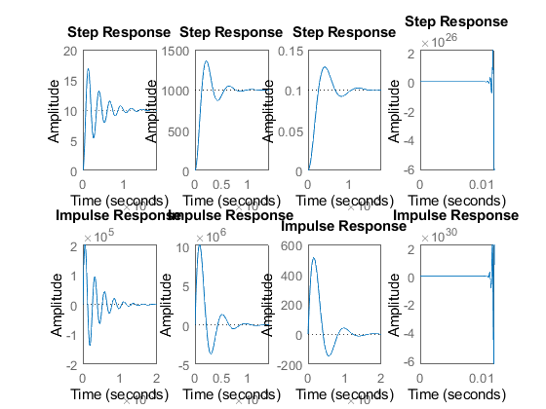

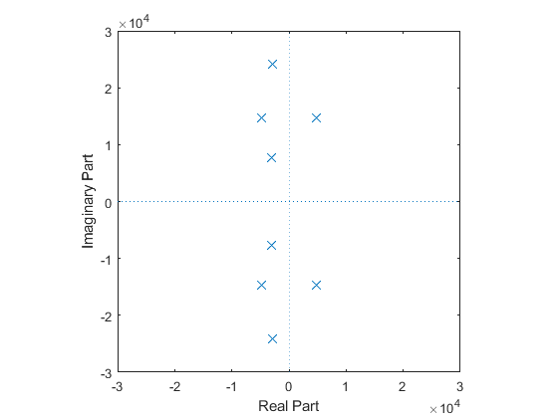

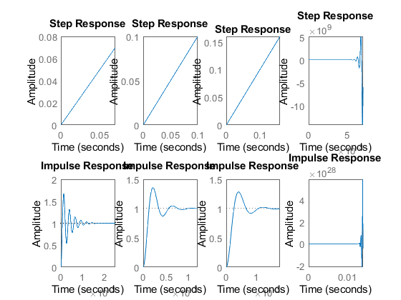

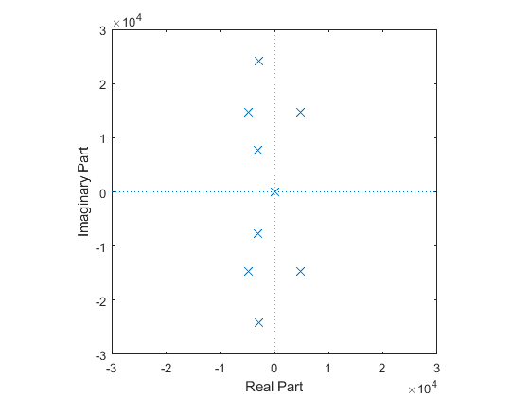

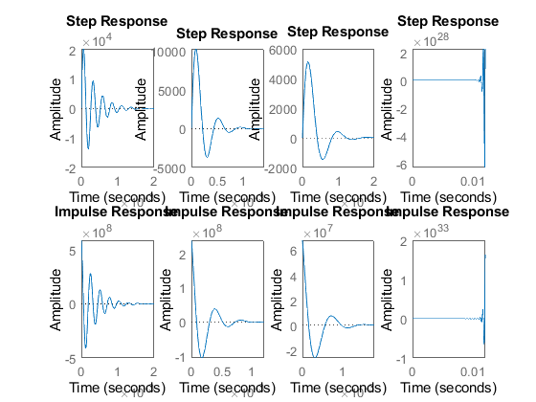

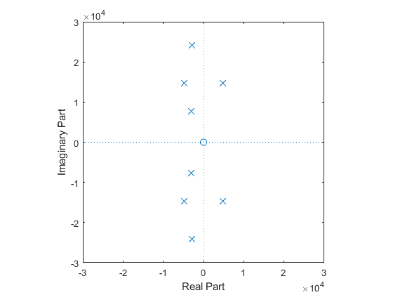

## Comparison Analysis

%Second order open loopwith controller  
%P controller  
% Only peak value of the system is changes  
  
%I controller  
%For I controller the system become unstable  
%For one pole it is marginally stable  
  
%D controoler  
%For D controller speed of the system is more  
%In this settling time is also less

# Control system - RLC circuit - Second Order System with controlers

## Plant Description

implementation

%This plant has a model for RL circuit.  
%The 3 different values of R, L and C are analyzed  
  
% equation- V(t)= I(t)R + L{dI(t)/dt} + (1/c)(integ(Idt);

## Math analysis

I- t D- V,I C- R,L,C

## Tool analysis

R = [100 200 300 400 500];  
L = [10e-3 20e-3 30e-3 40e-3 50e-3];  
C = [100e-6 200e-6 300e-6 400e-6 500e-6];  
zeta = [1 0.5 1.5 -0.5 -2];  
  
for i = 1:5  
  
 w_n = (1/(sqrt(L(i)*C(i))));  
 root1 = (((zeta(i)*w_n)* -1) + (w_n*(sqrt((zeta(i)*zeta(i))-1))));  
 root2 = (((zeta(i)*w_n)* -1) - (w_n*(sqrt((zeta(i)*zeta(i))-1))));  
 zplane(root1);  
 %pzmap(root1);  
 xlim([-1500 1500]);  
 ylim([-1500 1500]);  
 hold on  
 zplane(root2);  
 %pzmap(root2);  
 xlim([-1500 1500]);  
 ylim([-1500 1500]);  
  
end  
hold off;  
  
% Hear we calculate different roots for different values

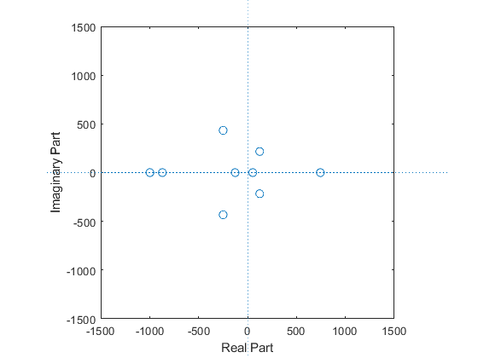

# Control system - RLC circuit - Second Order System

Name - Katherapalle rama subba reddy PS No - 99003759 Date - 08/04/2021 Version - 2.0

## Plant Description

implementation

%This plant has a model for RL circuit.  
%The 3 different values of R, L and C are analyzed  
% equation- V(t)= I(t)R + L{dI(t)/dt} + (1/c)(integ(Idt);

## Tool analysis

poles = [-100+0i -150+0i -230-100i -280-100i -50+450i -50-450i 125+200i ...  
 125-200i -200+200i -200-200i -200+350i -200-350i];  
zeros = [0 0];  
gain = 0.8;  
s=zpk(zeros,poles,gain);  
pzplot(s)  
xlim([-350 150]);  
ylim([-500 500]);  
  
[Wn,zeta]=damp(s)  
stepinfo(poles)

Warning: This zpk model has a complex gain or some complex zeros or poles that  
do not come in conjugate pairs.   
  
Wn =  
  
 100.0000  
 150.0000  
 235.8495  
 235.8495  
 250.7987  
 282.8427  
 282.8427  
 297.3214  
 403.1129  
 403.1129  
 452.7693  
 452.7693  
  
  
zeta =  
  
 1.0000  
 1.0000  
 -0.5300  
 -0.5300  
 0.9171  
 0.7071  
 0.7071  
 0.9417  
 0.4961  
 0.4961  
 0.1104  
 0.1104  
  
  
ans =   
  
 struct with fields:  
  
 RiseTime: 1.6000 + 5.6000i  
 SettlingTime: 11.9767  
 SettlingMin: -150  
 SettlingMax: -5.0000e+01 + 4.5000e+02i  
 Overshoot: -1.9077e+02 - 6.6154e+01i  
 Undershoot: 0  
 Peak: 452.7693  
 PeakTime: 5

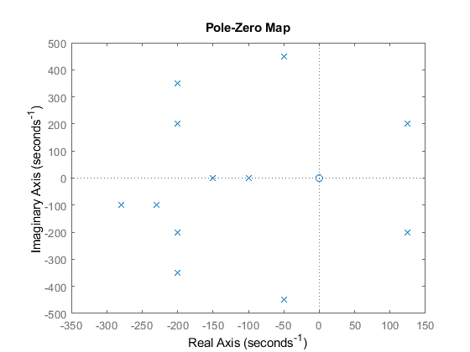

## comparison anyalsis

Has the poles goes away from the origin

# Control system - Mixing Process circuit - First Order System

## Plant Description

implementation

%This plant has a model for RL circuit.  
%The 3 different values of R, L and C are analyzed  
  
% equation- qX - qY = d(VY)/dt = V(dy/

## Math analysis

I- t D- Y,X C- V,q

## Roots calculation

s = -q/V;

## Tool anyalasis

q = ([3 5 10]);  
v = ([25 200 2000]);  
K = ([100 1000 0.1]);  
  
for i=1:3  
 Tau = v(i)/q(i);  
 Lf = tf([0 1],[Tau 1])  
 figure(1);  
 subplot(2,3,i);  
 impulse(Lf);  
 title('Impulse Input');  
 subplot(2,3,i+3);  
 step(Lf);  
 title('Step Input');  
 hold on;  
 [z,p,k]= tf2zp([0 1],[Tau 1])  
 figure(2);  
 zplane(z,p);  
 xlim([-30e-3 30e-3]);  
 ylim([-30e-3 30e-3]);  
 hold on;  
 stepinfo(Lf)  
end  
hold off;  
  
%closed loop  
  
%q = ([3 5 10]);  
%v = ([25 200 2000]);  
% Positive Feedback  
for i=1:3  
 Tau = v(i)/q(i);  
 Lf = (tf([0 1],[Tau 0]))  
 figure(1);  
 subplot(2,4,i);  
 impulse(Lf);  
 title('Impulse Input');  
 subplot(2,4,i+4);  
 step(Lf);  
 title('Step Input');  
 hold on;  
 [z,p,k]= tf2zp([0 1],[Tau 0])  
 figure(2);  
 zplane(z,p);  
 xlim([-30 600]);  
 ylim([-100 100]);  
 hold on;  
 stepinfo(Lf)  
end  
hold off;  
  
% Negative Feedback with and without PID  
  
%q = ([3 5 10]);  
%v = ([25 200 2000]);  
  
for i = 1:3  
 Tau = v(i)/q(i);  
 sys_ol = tf([0 1],[Tau 2])  
 stepinfo(sys_ol)  
 sys_cl = feedback(sys_ol,1)  
  
  
 [GC_PI,info_PI] = pidtune(sys_ol,'PI');  
 sys_cl_PI = feedback(sys_ol * GC_PI,1)  
 stepinfo(sys_cl_PI)  
  
 [GC_PD,info_PD] = pidtune(sys_ol,'PD');  
 sys_cl_PD = feedback(sys_ol * GC_PD,1)  
 stepinfo(sys_cl_PD)  
  
 [GC_PID,info_PID] = pidtune(sys_ol,'PID');  
 sys_cl_PID = feedback(sys_ol * GC_PID,1)  
 stepinfo(sys_cl_PID)  
  
% input response plots  
 figure(3);  
 subplot(4,3,i);  
 step(sys_ol);  
 title(['Step of ', num2str(i) ,'th OL TF']);  
  
 subplot(4,3,i+3);  
 impulse(sys_ol);  
 title(['impulse of ', num2str(i) ,'th OL TF']);  
  
 subplot(4,3,i+6);  
 step(sys_cl);  
 title(['Step of ', num2str(i) ,'th CL TF']);  
  
 subplot(4,3,i+9);  
 impulse(sys_cl);  
 title(['impulse of ', num2str(i) ,'th CL TF']);  
  
% controller plots  
 figure(4);  
 subplot(4,3,i);  
 step(sys_cl)  
 title(['CL Uncontrolled response of ', num2str(i) ,'th TF']);  
  
 subplot(4,3,i+3);  
 step(sys_cl_PI)  
 title(['CL PI controlled response of ', num2str(i) ,'th TF']);  
  
 subplot(4,3,i+6);  
 step(sys_cl_PD)  
 title(['CL PD controlled response of ', num2str(i) ,'th TF']);  
  
 subplot(4,3,i+9);  
 step(sys_cl_PID)  
 title(['CL PID controlled response of ', num2str(i) ,'th TF']);  
  
% Bode plots  
 figure(5);  
 subplot(3,3,i);  
 bode(sys_ol)  
 title(['OL of ',num2str(i),'th TF']);  
  
 subplot(3,3,i+3);  
 bode(sys_cl)  
 title(['CL uncontrolled ',num2str(i),'th TF']);  
  
 subplot(3,3,i+6);  
 bode(sys_cl_PID)  
 title(['CL PID controlled ',num2str(i),'th TF']);  
  
end

Lf =  
   
 1  
 -----------  
 8.333 s + 1  
   
Continuous-time transfer function.  
  
  
z =  
  
 0×1 empty double column vector  
  
  
p =  
  
 -0.1200  
  
  
k =  
  
 0.1200  
  
  
ans =   
  
 struct with fields:  
  
 RiseTime: 18.3084  
 SettlingTime: 32.6006  
 SettlingMin: 0.9045  
 SettlingMax: 1.0000  
 Overshoot: 0  
 Undershoot: 0  
 Peak: 1.0000  
 PeakTime: 87.8820  
  
  
Lf =  
   
 1  
 --------  
 40 s + 1  
   
Continuous-time transfer function.  
  
  
z =  
  
 0×1 empty double column vector  
  
  
p =  
  
 -0.0250  
  
  
k =  
  
 0.0250  
  
  
ans =   
  
 struct with fields:  
  
 RiseTime: 87.8803  
 SettlingTime: 156.4830  
 SettlingMin: 0.9045  
 SettlingMax: 1.0000  
 Overshoot: 0  
 Undershoot: 0  
 Peak: 1.0000  
 PeakTime: 421.8336  
  
  
Lf =  
   
 1  
 ---------  
 200 s + 1  
   
Continuous-time transfer function.  
  
  
z =  
  
 0×1 empty double column vector  
  
  
p =  
  
 -0.0050  
  
  
k =  
  
 0.0050  
  
  
ans =   
  
 struct with fields:  
  
 RiseTime: 439.4013  
 SettlingTime: 782.4149  
 SettlingMin: 0.9045  
 SettlingMax: 1.0000  
 Overshoot: 0  
 Undershoot: 0  
 Peak: 1.0000  
 PeakTime: 2.1092e+03  
  
  
Lf =  
   
 1  
 -------  
 8.333 s  
   
Continuous-time transfer function.  
  
  
z =  
  
 0×1 empty double column vector  
  
  
p =  
  
 0  
  
  
k =  
  
 0.1200  
  
  
ans =   
  
 struct with fields:  
  
 RiseTime: NaN  
 SettlingTime: NaN  
 SettlingMin: NaN  
 SettlingMax: NaN  
 Overshoot: NaN  
 Undershoot: NaN  
 Peak: Inf  
 PeakTime: Inf  
  
  
Lf =  
   
 1  
 ----  
 40 s  
   
Continuous-time transfer function.  
  
  
z =  
  
 0×1 empty double column vector  
  
  
p =  
  
 0  
  
  
k =  
  
 0.0250  
  
  
ans =   
  
 struct with fields:  
  
 RiseTime: NaN  
 SettlingTime: NaN  
 SettlingMin: NaN  
 SettlingMax: NaN  
 Overshoot: NaN  
 Undershoot: NaN  
 Peak: Inf  
 PeakTime: Inf  
  
  
Lf =  
   
 1  
 -----  
 200 s  
   
Continuous-time transfer function.  
  
  
z =  
  
 0×1 empty double column vector  
  
  
p =  
  
 0  
  
  
k =  
  
 0.0050  
  
  
ans =   
  
 struct with fields:  
  
 RiseTime: NaN  
 SettlingTime: NaN  
 SettlingMin: NaN  
 SettlingMax: NaN  
 Overshoot: NaN  
 Undershoot: NaN  
 Peak: Inf  
 PeakTime: Inf  
  
  
sys_ol =  
   
 1  
 -----------  
 8.333 s + 2  
   
Continuous-time transfer function.  
  
  
ans =   
  
 struct with fields:  
  
 RiseTime: 9.1542  
 SettlingTime: 16.3003  
 SettlingMin: 0.4523  
 SettlingMax: 0.5000  
 Overshoot: 0  
 Undershoot: 0  
 Peak: 0.5000  
 PeakTime: 43.9410  
  
  
sys_cl =  
   
 1  
 -----------  
 8.333 s + 3  
   
Continuous-time transfer function.  
  
  
sys_cl_PI =  
   
 2.085 s + 1.502  
 ---------------------------  
 8.333 s^2 + 4.085 s + 1.502  
   
Continuous-time transfer function.  
  
  
ans =   
  
 struct with fields:  
  
 RiseTime: 3.3721  
 SettlingTime: 12.3337  
 SettlingMin: 0.9001  
 SettlingMax: 1.1382  
 Overshoot: 13.8188  
 Undershoot: 0  
 Peak: 1.1382  
 PeakTime: 7.3280  
  
  
sys_cl_PD =  
   
 141.8  
 ---------------  
 8.333 s + 143.8  
   
Continuous-time transfer function.  
  
  
ans =   
  
 struct with fields:  
  
 RiseTime: 0.1273  
 SettlingTime: 0.2267  
 SettlingMin: 0.8919  
 SettlingMax: 0.9861  
 Overshoot: 0  
 Undershoot: 0  
 Peak: 0.9861  
 PeakTime: 0.6111  
  
  
sys_cl_PID =  
   
 2.863 s + 1.246  
 ---------------------------  
 8.333 s^2 + 4.863 s + 1.246  
   
Continuous-time transfer function.  
  
  
ans =   
  
 struct with fields:  
  
 RiseTime: 3.8006  
 SettlingTime: 13.1891  
 SettlingMin: 0.9005  
 SettlingMax: 1.0608  
 Overshoot: 6.0819  
 Undershoot: 0  
 Peak: 1.0608  
 PeakTime: 8.2070  
  
  
sys_ol =  
   
 1  
 --------  
 40 s + 2  
   
Continuous-time transfer function.  
  
  
ans =   
  
 struct with fields:  
  
 RiseTime: 43.9401  
 SettlingTime: 78.2415  
 SettlingMin: 0.4523  
 SettlingMax: 0.5000  
 Overshoot: 0  
 Undershoot: 0  
 Peak: 0.5000  
 PeakTime: 210.9168  
  
  
sys_cl =  
   
 1  
 --------  
 40 s + 3  
   
Continuous-time transfer function.  
  
  
sys_cl_PI =  
   
 2.085 s + 0.3128  
 -------------------------  
 40 s^2 + 4.085 s + 0.3128  
   
Continuous-time transfer function.  
  
  
ans =   
  
 struct with fields:  
  
 RiseTime: 16.1861  
 SettlingTime: 59.2017  
 SettlingMin: 0.9001  
 SettlingMax: 1.1382  
 Overshoot: 13.8188  
 Undershoot: 0  
 Peak: 1.1382  
 PeakTime: 35.1745  
  
  
sys_cl_PD =  
   
 141.8  
 ------------  
 40 s + 143.8  
   
Continuous-time transfer function.  
  
  
ans =   
  
 struct with fields:  
  
 RiseTime: 0.6110  
 SettlingTime: 1.0880  
 SettlingMin: 0.8919  
 SettlingMax: 0.9861  
 Overshoot: 0  
 Undershoot: 0  
 Peak: 0.9861  
 PeakTime: 2.9330  
  
  
sys_cl_PID =  
   
 2.863 s + 0.2595  
 -------------------------  
 40 s^2 + 4.863 s + 0.2595  
   
Continuous-time transfer function.  
  
  
ans =   
  
 struct with fields:  
  
 RiseTime: 18.2427  
 SettlingTime: 63.3079  
 SettlingMin: 0.9005  
 SettlingMax: 1.0608  
 Overshoot: 6.0819  
 Undershoot: 0  
 Peak: 1.0608  
 PeakTime: 39.3934  
  
  
sys_ol =  
   
 1  
 ---------  
 200 s + 2  
   
Continuous-time transfer function.  
  
  
ans =   
  
 struct with fields:  
  
 RiseTime: 219.7006  
 SettlingTime: 391.2074  
 SettlingMin: 0.4523  
 SettlingMax: 0.5000  
 Overshoot: 0  
 Undershoot: 0  
 Peak: 0.5000  
 PeakTime: 1.0546e+03  
  
  
sys_cl =  
   
 1  
 ---------  
 200 s + 3  
   
Continuous-time transfer function.  
  
  
sys_cl_PI =  
   
 2.085 s + 0.06257  
 ---------------------------  
 200 s^2 + 4.085 s + 0.06257  
   
Continuous-time transfer function.  
  
  
ans =   
  
 struct with fields:  
  
 RiseTime: 80.9307  
 SettlingTime: 296.0084  
 SettlingMin: 0.9001  
 SettlingMax: 1.1382  
 Overshoot: 13.8188  
 Undershoot: 0  
 Peak: 1.1382  
 PeakTime: 175.8727  
  
  
sys_cl_PD =  
   
 141.8  
 -------------  
 200 s + 143.8  
   
Continuous-time transfer function.  
  
  
ans =   
  
 struct with fields:  
  
 RiseTime: 3.0552  
 SettlingTime: 5.4402  
 SettlingMin: 0.8919  
 SettlingMax: 0.9861  
 Overshoot: 0  
 Undershoot: 0  
 Peak: 0.9861  
 PeakTime: 14.6652  
  
  
sys_cl_PID =  
   
 2.863 s + 0.0519  
 --------------------------  
 200 s^2 + 4.863 s + 0.0519  
   
Continuous-time transfer function.  
  
  
ans =   
  
 struct with fields:  
  
 RiseTime: 91.2134  
 SettlingTime: 316.5393  
 SettlingMin: 0.9005  
 SettlingMax: 1.0608  
 Overshoot: 6.0819  
 Undershoot: 0  
 Peak: 1.0608  
 PeakTime: 196.9669

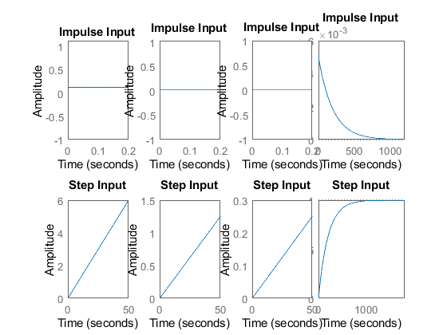

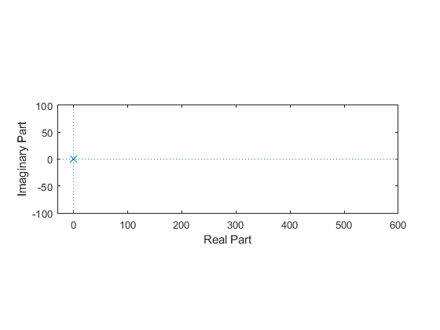

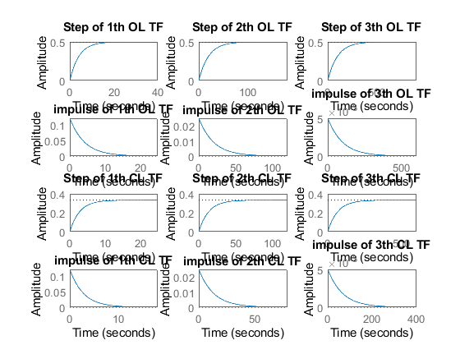

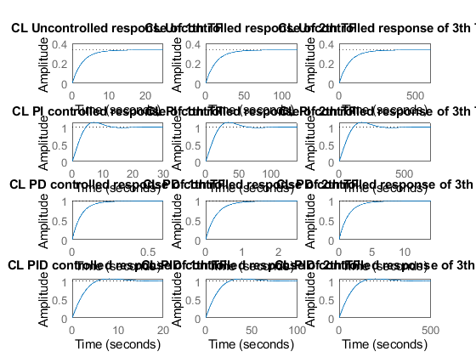

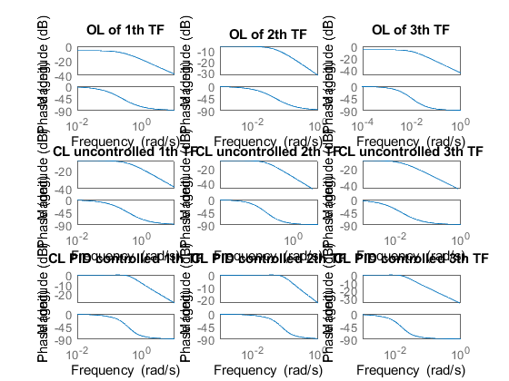

## Comparison Analysis

Speed Has the poles of the transfer function moves away from the origin The rise time is decreasing so the response of the system is speed

%Accuracy  
% Has the poles of the transfor function moves away from the origin  
% The settling time is decreasing so the accuracy is more  
%Stability  
% For the transfor functions above the poles negative side so they are stable  
  
%positive feed back  
%For some values of RL system is become unstable  
  
%Negative feedback without PID  
%In this the rise time and settling time both are increasing  
  
%With PID  
%PI  
%In this the rise time and settling time both are increasing  
%PD  
%In this the rise time and settling time both are decreasing  
%PID  
%In this the rise time and settling time both are increasing