./

Learning Report – Applied System Development Life Cycle and Software Testing



|  |  |  |  |  |  |
| --- | --- | --- | --- | --- | --- |
| **Ver. Rel. No.** | **Release Date** | **Prepared. By** | **Reviewed By** | **To be approved By** | **Remarks/Revision Details** |
| 1 |  | Name/PS No | Name/PS No | Module Owner Name | Comments |
| 2 | 15/02/21 | 99003759 |  |  |  |
| 3 |  |  |  |  |  |
|  |  |  |  |  |  |
|  |  |  |  |  |  |

**Document History**

Table of Contents

Table of Figures 3

ACTIVITY 1: SYSTEM/ SOFTWARE DEVELOPMENT 4

INTRODUCTION 4

MY PRODUCT: “Name ” 4

SWOT ANALYSIS 5

REQUIREMENTS 6

DESIGN 8

HIGH LEVEL DESIGN 8

LOW LEVEL DESIGN 8

TEST PLANS 10

ACTIVITY 2: AGILE METHODOLOGY 15

THEME 15

EPIC 15

USER STORY 15

## Table of Figures

Figure 1 CLASS DIAGRAM(HIGH LEVEL) 7

Figure 2 OBJECT DIAGRAM (LOW LEVEL) 8

Figure 3 USE CASE DIAGRAM (LOW LEVEL) 9

Figure 4 TEST PLAN 10

Figure 5 GIT 10

Figure 6 GIT ISSUES 11

Figure 7 GIT COMMITS 12

Figure 8 GIT BUILD 13

**ACTIVITY 1: SYSTEM/ SOFTWARE DEVELOPMENT**

Introduction

The first electronic calculator was created in the early 1960s. Pocket-sized devices became available in the 1970s, especially after the intel 404, the first microprocessor, was developed by intel for the Japanese calculator company Busicom. They later became used commonly within the petroleum industry (oil and gas).

Modern electronic calculators vary from cheap, give-away, credit -card-sized models to sturdy desktop models with built-in printers. They became popular in the mid-1970s as the incorporation of integrated circuits reduced their size and cost. By the end of that decade, prices had dropped to the point where a basic calculator was affordable to most and they became common in schools.

Computer operating systems as far back as early Unix have included interactive calculator programs such as dc and hoc, and calculator functions are included in almost all personal digital assessment (PDA) type devices, the exceptions being a few dedicated address book and dictionary devices.

In addition to general purpose calculators, there are those designed for specific markets. For example, there are [scientific calculators](https://en.wikipedia.org/wiki/Scientific_calculator) which include [trigonometric](https://en.wikipedia.org/wiki/Trigonometry) and [statistical](https://en.wikipedia.org/wiki/Statistics) calculations. Some calculators even have the ability to do [computer algebra](https://en.wikipedia.org/wiki/Computer_algebra). [Graphing calculators](https://en.wikipedia.org/wiki/Graphing_calculator) can be used to graph functions defined on the real line, or higher-dimensional [Euclidean space](https://en.wikipedia.org/wiki/Euclidean_space). As of 2016, basic calculators cost little, but scientific and graphing models tend to cost more.

In 1986, calculators still represented an estimated 41% of the world's general-purpose hardware capacity to compute information. By 2007, this had diminished to less than 0.05%.

**MY PRODUCT:**

* It can do all basic operations (Addition, Subtraction, Multiplication, Division).
* Logarithmic operations, Exponential operations are also available.
* Power functions, Factorial and Conversions which are helpful for students are added.
* Basic Trigonometric Operations are also available.
* Basic Matrix Operations are also available.
* It has double precision.

**SWOT** ANALYSIS

# ****SWOT- Strengths, and Weakness, Opportunities Threats****

**Strengths**

• User Friendly

• All basic operations

• Double Precision

• Trigonometric operations

• Matrix Operations **Weakness**

• Limited Operations • Memory Wastage

**Opportunities**

• It can be expanded by adding additional features like Inverse Trigonometric operations, Equations etc.

**Threats**

• There are other programmable calculators which may affect our product marketing.

**REQUIREMENTS**

**HIGH LEVEL REQUIREMENTS**

|  |  |
| --- | --- |
| **High level Requirement** | **Description** |
| HLR1 | Basic Operations |
| HLR2 | Trigonometric Operations |
| HLR3 | Matrix Operations |
| HLR4 | Conversions |

**LOW LEVEL REQUIREMENTS**

|  |  |
| --- | --- |
| **Low level Requirement** | **Description** |
| LLR1 | Addition |
| LLR2 | Subtraction |
| LLR3 | Multiplication |
| LLR4 | Division |
| LLR5 | Sine, Cos, Tan |
| LLR6 | Cosec, Sec, Cot |
| LLR7 | Matrix Addition |
| LLR8 | Matrix Subtraction |
| LLR9 | Matrix Multiplication |
| LLR10 | Base Decimal Conversion |
| LLR11 | Unit Conversion |
| LLR12 | Check for Real numbers |

**DESIGN**

**High level design**

**Class diagram**

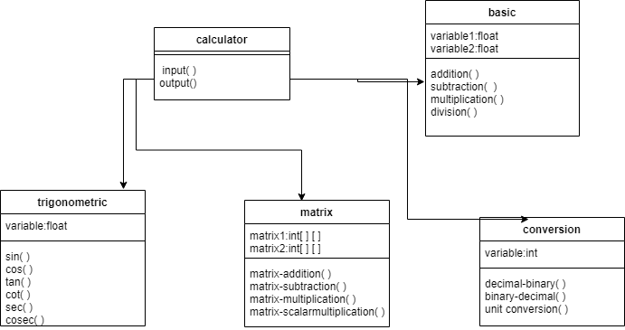

**Low level design**

**Object diagram**

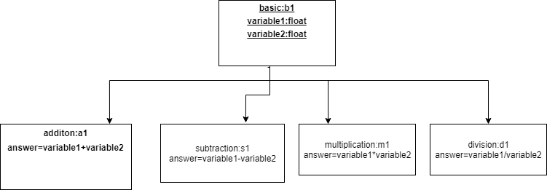

**Use case diagram**

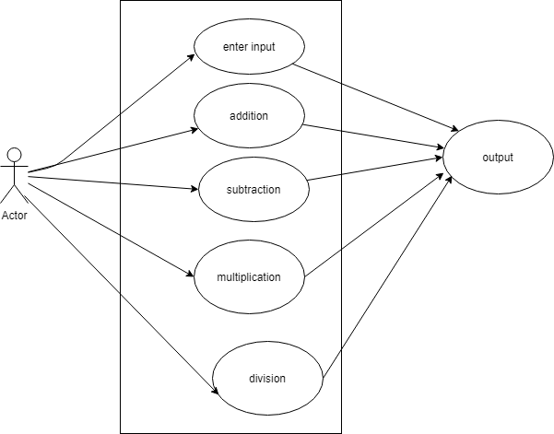

**TEST PLAN**

|  |  |  |  |
| --- | --- | --- | --- |
| TEST CASE ID | DESCRIPTION | EXPECTED INPUTPUT | EXPECTED OUTPUT |
| LLR01 | Check the number dived by zero | Given number is divided by zero | Error |
| LLR02 | Check the base of log | Given number is other than 2,10 | Error |
| LLR03 | Check the number in square root | Given number is negative not positive | Error |
| LLR04 | Check the number in cube root | Given number is negative | Negative number |
| LLR05 | Check divided by big number | Given number is greater | Less than zero |
| LLR06 | Check divided by smaller number | Given number is smaller | Greater than zero |
| LLR07 | Check divided by negative number | Given number is negative | Negative number |

**GIT**

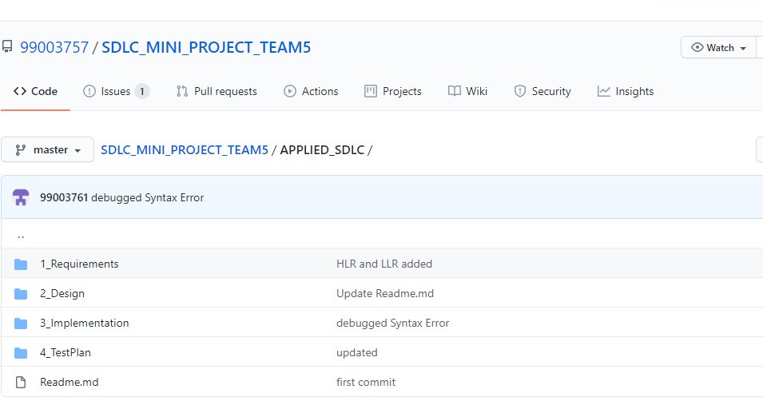

**GIT Issues**

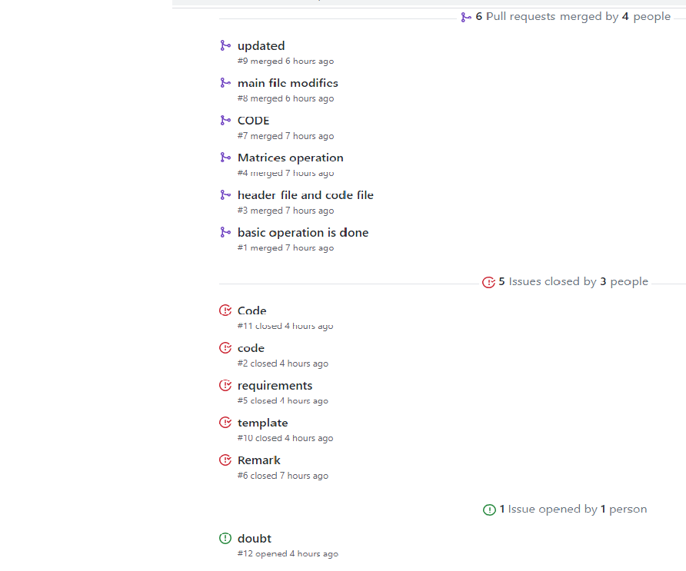

GIT Commits

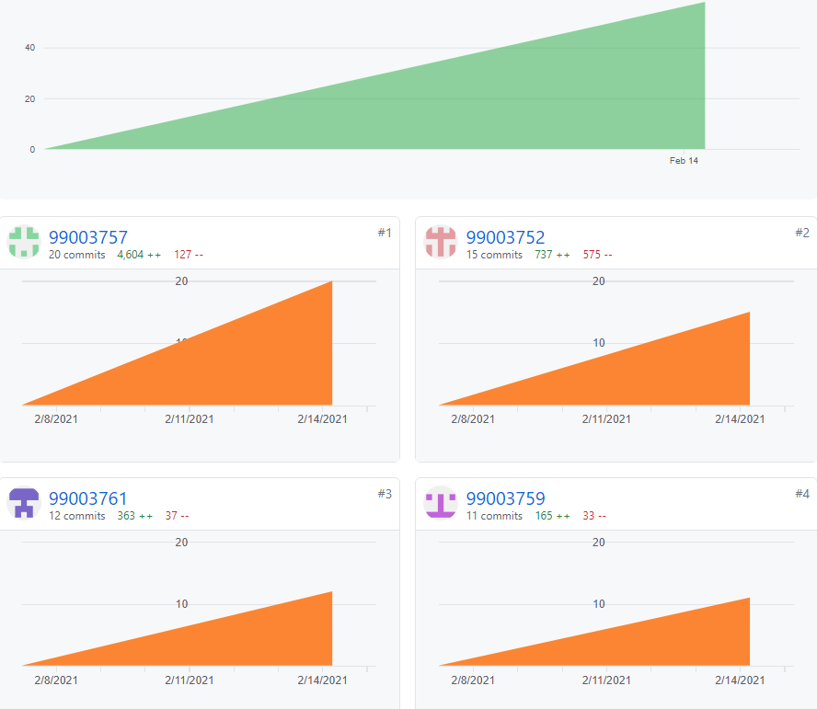

GIT Build

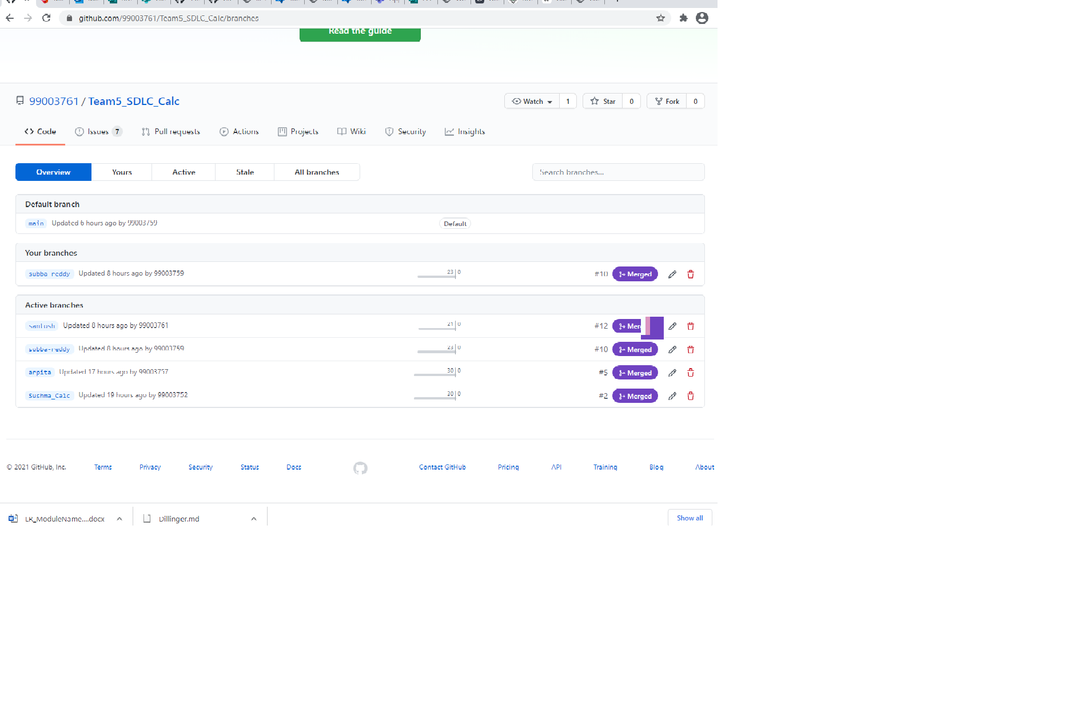

##### **ACTIVITY 2- AGILE METHODOLOGY (CALCULATOR)**

Agile Methodology

THEME - Calculator :

Design a calculator with selected appropriate features that meets the expected requirements.

Based on the literature survey and research done, the team decided to choose educational institutions as the target customers.

EPIC:

Introduction:

The additional features in calculators enables the users in quick computation of all data type values (int, float, double) and hence results in enhanced calculation speed. Thus, there is a need for a user friendly, well featured calculators that can be affordable at

The high-level requirement features of calculator system can be divided into the following user stories:

1.     Basic arithmetic operations

2.     Unit conversions

3.     Trigonometric

4. Matrix operations

STORIES:

Based on the high level and low level requirements of the designed calculator, the following are the user stories from the perspective of the end user:

1.     Basic arithmetic operations

2.     Unit Conversions

3.     Trigonometric

4. Matrix operations