./

Migration Report – Control Systems



|  |  |  |  |  |  |
| --- | --- | --- | --- | --- | --- |
| **Ver. Rel. No.** | **Release Date** | **Prepared. By** | **Reviewed By** | **To be approved By** | **Remarks/Revision Details** |
| 1 | 14-04-2021 | Katherapalle Rama Subba Reddy |  |  |  |
|  |  |  |  |  |  |
|  |  |  |  |  |  |
|  |  |  |  |  |  |
|  |  |  |  |  |  |

**Document History**

Table of Contents

1. INTRODUCTION 3

2. MATLAB 4

3. Octave 6

Comparison Analysis from the scripts: 9

4. Simulink Modelling 11

5. Modellica Modelling: 12

6. Comparison Analysis from the modelling: 15

# INTRODUCTION

This document contains the migration of system transfer function from MATLAB to Octave.

It contains the different scripts and block diagrams present in both the tools.

The RL circuit is taken as the system. It is a first order system as the order of the

System is 1.

Equation of the system is given below:

**V(t) = I(t)*R + L*dI(t)/dt.**

V is voltage, I is current, L is inductance, R is resistance.

Applications of the system are as follows:

* It is used in the DC power supplies for RF amplifiers.

# MATLAB

Plant Description:

The RL circuit firstorder system is taken as Plant.

%% Plant Description

% implementation

%This plant has a model for RL circuit.

%The 3 different values of R, L and C are analyzed

% equation- V(t)= I(t)R + L{dI(t)/dt} //V(t) = I(t)R + L{\frac{dI(t)}{dt}}

%% Math analysis

% I- t

% D- V,I

% C- R,L

Code:

%% Tool Analysis

%R = ([10e3 1e3 0.1e3]);

%L = ([50e-3 10e-3 5e-3]);

R = ([100 100e-3 0.32e-3 -100e-3]);

L = ([5 25e-3 2e-3 25e-3]);

for i=1:3

Tau = L(i)/R(i);

Lf = tf([0 (1/R(i))],[Tau 1])

figure(1);

subplot(2,3,i);

impulse(Lf);

title('Impulse Input');

subplot(2,3,i+3);

step(Lf);

title('Step Input');

hold on;

[z,p,k]= tf2zp([0 (1/R(i))],[Tau 1]);

figure(2);

zplane(z,p);

% xlim([-4*1e5 2*1e5]);

% ylim([-4*1e5 2*1e5]);

xlim([-30 30]);

ylim([-30 30]);

hold on;

stepinfo(Lf)

end

hold off;

Transfer Function:

Lf =

0.01

----------

0.05 s + 1

Position of Poles:

p =

-0.1600

RiseTime: 13.7313

SettlingTime: 24.4505

SettlingMin: 2.8266e+03

SettlingMax: 3.1249e+03

Overshoot: 0

Undershoot: 0

Peak: 3.1249e+03

PeakTime: 65.9115

## 

# Octave

Code:

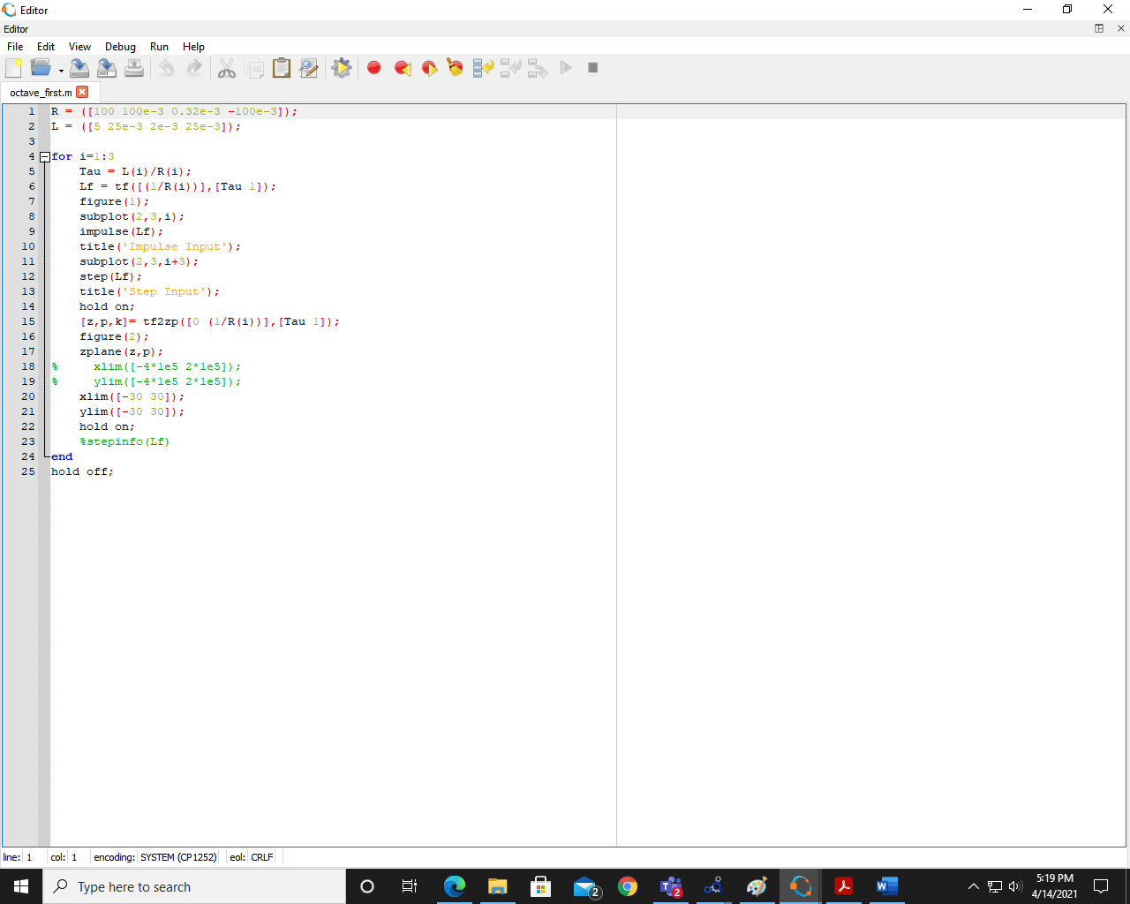

Location of Poles:

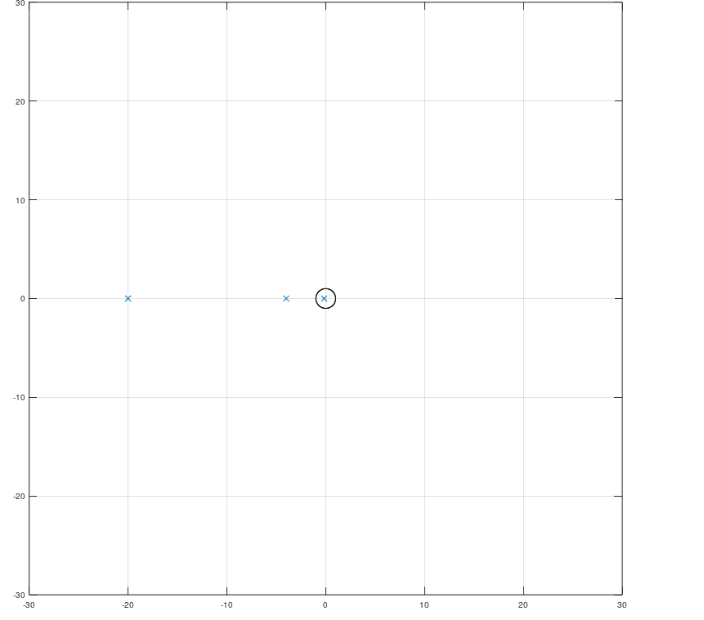

Plots:

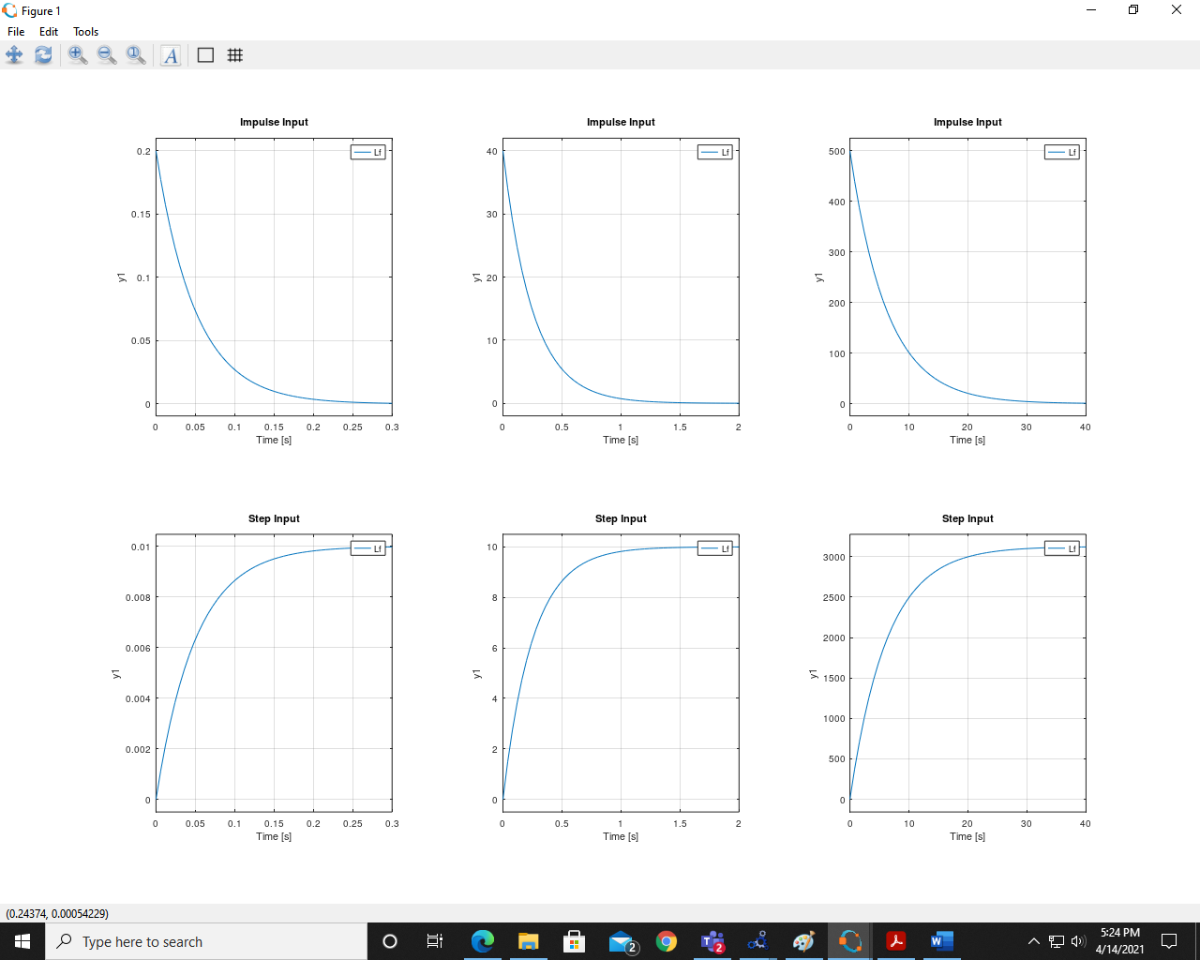

# Comparison Analysis from the scripts:

Above we have built the transfer function of the first order RL circuit in both Simulink

and SciLab.

As we go through both the graph we find output time domain response to be similar in both the tools.

The settling time and peak remains the same.

# Simulink Modelling

Model:

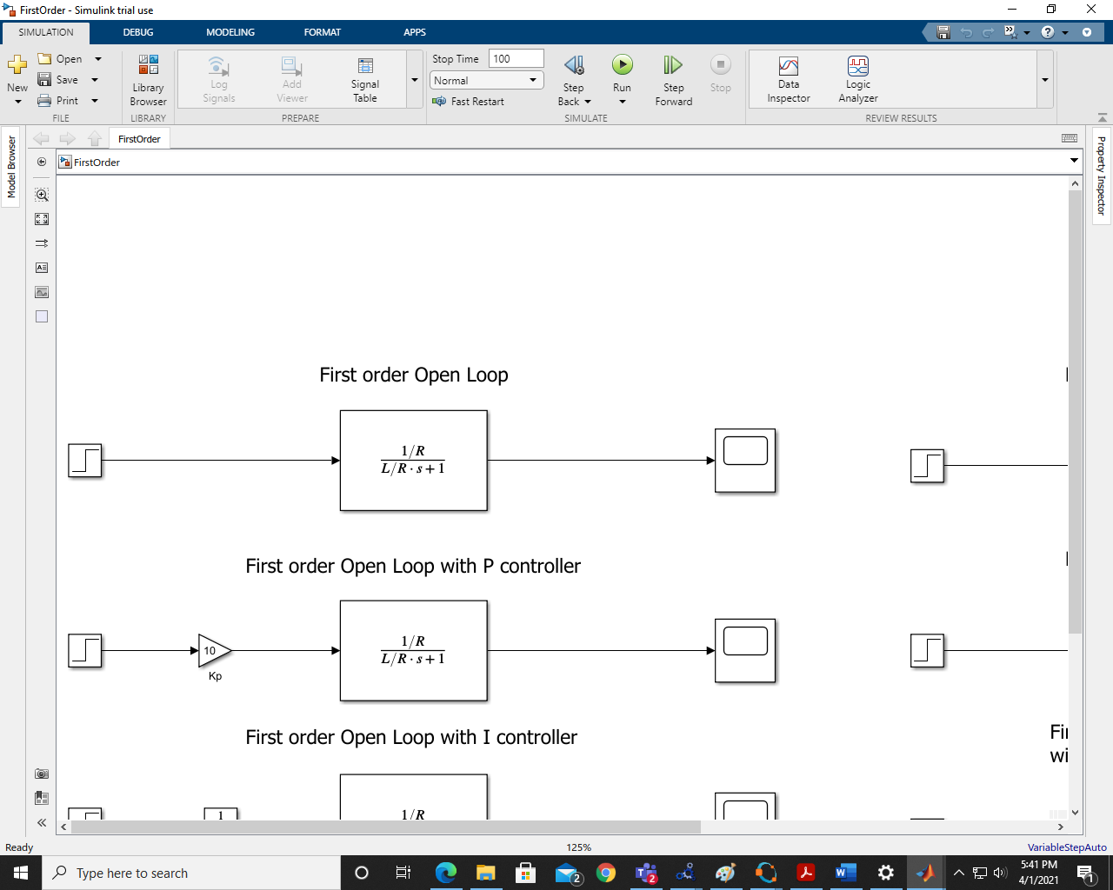

Output Response:

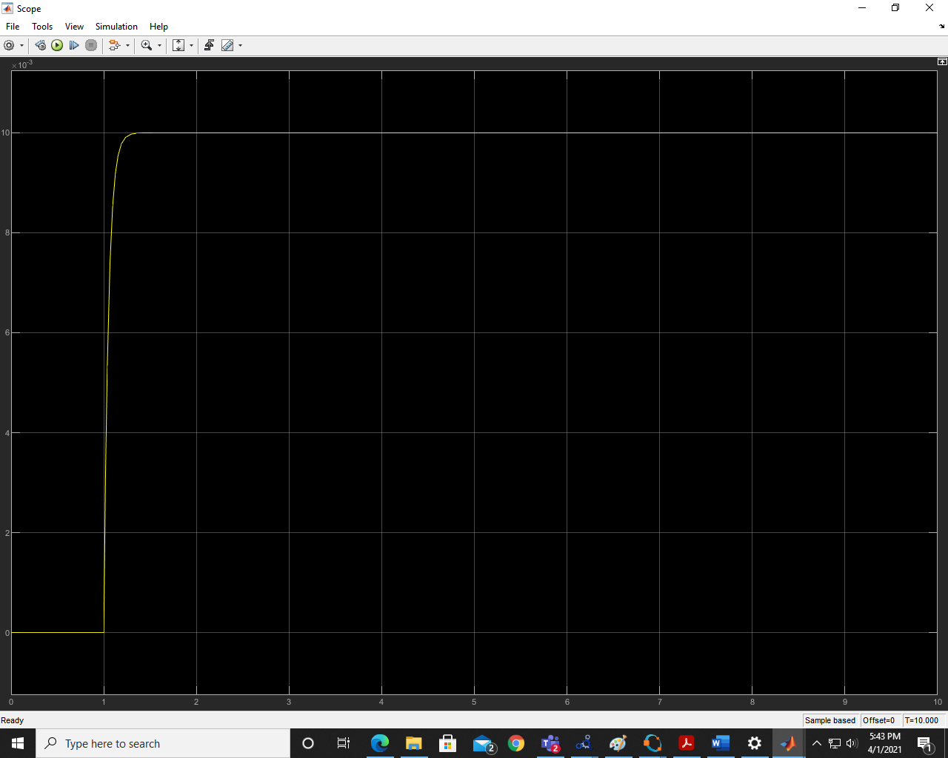

# Modellica Modelling:

Model:

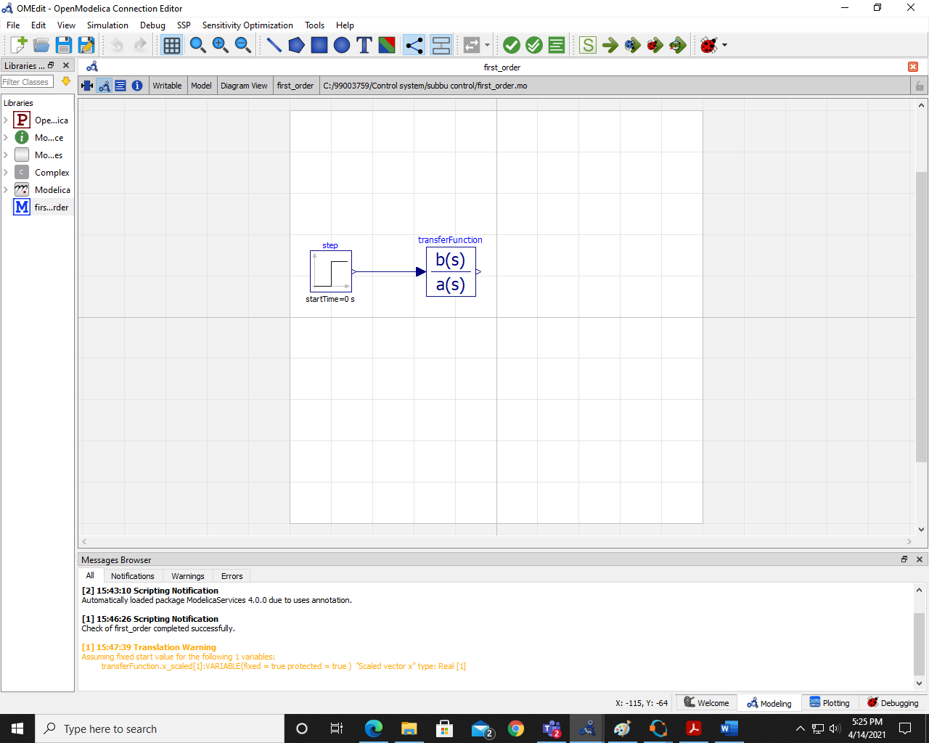

Output Response:

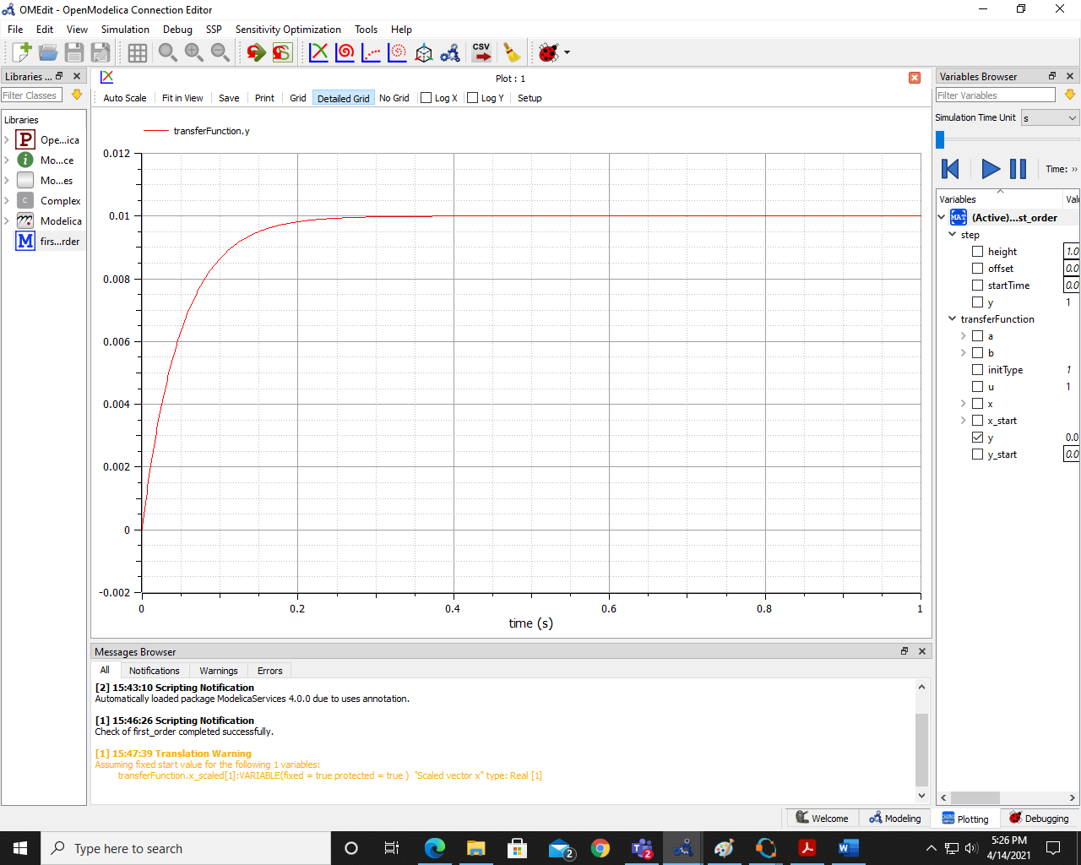

# Comparison Analysis from the modelling:

Above we have built the transfer function of the first order RL circuit in both Simulink

and SciLab.

As we go through both the graph we find output time domain response to be similar in both the tools.

The settling time and peak remains the same.