Chapter 4
Applications of First-order Differential Equations to Real World Systems
  - Cooling/Warming Law
  - Population Growth and Decay
  - Radio-Active Decay and Carbon Dating
  - Mixture of Two Salt Solutions
  - Series Circuits
  - Survivability with AIDS
  - Draining a tank
  - Economics and Finance
  - Mathematics Police Women
  - Drug Distribution in Human Body
  - A Pursuit Problem
  - Harvesting of Renewable Natural Resources
  - Exercises
In Section 1.4 we have seen that real world problems can be represented by first-order differential equations.
In chapter 2 we have discussed few methods to solve first order differential equations. We solve in this chapter first-order differential equations modeling phenomena of cooling, population growth, radioactive decay, mixture of salt solutions, series circuits, survivability with AIDS, draining a tank, economics and finance, drug distribution, pursuit problem and harvesting of renewable natural resources.
4.1 Cooling/Warming law
We have seen in Section 1.4 that the mathematical formulation of Newton’s empirical law of cooling of an object in given by the linear first-order differential equation (1.17)
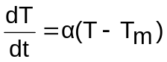
This is a separable differential equation. We have
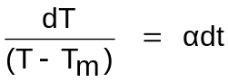
or ln|T-T_{m} |=αt+c₁
or T(t) = T_{m}+c₂e^{αt} (4.1)
Example 4.1: When a chicken is removed from an oven, its temperature is measured at 300⁰F. Three minutes later its temperature is 200º F. How long will it take for the chicken to cool off to a room temperature of 70ºF.
Solution: In (4.1) we put T_{m} = 70 and T=300 at for t=0.
T(0)=300=70+c₂e^{α.0}
This gives c₂=230
For t=3, T(3)=200
Now we put t=3, T(3)=200 and c₂=230 in (4.1) then
200=70 + 230 e^{α.3}
or 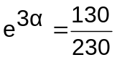
or 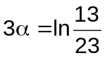
or 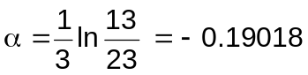
Thus T(t)=70+230 e^{-0.19018t} (4.2)
We observe that (4.2) furnishes no finite solution to T(t)=70 since
limit T(t) =70.
t→ ∞
The temperature variation is shown graphically in Figure 4.1. We observe that the limiting temperature is 70⁰F.

Figure 4.1
4.2 Population Growth and Decay
We have seen in section 1.4.1 that the differential equation
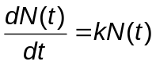
where N(t) denotes population at time t and k is a constant of proportionality, serves as a model for population growth and decay of insects, animals and human population at certain places and duration.
Solution of this equation is
N(t)=Ce^{kt}, where C is the constant of integration:
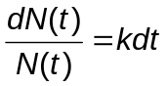
Integrating both sides we get
lnN(t)=kt+ln C
or 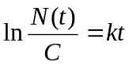
or N(t)=Ce^{kt}
C can be determined if N(t) is given at certain time.
Example 4.2: The population of a community is known to increase at a rate proportional to the number of people present at a time t. If the population has doubled in 6 years, how long it will take to triple?
Solution : Let N(t) denote the population at time t. Let N(0) denote the initial population (population at t=0).
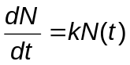
Solution is N(t)=Ae^{kt} , where A=N(0)
Ae^{6k}=N(6) =2N(0) = 2A
or e^{6k}=2 or k = 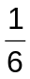ln 2
Find t when N(t)=3A=3N(0)
or N(0) e^{kt}=3N(0)
or 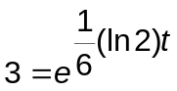
or ln 3= 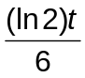
or t= 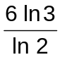∼9.6 years (approximately 9 years 6 months)
Example 4.3 Let population of country be decreasing at the rate proportional to its population. If the population has decreased to 25% in 10 years, how long will it take to be half?
Solution: This phenomenon can be modeled by 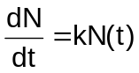
Its solution is
N(t)=N(0) e^{kt}, where
N(0) in the initial population
For t=10, N(10)=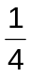N(0)
N(0) = N(0) e^{10k}
or e^{10k}=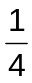
or k=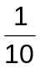ln
Set N(t)=N(0)
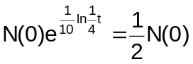
or t=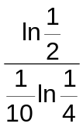 ∼ 8.3 years approximately.
Example 4.4 Let N(t) be the population at time t and Let N₀ denote the initial population, that is, N(0)=N₀.
Find the solution of the model
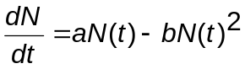
with initial condition
N(0)=N_{o}
Solution: This is a separable differential equation, and its solution is
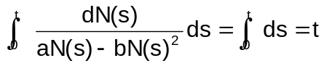
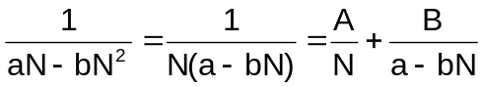
To find A and B, observe that
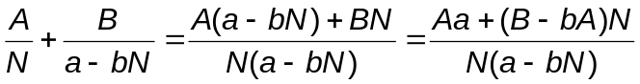
Therefore, Aa+(B-bA)N=1. Since this equation is true for all values of N, we see that Aa=1 and B-bA=0. Consequently, A=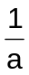, B=b/a, and
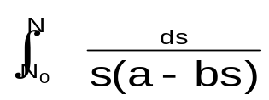 = 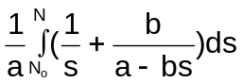
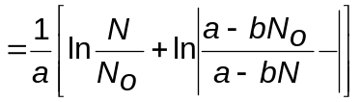
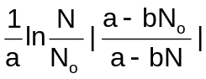
Thus
at = ln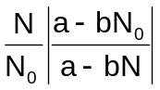
It can be verified that 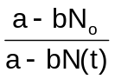 is always positive for 0<t<∞. Hence
at = ln 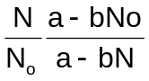
Taking exponentials of both sides of this equation gives
e^{at}=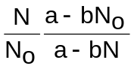
N₀(a-bN)e^{at} = (a-bN₀)N
Bringing all terms involving N to the left-hand side of this equation, we see that
[a-bN_{o} + bN₀e^{at}] N(t) = aN₀e^{at}
or N(t)=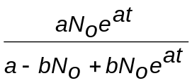
4.3 Radio-active Decay and Carbon Dating
As discussed in Section 1.4.2. a radioactive substance decomposes at a rate proportional to its mass. This rate is called the decay rate. If m(t) represents the mass of a substance at any time, then the decay rate 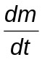is proportional to m(t). Let us recall that the half-life of a substance is the amount of time for it to decay to one-half of its initial mass.
Example 4.5. A radioactive isotope has an initial mass 200mg, which two years later is 50mg. Find the expression for the amount of the isotope remaining at any time. What is its half-life?
Solution: Let m be the mass of the isotope remaining after t years, and let -k be the constant of proportionality. Then the rate of decomposition is modeled by
= - km,
where minus sign indicates that the mass is decreasing. It is a separable equation. Separating the variables, integrating, and adding a constant in the form lnc, we get
lnm+lnc = - kt
Simplifying,
lnmc = - kt (4.3)
or mc = e^{-kt}
or m = c₁e^{-kt}, where c₁=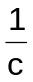
To find c₁, recall that m =200 when t=0. Putting these values of m and t in (4.3) we get
200 = c₁ e^{-ko} = c₁.1
or c₁=200
and m = 200e^{-kt} (4.4)
The value of k may now be determined from (4.4) by substituting t=2, m=150.
150 = 200 e^{-2k}
or 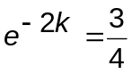
or –2k=ln 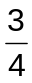
This gives
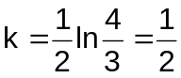(0.2877)= 0.1438 ≈ 0.14
The mass of the isotope remaining after t years is then given by
m(t) =200e ^{-.1438t}
The half-life t_{h} is the time corresponding to m=100mg.
Thus
100 = 200 e^{-0.14t}_{h}
or 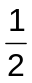= e^{-0.14t}_{h}
or t_{h}= - 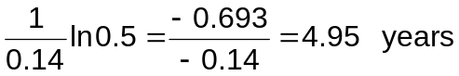
Carbon Dating: The key to the carbon dating of paintings and other materials such as fossils and rocks lies in the phenomenon of radioactivity discovered at the turn of the century. The physicist Rutherford and his colleagues showed that the atoms of certain radioactive elements are unstable and that within a given time period a fixed portion of the atoms spontaneously disintegrate to form atoms of a new element. Because radioactivity is a property of the atom, Rutherford showed that the radioactivity of a substance is directly proportional to the number of atoms of the substance present. Thus, if N(t) denotes the number of atoms present at time t, then 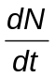, the number of atoms that disintegrate per unit time, is proportional to N; that is,
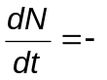λN (4.5)
The constant λ, which is positive, is known as the decay constant of the substance. The larger λ is, the faster the substance decays.
To compute the half life of substance in terms of λ, assume that at time t=t₀, N(t₀)=N₀. The solution of the initial value problem
λN
N(t₀) = N₀ (4.6)
is
N(t)=N₀e^{-λ(t-t}_{o})
or 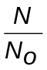e^{-λ(t-t}_{o})
Taking logarithms of both sides we obtain
-λ (t-t₀)=ln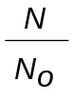 (4.7)
If = , then -λ (t-t₀)=ln , so that
t-t₀ = 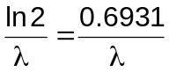
Thus the half life of a substance is ln2 divided by the decay constant λ.
The half-life of many substances have been determined and are well published. For example, half-life of carbon-14 is 5568 years, and the half-life of uranium 238 is 4.5 billion years.
Remark 4.3.1 a) In (4.5) λ is positive and is decay constant. We may write
equation (4.5) in the form
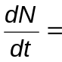λN, where λ is negative constant, that is, λ <0.
b) The dimension of λ is reciprocal time. It t is measured in years, then λ has the dimension of reciprocal years, and if t is measured in minutes, then λ has the dimension of reciprocal minutes.
c) From (4.7) we can solve for
t-t₀= 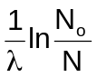 (4.8)
If t₀ is the time the substance was initially formed or manufactured, then the age of the substance is 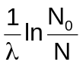. The decay constant λ is known or can be computed in most cases. N can be computed quite usually. Computation or pre-knowledge of N₀ will yield the age of the substance.
By the Libby’s discovery discussed in Section 1.4.2. the present rate R(t) of disintegration of the C-14 in the sample is given by R(t)= λN(t)= λN₀e^{-λt} and the original rate of disintegration is R(o)=λN₀. Thus
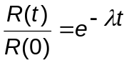 so that
t=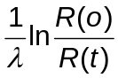 (4.9)
d) If we measure R(t), that present rate of disintegration of the C-14 in the charcoal and observe that R(o) must equal the rate of disintegration of the C-14 in the comparable amount of living wood then we can compute the age t of the charcoal.
e) The process of estimating the age of an artifact is called carbon dating.
Example 4.6 : Suppose that we have an artifact, say a piece of fossilized wood, and measurements show that the ratio of C-14 to carbon in the sample is 37% of the current ratio. Let us assume that the wood died at time 0, then compute the time T it would take for one gram of the radio active carbon to decay this amount.
Solution: By model (1.10)
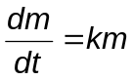
This is a separable differential equation. Write it in the form
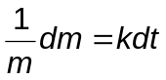
Integrate it to obtain
ln|m|=kt+c
Since mass is positive, lml=m and
ln(m)=kt+c.
Then
m(t) = e ^{kt+c}=Ae^{kt}, where A = e^{c} is positive constant. Let at some time, designated at time zero, there are M grams present. This is called the initial mass. Then
m(o) = A = M, so
m(t) = Me^{kt.}
If at some later time T we find that there are M_{T} grams, then
m(T) = M_{T} = Me^{kT}.
Then
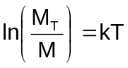
hence
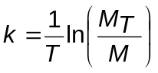
This gives us k and determines the mass at any time:
m(t) = 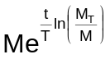
Let T=λ be the time at which half of the mass has radiated away, that is, half-life. At this time, half of the mass remains, so M_{T}=M/2 and M_{T}/M = .
Now the expression for mass becomes
m(t) = 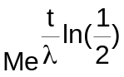
or m(t) = 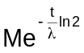
Half-life of C-14 is 5600 years approximately, that is,
λ = 5600
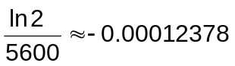
≈ means approximately equal (all decimal places are not listed).
Therefore
m(t)=Me ^{-0.00012378t}
or 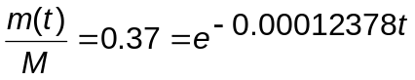
by the given condition that 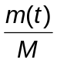 is .37 during t.
∴T= - 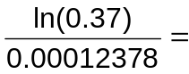 8031 years approximately.
Example 4.7 (a) A fossilized bone is found to contain one thousandth the original amount of C-14. Determine the age of fossil.
(b) Use the information provided in part (a) to determine the approximate age of a piece of wood found in an archaeological excavation at the site to date prehistoric paintings and drawing on the walls and ceilings of a cave in Lascaux, France, provided 85.5% of the C-14 had decayed.
Solution: a. The separable differential equation
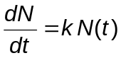, where k is the constant of proportionality of decay, models the phenomenon as discussed above.
The solution is
N(t) = N₀e^{kt} (say λ = -k, if we want to put in the form of the above discussion).
Half-life of C-14 is approximately 5600 years
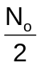= N(5600)
or 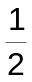 N₀ = N₀e^{5600k}. By cancelling N₀ and taking logarithm of both sides we get
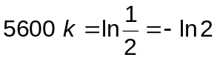
or k= -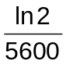 = -0.00012378
Therefore
N(t) = N₀ e^{-0.00012378t}
With N(t) =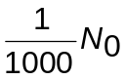 we have
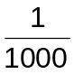N₀=N₀e^{-0.00012378t}
-0.00012378t = ln= - ln 1000. Thus
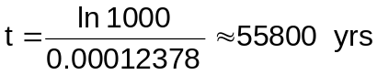
- Let N(t)= N₀e^{kt} where k= -0.00012378 by part (a).
85.5% of C-14 had decayed; that is,
N(t) = 0.145 N₀
or N₀e ^{- 0.00012378t} = 0.145 No
Taking logarithm of both sides and solving for t, we get
t≈15,600 years
4.4 Mixture of Two Salt Solutions
Example. 4.8 A tank contains 300 litres of fluid in which 20 grams of salt is dissolved. Brine containing 1 gm of salt per litre is then pumped into the tank at a rate of 4 L/min; the well-mixed solution is pumped out at the same rate. Find the number N(t) of grams of salt in the tank at time t.
Solution: By the data given in this example we have
P(t ) = N(t)
n=4, p=1, m=300
in the model (1.23)
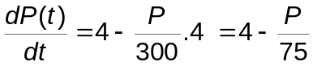
or 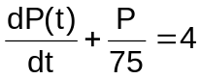
This is a linear differential of first order in P whose integrating factor is
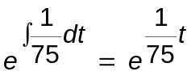 (See Section 2.3)
Solution is given by
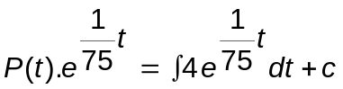
P(t) = 300 + c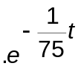

Since P(0) = 20 is given we get
20=P(0) = 300+Ce⁰, that is c= -280
Thus P(t) = 300 - 280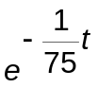
4.5 Series Circuits
Let a series circuit contain only a resistor and an inductor as shown in Figure 4.2

Figure 4.2 LR Series circuit

By Kirchhoff’s second law the sum of the voltage drop across the inductor 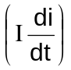 and the voltage drop across the resistor (iR) is the same as the impressed voltage (E(t)) on the circuit. Current at time t, i(t), is the solution of the differential equation.
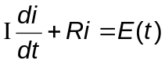 (4.10)
where Ι and R are constants known as the inductance and the resistance respectively.
The voltage drop across a capacitor with capacitance C is given by 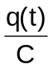, where q is the charge on the capacitor. Hence, for the series circuit shown in Figure 4.3 we get the following equation by applying Kirchhoff’s second law
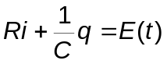 (4.11)

Figure 4.3 RC Series Circuit
Since 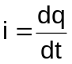, (4.11) can be written as
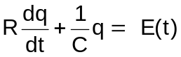 (4.12)
Example 4.9 Find the current in a series RL circuit in which the resistance, inductance, and voltage are constant. Assume that i(o)=0; that is initial current is zero.
Solution: It is modeled by (4.10)
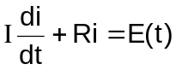
or 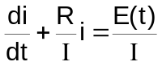 (4.13)
Since Ι, R and E are constant
(4.13) is linear equation of first-order in i with integrating factor
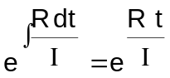
The solution of (4.13) is
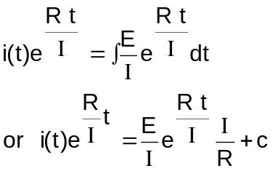
or i(t) = 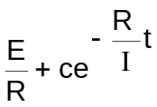 (4.14)
Since i(0) = 0, c = -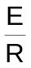
Putting this value of c in (4.14) we get
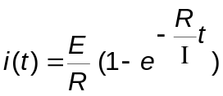
Example 4.10 A 100-volt electromotive force is applied to an RC series circuit in which the resistance is 200 ohms and the capacitance is 10⁻⁴ farads. Find the charge q(t) on the capacitor if q (0)=0. Find the current i(t).
Solution: The phenomenon is modeled by (4.12):
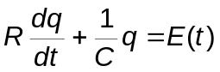 , where
R=200, C=10⁻⁴, E(t) = 100
Thus
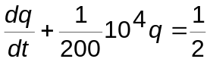 (4.15)
This is a linear differential equation of first-order
The integrating factor is 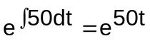
and so the solution of (4.15) is
q(t)e^{50t}=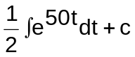
or q(t)=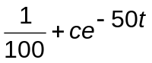
q(0)=0=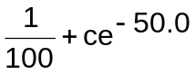
or 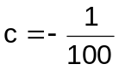 and so
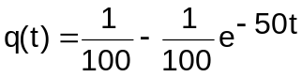
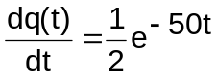
But 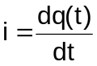 and so
i=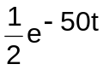
4.6 Survivability with AIDS
Equation (1.31) provides survival fraction S(t). It is a separable equation and its solution is
S(t) =S_{i}+(1-S_{i})e^{-kt}:
Given equation is
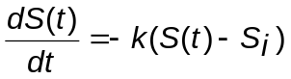
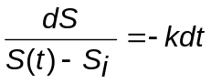
Integrating both sides, we get
ln|S(t)-S_{i}|=-kt+lnc
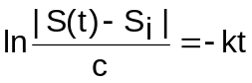
or 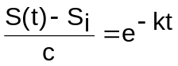
S(t)=S_{i}+ce^{-kt}
Let S(0)=1 then c=1-Si. Therefore
S(t) =S_{i} +(1-S_{i})e^{-kt}
We can rewrite this equation in the equivalent form.
S(t)=S_{i}+(1-S_{i})e^{-t/T}
where, in analogy to radioactive nuclear decay,
T is the time required for half of the mortal part of the cohort to die-that is, the survival half life.
Example 4.11 Consider the initial-value problem
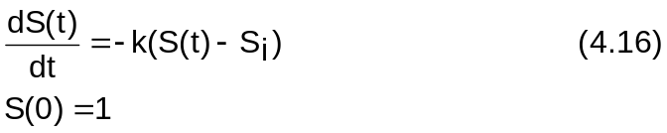
as the survivability with AIDS.
- Show that, in general, the half-life T for the mortal part of the cohort to die is 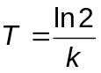
- (b) Show that the solution of the initial value problem can be written as
S(t)=S_{i}+(1-S_{i})2^{-t/T} (4.17)
Solution: The solution of the separable differential equation in (4.16) is
S(t) = (1-S_{i})e^{-kt}+S_{i} (4.18)
Let S(t) =S(0), and solving for t we obtain the half=life T =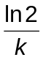
(b) Putting 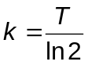 in (4.18) we obtain
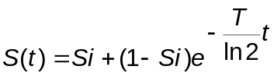
4.7 Draining a Tank
In Section 1.4.8 modeling of draining a tank is discussed. Equation (1.26) models the rate at which the water level is dropping.
Example 4.12 A tank in the form of a right-circular cylinder standing on end is leaking water through a circular hole in its bottom. Find the height h of water in the tank at any time t if the initial height of the water is H.
Solution: As discussed in Section 1.4.8, h(t) is the solution of the equation (1.26); that is,
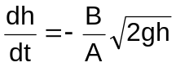 (4.19)
where A is the cross section area of the cylinder and B is the cross sectional area of the orifice at the base of the container.
(4.19) can be written as
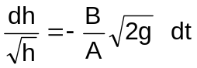
or 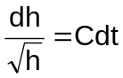 where
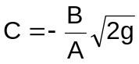
By integrating this equation we get
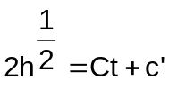
For t=0 h=H and so
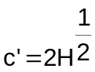 Therefore
h(t) =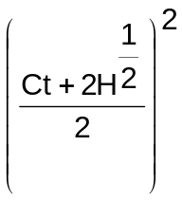
4.8 Economics and Finance
We have presented models of supply, demand and compounding interest in Section 1.4.3. We solve those models, namely equations (1.11) and (1.16).
(1.11), that is equation
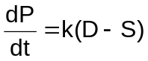 is a separable differential equation of first-order. We can write it as
dP=k(D-S) dt.
Integrating both sides, we get
P(t)=k(D-S)t+A
where A is a constant of integration.
Solution of (1.16), which is also a separable equation, is
S(t)=S(0) e^{rt} (4.20)
where S(0) is the initial money in the account
Example 4.13 Find solution of the model of Example 1.21 with no initial demand (D(0)=0).
Solution: The model is
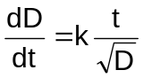
This can be written as
D^{1/2}dD=k tdt
Integrating both sides we get
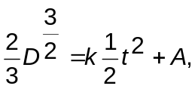
where A is a constant integration. If Demand D=0 at the initial time t=0, then A=0 and demand D(t) at any time t is given by
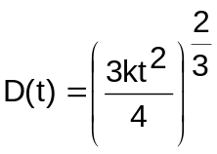
4.9 Mathematics Police Women
The time of death of a murdered person can be determined with the help of modeling through differential equation. A police personnel discovers the body of a dead person presumably murdered and the problem is to estimate the time of death. The body is located in a room that is kept at a constant 70 degree F. For some time after the death, the body will radiate heat into the cooler room, causing the body’s temperature to decrease assuming that the victim’s temperature was normal 98.6F at the time of death. Forensic expert will try to estimate this time from body’s current temperature and calculating how long it would have had to lose heat to reach this point.
According to Newton’s law of cooling, the body will radiate heat energy into the room at a rate proportional to the difference in temperature between the body and the room. If T(t) is the body temperature at time t, then for some constant of proportionality k,
T'(t)=k[T(t)-70]
This is a separable differential equation and is written as
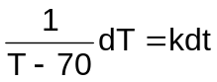
Upon integrating both sides, one gets
ln|T-70|=kt+c
Taking exponential, one gets
|T-70|=e^{kt+C}=Ae^{kt}
where A = e^{C}. Then
T-70= ± Ae^{kt}= Be^{kt}
Then
T(t)=70 + Be^{kt}
Constants k and B can be determined provided the following information is available: Time of arrival of the police personnel, the temperature of the body just after his arrival, temperature of the body after certain interval of time.
Let the officer arrived at 10.40 p.m. and the body temperature was 94.4 degrees. This means that if the officer considers 10:40 p.m. as t=0 then
T(0)=94.4=70+B and so
B=24.4 giving
T(t)=70 + 24.4 e^{kt.}
Let the officer makes another measurement of the temperature say after 90 minutes, that is, at 12.10 a.m. and temperature was 89 degrees. This means that
T(90)=89=70+24.4 e^{90k}
Then
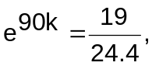
so
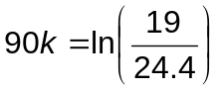
and
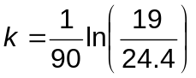
The officer has now temperature function
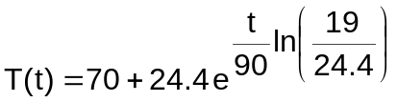
In order to find when the last time the body was 98.6 (presumably the time of death), one has to solve for time the equation
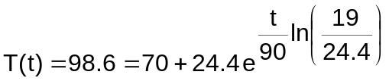
To do this, the officer writes
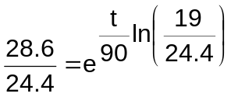
and takes logarithms of both sides to obtain
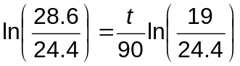
Therefore, the time of death, according to this mathematical model, was
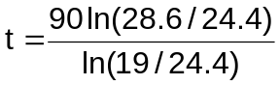 which is approximately –57.0.7 minutes.
The death occurred approximately 57.07 minutes before the first measurement at 10.40 p.m. , that is at 9.43 p.m. approximately
4.10 Drug Distribution (Concentration) in Human Body
To combat the infection to human a body appropriate dose of medicine is essential. Because the amount of the drug in the human body decreases with time medicine must be given in multiple doses. The rate at which the level y of the drug in a patient’s blood decays can be modeled by the decay equation
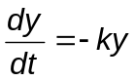
where k is a constant to be experimentally determined for each drug. If initially, that is, at t=0 a patient is given an initial dose y_{p}, then the drug level y at any time t is the solution of the above differential equations, that is,
y(t)=y_{p} e^{-kt}
Remark: 4.10.1. In this model it is assumed that the ingested drug is absorbed immediately which is not usually the case. However, the time of absorption is small compared with the time between doses.
Example 4.14: A representative of a pharmaceutical company recommends that a new drug of his company be given every T hours in doses of quantity y₀, for an extended period of time. Find the steady state drug in the patient’s body.
Solution: Since the initial dose is y₀, the drug concentration at any time t ≥o is found by the equation y=y₀e^{-kt}, the solution of the equation
At t=T the second dose of y₀ is taken, which increases the drug level to
y(T)=y₀+y₀ e^{-kT} = y₀(1+e^{-kT})
The drug level immediately begins to decay. To find its mathematical expression we solve the initial-value problem:
y(T)=y₀(1+e^{-kT})
Solving this initial value problem we get
y=y₀(1+e^{-kT})e^{-k(t-T)}
This equation gives the drug level for t>T. The third dose of y₀ is to be taken at t=2T and the drug just before this dose is taken is given by
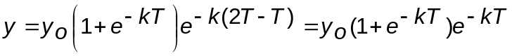
The dosage y₀ taken at t=2T raises the drug level to
y(2T) = y₀ + y₀(1+e^{-kT})e^{-kT} = y₀(1+e^{-kT}+e^{-2kt})
Continuing in this way, we find after (n+1)th dose is taken that the drug level is
y(nT)=y₀(1+e^{-kT}+e^{-2kT}+…..+e^{-nkT})
We notice that the drug level after (n+1)^{th} dose is the sum of the first n terms of a geometric series, with first term as y_{o} and the common ratio e^{-kT}. This sum can be written as
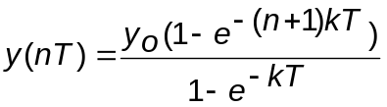
As n becomes large, the drug level approaches a steady state value, say y_{s} given by
y_{s} = lim y(nT)
n→∞

=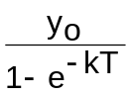
The steady state value y_{s} is called the saturation level of the drug.
4.11 A Pursuit Problem

Figure 4.4
A dog chasing a rabbit is shown in Figure 4.4. The rabbit starts at the position (0,0) and runs at a constant speed v_{R} along the y-axis. The dog starts chase at the position (1.0) and runs at a constant speed v_{D} so that its line of sight is always directed at the rabbit. If v_{D}>v_{R}, the dog will catch the rabbit; otherwise the rabbit gets away. Finding the function representing the pursuit curve gives the path the dog follows. Since the dog always runs directly at the rabbit during the pursuit, the slope of the line of sight between the dog and the rabbit at any time t is given by
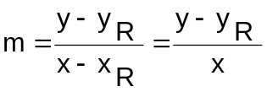
If we assume that the line of sight is tangent to the pursuit curve y=f(x), then m= 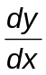 and therefore 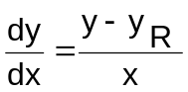 (4.21)
is the mathematical model of the “Pursuit Problem”. The solution of (4.21) will give the path taken by the dog.
The position of the dog at any time t>0 is (x,y), and the y coordinate of the rabbit at the corresponding time is y_{R}=0+v_{R}t =v_{R}t, so
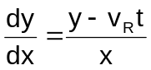
or 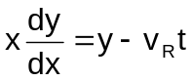
Implicitly differentiating this expression with respect to x yields
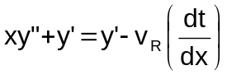
where 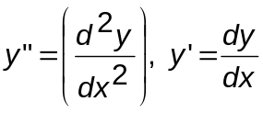
This may be written as
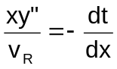 (4.22)
Finally, we note that the speed of the dog can be written as
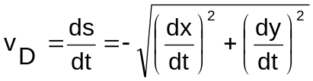
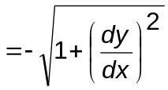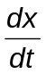
Solving this for 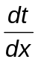, we have
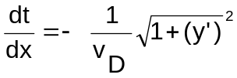
Substituting this result into Equation (4.22) yields
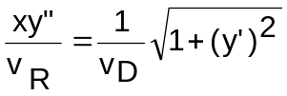
Put y'=w, then this equation takes the form
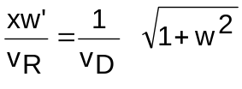
or 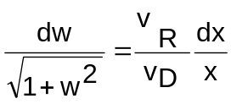
Integrating both sides we get w and by integrating w we get y. The constant of integration can be found by using the initial conditions y(1)=0 and y' (1)=0.
4.12 Harvesting of Renewable Natural Resources
There are many renewable natural resources that humans desire to use. Examples are fishes in rivers and sea and trees from our forests. It is desirable that a policy be developed that will allow a maximal harvest of a renewable natural resource and yet not deplete that resource below a sustainable level. We introduce a mathematical model providing some insights into the management of renewable resources.
Let P(t) denote the size of a population at time t, the model for exponential growth begins with the assumption that 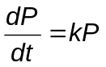 for some k>0. In this model the relative or specific, growth rate defined by
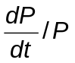
is assumed to be a constant.
In many cases 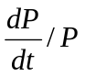 is not constant but a function of P, let
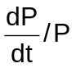 = f(P)
or 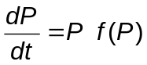
Suppose an environment is capable of sustaining no more than a fixed number K of individuals in its population. The quantity is called the carrying capacity of the environment.
Special cases: (i) f (P)=c₁P +c₂
(ii) If f(0)=r and f(K)=0 then
c₂=r and c₁= -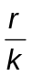, and so (i) takes the form
f (P) = r-()P.
Simple Renewable natural resources model is
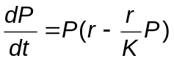
This equation can also be written as
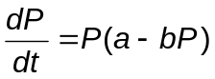
Example 4.15: Find the solution of the following harvesting model
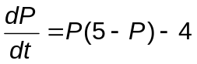
P(o)=P_{o}
Solution: 4.15 The differential equation can be written as
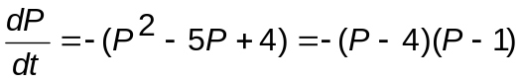
or 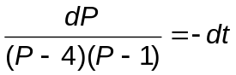
or 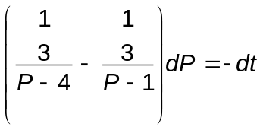
Integrating we get
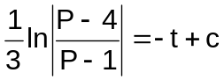
or 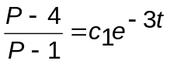
Setting t=0 and P=P₀ we find c₁=(P_{o}-4)/(P_{o}-1).
Solving for P we get
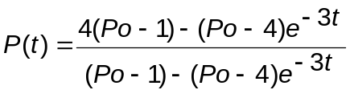
  - Exercises

Newton’s Law of Cooling/Warming
- A thermometer reading 100⁰ F is placed in a pan of oil maintained at 10⁰ F. What is the temperature of the thermometer when t=20 sec, if its temperature is 60⁰ F when t = 8 sec?
- A thermometer is removed from a room where the air temperature is 60⁰ F and is taken outside, where the temperature is 10⁰ F. After 1 minute the thermometer reads 50⁰ F. What is the reading of the thermometer at t=2 minutes? How long will it take for the thermometer to reach 20⁰ F .
- Water is heated to a boiling point temperature 120⁰C. It is then removed from the burner and kept in a room of 30⁰C temperature. Assuming that there is no change in the temperature of the room and the temperature of the hot water is 110ºC after 3 minutes. (a) Find the temperature of water after 6 minutes (b) Find the duration in which water will cool down to the room temperature?

Population Growth and decay
- A culture initially has P_{o} number of bacteria. At t=1 hour, the number of bacteria is measured to be 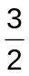 P₀. If the rate of growth is proportional to the number of bacteria P(t) present at time t, determine the time necessary for the number of bacteria to triple.
- Solve the logistic differential equation:
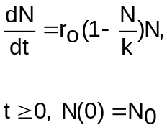
- Insects in a tank increase at a rate proportional to the number present. If the number increases from 50,000 to 100,000 in one hour, how many insects are present at the end of two hours.
- It was estimated that the earth’s human population in 1961 was 3,060,000,000. Assuming the population increases at the rate of 2 percent, find the earth’s population in 1996 using model of population growth (1.8). Check this number with the actual population of the earth available from authentic sources.
Radio-Active Decay and Carbon Dating
- A breeder reactor converts relatively stable uranium 238 into the isotope plutonium 239. After 30 years it is determined that 0.022% of the initial amount N₀ of plutonium has disintegrated. Find the half-life of this isotope if the rate of disintegration in proportional to the amount remaining.
- The radioactive isotope of lead, Pb-209, decays at a rate proportional to the amount present at time t and has a half-life of 4 hours. If 1 gram of lead is present initially, how long will it take for 80% of the lead to decay?
- Solve the model obtained in Exercise 32 of chapter 1.
- In the 1950 excavation at Nippur, a city of Babylonia, charcoal from a roof beam gave a count of 4.09 dis/min/g. Living wood gave 6.68 disintegrations. Assuming that this charcoal was formed during the time of Hammurabi’s reign, find an estimate for the likely time of Hammurabi’s succession.

Mixture of Two Salt Solutions
- A tank with a capacity of 600 litres initially contains 200 litres of pure water. A salt solution containing 3 Kg of salt per litre is allowed to run into the tank at a rate of 16 lit/min, and the mixture is then removed at a rate of 12 lit/min. Find the expression for the number of Kilograms of salt in the tank at any time t.
- A large tank is filled with 600 liters of pure water. Brine containing 2 Kg of salt per litre is pumped into the tank at a rate of 5 litre/min. The well-mixed solution is pumped out at the same rate. Find the number P(t) of kilograms of salt in the tank at time t. What is the concentration of the solution in the tank at t=10 min?
- A 250-litre tank contains 100 litres of pure water. Brine containing 4 kg of salt per litre flows into the tank at 5 lit/hr. If the well-stirred mixture flows out at 3 lit/hr, find the concentration of salt in the tank at the instant it is filled to the top.
Series circuit
- A series RL circuit has a resistance 20 ohms, and an inductance of 1 henry, and an impressed voltage of 12 volts. Find the current i(t) if the initial current is zero.
- An electromotive force
120, 0 ≤ t ≤ 20
E(t)=
0 , t > 20

is applied to an LR series circuit in which the inductance is 20 henries and the resistance is 2 ohms. Find the current i(t) if i(0)=0

Survivability with AIDS
- Find survival fraction S(t) with aids after 2 years by applying model (1.31).

Draining a Tank
- A tank in the form of a right-circular cylinder standing on end is leaking water through a circular hole in its bottom. Let us assume that the height of the tank is 10 ft. high and has radius 2 ft. and circular hole has radius ½ inches. If the tank is initially full, how long it will take to empty?
Economics and Finance
- What rate of interest payable annually is equivalent to 6% continuously compounded?
- Suppose a person deposits 10,000 Indian rupees in a bank account at the rate of 5% per annum compounded continuously. How much money will be in his bank account 18 months later? How much he has in the account if the interest were compounded monthly.
Drug distribution(Concentration) in Human Body
- A drug with k=0.01 is administered every 12 hours in doses of 4 mg. Calculate the amount of the drug in the patient’s body after the 4th dose is taken.
- A drug with k=0 .030 is to be administered in doses of y₀=4mg, gradually building upto a saturation level in the patient of y_{s}=20mg. Calculate the dosage time interval. Assume that the time interval is in hours.

Pursuit Problem
- Complete the solution of the pursuit problem.
- Solve the pursuit problem if ν_{R}=3 and ν_{D}=2. Draw the path pursued by the dog.

Harvesting of Renewable Natural Resources
25(a) Solve the initial value problem
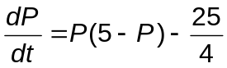
P(0)=P₀
- (b) Find when the population becomes extinct in the case 0< P₀<5/2

