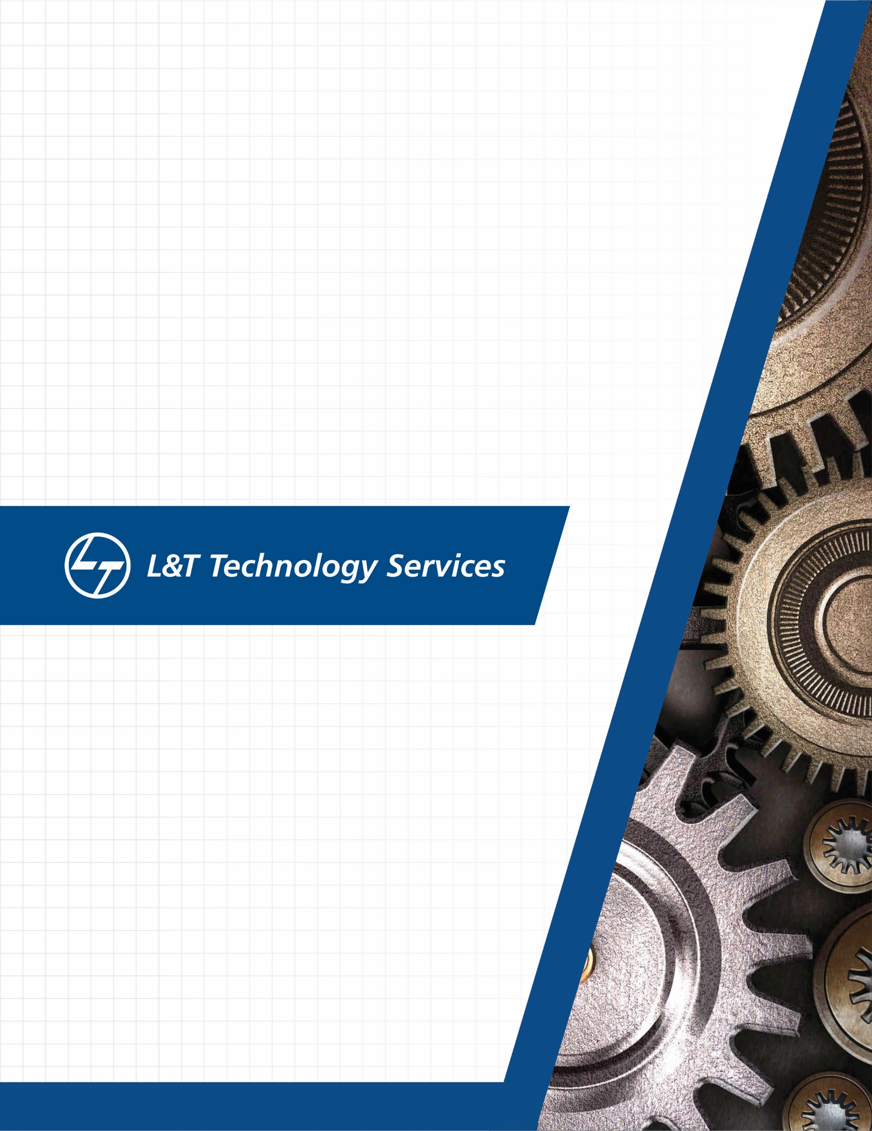
./
Networking - L2, L3 (OSI layer and Stack), Packet Flows, Debugging the packets


Ver. Rel. No. | Release Date | Prepared. By | Reviewed By | To be approved By | Remarks/Revision Details
1 |  | Name/PS No | Name/PS No | Module Owner Name | Comments
2
3
Document History

Table of Contents
Table of Figures 3
Table of Tables 4
ACTIVITY 1: SYSTEM/ SOFTWARE DEVELOPMENT 4
INTRODUCTION 4
MY PRODUCT: “Name ” 6
SWOT ANALYSIS 7
REQUIREMENTS 7
DESIGN 8
HIGH LEVEL DESIGN 8
LOW LEVEL DESIGN 11
TEST PLANS 13
REFERENCES 15
ACTIVITY 2: AGILE METHODOLOGY 15
THEME 15
EPIC 15
USER STORY 16
REFERENCES 17
APPENDIX: 17

Table of Figures
Figure 1 CLASS DIAGRAM(HIGH LEVEL) 10
Figure 2 USE CASE DIAGRAM (HIGH LEVEL) 11
Figure 3 ACTIVITY DIAGRAM (HIGH LEVEL) 12
Figure 4 USE CASE DIAGRAM (LOW LEVEL) 12
Figure 5 ACTVITY DIAGRAM (LOW LEVEL) 13
Figure 6 BLOCK DIAGRAM 13
Figure 7 COMPONENT DIAGRAM (HIGH LEVEL) 22
Figure 8 ACTIVITY DIAGRAM (high level) 23
Figure 9 ACTIVITY DIAGRAM (LOW LEVEL) 24
Figure 10- ACTIVITY DIAGRAM (LOW LEVEL) 24
Figure 11 TEST PLAN 25
Figure 12 GIT 27
Figure 13 GIT ISSUES 28
Figure 14 GIT COMMITS 1 28
Figure 15 GIT COMMIT 2 29
Figure 16 GIT 30
Figure 17 GIT MAKE 31
Figure 18 GIT MAKE 2 31
Figure 19 GIT BUILD 32
Figure 20 GIT CODE QUALITY 32

Table of Tables
Table 1 AGING 6
Table 2 GRADING COST 6
Table 3 REQUIREMENTS 8
Table 4 HIGH LEVEL TEST PLAN 15
Table 5 LOW LEVEL TEST PLAN 16
Table 6 USER STORIES 17
Table 7 AGING 19
Table 8 GRADING COST 19
Table 9 REQUIREMENTS 21
Table 10 USER STORIES 27

Transmission Modes

Transmission mode defines the direction of the flow of information between two communication devices. It is also called Data Communication or Directional Mode. It specifies the direction of the flow of information from one place to another in a computer network.
In the Open System Interconnection(OSI) Layer Model, the Physical Layer is dedicated to data transmission in the network. It mainly decides the direction of data in which the data needs to travel to reach the receiver system or node.

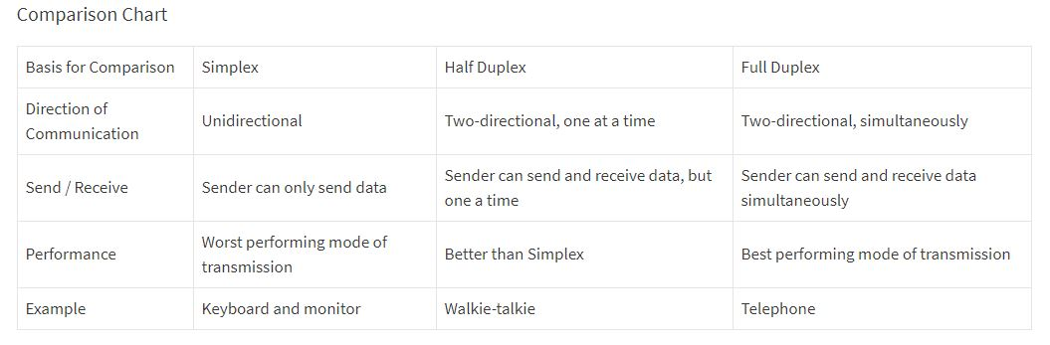

What are network devices?
Network devices, or networking hardware, are physical devices that are required for communication and interaction between hardware on a computer network.

Types of network devices -
- Hub
- Switch
- Router
- Bridge
- Gateway
- Modem
- Repeater
- Access Point

HUB -
Hubs are networking devices operating at a physical layer of the Open Systems Interconnection (OSI) model that are used to connect multiple devices in a network. They are generally used to connect computers in a LAN. A hub has numerous ports. A computer which intends to be connected to the network is plugged in to one of these ports. When a data frame arrives at a port, it is broadcast to every other port, without considering whether it is destined for a particular destination device or not. Also, they do not have the intelligence to find out best path for data packets which leads to inefficiencies and wastage.
Hubs do not perform packet filtering or addressing functions; they just send data packets to all connected devices. Collision domain of all hosts connected through hub remains one. A hub can be used with both digital and analog data, provided its settings have been configured to prepare for the formatting of the incoming data. For example, if the incoming data is in digital format, the hub must pass it on as packets; however, if the incoming data is analog, then the hub passes it on in signal form. Transmission mode is half duplex. They generally have fewer ports of 4/12.

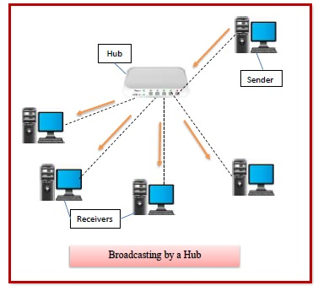

Types of Hubs –
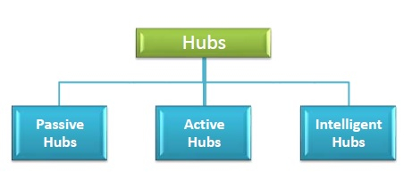

- Passive Hubs − Passive hubs connects nodes in a star configuration by collecting wiring from nodes. They broadcast signals onto the network without amplifying or regenerating them. As they cannot extend the distance between nodes, they limit the size of the LAN. The passive hubs are the connection point for wires that helps to make the physical network. It is capable of determining the bugs and faulty hardware. Simply, it accepts the packet over a port and circulates it to all ports. It includes connectors (10base-2 port and RJ-45) that can be applied as a standard in your network. This connector is connected to all local area network (LAN) devices.
- Active Hubs − Active hubs amplify and regenerate the incoming electrical signals before broadcasting them. They have their own power supply and serves both as a repeater as well as connecting centre. Due to their regenerating capabilities, they can extend the maximum distance between nodes, thus increasing the size of LAN. It is able to monitor the data sent to the connected devices. It plays an important role between the connected devices with the help of store technology, where it checks the data to be sent and decides which packet to send first.
- Intelligent Hubs − Intelligent hubs are active hubs that provide additional network management facilities. They can perform a variety of functions of more intelligent network devices like network management, switching, providing flexible data rates etc. These hubs have some kinds of management software that help to analyze the problem in the network and resolve them. It is beneficial to expend the business in networking; the management can assign users that help to work more quickly and share a common pool efficiently by using intelligent hubs. However, it offers better performance for the local area network. Furthermore, with any physical device, if any problem is detected, it is able to detect this problem easily.
SWITCH -
A switch is a data link layer networking device which connects devices in a network and uses packet switching to send and receive data over the network. A switch has many ports, to which computers are plugged in. When a data frame arrives at any port of a network switch, it examines the destination address, performs necessary checks and sends the frame to the corresponding device(s).It supports unicast, multicast as well as broadcast communications.A switch is a multiport bridge with a buffer and a design that can boost its efficiency (a large number of ports imply less traffic) and performance. The switch can perform error checking before forwarding data, that makes it very efficient as it does not forward packets that have errors and forward good packets selectively to correct port only. Switch divides collision domain of hosts, but broadcast domain remains same.
Using switches improves network efficiency over hubs or routers because of the virtual circuit capability. Switches also improve network security because the virtual circuits are more difficult to examine with network monitors. You can think of a switch as a device that has some of the best capabilities of routers and hubs combined. A switch can work at either the Data Link layer or the Network layer of the OSI model. A multilayer switch is one that can operate at both layers, which means that it can operate as both a switch and a router. A multilayer switch is a high-performance device that supports the same routing protocols as routers. Switches can be subject to distributed denial of service (DDoS) attacks; flood guards are used to prevent malicious traffic from bringing the switch to a halt. Switch port security is important so be sure to secure switches: Disable all unused ports and use DHCP snooping, ARP inspection and MAC address filtering.
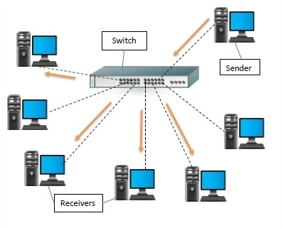
Types of Switches –

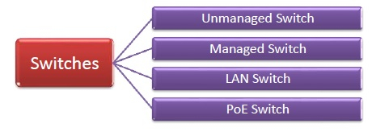
- Unmanaged Switch − These are inexpensive switches commonly used in home networks and small businesses. They can be set up by simply plugging in to the network, after which they instantly start operating. When more devices needs to be added, more switches are simply added by this plug and play method. They are referred to as u managed since they do not require to be configured or monitored.
- Managed Switch − These are costly switches that are used in organisations with large and complex networks, since they can be customized to augment the functionalities of a standard switch. The augmented features may be QoS (Quality of Service) like higher security levels, better precision control and complete network management. Despite their cost, they are preferred in growing organizations due to their scalability and flexibility. Simple Network Management Protocol (SNMP) is used for configuring managed switches.

- LAN Switch − Local Area Network (LAN) switches connects devices in the internal LAN of an organization. They are also referred as Ethernet switches or data switches. These switches are particularly helpful in reducing network congestion or bottlenecks. They allocate bandwidth in a manner so that there is no overlapping of data packets in a network.
- PoE Switch − Power over Ethernet (PoE) switches are used in PoE Gogabit Ethernets. PoE technology combine data and power transmission over the same cable so that devices connected to it can receive both electricity as well as data over the same line. PoE switches offer greater flexibility and simplifies the cabling connections.

ROUTER -
Routers are networking devices operating at network layer of the OSI model. They are responsible for receiving, analyzing, and forwarding data packets among the connected computer networks. When a data packet arrives, the router inspects the destination address, consults its routing tables to decide the optimal route and then transfers the packet along this route.
Routers help transmit packets to their destinations by charting a path through the sea of interconnected networking devices using different network topologies. Routers are intelligent devices, and they store information about the networks they’re connected to. Most routers can be configured to operate as packet-filtering firewalls and use access control lists (ACLs). Routers, in conjunction with a channel service unit/data service unit (CSU/DSU), are also used to translate from LAN framing to WAN framing. This is needed because LANs and WANs use different network protocols. Such routers are known as border routers. They serve as the outside connection of a LAN to a WAN, and they operate at the border of your network.Routers usually communicate routing and other information using one of three standard protocols: Routing Information Protocol (RIP), Border Gateway Protocol (BGP) or Open Shortest Path First (OSPF).
Routers are your first line of defense, and they must be configured to pass only traffic that is authorized by network administrators. The routes themselves can be configured as static or dynamic. If they are static, they can only be configured manually and stay that way until changed. If they are dynamic, they learn of other routers around them and use information about those routers to build their routing tables.
Routers are general-purpose devices that interconnect two or more heterogeneous networks. They are usually dedicated to special-purpose computers, with separate input and output network interfaces for each connected network. Because routers and gateways are the backbone of large computer networks like the internet, they have special features that give them the flexibility and the ability to cope with varying network addressing schemes and frame sizes through segmentation of big packets into smaller sizes that fit the new network components. Each router interface has its own Address Resolution Protocol (ARP) module, its own LAN address (network card address) and its own Internet Protocol (IP) address. The router, with the help of a routing table, has knowledge of routes a packet could take from its source to its destination. The routing table, like in the bridge and switch, grows dynamically. Upon receipt of a packet, the router removes the packet headers and trailers and analyzes the IP header by determining the source and destination addresses and data type, and noting the arrival time. It also updates the router table with new addresses not already in the table. The IP header and arrival time information is entered in the routing table. Routers normally work at the Network layer of the OSI model.
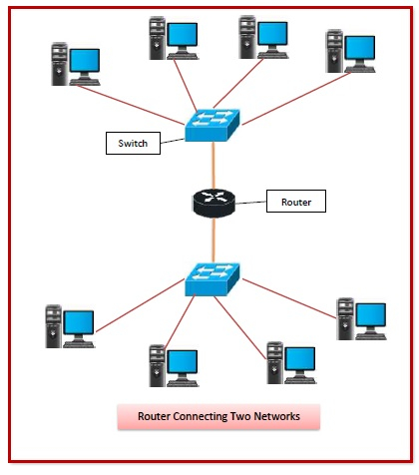

Routing Table -
The functioning of a router depends largely upon the routing table stored in it. The routing table stores the available routes for all destinations. The router consults the routing table to determine the optimal route through which the data packets can be sent.
A routing table typically contains the following entities −
- IP addresses and subnet mask of the nodes in the network
- IP addresses of the routers in the network
- Interface information among the network devices and channels
Routing tables are of two types −
- Static Routing Table − Here, the routes are fed manually and are not refreshed automatically. It is suitable for small networks containing 2-3 routers.
- Dynamic Routing Table − Here, the router communicates with other routers using routing protocols to determine the available routes. It is suited for larger networks having large number of routers.

Types of Routers –

- Wireless Router − They provide WiFi connection WiFi devices like laptops, smartphones etc. They can also provide standard Ethernet routing. For indoor connections, the range is 150 feet while its 300 feet for outdoor connections.
- Broadband Routers − They are used to connect to the Internet through telephone and to use voice over Internet Protocol (VoIP) technology for providing high-speed Internet access. They are configured and provided by the Internet Service Provider (ISP).
- Core Routers − They can route data packets within a given network, but cannot route the packets between the networks. They helps to link all devices within a network thus forming the backbone of network. It is used by ISP and communication interfaces.
- Edge Routers − They are low-capacity routers placed at the periphery of the networks. They connect the internal network to the external networks, and are suitable for transferring data packets across networks. They use Border Gateway Protocol (BGP) for connectivity. There are two types of edge routers, subscriber edge routers and label edge routers.
- Brouters − Brouters are specialised routers that can provide the functionalities of bridges as well. Like a bridge, brouters help to transfer data between networks. And like a router, they route the data within the devices of a network.

Bridge -
Bridges are used to connect two or more hosts or network segments together. The basic role of bridges in network architecture is storing and forwarding frames between the different segments that the bridge connects. They use hardware Media Access Control (MAC) addresses for transferring frames. By looking at the MAC address of the devices connected to each segment, bridges can forward the data or block it from crossing. Bridges can also be used to connect two physical LANs into a larger logical LAN. Bridges work only at the Physical and Data Link layers of the OSI model. Bridges are used to divide larger networks into smaller sections by sitting between two physical network segments and managing the flow of data between the two.
Bridges are like hubs in many respects, including the fact that they connect LAN components with identical protocols. However, bridges filter incoming data packets, known as frames, for addresses before they are forwarded. As it filters the data packets, the bridge makes no modifications to the format or content of the incoming data. The bridge filters and forwards frames on the network with the help of a dynamic bridge table. The bridge table, which is initially empty, maintains the LAN addresses for each computer in the LAN and the addresses of each bridge interface that connects the LAN to other LANs. Bridges, like hubs, can be either simple or multiple port. Bridges have mostly fallen out of favor in recent years and have been replaced by switches, which offer more functionality. In fact, switches are sometimes referred to as “multiport bridges” because of how they operate.
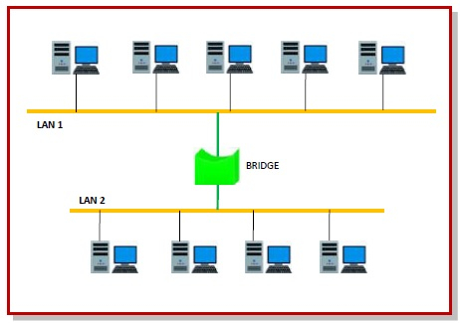
Types of Bridges -
  - Transparent Bridge
As the name suggests, it is an invisible bridge in the computer network. The main function of this bridge is to block or forward the data depending on the MAC address. The other devices within the network are unaware of the existence of bridges. These types of bridges are most popular and operate in a transparent way to the entire networks which are connected to hosts.
This bridge saves the addresses of MAC within a table that is similar to a routing table. This estimates the information when a packet is routed to its position. So it can also merge several bridges to check incoming traffic in a better way. These bridges are implemented mainly in Ethernet networks.
  - Translational Bridge
A translational bridge plays a key role in changing a networking system from one type to another. These bridges are used to connect two different networks like token ring & Ethernet. This bridge can add or remove the data based on the traveling direction, and forward the frames of the data link layer in between LANs which uses various types of network protocols. The different network connections are Ethernet to FDDI/token ring otherwise Ethernet on UTP (unshielded twisted pair) to coax & in between FOC and copper wiring.
  - Source-route Bridge
Source-route Bridge is one type of technique used for Token Ring networks and it is designed by IBM. In this bridge, the total frame route is embedded in one frame. So that it allows the bridge to make precise decisions of how the frame is forwarding using the network. By using this method, two similar network segments are connected to the data link layer. It can be done in a distributed way wherever end-stations join within the bridging algorithm.

Gateway –
A gateway is a network node that forms a passage between two networks operating with different transmission protocols. The most common type of gateways, the network gateway operates at network layer of the OSI model. However, depending upon the functionality, a gateway can operate at any of the seven layers of OSI model. It acts as the entry – exit point for a network since all traffic that flows across the networks should pass through the gateway. Only the internal traffic between the nodes of a LAN does not pass through the gateway.
Gateways normally work at the Transport and Session layers of the OSI model. At the Transport layer and above, there are numerous protocols and standards from different vendors; gateways are used to deal with them. Gateways provide translation between networking technologies such as Open System Interconnection (OSI) and Transmission Control Protocol/Internet Protocol (TCP/IP). Because of this, gateways connect two or more autonomous networks, each with its own routing algorithms, protocols, topology, domain name service, and network administration procedures and policies. Gateways perform all of the functions of routers and more. In fact, a router with added translation functionality is a gateway. The function that does the translation between different network technologies is called a protocol converter.
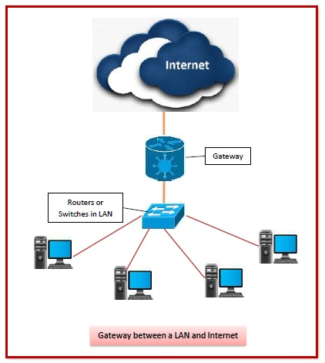

Types of Gateways -
On basis of direction of data flow, gateways are broadly divided into two categories −
- Unidirectional Gateways − They allow data to flow in only one direction. Changes made in the source node are replicated in the destination node, but not vice versa. They can be used as archiving tools.
- Bidirectional Gateways − They allow data to flow in both directions. They can be used as synchronization tools.
On basis of functionalities, there can be a variety of gateways, the prominent among them are as follows −
- Network Gateway − This is the most common type of gateway that provides as interface between two dissimilar networks operating with different protocols. Whenever the term gateway is mentioned without specifying the type, it indicates a network gateway.
- Cloud Storage Gateway − It is a network node or server that translates storage requests with different cloud storage service API calls, such as SOAP (Simple Object Access Protocol) or REST (REpresentational State Transfer).It facilitates integration of private cloud storage into applications without necessitating transfer of the applications into any public cloud, thus simplifying data communication.
- Internet-To-Orbit Gateway (I2O) − It connects devices on the Internet to satellites and spacecraft orbiting the earth. Two prominent I2O gateways are Project HERMES and Global Educational Network for Satellite Operations (GENSO).
- IoT Gateway − IoT gateways assimilates sensor data from IoT (Internet of Things) devices in the field and translates between sensor protocols before sending it to the cloud network. They connect IoT devices, cloud network and user applications.
- VoiP Trunk Gateway − It facilitates data transmission between plain old telephone service (POTS) devices like landline phones and fax machines, with VoIP (voice over Internet Protocol) network.

Repeater -
A repeater is an electronic device that amplifies the signal it receives and retransmits it at a higher level or higher power so that the signal can cover longer distances, more than 100 meters for standard LAN cables. Repeaters are network devices operating at physical layer of the OSI model that amplify or regenerate an incoming signal before retransmitting it. They are incorporated in networks to expand its coverage area. They are also known as signal boosters.
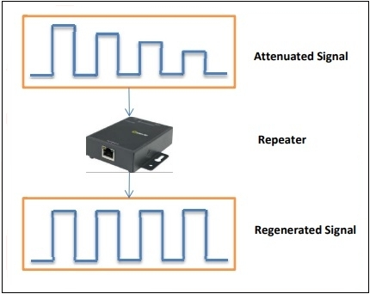
When an electrical signal is transmitted via a channel, it gets attenuated depending upon the nature of the channel or the technology. This poses a limitation upon the length of the LAN or coverage area of cellular networks. This problem is alleviated by installing repeaters at certain intervals.
Repeaters amplifies the attenuated signal and then retransmits it. Digital repeaters can even reconstruct signals distorted by transmission loss.So, repeaters are popularly incorporated to connect between two LANs thus forming a large single LAN. This is shown in the following diagram −
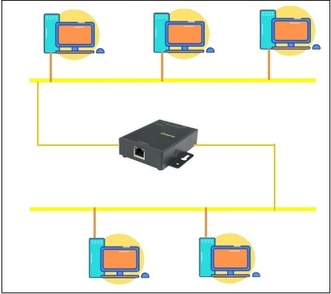

Types of Repeaters -
According to the types of signals that they regenerate, repeaters can be classified into two categories −
- Analog Repeaters − They can only amplify the analog signal.
- Digital Repeaters − They can reconstruct a distorted signal.
According to the types of networks that they connect, repeaters can be categorized into two types −
- Wired Repeaters − They are used in wired LANs.
- Wireless Repeaters − They are used in wireless LANs and cellular networks.
According to the domain of LANs they connect, repeaters can be divided into two categories −
- Local Repeaters − They connect LAN segments separated by small distance.
- Remote Repeaters − They connect LANs that are far from each other.

Modem
Modems (modulators-demodulators) are used to transmit digital signals over analog telephone lines. Thus, digital signals are converted by the modem into analog signals of different frequencies and transmitted to a modem at the receiving location. The receiving modem performs the reverse transformation and provides a digital output to a device connected to a modem, usually a computer. The digital data is usually transferred to or from the modem over a serial line through an industry standard interface, RS-232. Many telephone companies offer DSL services, and many cable operators use modems as end terminals for identification and recognition of home and personal users. Modems work on both the Physical and Data Link layers.

