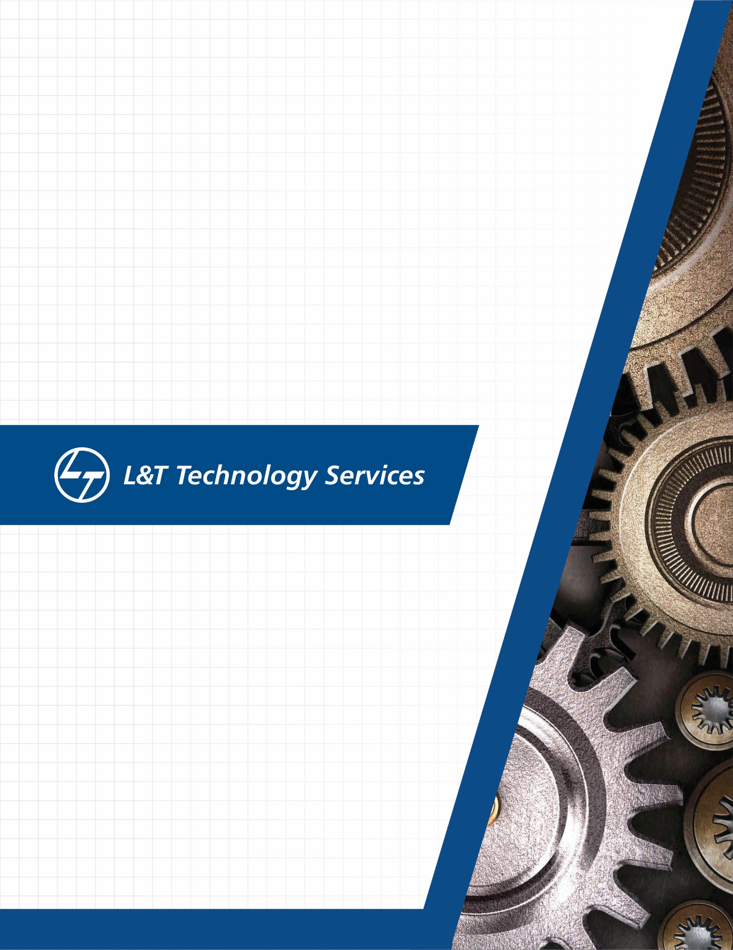
./
Networking - L2, L3 (OSI layer and Stack), Packet Flows, Debugging the packets


Ver. Rel. No. | Release Date | Prepared. By | Reviewed By | To be approved By | Remarks/Revision Details
1 |  | Name/PS No | Name/PS No | Module Owner Name | Comments
2
3
Document History

Table of Contents
Table of Figures 3
Table of Tables 4
ACTIVITY 1: SYSTEM/ SOFTWARE DEVELOPMENT 4
INTRODUCTION 4
MY PRODUCT: “Name ” 6
SWOT ANALYSIS 7
REQUIREMENTS 7
DESIGN 8
HIGH LEVEL DESIGN 8
LOW LEVEL DESIGN 11
TEST PLANS 13
REFERENCES 15
ACTIVITY 2: AGILE METHODOLOGY 15
THEME 15
EPIC 15
USER STORY 16
REFERENCES 17
APPENDIX: 17

Table of Figures
Figure 1 CLASS DIAGRAM(HIGH LEVEL) 10
Figure 2 USE CASE DIAGRAM (HIGH LEVEL) 11
Figure 3 ACTIVITY DIAGRAM (HIGH LEVEL) 12
Figure 4 USE CASE DIAGRAM (LOW LEVEL) 12
Figure 5 ACTVITY DIAGRAM (LOW LEVEL) 13
Figure 6 BLOCK DIAGRAM 13
Figure 7 COMPONENT DIAGRAM (HIGH LEVEL) 22
Figure 8 ACTIVITY DIAGRAM (high level) 23
Figure 9 ACTIVITY DIAGRAM (LOW LEVEL) 24
Figure 10- ACTIVITY DIAGRAM (LOW LEVEL) 24
Figure 11 TEST PLAN 25
Figure 12 GIT 27
Figure 13 GIT ISSUES 28
Figure 14 GIT COMMITS 1 28
Figure 15 GIT COMMIT 2 29
Figure 16 GIT 30
Figure 17 GIT MAKE 31
Figure 18 GIT MAKE 2 31
Figure 19 GIT BUILD 32
Figure 20 GIT CODE QUALITY 32

Table of Tables
Table 1 AGING 6
Table 2 GRADING COST 6
Table 3 REQUIREMENTS 8
Table 4 HIGH LEVEL TEST PLAN 15
Table 5 LOW LEVEL TEST PLAN 16
Table 6 USER STORIES 17
Table 7 AGING 19
Table 8 GRADING COST 19
Table 9 REQUIREMENTS 21
Table 10 USER STORIES 27

OVERFLOWS –
Overflows can be caused deliberately by hackers and then exploited to run malicious code.
There are two types of overflows: stack and heap. The stack and the heap are two areas of the memory structure that are allocated when a program is run. Function calls are stored in the stack, and dynamically allocated variables are stored in the heap. A particular amount of memory is allocated to the buffer. Static variable storage (variables defined within a function) is referred to as stack, because they are actually stored on the stack in memory. Heap data is the memory that is dynamically allocated at runtime, such as by C's malloc () function. This data is not actually stored on the stack, but somewhere amidst a giant "heap" of temporary, disposable memory used specifically for this purpose. Actually exploiting a heap buffer overflow is a lot more involved, because there are no convenient frame pointers (as are on the stack) to overwrite.
Attackers can use buffer overflows in the heap to overwrite a password, a filename, or other data. If the filename is overwritten, a different file will be opened. If this is an executable file, code will be run that was not intended to be run. On UNIX systems, the substituted program code is usually the command interpreter, which allows the attacker to execute commands with the privileges of the process's owner, which (if the setup id bit is set and the program has ownership of the root) could result in the attacker having Superuser privileges. On Windows systems, the overflow code could be sent using an HTTP requests to download malicious code of the attacker's choice. In either case, under the right circumstances, the result could be devastating.

CRYPTOGRAPHY –
Cryptography is probably the most important aspect of communications security and is becoming increasingly important as a basic building block for computer security. It is associated with the process of converting ordinary plain text into unintelligible text and vice-versa. It is a method of storing and transmitting data in a particular form so that only those for whom it is intended can read and process it. Cryptography not only protects data from theft or alteration, but can also be used for user authentication.

Cryptographic systems are characterized along three independent dimensions:
1. The type of operations used for transforming plaintext to ciphertext. All encryption algorithms are based on two general principles: substitution, in which each element in the plaintext (bit, letter, group of bits or letters) is mapped into another element, and transposition, in which elements in the plaintext are rearranged. The fundamental requirement is that no information be lost (i.e., that all operations are reversible). Most systems, referred to as product systems, involve multiple stages of substitutions and transpositions.
2. The number of keys used. If both sender and receiver use the same key, the system is referred to as symmetric, single-key, secret-key, or conventional encryption. If the sender and receiver use different keys, the system is referred to as asymmetric, two-key, or public-key encryption.
3. The way in which the plaintext is processed. A block cipher processes the input one block of elements at a time, producing an output block for each input block. A stream cipher processes the input elements continuously, producing output one element at a time, as it goes along.

Data Confidentiality, Data Integrity, Authentication and Non-repudiation are core principles of modern-day cryptography.
- Confidentiality refers to certain rules and guidelines usually executed under confidentiality agreements which ensure that the information is restricted to certain people or places.
- Data integrity refers to maintaining and making sure that the data stays accurate and consistent over its entire life cycle.
- Authentication is the process of making sure that the piece of data being claimed by the user belongs to it.
- Non-repudiation refers to ability to make sure that a person or a party associated with a contract or a communication cannot deny the authenticity of their signature over their document or the sending of a message.

Three types of cryptographic techniques used in general :
1) Symmetric-key Cryptography: Both the sender and receiver share a single key. The sender uses this key to encrypt plaintext and send the cipher text to the receiver. On the other side the receiver applies the same key to decrypt the message and recover the plain text.
2) Public-Key Cryptography: This is the most revolutionary concept in the last 300-400 years. In Public-Key Cryptography two related keys (public and private key) are used. Public key may be freely distributed, while its paired private key, remains a secret. The public key is used for encryption and for decryption private key is used.
3) Hash Functions: No key is used in this algorithm. A fixed-length hash value is computed as per the plain text that makes it impossible for the contents of the plain text to be recovered. Hash functions are also used by many operating systems to encrypt passwords.

ENCRYPTION –
Encryption is a security method in which information is encoded in such a way that only authorized user can read it. It uses encryption algorithm to generate ciphertext that can only be read if decrypted. They can help to protect data we send, receive, and store, using a device, that can include text messages stored on your smartphone, running logs saved on your fitness watch, and banking information sent through your online account. Encryption is the process that scrambles readable text so it can only be read by the person who has the secret code, or decryption key. It helps provide data security for sensitive information.
Encryption is the process of taking plain text, like a text message or email, and scrambling it into an unreadable format — called “cipher text.” This helps protect the confidentiality of digital data either stored on computer systems or transmitted through a network like the internet.
When the intended recipient accesses the message, the information is translated back to its original form. This is called decryption.
To unlock the message, both the sender and the recipient have to use a “secret” encryption key — a collection of algorithms that scramble and unscramble data back to a readable format.

Types of Encryption
There are two types of encryptions schemes as listed below:
- Symmetric Key encryption
- Public Key encryption
Symmetric key encryption algorithm uses same cryptographic keys for both encryption and decryption of cipher text.

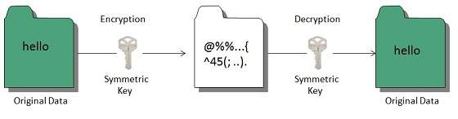

Public key encryption algorithm uses pair of keys, one of which is a secret key and one of which is public. These two keys are mathematically linked with each other.
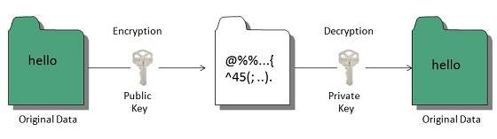
Types of Encryption –
- Data Encryption Standard (DES)
Data Encryption Standard is considered a low-level encryption standard. The U.S. government established the standard in 1977. Due to advances in technology and decreases in the cost of hardware, DES is essentially obsolete for protecting sensitive data.
- Triple DES
Triple DES runs DES encryption three times. Here’s how it works: It encrypts, decrypts, and encrypts data — thus, “triple.” It strengthens the original DES standard, which became regarded as too weak a type of encryption for sensitive data.
- RSA
RSA takes its name from the familial initials of three computer scientists. It uses a strong and popular algorithm for encryption. RSA is popular due to its key length and therefore widely used for secure data transmission.
- TwoFish
Twofish is considered one of the fastest encryption algorithms and is free for anyone to use. It’s used in hardware and software.

Why is encryption important? Here are three reasons:
1. Internet privacy concerns are real
Encryption helps protect your online privacy by turning personal information into “for your eyes only” messages intended only for the parties that need them — and no one else.
You should make sure that your emails are being sent over an encrypted connection, or that you are encrypting each message.
Most email clients come with the option for encryption in their Settings menu, and if you check your email with a web browser, take a moment to ensure that SSL encryption is available.
2. Hacking is big business
Cybercrime is a global business, often run by multinational outfits.
Many of the large-scale data breaches that you may have heard about in the news demonstrate that cybercriminals are often out to steal personal information for financial gain.
3. Regulations demand it
The Health Insurance Portability and Accountability Act (HIPAA) requires healthcare providers to implement security features that help protect patients’ sensitive health information online.
Institutions of higher learning must take similar steps under the Family Education Rights and Privacy Act (FERPA) to protect student records.
Retailers must contend with the Fair Credit Practices Act (FCPA) and similar laws that help protect consumers.
Encryption helps businesses stay compliant with regulatory requirements and standards. It also helps protect the valuable data of their customers.

SSH PROTOCOL –

SSH (also known as the Secure Shell or Secure Socket Shell) can be defined as a cryptographic network protocol. SSH aims to give the users (mostly the system administrators) a secure means to reach a computer within a network.
Although SSH is often used for applications like remote login, remote command line and remote command execution, almost all network services can be secured with the use of SSH.
Secure Socket Shell employs the public-key cryptography methods in order to carry out authentication processes for the remote computer. You can opt for various different ways to use SSH -for instance you can first encrypt your network connection by using automatically generated key pairs (public-private key pairs), then you can go for password authentication for logging on. Or you can opt for using a manually generated key pair (public-private) for the authentication process. This way you can let the users and/or programs log in without hassling with a password.

SSH offers two main functions:
Logging on to remote systems and running terminal sessions, remote commands and such on these remote systems.
Transferring files between remote systems on the same network.
Before SSH was developed and popularized, different methods were in use for each of these functions:
Insecure emulation or login programs like rlogin, Telnet and remote shell (rsh) for remote log on and running remote terminal sessions.
File transfer programs like rcp (remote copy) and File Transfer Protocol (FTP) for file transfer purposes in the network

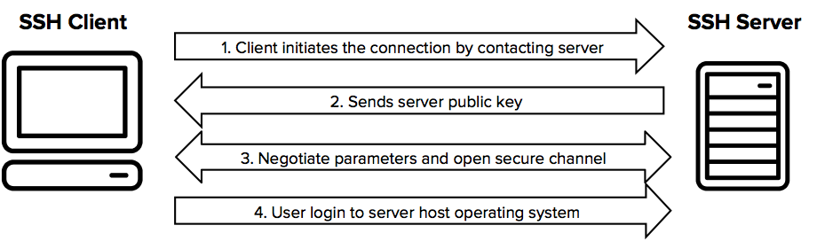

It always comes in key pair:
- Public key – Everyone can see it, no need to protect it. (for encryption function)
- Private key – Stays in computer, must be protected. (for decryption function)
Key pairs can be of the following types:
- User Key – If public key and private key remain with the user.
- Host Key – If public key and private key are on a remote system.
- Session key – Used when large amount of data is to be transmitted.

How SSH Works ?
It uses assymetric cipher for performing encryption and decryption. There are many encryption methods:
rsa, dsa, ed25519 etc.
General procedure is :-
Public keys from the local computers (system) are passed to the server which is to be accessed.
Server then identifies if the public key is registered.
If so, the server then creates a new secret key and encrypts it with the public key which was send to it via local computer.
This encrypted code is send to the local computer.
This data is unlocked by the private key of the system and is send to the server.
Server after receiving this data verifies the local computer.
SSH creates a route and all the encrypted data are transferred through it with no security issues.
SSH is key based authentication that is not prone to brute-force attack.
It is more convenient and secure than login ids and passwords (which can be stolen in middle). There is no exposure of valid credentials, if a server has been compromised.

Generating an SSH key pair:
Open your command prompt
type : ssh-keygen
Press enter
It will ask you for a location. Press Enter for default location.
If its already there, press 'y' to overwrite.
You may enter passphrase as you like, press enter.
Generating SSH keys on Windows, Linux and Mac:
OMAC OsX and Linux : terminal (build in)
OWindows :- PuTTY

TLS PROTOCOL –
TLS is a cryptographic protocol that provides end-to-end communications security over networks and is widely used for internet communications and online transactions. It is an IETF standard intended to prevent eavesdropping, tampering and message forgery. Common applications that employ TLS include Web browsers, instant messaging, e-mail and voice over IP. A primary use case of TLS is encrypting the communication between web applications and servers, such as web browsers loading a website. TLS can also be used to encrypt other communications such as email, messaging, and voice over IP (VoIP). In this article we will focus on the role of TLS in web application security.

There are several benefits of TLS:
Encryption:
TLS/SSL can help to secure transmitted data using encryption.
Interoperability:
TLS/SSL works with most web browsers, including Microsoft Internet Explorer and on most operating systems and web servers.
Algorithm flexibility:
TLS/SSL provides operations for authentication mechanism, encryption algorithms and hashing algorithm that are used during the secure session.
Ease of Deployment:
Many applications TLS/SSL temporarily on a windows server 2003 operating systems.
Ease of Use:
Because we implement TLS/SSL beneath the application layer, most of its operations are completely invisible to client.
Working of TLS:
For a website or application to use TLS, it must have a TLS certificate installed on its origin server (the certificate is also known as an "SSL certificate" because of the naming confusion described above). A TLS certificate is issued by a certificate authority to the person or business that owns a domain. The certificate contains important information about who owns the domain, along with the server's public key, both of which are important for validating the server's identity.
A TLS connection is initiated using a sequence known as the TLS handshake. When a user navigates to a website that uses TLS, the TLS handshake begins between the user's device (also known as the client device) and the web server.
During the TLS handshake, the user's device and the web server:
Specify which version of TLS (TLS 1.0, 1.2, 1.3, etc.) they will use
Decide on which cipher suites (see below) they will use
Authenticate the identity of the server using the server's TLS certificate
Generate session keys for encrypting messages between them after the handshake is complete
The TLS handshake establishes a cipher suite for each communication session. The cipher suite is a set of algorithms that specifies details such as which shared encryption keys, or session keys, will be used for that particular session. TLS is able to set the matching session keys over an unencrypted channel thanks to a technology known as public key cryptography.
The handshake also handles authentication, which usually consists of the server proving its identity to the client. This is done using public keys. Public keys are encryption keys that use one-way encryption, meaning that anyone with the public key can unscramble the data encrypted with the server's private key to ensure its authenticity, but only the original sender can encrypt data with the private key. The server's public key is part of its TLS certificate.
Once data is encrypted and authenticated, it is then signed with a message authentication code (MAC). The recipient can then verify the MAC to ensure the integrity of the data. This is kind of like the tamper-proof foil found on a bottle of aspirin; the consumer knows no one has tampered with their medicine because the foil is intact when they purchase it.
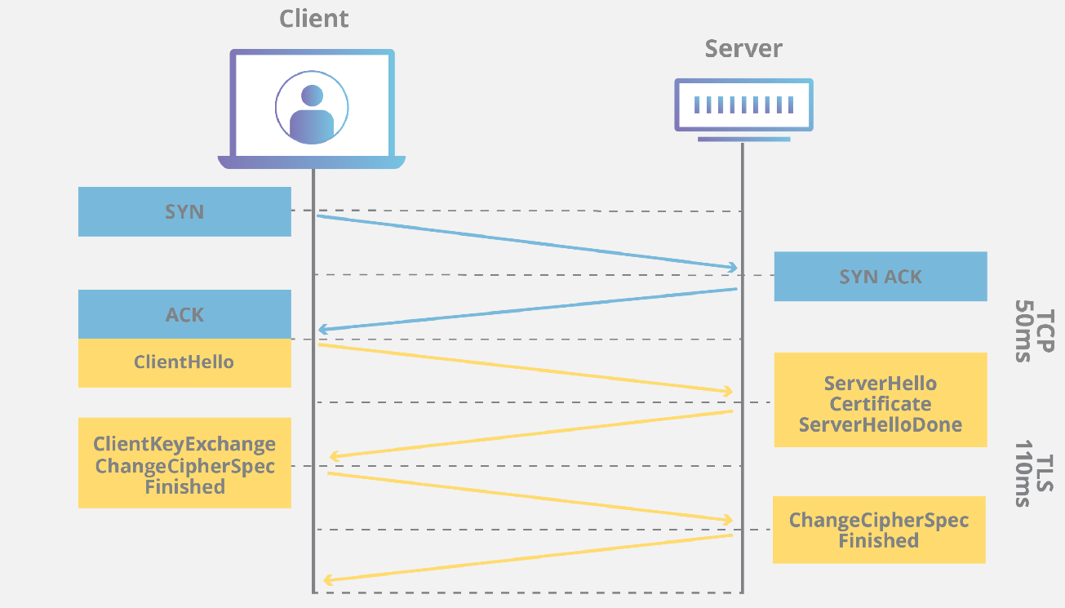

MTLS PROTOCOL –

Transmission Modes

Transmission mode defines the direction of the flow of information between two communication devices. It is also called Data Communication or Directional Mode. It specifies the direction of the flow of information from one place to another in a computer network.
In the Open System Interconnection(OSI) Layer Model, the Physical Layer is dedicated to data transmission in the network. It mainly decides the direction of data in which the data needs to travel to reach the receiver system or node.

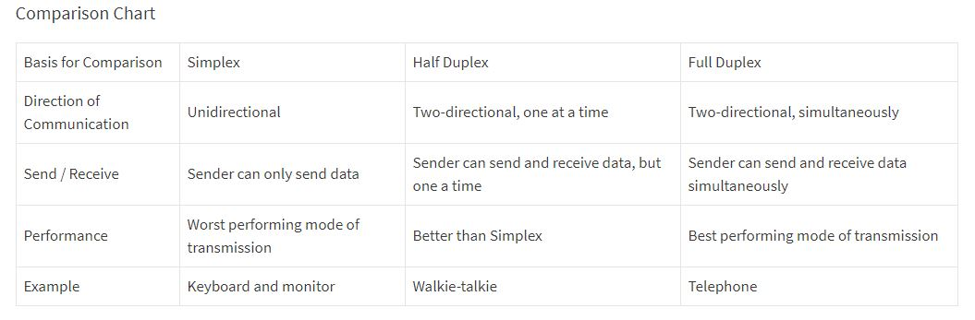

What are network devices?
Network devices, or networking hardware, are physical devices that are required for communication and interaction between hardware on a computer network.

Types of network devices -
- Hub
- Switch
- Router
- Bridge
- Gateway
- Modem
- Repeater
- Access Point

HUB -
Hubs are networking devices operating at a physical layer of the Open Systems Interconnection (OSI) model that are used to connect multiple devices in a network. They are generally used to connect computers in a LAN. A hub has numerous ports. A computer which intends to be connected to the network is plugged in to one of these ports. When a data frame arrives at a port, it is broadcast to every other port, without considering whether it is destined for a particular destination device or not. Also, they do not have the intelligence to find out best path for data packets which leads to inefficiencies and wastage.
Hubs do not perform packet filtering or addressing functions; they just send data packets to all connected devices. Collision domain of all hosts connected through hub remains one. A hub can be used with both digital and analog data, provided its settings have been configured to prepare for the formatting of the incoming data. For example, if the incoming data is in digital format, the hub must pass it on as packets; however, if the incoming data is analog, then the hub passes it on in signal form. Transmission mode is half duplex. They generally have fewer ports of 4/12.

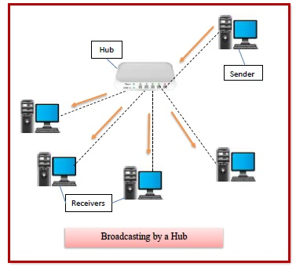

Types of Hubs –
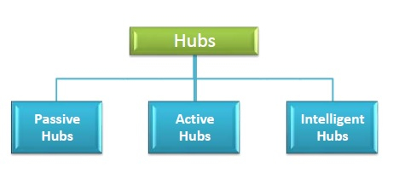

- Passive Hubs − Passive hubs connects nodes in a star configuration by collecting wiring from nodes. They broadcast signals onto the network without amplifying or regenerating them. As they cannot extend the distance between nodes, they limit the size of the LAN. The passive hubs are the connection point for wires that helps to make the physical network. It is capable of determining the bugs and faulty hardware. Simply, it accepts the packet over a port and circulates it to all ports. It includes connectors (10base-2 port and RJ-45) that can be applied as a standard in your network. This connector is connected to all local area network (LAN) devices.
- Active Hubs − Active hubs amplify and regenerate the incoming electrical signals before broadcasting them. They have their own power supply and serves both as a repeater as well as connecting centre. Due to their regenerating capabilities, they can extend the maximum distance between nodes, thus increasing the size of LAN. It is able to monitor the data sent to the connected devices. It plays an important role between the connected devices with the help of store technology, where it checks the data to be sent and decides which packet to send first.
- Intelligent Hubs − Intelligent hubs are active hubs that provide additional network management facilities. They can perform a variety of functions of more intelligent network devices like network management, switching, providing flexible data rates etc. These hubs have some kinds of management software that help to analyze the problem in the network and resolve them. It is beneficial to expend the business in networking; the management can assign users that help to work more quickly and share a common pool efficiently by using intelligent hubs. However, it offers better performance for the local area network. Furthermore, with any physical device, if any problem is detected, it is able to detect this problem easily.
SWITCH -
A switch is a data link layer networking device which connects devices in a network and uses packet switching to send and receive data over the network. A switch has many ports, to which computers are plugged in. When a data frame arrives at any port of a network switch, it examines the destination address, performs necessary checks and sends the frame to the corresponding device(s).It supports unicast, multicast as well as broadcast communications.A switch is a multiport bridge with a buffer and a design that can boost its efficiency (a large number of ports imply less traffic) and performance. The switch can perform error checking before forwarding data, that makes it very efficient as it does not forward packets that have errors and forward good packets selectively to correct port only. Switch divides collision domain of hosts, but broadcast domain remains same.
Using switches improves network efficiency over hubs or routers because of the virtual circuit capability. Switches also improve network security because the virtual circuits are more difficult to examine with network monitors. You can think of a switch as a device that has some of the best capabilities of routers and hubs combined. A switch can work at either the Data Link layer or the Network layer of the OSI model. A multilayer switch is one that can operate at both layers, which means that it can operate as both a switch and a router. A multilayer switch is a high-performance device that supports the same routing protocols as routers. Switches can be subject to distributed denial of service (DDoS) attacks; flood guards are used to prevent malicious traffic from bringing the switch to a halt. Switch port security is important so be sure to secure switches: Disable all unused ports and use DHCP snooping, ARP inspection and MAC address filtering.
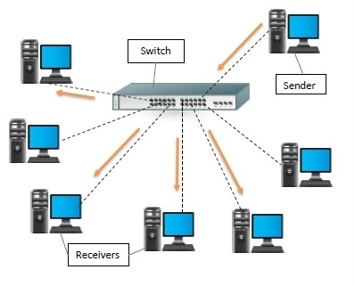
Types of Switches –

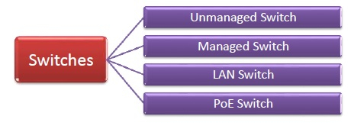
- Unmanaged Switch − These are inexpensive switches commonly used in home networks and small businesses. They can be set up by simply plugging in to the network, after which they instantly start operating. When more devices needs to be added, more switches are simply added by this plug and play method. They are referred to as u managed since they do not require to be configured or monitored.
- Managed Switch − These are costly switches that are used in organisations with large and complex networks, since they can be customized to augment the functionalities of a standard switch. The augmented features may be QoS (Quality of Service) like higher security levels, better precision control and complete network management. Despite their cost, they are preferred in growing organizations due to their scalability and flexibility. Simple Network Management Protocol (SNMP) is used for configuring managed switches.

- LAN Switch − Local Area Network (LAN) switches connects devices in the internal LAN of an organization. They are also referred as Ethernet switches or data switches. These switches are particularly helpful in reducing network congestion or bottlenecks. They allocate bandwidth in a manner so that there is no overlapping of data packets in a network.
- PoE Switch − Power over Ethernet (PoE) switches are used in PoE Gogabit Ethernets. PoE technology combine data and power transmission over the same cable so that devices connected to it can receive both electricity as well as data over the same line. PoE switches offer greater flexibility and simplifies the cabling connections.

ROUTER -
Routers are networking devices operating at network layer of the OSI model. They are responsible for receiving, analyzing, and forwarding data packets among the connected computer networks. When a data packet arrives, the router inspects the destination address, consults its routing tables to decide the optimal route and then transfers the packet along this route.
Routers help transmit packets to their destinations by charting a path through the sea of interconnected networking devices using different network topologies. Routers are intelligent devices, and they store information about the networks they’re connected to. Most routers can be configured to operate as packet-filtering firewalls and use access control lists (ACLs). Routers, in conjunction with a channel service unit/data service unit (CSU/DSU), are also used to translate from LAN framing to WAN framing. This is needed because LANs and WANs use different network protocols. Such routers are known as border routers. They serve as the outside connection of a LAN to a WAN, and they operate at the border of your network.Routers usually communicate routing and other information using one of three standard protocols: Routing Information Protocol (RIP), Border Gateway Protocol (BGP) or Open Shortest Path First (OSPF).
Routers are your first line of defense, and they must be configured to pass only traffic that is authorized by network administrators. The routes themselves can be configured as static or dynamic. If they are static, they can only be configured manually and stay that way until changed. If they are dynamic, they learn of other routers around them and use information about those routers to build their routing tables.
Routers are general-purpose devices that interconnect two or more heterogeneous networks. They are usually dedicated to special-purpose computers, with separate input and output network interfaces for each connected network. Because routers and gateways are the backbone of large computer networks like the internet, they have special features that give them the flexibility and the ability to cope with varying network addressing schemes and frame sizes through segmentation of big packets into smaller sizes that fit the new network components. Each router interface has its own Address Resolution Protocol (ARP) module, its own LAN address (network card address) and its own Internet Protocol (IP) address. The router, with the help of a routing table, has knowledge of routes a packet could take from its source to its destination. The routing table, like in the bridge and switch, grows dynamically. Upon receipt of a packet, the router removes the packet headers and trailers and analyzes the IP header by determining the source and destination addresses and data type, and noting the arrival time. It also updates the router table with new addresses not already in the table. The IP header and arrival time information is entered in the routing table. Routers normally work at the Network layer of the OSI model.
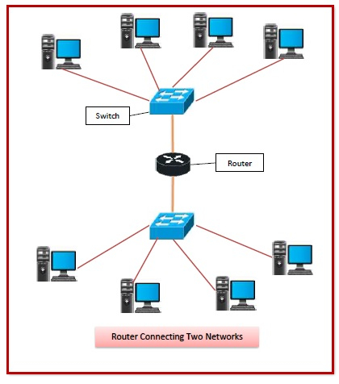

Routing Table -
The functioning of a router depends largely upon the routing table stored in it. The routing table stores the available routes for all destinations. The router consults the routing table to determine the optimal route through which the data packets can be sent.
A routing table typically contains the following entities −
- IP addresses and subnet mask of the nodes in the network
- IP addresses of the routers in the network
- Interface information among the network devices and channels
Routing tables are of two types −
- Static Routing Table − Here, the routes are fed manually and are not refreshed automatically. It is suitable for small networks containing 2-3 routers.
- Dynamic Routing Table − Here, the router communicates with other routers using routing protocols to determine the available routes. It is suited for larger networks having large number of routers.

Types of Routers –

- Wireless Router − They provide WiFi connection WiFi devices like laptops, smartphones etc. They can also provide standard Ethernet routing. For indoor connections, the range is 150 feet while its 300 feet for outdoor connections.
- Broadband Routers − They are used to connect to the Internet through telephone and to use voice over Internet Protocol (VoIP) technology for providing high-speed Internet access. They are configured and provided by the Internet Service Provider (ISP).
- Core Routers − They can route data packets within a given network, but cannot route the packets between the networks. They helps to link all devices within a network thus forming the backbone of network. It is used by ISP and communication interfaces.
- Edge Routers − They are low-capacity routers placed at the periphery of the networks. They connect the internal network to the external networks, and are suitable for transferring data packets across networks. They use Border Gateway Protocol (BGP) for connectivity. There are two types of edge routers, subscriber edge routers and label edge routers.
- Brouters − Brouters are specialised routers that can provide the functionalities of bridges as well. Like a bridge, brouters help to transfer data between networks. And like a router, they route the data within the devices of a network.

Bridge -
Bridges are used to connect two or more hosts or network segments together. The basic role of bridges in network architecture is storing and forwarding frames between the different segments that the bridge connects. They use hardware Media Access Control (MAC) addresses for transferring frames. By looking at the MAC address of the devices connected to each segment, bridges can forward the data or block it from crossing. Bridges can also be used to connect two physical LANs into a larger logical LAN. Bridges work only at the Physical and Data Link layers of the OSI model. Bridges are used to divide larger networks into smaller sections by sitting between two physical network segments and managing the flow of data between the two.
Bridges are like hubs in many respects, including the fact that they connect LAN components with identical protocols. However, bridges filter incoming data packets, known as frames, for addresses before they are forwarded. As it filters the data packets, the bridge makes no modifications to the format or content of the incoming data. The bridge filters and forwards frames on the network with the help of a dynamic bridge table. The bridge table, which is initially empty, maintains the LAN addresses for each computer in the LAN and the addresses of each bridge interface that connects the LAN to other LANs. Bridges, like hubs, can be either simple or multiple port. Bridges have mostly fallen out of favor in recent years and have been replaced by switches, which offer more functionality. In fact, switches are sometimes referred to as “multiport bridges” because of how they operate.
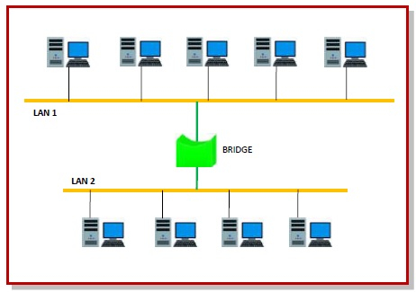
Types of Bridges -
  - Transparent Bridge
As the name suggests, it is an invisible bridge in the computer network. The main function of this bridge is to block or forward the data depending on the MAC address. The other devices within the network are unaware of the existence of bridges. These types of bridges are most popular and operate in a transparent way to the entire networks which are connected to hosts.
This bridge saves the addresses of MAC within a table that is similar to a routing table. This estimates the information when a packet is routed to its position. So it can also merge several bridges to check incoming traffic in a better way. These bridges are implemented mainly in Ethernet networks.
  - Translational Bridge
A translational bridge plays a key role in changing a networking system from one type to another. These bridges are used to connect two different networks like token ring & Ethernet. This bridge can add or remove the data based on the traveling direction, and forward the frames of the data link layer in between LANs which uses various types of network protocols. The different network connections are Ethernet to FDDI/token ring otherwise Ethernet on UTP (unshielded twisted pair) to coax & in between FOC and copper wiring.
  - Source-route Bridge
Source-route Bridge is one type of technique used for Token Ring networks and it is designed by IBM. In this bridge, the total frame route is embedded in one frame. So that it allows the bridge to make precise decisions of how the frame is forwarding using the network. By using this method, two similar network segments are connected to the data link layer. It can be done in a distributed way wherever end-stations join within the bridging algorithm.

Gateway –
A gateway is a network node that forms a passage between two networks operating with different transmission protocols. The most common type of gateways, the network gateway operates at network layer of the OSI model. However, depending upon the functionality, a gateway can operate at any of the seven layers of OSI model. It acts as the entry – exit point for a network since all traffic that flows across the networks should pass through the gateway. Only the internal traffic between the nodes of a LAN does not pass through the gateway.
Gateways normally work at the Transport and Session layers of the OSI model. At the Transport layer and above, there are numerous protocols and standards from different vendors; gateways are used to deal with them. Gateways provide translation between networking technologies such as Open System Interconnection (OSI) and Transmission Control Protocol/Internet Protocol (TCP/IP). Because of this, gateways connect two or more autonomous networks, each with its own routing algorithms, protocols, topology, domain name service, and network administration procedures and policies. Gateways perform all of the functions of routers and more. In fact, a router with added translation functionality is a gateway. The function that does the translation between different network technologies is called a protocol converter.
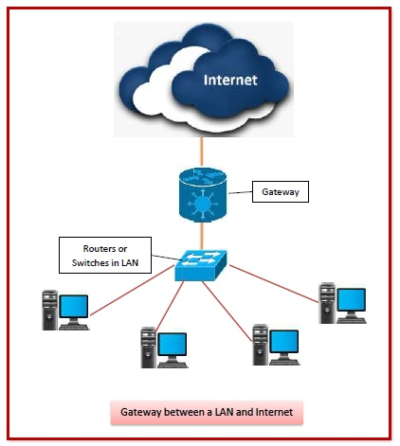

Types of Gateways -
On basis of direction of data flow, gateways are broadly divided into two categories −
- Unidirectional Gateways − They allow data to flow in only one direction. Changes made in the source node are replicated in the destination node, but not vice versa. They can be used as archiving tools.
- Bidirectional Gateways − They allow data to flow in both directions. They can be used as synchronization tools.
On basis of functionalities, there can be a variety of gateways, the prominent among them are as follows −
- Network Gateway − This is the most common type of gateway that provides as interface between two dissimilar networks operating with different protocols. Whenever the term gateway is mentioned without specifying the type, it indicates a network gateway.
- Cloud Storage Gateway − It is a network node or server that translates storage requests with different cloud storage service API calls, such as SOAP (Simple Object Access Protocol) or REST (REpresentational State Transfer).It facilitates integration of private cloud storage into applications without necessitating transfer of the applications into any public cloud, thus simplifying data communication.
- Internet-To-Orbit Gateway (I2O) − It connects devices on the Internet to satellites and spacecraft orbiting the earth. Two prominent I2O gateways are Project HERMES and Global Educational Network for Satellite Operations (GENSO).
- IoT Gateway − IoT gateways assimilates sensor data from IoT (Internet of Things) devices in the field and translates between sensor protocols before sending it to the cloud network. They connect IoT devices, cloud network and user applications.
- VoiP Trunk Gateway − It facilitates data transmission between plain old telephone service (POTS) devices like landline phones and fax machines, with VoIP (voice over Internet Protocol) network.

Repeater -
A repeater is an electronic device that amplifies the signal it receives and retransmits it at a higher level or higher power so that the signal can cover longer distances, more than 100 meters for standard LAN cables. Repeaters are network devices operating at physical layer of the OSI model that amplify or regenerate an incoming signal before retransmitting it. They are incorporated in networks to expand its coverage area. They are also known as signal boosters.
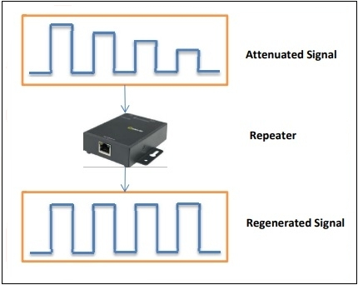
When an electrical signal is transmitted via a channel, it gets attenuated depending upon the nature of the channel or the technology. This poses a limitation upon the length of the LAN or coverage area of cellular networks. This problem is alleviated by installing repeaters at certain intervals.
Repeaters amplifies the attenuated signal and then retransmits it. Digital repeaters can even reconstruct signals distorted by transmission loss.So, repeaters are popularly incorporated to connect between two LANs thus forming a large single LAN. This is shown in the following diagram −
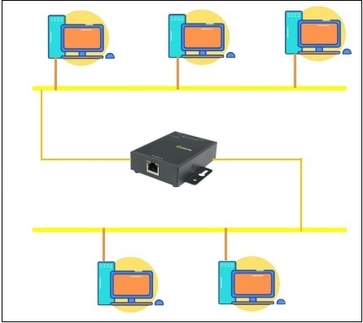

Types of Repeaters -
According to the types of signals that they regenerate, repeaters can be classified into two categories −
- Analog Repeaters − They can only amplify the analog signal.
- Digital Repeaters − They can reconstruct a distorted signal.
According to the types of networks that they connect, repeaters can be categorized into two types −
- Wired Repeaters − They are used in wired LANs.
- Wireless Repeaters − They are used in wireless LANs and cellular networks.
According to the domain of LANs they connect, repeaters can be divided into two categories −
- Local Repeaters − They connect LAN segments separated by small distance.
- Remote Repeaters − They connect LANs that are far from each other.

Modem
Modems (modulators-demodulators) are used to transmit digital signals over analog telephone lines. Thus, digital signals are converted by the modem into analog signals of different frequencies and transmitted to a modem at the receiving location. The receiving modem performs the reverse transformation and provides a digital output to a device connected to a modem, usually a computer. The digital data is usually transferred to or from the modem over a serial line through an industry standard interface, RS-232. Many telephone companies offer DSL services, and many cable operators use modems as end terminals for identification and recognition of home and personal users. Modems work on both the Physical and Data Link layers.

