./

Learning Report – Networking



|  |  |  |  |  |  |
| --- | --- | --- | --- | --- | --- |
| **Ver. Rel. No.** | **Release Date** | **Prepared. By** | **Reviewed By** | **To be approved By** | **Remarks/Revision Details** |
| 1 |  | Name/PS No | Name/PS No | Module Owner Name | Comments |
| 2 | 15/02/21 |  |  |  |  |
| 3 |  |  |  |  |  |
|  |  |  |  |  |  |
|  |  |  |  |  |  |

**Document History**

**Network:**

A network consists of two or more computers that are linked in order to share resources (such as printers and CDs), exchange files, or allow electronic communications. The computers on a network may be linked through cables, telephone lines, radio waves, satellites, or infrared light beams.

**Type of Networks:**

There are various types of computer networks available. We can categorize them according to their size as well as their purpose.

* **Personal Area Network** (**PAN**)

The smallest and most basic type of network, a PAN is made up of a wireless modem, a computer or two, phones, printers, tablets, etc., and revolves around one person in one building. These types of networks are typically found in small offices or residences, and are managed by one person or organization from a single device.

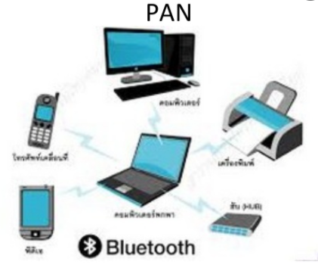

* **Local Area Network(LAN)**

Local area networks, generally called LANs, are privately-owned networks within a single building or campus of up to a few kilometers in size. They are widely used to connect personal computers and workstations in company offices and factories to share resources (e.g., printers) and exchange information. LANs are distinguished from other kinds of networks by three characteristics:

(1) their size,

(2) their transmission technology,

(3) their topology.

LANs are restricted in size.

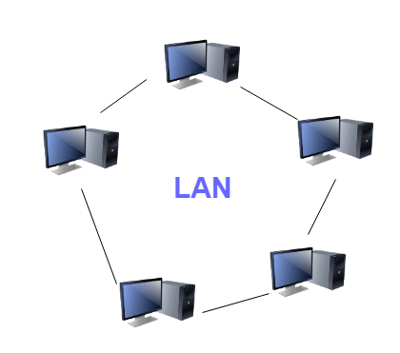

* **Metropolitan Area Networks(MAN)**

A metropolitan area network, or MAN, covers a city. The best-known example of a MAN is the cable television network available in many cities. This system grew from earlier community antenna systems used in areas with poor over-the-air television reception. In these early systems, a large antenna was placed on top of a nearby hill and signal was then piped to the subscribers' houses.

* A metropolitan area network based on cable TV

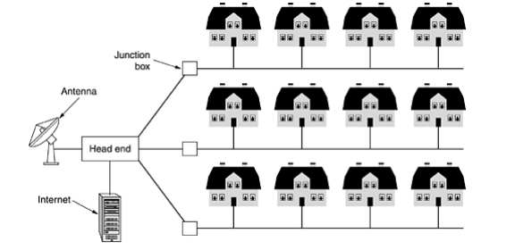

* **Wide Area Networks**:

1. A wide area network, or WAN, spans a large geographical area, often a country or continent.
2. It contains a collection of machines intended for running user (i.e., application) programs. We will follow traditional usage and call these machines hosts.
3. The hosts are connected by a communication subnet, or just subnet for short. The hosts are owned by the customers (e.g., people's personal computers), whereas the communication subnet is typically owned and operated by a telephone company or Internet service provider.
4. The job of the subnet is to carry messages from host to host, just as the telephone system carries words from speaker to listener. Separation of the pure communication aspects of the network (the subnet) from the application aspects (the hosts), greatly simplifies the complete network design.

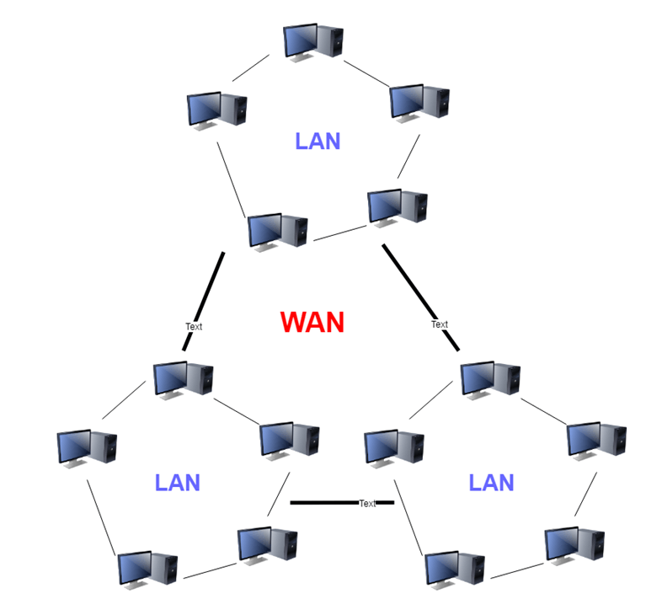

**OSI**

**Open System Interconnection:**

Established in 1947, the International Standards Organization (ISO) is a multinational body dedicated to worldwide agreement on international standards. An ISO standard that covers all aspects of network communications is the Open Systems Interconnection (OSI) model. It was first introduced in the late 1970s.

Introduction:

OSI (Open Systems Interconnection) is used to understand how data is transfer from one device to another. It has 7 layers. It is a reference model for how applications communicate over a network. This model focuses on providing a visual design of how each communications layer is built on top of the other.

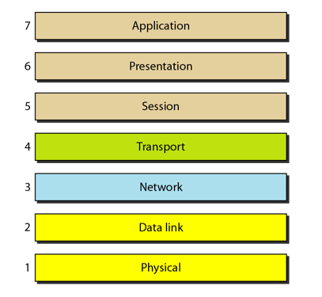

* Application, Presentation, Session layer are the software layers
* Transport Layer is the heart of the OSI layer
* Network, Datalink, Physical layers are the hardware layers

Layer 7: The Application Layer:  
  
The top layer of an OSI model (layer seven) is the application layer that delivers network services or protocols that comply with an end-user’s data to the end-user. It provides protocols that allow software to send and receive information and present meaningful data to users.  
  
Examples of Layer 7 applications include web browsers such as Google Chrome or Firefox, as well as apps such as Office, Outlook, and Skype. The services provided by each of these applications permit the application layer to supply and receive data from the Presentation layer.  
  
A few examples of application layer protocols are the Hypertext Transfer Protocol (HTTP), File Transfer Protocol (FTP), Post Office Protocol (POP), Simple Mail Transfer Protocol (SMTP), and Domain Name System (DNS).  
  
**Layer 6: Presentation layer:**  
  
Presentation layer get the data from the Application layer. The data is in the form of numbers and characters. Presentation layer convert that characters and numbers to machine understandable binary format

* Example conversion of ASCII to EBCDIC (Extended Binary Coded Decimal Interchange Code)
* This process is known as translation. Before the data is transmitted to the presentation layer reduces the number of bits that are used to represent the original data.
* This bit reduction process is called data compression and it can be Lossy or Lossless.
* To maintain the integrity of data, before transmission data is encrypted at the sender side and data is decrypted at the receiver side.
* Here SSL (Secure Sockets Layer) protocol is used for encrypting and decrypting the data.
* Some of the protocols used in presentation layer are SSH, IMAP, MPEG, JPEG

**Layer 5: Session Layer:**

Session layer helps in setting up and managing connections enabling sending and receiving of data followed by termination of connections or sessions

* Session layer has its helpers called APIs (Application Programming interfaces)
* NETBIOS (Network Basic Input output System) is an example of APIs which allows applications of different computers to communicate with each other. Just before a session or connection is established with the server.
* Server perform a function called authentication. It is a process of verifying who you are.
* For this server uses a username and password. Once the username and password are matched the session or a connection is established between your computer and the server
* After the authentication session layer check for authorization
* This process is determined if you have permission to access a file. If not you will get a message saying you are not authorized to access this page.
* These are the two functions authentication and authorization are performed by the session layer

**Layer 4: Transport Layer:**

Transport layer controls the reliability of communication through Segmentation, Flow control, Error control.

* + Segmentation:
    - In segmentation the data received from the session layer is divided into small data units called as segments.
    - Each segment contain a source and destination port number and a sequence number.
    - Port number help to direct each segment to the correct application
    - Sequence number helps to reassemble the segments in correct order to form correct message at the receiver.
  + Flow Control:
    - In flow control the transport layer controls the amount of data being transmitted.
    - For example a mobile is connected to a server, Here server can transmit data maximum at 100Mbps and our mobile can process data maximum at 10Mbps. Now we are downloading the file from the server. Server start sending the file at 50Mbps which is greater than the rate our mobile can process.
    - So the mobile phone tell the transmission layer to slow down the data transmission rate up to 10Mbps so that no data can get lost. Like this wise versa.
* Error Control:
* Transport layer also help in error control, if some data does not arrive the destination. Transport layer uses automatic repeat request scheme to retransmit the lost or corrupted data.
* A group of bits called checksum is added to each segment by the transport layer to find out the received corrupted segment
* Protocols for transport layer:
* Transmission Control protocol (TCP)

1. TCP is the connection oriented transmission
2. It provided feedback that data delivered or not.
3. Lost data can be recovered in TCP

* User Datagram Protocol (UDP)

1. UDP is the connectionless transmission it is faster than the
2. It doesn’t provide any feedback where it delivered data or not
3. Lost data can’t be recovered

**LAYER 3: Network Layer:**

1. Network layer work for the transmission of the received data segment from one computer to the another located in different networks.
2. Data units in network layer are called packets. It is the layer where routers to decide the function of network layer are logical addressing, routing and path determination.
3. IP addressing (IPv4, IPv6) done in network layer is called logical addressing.
4. Every computer in a network has a unique IP addressing
5. IP address is assigned to each data packet to ensure that data can reach the correct destination.
6. Routing is a method of moving the data packets from source to destination and it is based on the logical address format of IPv4 or IPv6.
7. Based on IP address and Mask routing decisions are made in a computer.

* Path Determination

A computer can be connected to internet server for a computer in a number of ways. Choosing the best delivery path for the data delivery from source to destination.

* Protocols used
* OSPF (Open Shortest path first border)
* BGP (Boarder Gateway protocol)
* IS-IS (Intermediate System To Intermediate)

These are the protocols to determine the best path for data delivery.

**Layer 2: Data Link Layer:**

1. Data link layer receives data from the Network layer. data packets contain IP address of sender and receiver
2. There are 2 types of addressing

* Logical addressing: It is done at network layer where the segment is assigned with the sender and receiver IP address to form a data packet.
* Physical addressing: It is done at the data link layer where the data packets are assigned with the MAC address of sender and receiver and form a frame.
* Data unit in Data link layer is called frame

1. Example if we want to transfer the data from computer to the laptop here computer is connected to the router through an ethernet cable and laptop is connected with the wireless network.
2. Data link layer add some data as head and tail to an IP packet form it as a frame and passes through the ethernet cable. The router de capsulate as a packet and encapsulate as a frame
3. At the other end router de capsulate as a packet and encapsulate again as a frame.
4. The laptop receives this wireless data link frame de capsulate it and then forward IP packet to network layer.
5. Finally arrives application layer. Application layer protocol make the received data and visible on the computer screen.
6. Network layer and higher level layers are able to transfer data over media with the help of Data link layer.
7. That is data link layer provides access to media for higher layer of OSI model

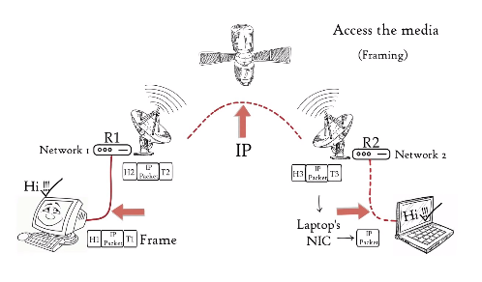

**Layer 1: Physical Layer:**

Physical layer convert the binary digits into signal and transmit over the local media.

1. It can be the electric signal in case of copper cable or LAN cable.
2. Light signal in case of optical fiber.
3. Radio signal in case of air

* At the receiver signal covert it to bits and pass it to data link layer as a frame. Frames is further de capsulate as the data move to higher layers finally data is moved to application layer.
* Application layer protocol makes the senders message visible in the application in the receivers computers screen.
* In this way the OSI model is helping to transfer data between distant hosts.

