./

Learning Report – Applied System Development Life Cycle and Software Testing



|  |  |  |  |  |  |
| --- | --- | --- | --- | --- | --- |
| **Ver. Rel. No.** | **Release Date** | **Prepared. By** | **Reviewed By** | **To be approved By** | **Remarks/Revision Details** |
| 1 |  | Name/PS No | Name/PS No | Module Owner Name | Comments |
| 2 | 15/02/21 | 99003770 |  |  |  |
| 3 |  |  |  |  |  |
|  |  |  |  |  |  |
|  |  |  |  |  |  |

**Document History**

Table of Contents

Table of Figures 3

Table of Tables 4

ACTIVITY 1: SYSTEM/ SOFTWARE DEVELOPMENT Error! Bookmark not defined.

**INTRODUCTION** **Error! Bookmark not defined.**

**MY PRODUCT: “Name ”** **Error! Bookmark not defined.**

**SWOT ANALYSIS** **Error! Bookmark not defined.**

**REQUIREMENTS** **Error! Bookmark not defined.**

**DESIGN** **Error! Bookmark not defined.**

HIGH LEVEL DESIGN **Error! Bookmark not defined.**

LOW LEVEL DESIGN **Error! Bookmark not defined.**

**TEST PLANS** **Error! Bookmark not defined.**

**REFERENCES** **Error! Bookmark not defined.**

ACTIVITY 2: AGILE METHODOLOGY Error! Bookmark not defined.

**THEME** **Error! Bookmark not defined.**

**EPIC** **Error! Bookmark not defined.**

**USER STORY** **Error! Bookmark not defined.**

**REFERENCES** **Error! Bookmark not defined.**

APPENDIX: Error! Bookmark not defined.

## Table of Figures

Figure 1 CLASS DIAGRAM(HIGH LEVEL) **Error! Bookmark not defined.**

Figure 2 USE CASE DIAGRAM (HIGH LEVEL) **Error! Bookmark not defined.**

Figure 3 ACTIVITY DIAGRAM (HIGH LEVEL) **Error! Bookmark not defined.**

Figure 4 USE CASE DIAGRAM (LOW LEVEL) **Error! Bookmark not defined.**

Figure 5 ACTVITY DIAGRAM (LOW LEVEL) **Error! Bookmark not defined.**

Figure 6 BLOCK DIAGRAM **Error! Bookmark not defined.**

Figure 7 COMPONENT DIAGRAM (HIGH LEVEL) **Error! Bookmark not defined.**

Figure 8 ACTIVITY DIAGRAM (high level) **Error! Bookmark not defined.**

[Figure 9 ACTIVITY DIAGRAM (LOW LEVEL) **Error! Bookmark not defined.**](https://lnttsgroup.sharepoint.com/sites/GEA/Global%20Engineering%20Academy/GEA%20Insights/Genesis/Shared%20Documents/Submission/MYSORE/2009MYSEMB/Foundation/Applied%20SDLC%20with%20Software%20Testing/99002439/FINAL.docx#_Toc52177322)

Figure 10- ACTIVITY DIAGRAM (LOW LEVEL) **Error! Bookmark not defined.**

Figure 11 TEST PLAN **Error! Bookmark not defined.**

Figure 12 GIT **Error! Bookmark not defined.**

Figure 13 GIT ISSUES **Error! Bookmark not defined.**

Figure 14 GIT COMMITS 1 **Error! Bookmark not defined.**

Figure 15 GIT COMMIT 2 **Error! Bookmark not defined.**

Figure 16 GIT **Error! Bookmark not defined.**

Figure 17 GIT MAKE **Error! Bookmark not defined.**

Figure 18 GIT MAKE 2 **Error! Bookmark not defined.**

Figure 19 GIT BUILD **Error! Bookmark not defined.**

Figure 20 GIT CODE QUALITY **Error! Bookmark not defined.**

## Table of Tables

Table 1 AGING **Error! Bookmark not defined.**

Table 2 GRADING COST **Error! Bookmark not defined.**

Table 3 REQUIREMENTS **Error! Bookmark not defined.**

Table 4 HIGH LEVEL TEST PLAN **Error! Bookmark not defined.**

Table 5 LOW LEVEL TEST PLAN **Error! Bookmark not defined.**

Table 6 USER STORIES **Error! Bookmark not defined.**

Table 7 AGING **Error! Bookmark not defined.**

Table 8 GRADING COST **Error! Bookmark not defined.**

Table 9 REQUIREMENTS **Error! Bookmark not defined.**

Table 10 USER STORIES **Error! Bookmark not defined.**

## **Introduction**

Calculator is a scientific device which is used to perform calculations, like arithmetic calculations, logical calculations, exponential calculations, trigonometric calculations and much more. In some calculators, we can also insert equations in raw format and we can obtain the results. Calculators are very handy and portable. They can be easily brought to any location as they come very handy. Using calculator, we can do simple calculations as well as scientific calculations also. Even scientists will use these calculators to come to conclusions of complex calculations. Calculators are very extensively used in statistics to find out results of present and also perform calculations for prediction of future trends.

## **Research**

Calculators range from few hundreds to few thousands of rupees based on the features they provide. Simple calculators can range from few hundreds, and scientific calculators are a bit more than Rs. 700.  These touch calculators can range from thousand of rupees. But they offer a lot more features than the standard scientific calculators.  These touch calculators can also display graphs in pictorial representation form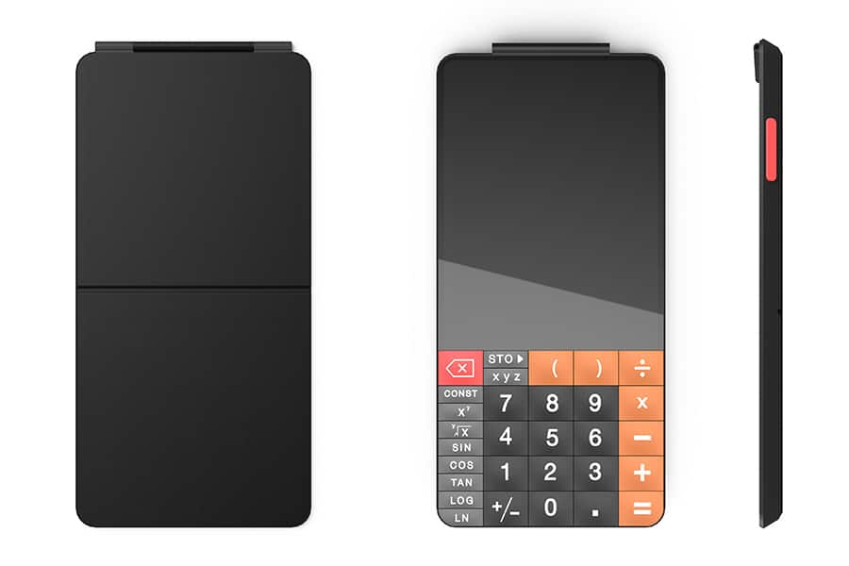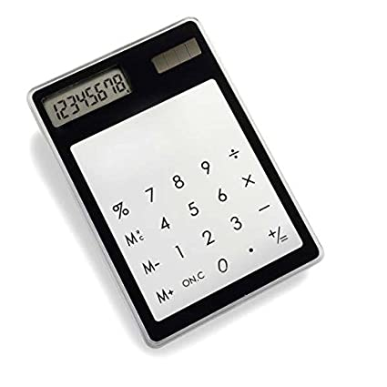

## **Cost and Features**

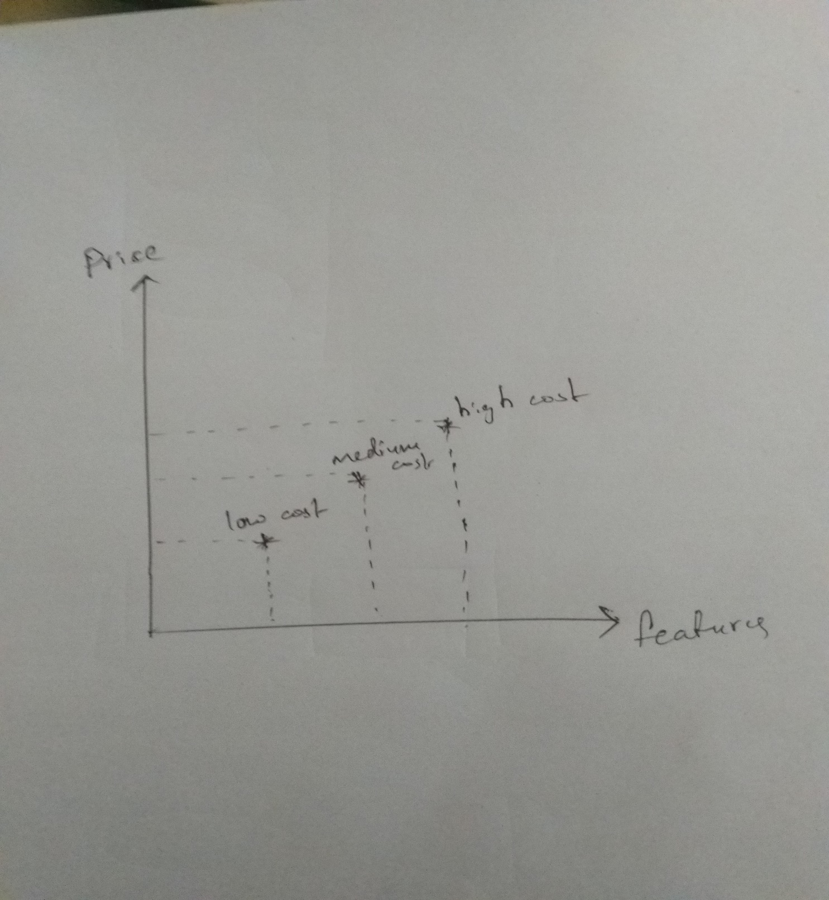

## **Defining Our System**

As the name describes that it is a smart calculator, it can do complex operations in less time and is user friendly we can do various type of operations in it. It has inputs for arithmetic calculations, temperature, conversion, dimension conversion and a lot more.

**SWOT ANALYSIS**

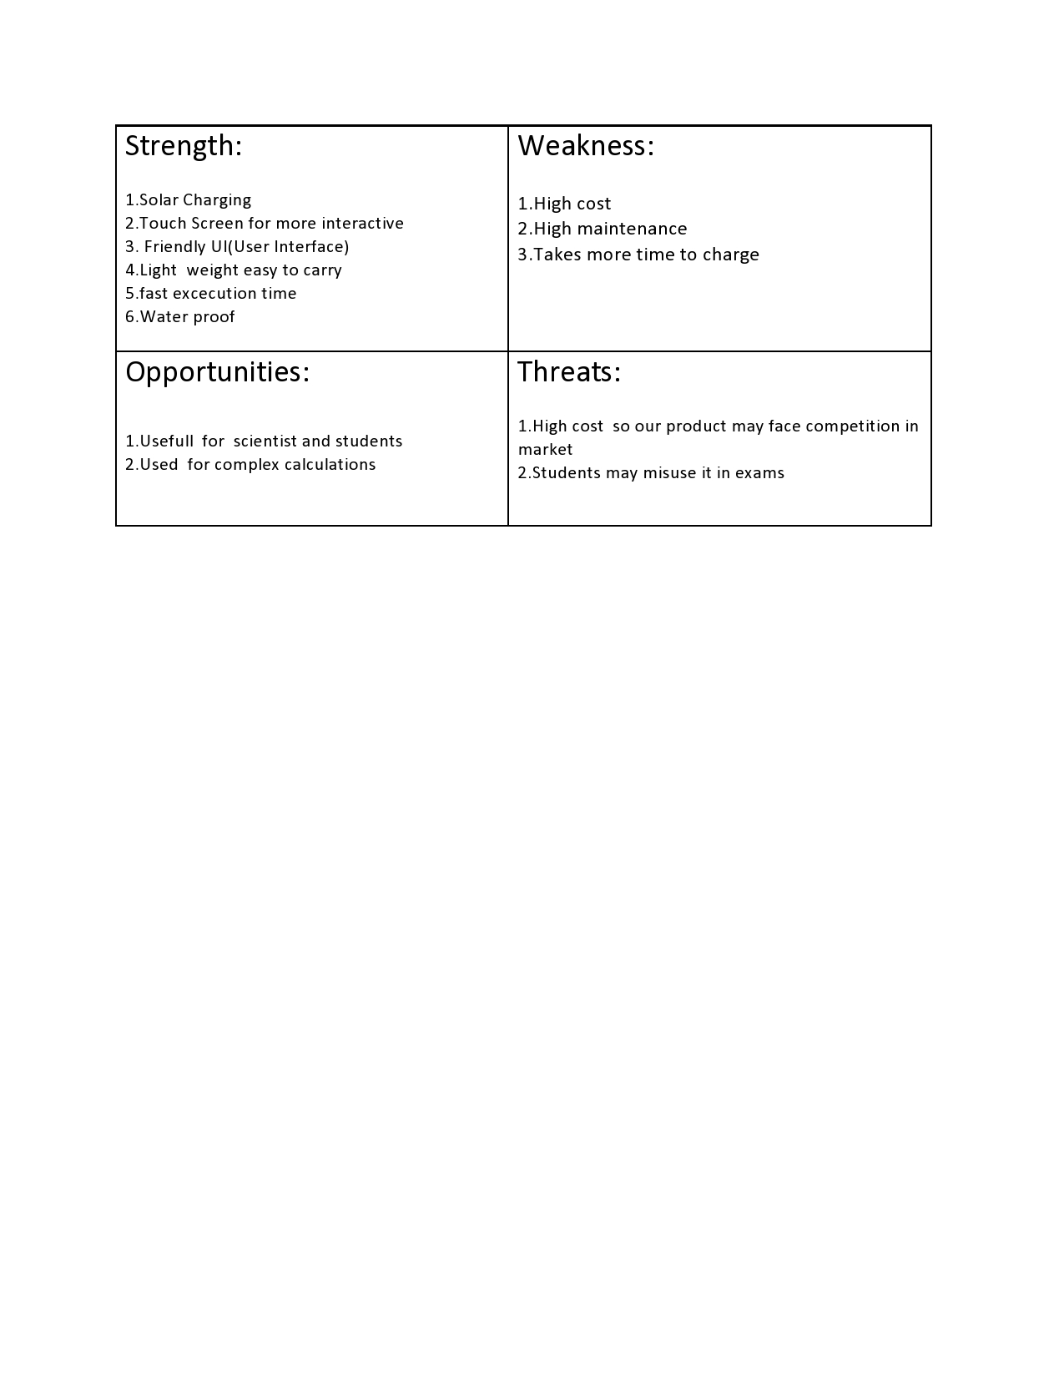

# 4W's and 1'H

## Who: Everyone can use this calculator especially scientist and students.

## What: It’s a smart scientific calculator.

## When: For fast, efficient and complex calculations.

## Where: Calculations, Statistics (comparing the previous data with present data).

## How: Easy to user interface.

# Detail requirements

# High Level Requirements:

* Arithmetic
* Area calculator
* Complex operation
* Trigonometric calculation
* Temperature conversion
* Volume calculation
* Discount calculation
* Interest calculation
* Length converter
* Square root function
* Matrix calculation
* Factorial calculation
* HCF
* LCM

## **Low level Requirements**:

* **Addition, subtraction, multiplication, division modules**
* **Length, breadth, height**
* **Fahrenheit, Celsius temperature values**
* **BODMAS**
* **formulae for trigonometric calculations**
* **Allow Digits 0-9.**

**High Level Diagram:**

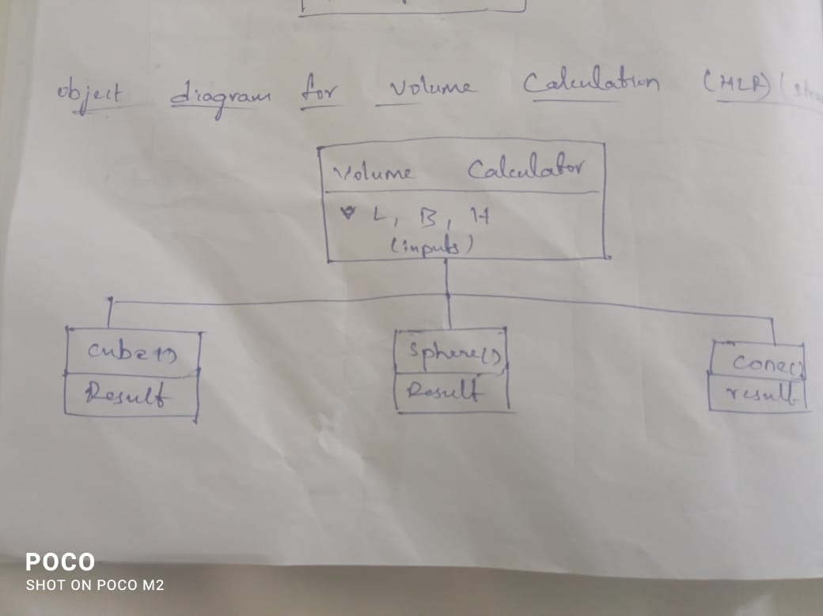

**Low level Diagram**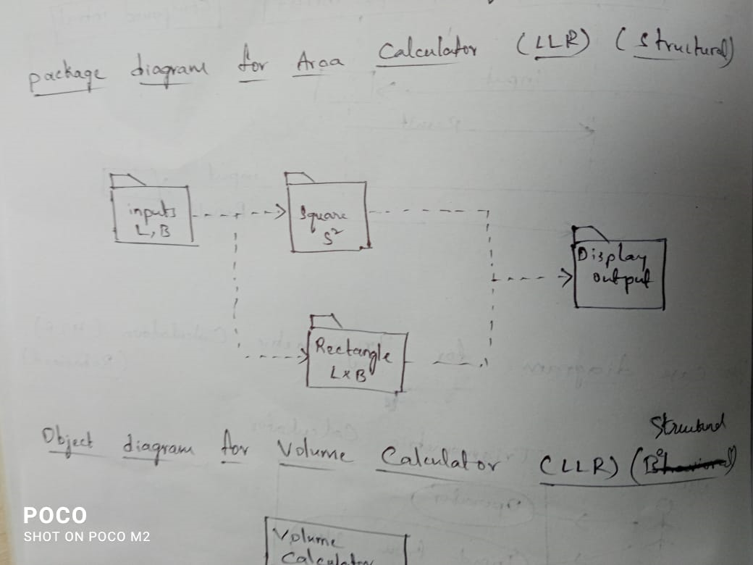

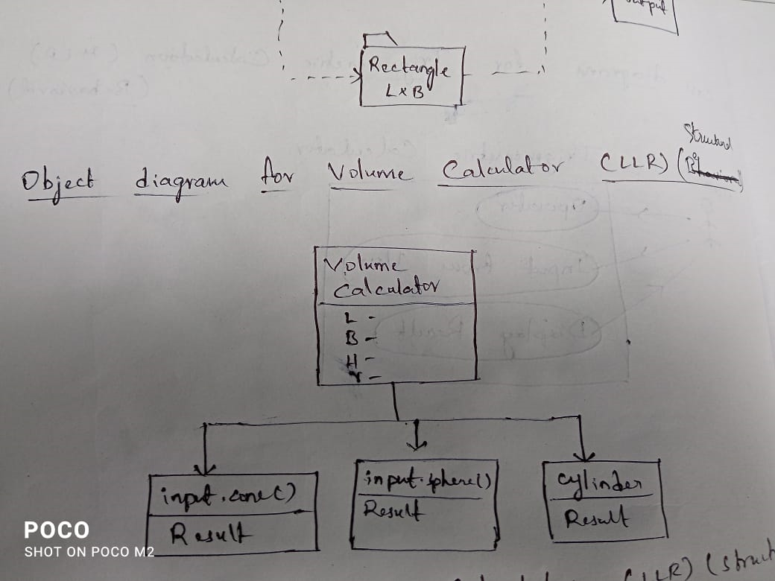

**Test Plan:**

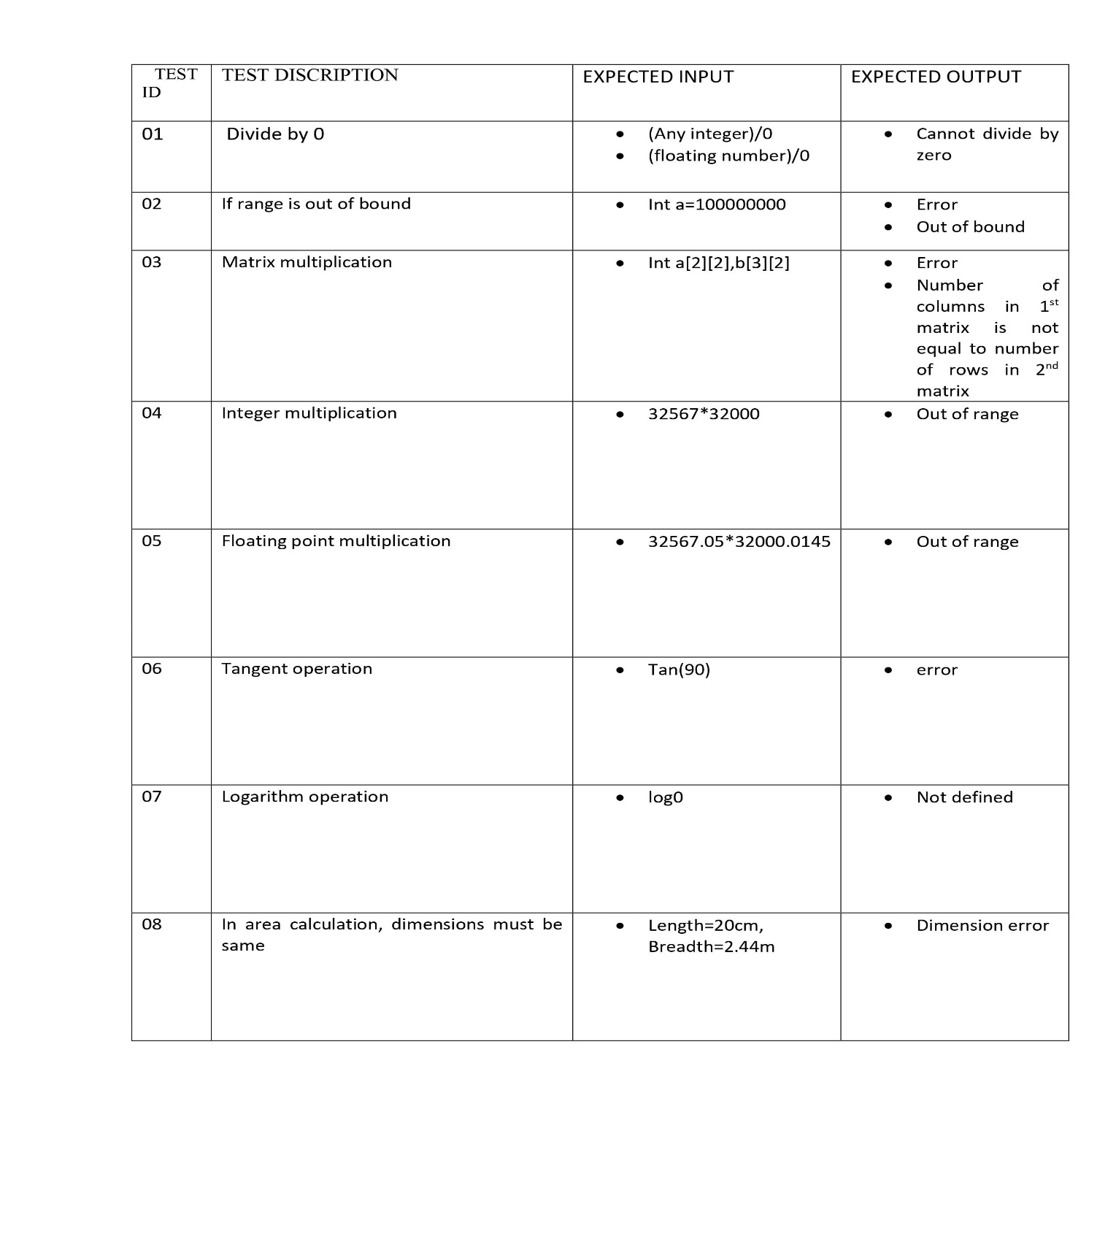

**Agile Methodologies:**

Agile software development refers to software development methodologies centered round the idea of iterative development, where requirements and solutions evolve through collaboration between self-organizing cross-functional teams. The ultimate value in Agile development is that it enables teams to deliver value faster, with greater quality and predictability, and greater aptitude to respond to change. Scrum and Kanban are two of the most widely used Agile methodologies.

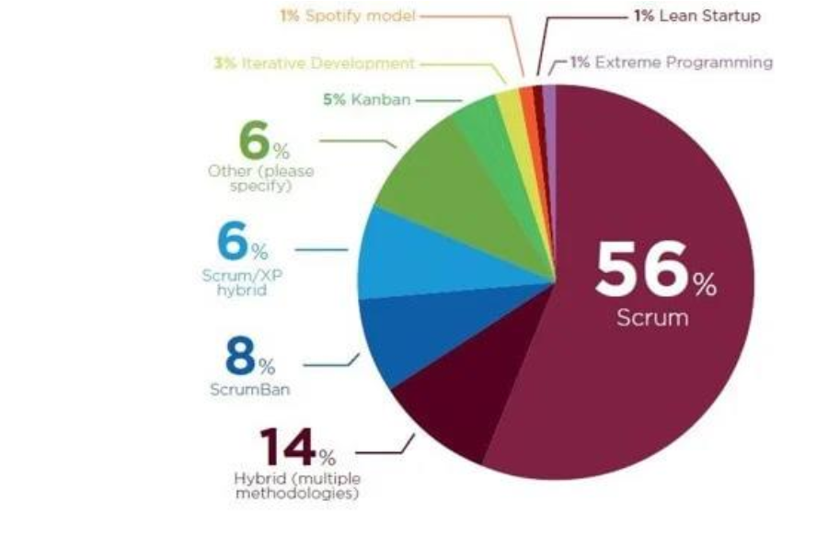

**Phases in Agile Model:**

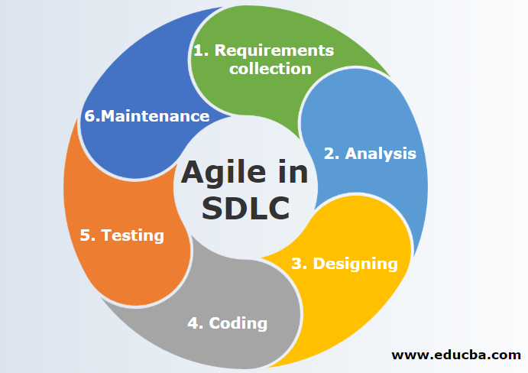

**GIT commits:**

