./

Learning Report – MBSE

Course Code: <CODE>



Version Number:

Team Members :

Team No:

Module: Model Based System Engineering

|  |  |  |  |  |  |
| --- | --- | --- | --- | --- | --- |
| **Ver. Rel. No.** | **Release Date** | **Prepared. By** | **Reviewed By** | **Approved By** | **Remarks/Revision Details** |
|  | 17-03-2021 | Kopparapu Jyothi Swaroopa Rani |  |  |  |
|  |  |  |  |  |  |
|  |  |  |  |  |  |
|  |  |  |  |  |  |
|  |  |  |  |  |  |

**Document History**

# 

Contents

**Activity 1** – MATLAB OnRamp 4

**Activity 2** –Simulink OnRamp 5

**Activity 3** – Stateflow OnRamp 6

**Activity 4** – Difference and Differential Equation 7

# Team Work

## **Activity 1** – MATLAB OnRamp

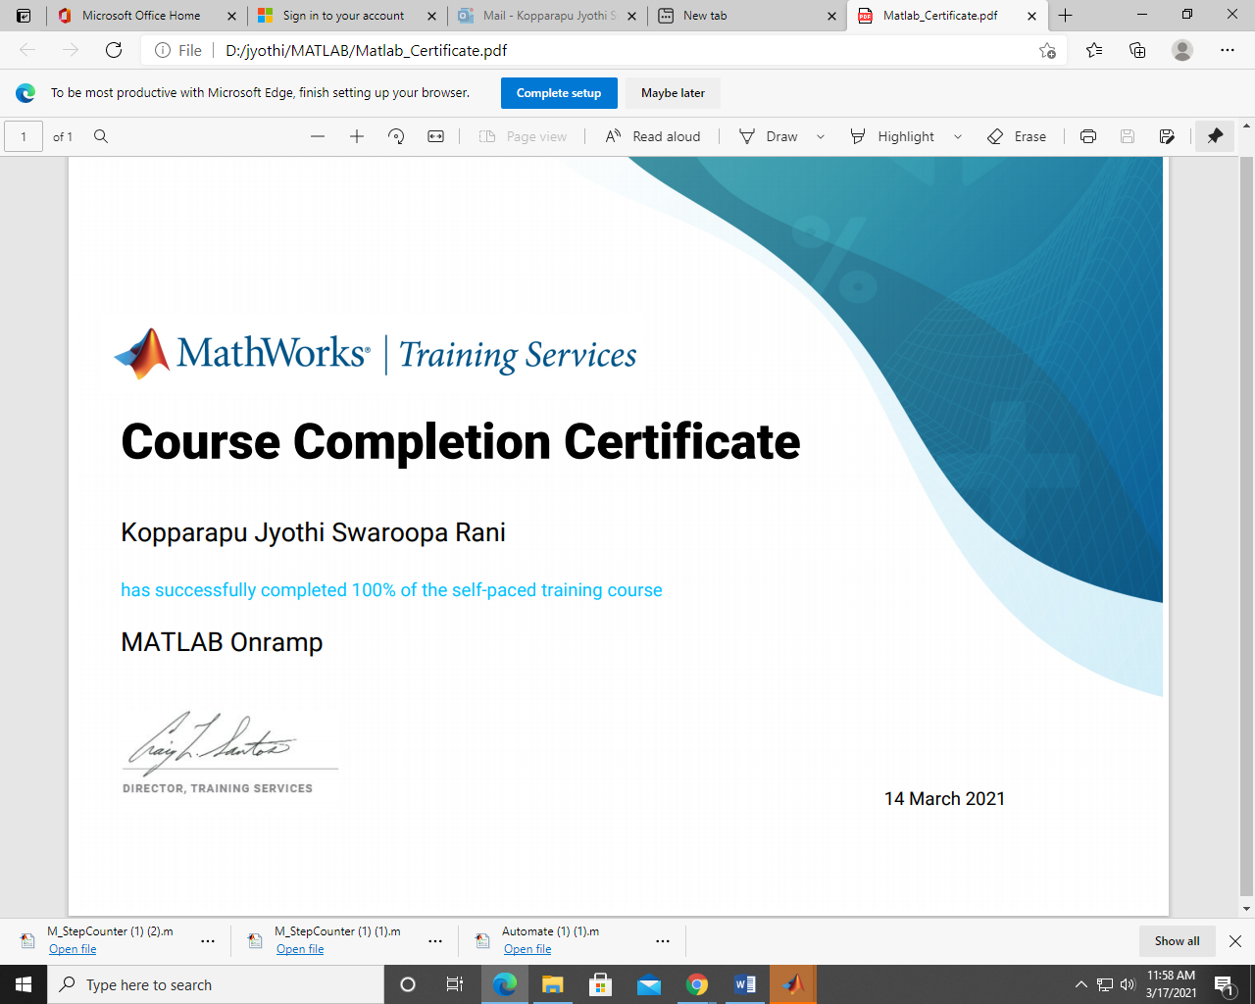

<https://matlabacademy.mathworks.com/progress/share/certificate.html?id=d593de68-7e3e-4a43-9af6-a5e974821788>

## 

## **Activity 2** – Simulink OnRamp

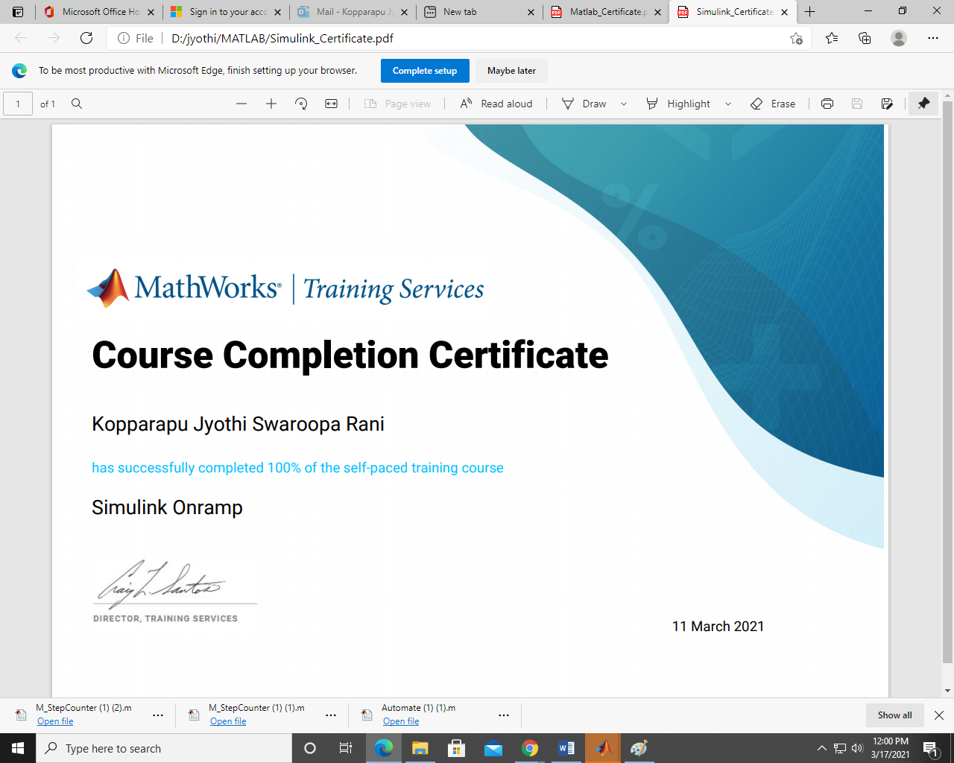

<https://matlabacademy.mathworks.com/progress/share/certificate.html?id=125e11be-a07a-4030-85dd-c6a3da55a1c5>

## 

## **Activity 3** – StateFlow OnRamp

## 

<https://matlabacademy.mathworks.com/progress/share/certificate.html?id=e0edc358-10be-44c7-a5b9-857f238b4d6c>

## 

## **Activity 4** – Differential and Difference Equation

4.1 Difference Equation:

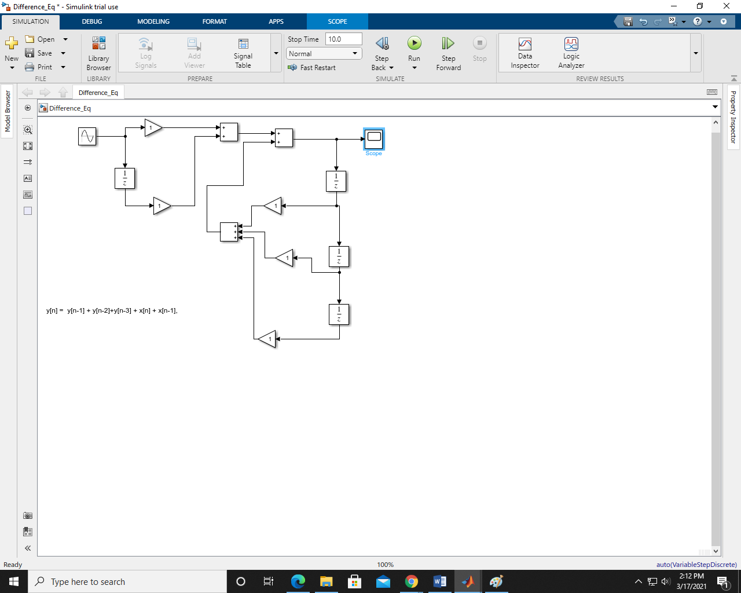

Output:

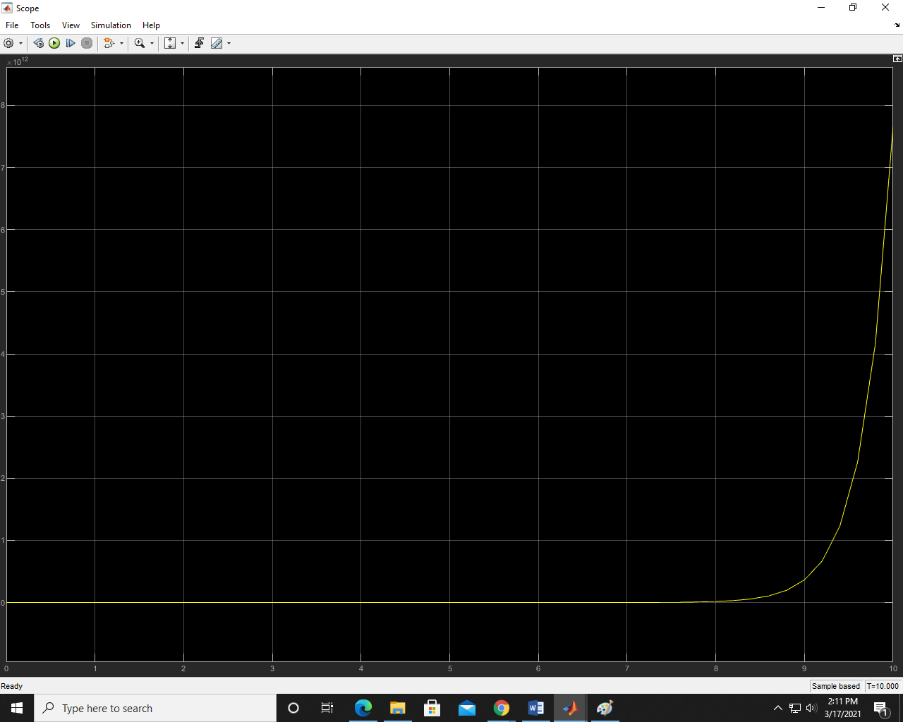

4.2 Differential Equation:

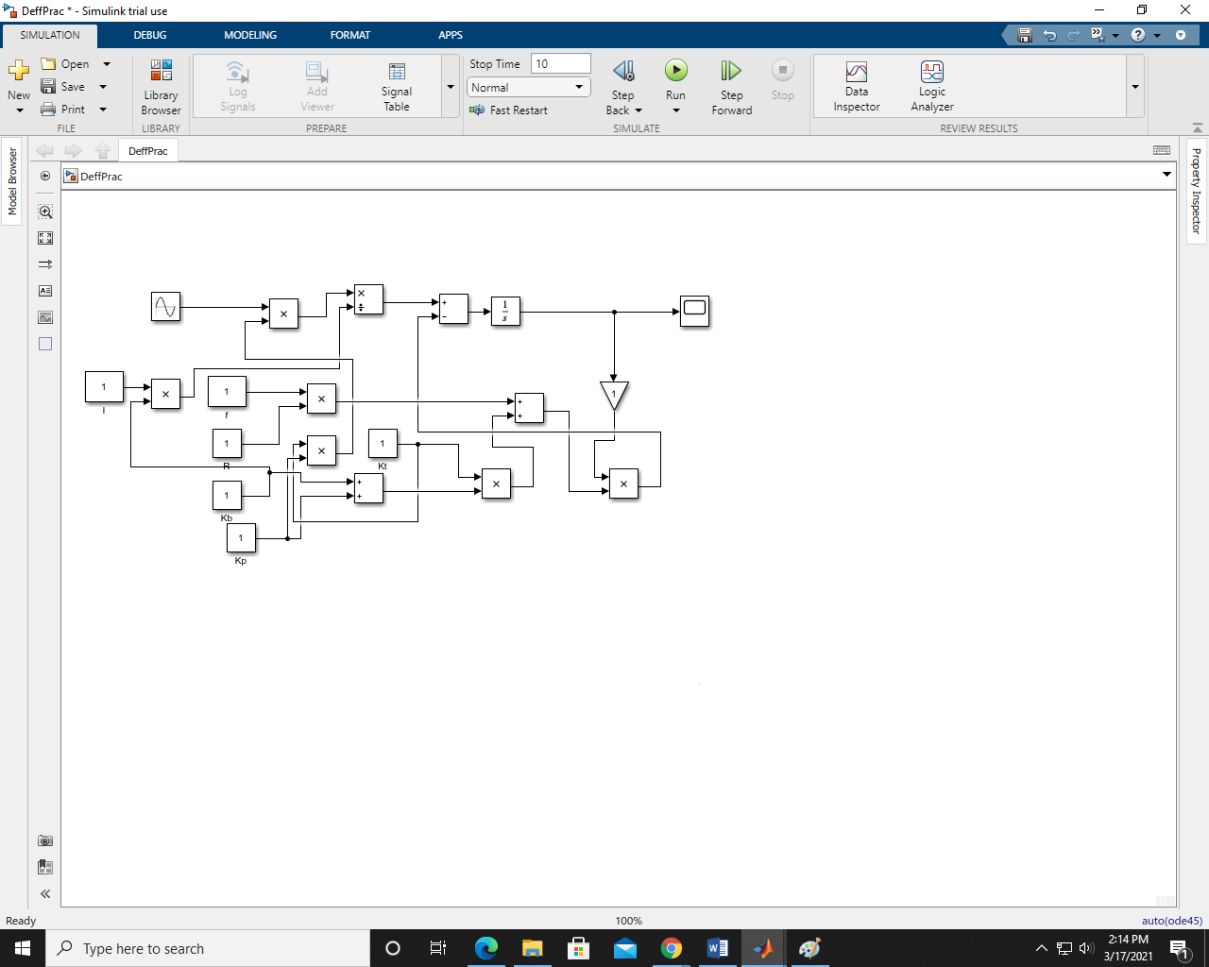

Output:

