LLR:-

1. Behavioral Diagrams:

Sequence Diagram:

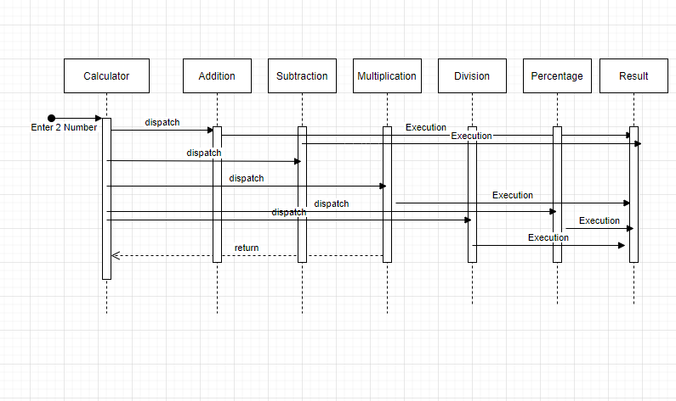

State diagram:

