./

Learning Report – C-PROGRAMMING



|  |  |  |  |  |  |
| --- | --- | --- | --- | --- | --- |
| **Ver. Rel. No.** | **Release Date** | **Prepared. By** | **Reviewed By** | **To be approved By** | **Remarks/Revision Details** |
| 1 |  | Name/PS No | Name/PS No | Module Owner Name | Comments |
| 2 | 20/02/21 | 99003726 |  |  |  |
|  |  |  |  |  |  |
|  |  |  |  |  |  |
|  |  |  |  |  |  |

**Document History**

Table of Contents

ACTIVITY 1……………………………………………………………………………………………………………………………………………………………………4

BASIC OF C PROGRAMMING……………..…………………………...………………………………………………………………………………………4

LEARNING CERIFICATE ON SOLOLEARN…………………………………………………………………………………………………………………….7

ACTIVITY 2……….…………………………………………………………………………………………………………………………………………………………8

FIRST PROGRAM …………………..………………………………………………………………………………………………………………………………..8

SECOND PROGRAM……………………………………………………………………………………………………………….………………………………..9

GITHUB……………………………………………………………………………………………………………………………………….…………………………10

Table of Figures 3

Table of Tables 3

## Table of Figures

Figure 1 C Programming Sololearn Certificate 7

Figure 2 Git Repository 10

## Table of Tables

Table 1 Basic Commands 4

Table 2 Section Description 6

**ACTIVITY 1**

**C-PROGRAMMING**

**Introduction to C Programming :**

C is a procedural programming language which was initially developed by Dennis Ritchie in the year 1972. The important characteristics of this language includes a clean style, low level access to memory, simple set of keywords, which makes this language very acceptable for programmers. Following is a list of commands and syntax used in c programming with explanation:

**Table 1: Commands**

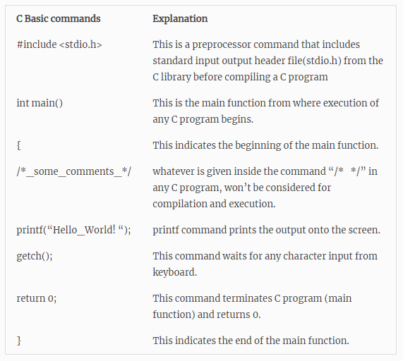

**Programming for beginners:**

The Hello world program shown below displays “Hello World” in the output. Every program statement terminates with a semicolon (;) and so it is known as statement terminator. Also C program is a case sensitive language. So upper case and lower case affects the programming.

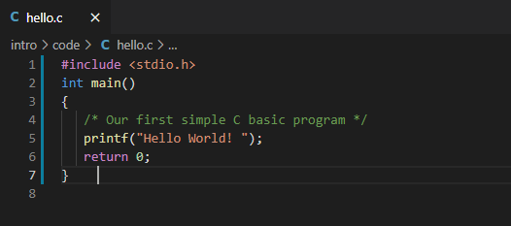

OUTPUT:

Hello World

**STEPS FOR COMPILING AND RUNNING A C PROGRAM:**

**Following are the steps required to create and get the output of any C program. The steps are common to all the programming language with no exception. No matter whether the code is large or small.**

**Coding**

**Compiling**

**Executing and running**

**Generating the output**

**WRITING COMPILING AND EXECUTION OF A C PROGRAM**

1. Prior Requirement: For creation, compilation and execution of C Program, it is necessary to have a compiler like gcc. For the course we used GCC compiler on platform called as Visual Studio code

**BASIC STRUCTURE OF A PROGRAM**

All programs has different section or parts which has its own function. Each section is used by the programmer with a set of protocols which define the structure of C program.

Below are the set of Functions:

Main Function

Definition section

Function prototype declaration section

Documentation Section

Link Section

Global Declaration section

User defined function definition section

**Table 2: Section Description**

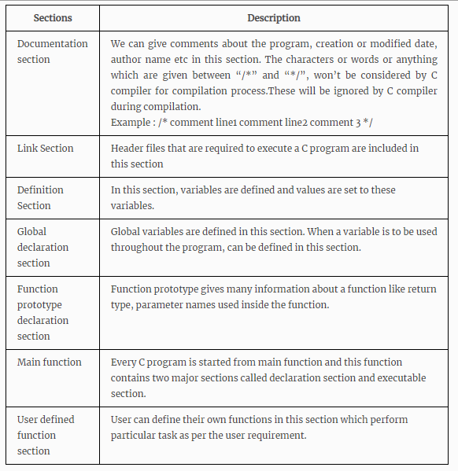

**Learning Certificate on SOLOLEARN:**

Below is the certificate on sololearn:

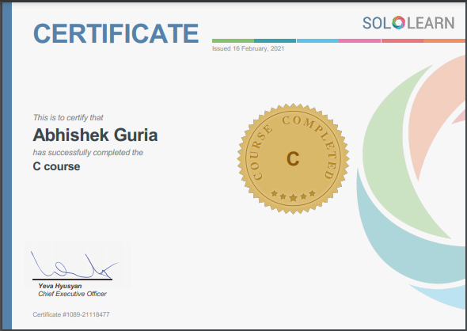

**Figure 1: C Program Learning Certificate**

**ACTIVITY 2**

**C-PROGRAMS**

**Program 1:- Write a program to break the given string and return the correct string between ‘$’ and ‘;’**

**Ex 1: Input “Garbage$Welcome to LTTS;ignore”**

**Output: “&Welcome to LTTS;”**

**Ex2: Input “Hello$This is $$an example #2string;And filled with words”**

**Output: “$an example #2string;”**

**Code:**

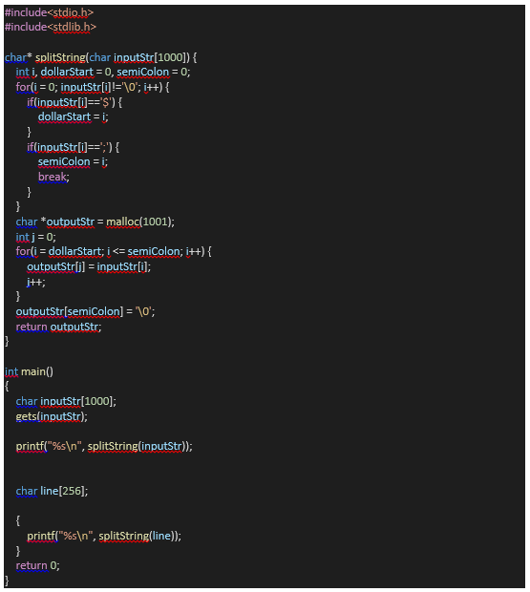

**Program 2: In program 1 pass the input string after reading from the file.**

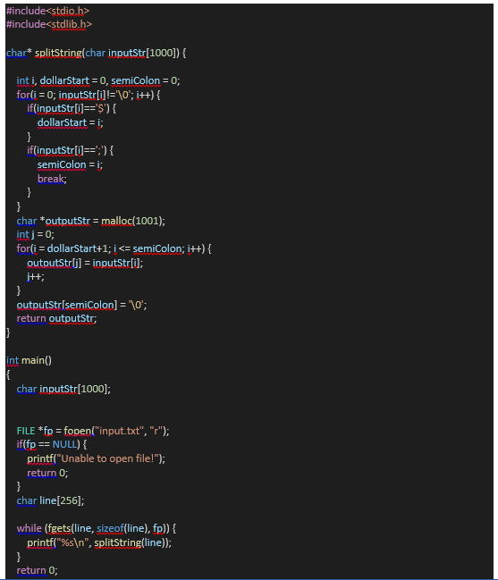

**GitHub :**

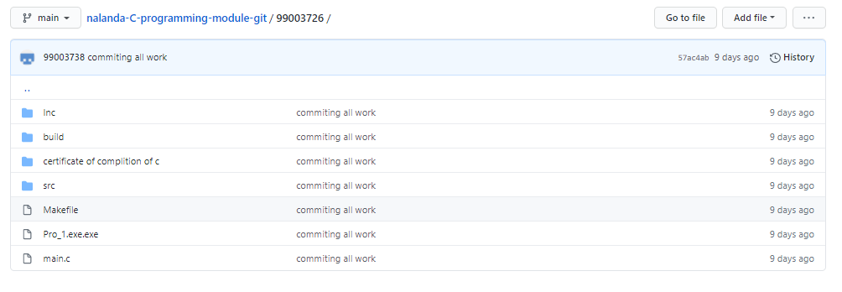

**Figure 2: Git Repository**