Hood Release MODULE

Requirements:

1. Hood switch or lever
2. Cable
3. Secondary latch

Flow chart:

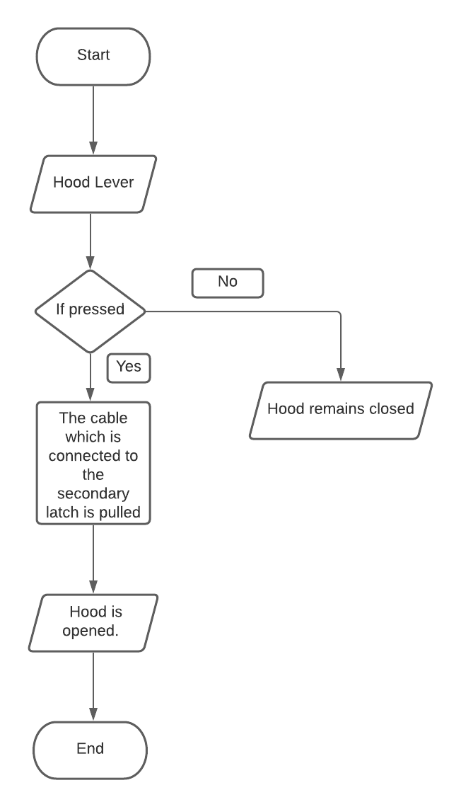

Data Sheet: