./

Learning Report – Automotive System and Overview



|  |  |  |  |  |  |
| --- | --- | --- | --- | --- | --- |
| **Ver. Rel. No.** | **Release Date** | **Prepared. By** | **Reviewed By** | **To be approved By** | **Remarks/Revision Details** |
| 1 |  | Name/PS No | Name/PS No | Module Owner Name | Comments |
| 2 | 19/03/2021 | Santosh/99003761 |  |  |  |
| 3 |  |  |  |  |  |
|  |  |  |  |  |  |
|  |  |  |  |  |  |

**Document History**

Table of Contents

Table of Figures 3

Table of Tables 4

ACTIVITY 1: SYSTEM/ SOFTWARE DEVELOPMENT 4

**INTRODUCTION** 5

**MY PRODUCT: “Name ”** 5

**SWOT ANALYSIS** 5

**REQUIREMENTS** 6

**DESIGN** 8

HIGH LEVEL DESIGN 8

LOW LEVEL DESIGN 9

**TEST PLANS** 10

**REFERENCES**

ACTIVITY 2: AGILE METHODOLOGY 11

**THEME**

**EPIC**

**USER STORY**

**REFERENCES**

APPENDIX:

## Table of Figures

Figure 1 CLASS DIAGRAM(HIGH LEVEL) 10

Figure 2 USE CASE DIAGRAM (HIGH LEVEL) 11

Figure 3 ACTIVITY DIAGRAM (HIGH LEVEL) 12

Figure 4 USE CASE DIAGRAM (LOW LEVEL) 12

Figure 5 ACTVITY DIAGRAM (LOW LEVEL) 13

Figure 6 BLOCK DIAGRAM 13

Figure 7 COMPONENT DIAGRAM (HIGH LEVEL) 22

Figure 8 ACTIVITY DIAGRAM (high level) 23

[Figure 9 ACTIVITY DIAGRAM (LOW LEVEL) 24](https://lnttsgroup.sharepoint.com/sites/GEA/Global%20Engineering%20Academy/GEA%20Insights/Genesis/Shared%20Documents/Submission/MYSORE/2009MYSEMB/Foundation/Applied%20SDLC%20with%20Software%20Testing/99002439/FINAL.docx#_Toc52177322)

Figure 10- ACTIVITY DIAGRAM (LOW LEVEL) 24

Figure 11 TEST PLAN 25

Figure 12 GIT 27

Figure 13 GIT ISSUES 28

Figure 14 GIT COMMITS 1 28

Figure 15 GIT COMMIT 2 29

Figure 16 GIT 30

Figure 17 GIT MAKE 31

Figure 18 GIT MAKE 2 31

Figure 19 GIT BUILD 32

Figure 20 GIT CODE QUALITY 32

## Table of Tables

Table 1 AGING 6

Table 2 GRADING COST 6

Table 3 REQUIREMENTS 8

Table 4 HIGH LEVEL TEST PLAN 15

Table 5 LOW LEVEL TEST PLAN 16

Table 6 USER STORIES 17

Table 7 AGING 19

Table 8 GRADING COST 19

Table 9 REQUIREMENTS 21

Table 10 USER STORIES 27

## **Introduction**

Windscreen wiper is essential for keeping the windscreen sufficiently clean for driver’s visibility specifically for modern high-speed vehicles. The washer cleans the driver’s side of the windscreen whenever required.

A **windscreen wiper** or **windshield wiper** is a device used to remove rain, snow, ice, washer fluid, water, and/or debris from a [vehicle's front window](https://en.wikipedia.org/wiki/Windscreen) so the vehicle's operator can better see what's ahead of them. Almost all [motor vehicles](https://en.wikipedia.org/wiki/Motor_vehicle), including [cars](https://en.wikipedia.org/wiki/Car), [trucks](https://en.wikipedia.org/wiki/Truck), [buses](https://en.wikipedia.org/wiki/Bus), [train](https://en.wikipedia.org/wiki/Train) [locomotives](https://en.wikipedia.org/wiki/Locomotive), and [watercraft](https://en.wikipedia.org/wiki/Watercraft) with a [cabin](https://en.wikipedia.org/wiki/Cabin_(ship))—and some [aircraft](https://en.wikipedia.org/wiki/Aircraft)—are equipped with one or more such wipers, which are usually a legal requirement.

**MY FEATURE: Wind Shield Wiper System**

# ****Research and literature Survey :****

**Selected Model: GMC 2020 Sierra Denali**

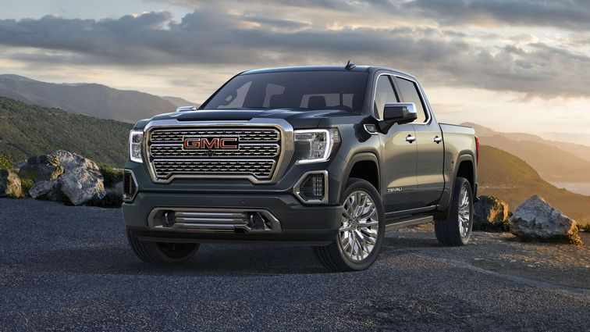

Image Source: <https://cnet1.cbsistatic.com/img/b4stHD0WB4wnELJpmnprXjd-t00=/756x425/2019/08/27/d8e894db-9c00-48fa-9fa3-4e1a50eb8fed/sierra-promo.jpg>

**BCM Feature Selected: Wind Shield Wiper System**

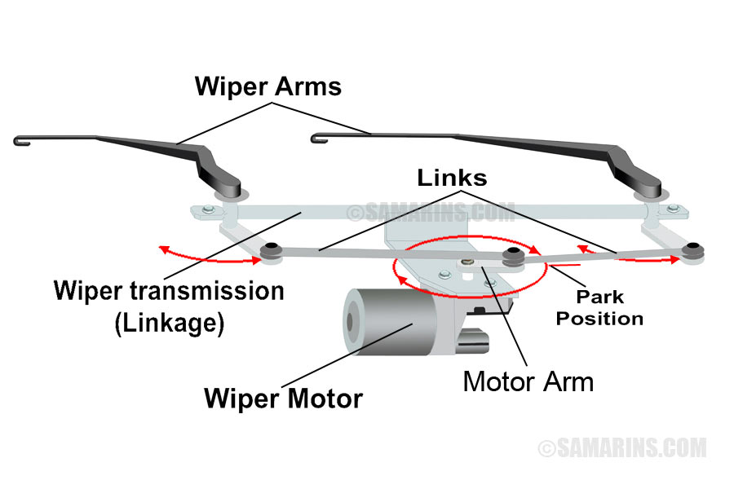

Image Source: <https://www.samarins.com/glossary/img/wiper-mechanism-large.jpg>

**ACTIVITY-2: FEATURE WORKING**

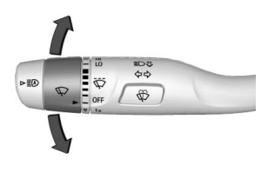

Image Source: 2020-gmc-sierra-owners-manual.pdf

Link: <https://cdn.dealereprocess.org/cdn/servicemanuals/gmc/2020-sierra1500.pdf>

* The windshield wiper control is on the turn signal lever.
* The windshield wipers are controlled by turning the band with N on it.

With the ignition on or in ACC/ ACCESSORY, turn the N band to select the wiper speed.

* **HI**: Use for fast wipes.
* **LO**: Use for slow wipes.
* : Turn the band up for more frequent intermittent wipes or down for less

frequent intermittent wipes.

* **OFF**: Use to turn the wipers off.
* **1x**: For a single wipe, briefly turn the N band down. For several wipes, hold

the band down.

* : Press  on the windshield wiper control to spray windshield washer fluid and activate the wipers. The wipers will continue until  is released or the maximum wash time is reached. When  is released, additional wipes may occur depending on how long the windshield washer had been activated.

**Identification of INPUTS and OUTPUTS**

**INPUTS:**

* **User inputs**
  + **HI –** From 4 position Rotary Switch
  + **LO -** From 4 position Rotary Switch.
  + **-** From 4 position Rotary Switch.
  + **OFF -** From 4 position Rotary Switch.
  + **1x –** From Push Button in Rotary Switch.
  + **-** From Push Button.

**OUPUTS:**

* Wiper Motor Control according to User inputs.
* Water Pump Control.

**Wiper Motor Characteristics:**

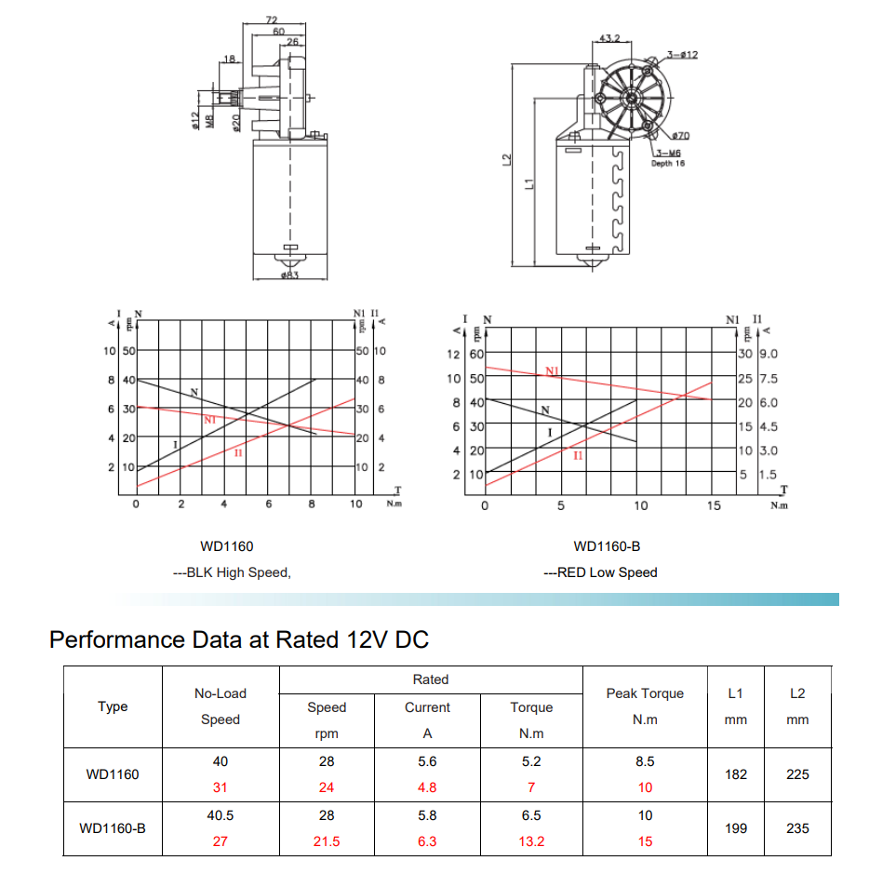

## **Motor Pump Characteristics:**

**Algorithms**

## 

## **SWOT ANALYSIS**

# ****SWOT- Strengths, and Weakness, Opportunities Threats****

|  |  |
| --- | --- |
| **Strengths:**   * **User friendly.** * **5 different modes of wipes.** * **Sufficiently removes rain water, snow, ice, washer liquid etc.** | **Weakness:**   * **Doesn’t have automatic operation.** * **No other means of control than the wiper lever.** |
| **Opportunities**   * It can be expanded to automated system   Like using rain sensor system operates automatic. | **Threats**   * **Motor failure** * **Wiper blade damages** |

# Detail requirements

# ****High Level Requirements****

| **High level Requirement** | **Description** |
| --- | --- |
| HLR1 | Wiper ON and OFF |
| HLR2 | Wiper Mode Control |
| HLR3 | Single wipe and several wipes |
| HLR4 | Spray windshield washer fluid and Activate the wipers |

# ****Low-Level Requirements****

| **Low level Requirement** | **Description** |
| --- | --- |
| LLR1 | Rotary switch to start and select wiper Mode |
| LLR2 | Push Button to turn on the washer fluid pump |
| LLR3 | Control wiper motor speed for different speed |

**UML Diagrams:**

1. **High Level Requirements.**
2. **Low level Diagram.**

**Test Plans:**