./

Learning Report – Applied System Development Life Cycle and Software Testing



|  |  |  |  |  |  |
| --- | --- | --- | --- | --- | --- |
| **Ver.Rel. No.** | **Release Date** | **Prepared. By** | **Reviewed By** | **To be approved By** | **Remarks/Revision Details** |
| 1 | 15.02.2021 | SOURAV DEY | AMIYA KUMAR PANDA | SRINIVAS  KAPALA  PRITHVI SEKHAR |  |
| 2 | 15.02.2021 | SOURAV DEY | KOPPARAPU JYOTHI SWAROOPA RANI | SRINIVAS  KAPALA  PRITHVI SEKHAR |  |
|  |  |  |  |  |  |
|  |  |  |  |  |  |
|  |  |  |  |  |  |

**Document History**

Table of Contents

Table of Figures 3

Table of Tables 4

ACTIVITY 1: SYSTEM/ SOFTWARE DEVELOPMENT 4

**INTRODUCTION** 4

**MY PRODUCT: “Name ”** 6

**SWOT ANALYSIS** 7

**REQUIREMENTS** 7

**DESIGN** 8

HIGH LEVEL DESIGN 8

LOW LEVEL DESIGN 11

**TEST PLANS** 13

**REFERENCES** 15

ACTIVITY 2: AGILE METHODOLOGY 15

**THEME** 15

**EPIC** 15

**USER STORY** 16

**REFERENCES** 17

APPENDIX: 17

## Table of Figures

Figure 1 ACTIVITY DIAGRAM (HIGH LEVEL) ………………………………………………………………………………………………..….09

Figure 2 USE CASE DIAGRAM (LOW LEVEL)…………………………………………………………………………………………………….10

Figure 3 CLASS DIAGRAM (LOW LEVEL) …………………………………………………………………………………………………………11

Figure 4 TEST PALN………………………………………………………………………………………………………………………………………..12

Figure 5 GIT 16

Figure 6 GIT ISSUES 17

Figure 7 GIT COMMITS 1 18

Figure 8 GIT COMMIT 2 19

## Table of Tables

Table 3 REQUIREMENTS (HLR AND LLR) 06

Table 4 HIGH LEVEL TEST PLAN 15

Table 5 LOW LEVEL TEST PLAN 16

**INTRODUCTION:**

Heating, ventilation and air conditioning (HVAC) is the technology for indoor and automotive ambient comfort. HVAC facilitates in managing the pleasant climate inside the cabin by controlling the degree of hotness/coolness.

There were times when having an air conditioner in a car was considered one of the big features, but today air conditioners have become standard equipment even in entry-level automobiles. The desire for even more comfort and luxury has led to the development of the climate control system inside an automobile. The primary purpose of automatic climate control is to manage the temperature of a given area for the comfort of onboard passengers.

**Literary Survey & Research:**

GMC SEIRRA

HVAC Module (Manual) – AC part only

User interface:

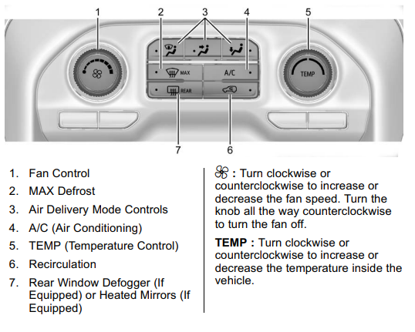

Classification:

Input:

1. Switches for human interface
2. Rotary Switches used in HVAC
3. Temp Sensor
4. Humidity Sensor

Switches for human interface:

* V series Rotary switch (3 position)
* AVH switches

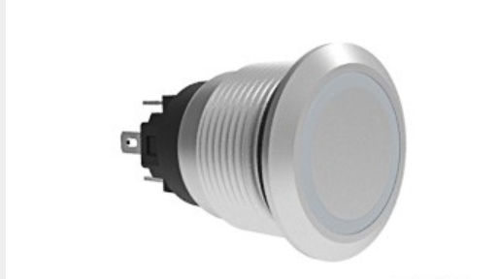

Temperature Sensors:

|  |  |  |  |  |  |
| --- | --- | --- | --- | --- | --- |
| Sensor_Name | Op_temp_range | Max_dissipation | Linearity | Op_current | Power |
| NTCLE203E3..SB0(NTC) | -55°C to +150 °C | 100mW | 25°C to 85°C | 2mA-5mA | 4V to 5V |
| HEL 700 series(RTD) | -70°C to +260°C | <15mW | -40°C to125°C | 2mA | 4V to 6V |
| LM 35(LM series) | -55°C to +150°C | Low self-heating | Full range | 10 mA | 4V to 5.5V |

* NTC: NTCLE203E3...SB0 – NTC Thermistor, 2-point radial leaded, Automotive Grade.

Features:

Operating temperature range: -55-degree C to + 150-degree C.

Maximum Dissipation: 100 mW

Response time: 7 secs

Resistance at 25-degree C: 2.06k to 30k

Accuracy between 25-degree C to 85-degree C: + or – 0.5-degree C

RTD: HEL 700 Series – Thin film platinum RTDs

Features:

Operating temperature Range: -70 °C to 260 °C

Maximum Dissipation: < 15 mW (self-heating)

Operating current: 2 mA

Linearity (-40 °C to 125 °C): ±0.1% of full scale

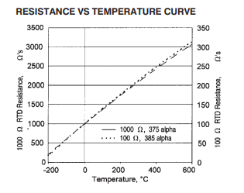

* **LM series: LM 35**

Features:

Operating temperature range: –55°Cto 150°C

Maximum dissipation:

Operating current: 10 mA

Power supply: 4V to 5.5V

Humidity Sensor datasheets:

|  |  |  |  |
| --- | --- | --- | --- |
| Sensor_Name | Op_temp_range | Operating_voltage | Power_dissipation |
| HDC1008 | -20°C to 60 °C | 2.7 v to 5.5 v | 150 uW |
| HTU21D(F) | -40 to +125 °C | 3.8 v | 2.7 uW |
|  |  |  |  |

Humidity Sensors:

* HDC1008:

Features:

Operating range: -20°C to 60 °C

Operating voltage: Nominal: 3V; Range: 2.7V to 5.5V

* HTU21D(F):

Features:

Operating range: -40 to +125 °C

Supply voltage: 3.8V

Power dissipation: 2.7uW

Algorithms:

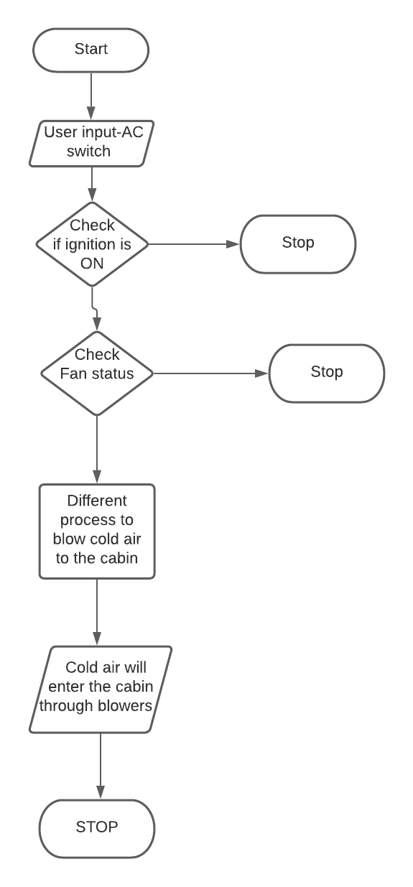

Fig: AC working

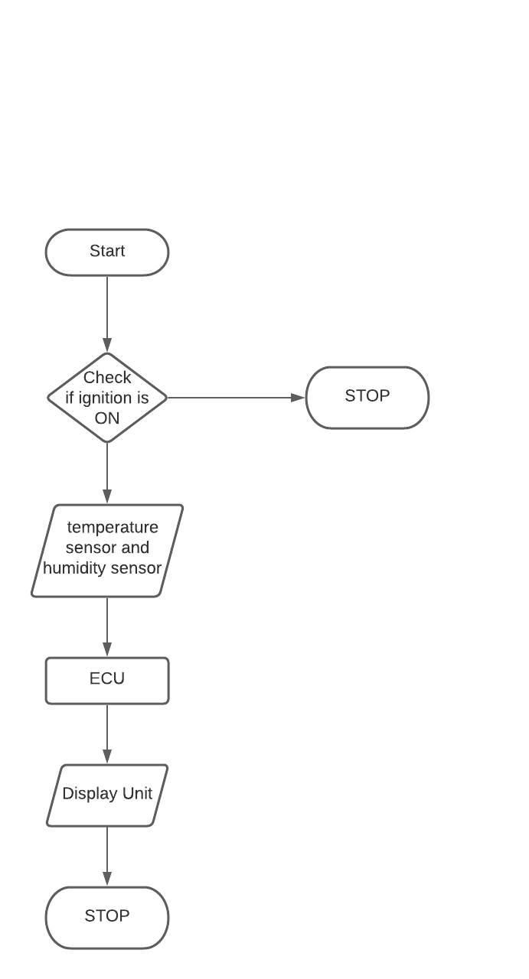

Fig: Calculation of Room temperature and humidity inside the cabin.

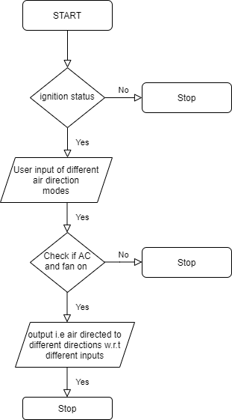

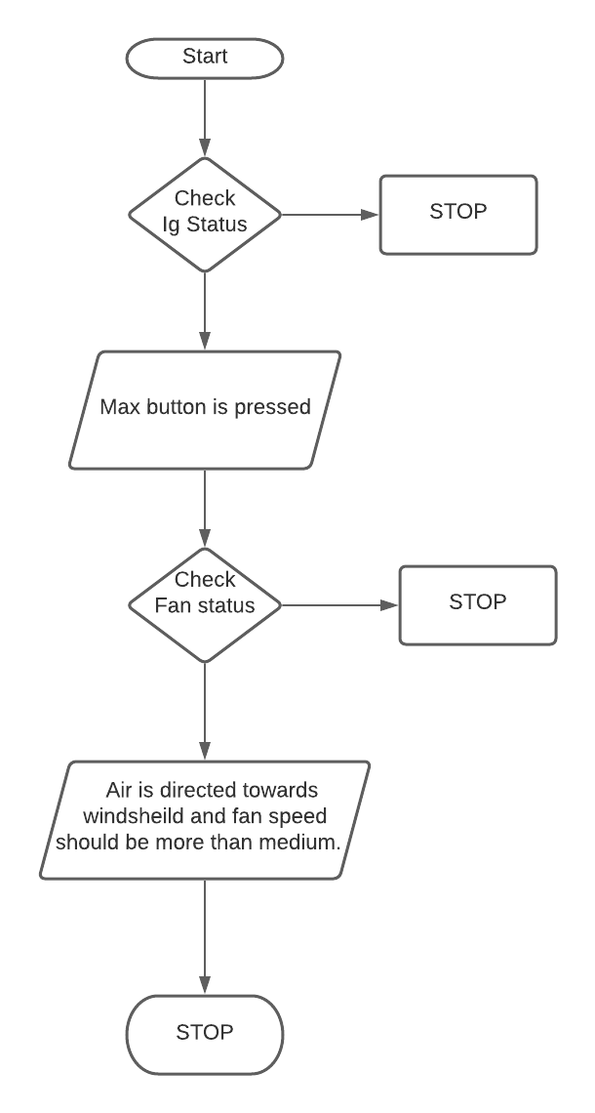

Output:

* The cooled air will reach the cabin through blowers.

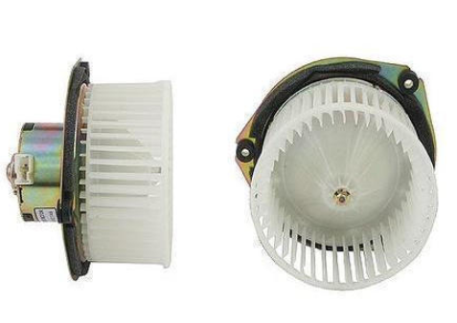

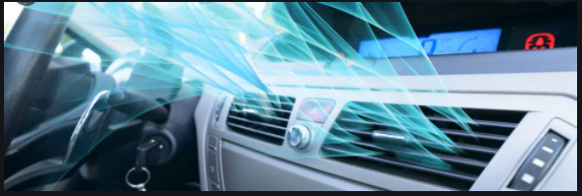

* The temperature and humidity of the car will be displayed in the dashboard.

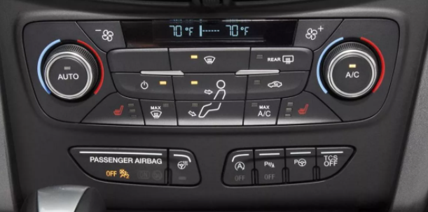

**FEATURE:**

The feature which I have selected is the HVAC module of GMC Seirra truck. This document covers only the working of AC part of total HVAC system. GMC Sierra has two types of HVAC system:

1. Manual HVAC
2. Automated HVAC

This document covers only the manual working of the HVAC system. In this module, the control of interface is given to the user i.e. the driver or the passenger must manually switch ON the AC button.

The AC would not work unless the fan of HVAC system is switched ON. There are three different modes to control the direction of the air inside the cabin.

Moreover, there is a recirculation button which cools the car as fast as possible.

The HVAC module also provides a “rear defogger” button that provides air (non-humid) to the rear wind shield. The operation of this button is to remove the fog created in the rear wind shield.

**SWOT:**

|  |  |
| --- | --- |
| **STRENGTH**   * To provide comfort to the driver and passengers by maintaining the temperature inside the cabin. * Less cost than manual HVAC. | **WEAKNESS**   * The driver or the passengers need to provide the modes to control the climate inside the car. (i.e. it is manual not automatic) * More fuel consumption. |
| **OPPERTUNITIES**   * Large market size in India. * Temperature conditions in subcontinent regions. | **THREATS**   * Existence of strong competitor. |

**REQUIREMENTS:**

HIGH LEVEL REQUIREMENTS:

|  |  |
| --- | --- |
| HLR_1 | When the driver or passenger turn on the AC and fan switch, then cool air must enter the cabin of the car through blowers. The ignition should be switched on. |
| HLR_2 | Fan rotary switch must control the speed of air entering the cabin. |
| HLR_3 | The temperature rotary switch must control the temperature of the air entering the cabin. |

LOW LEVEL REQUIREMENTS:

|  |  |
| --- | --- |
| LLR_1 | If AC is switched ON and fan is not switched ON then the AC should not work. |
| LLR_2 | The temperature sensor present below and above the cabin will monitor the temperature and its output is current, which is send to ECU that will convert the current into equivalent temperature. This value is displayed in the dashboard. |
| LLR_3 | The humidity sensor present in the cabin will calculate the humidity and the result will be displayed in the dashboard via ECU. |
| LLR_4 | When the recirculation switch is pressed then the cabin of the car must get cool at a faster rate. Here the fan speed must increase and the temperature of the air must decrease. |
| LLR_5 | Air delivery mode buttons present in the dashboard must start and stop the respective blowers in the respective directions. |
| LLR_6 | When Rear window defogger button is pressed, humid less air must enter the cabin and the fog created in the rear window must be removed. Here the fan speed should also increase. It must run when the engine is on. |
| LLR_7 | When the max button is pressed, air is directed towards the windshield and the fan runs at a higher speed if not above a medium fan speed. |

**UML:**

**TEST PLAN:**

|  |  |  |  |  |  |
| --- | --- | --- | --- | --- | --- |
|  |  |  |  |  |  |
|  |  |  |  |  |  |
|  |  |  |  |  |  |

**Reference:**

LM-35:https://robu.in/wp-content/uploads/2018/12/lm35-Datasheet.pdf

NTC - https://www.vishay.com/docs/29048/ntcle203.pdf