./

Learning Report – MBSE

Course Code: <CODE>



|  |  |  |  |  |  |
| --- | --- | --- | --- | --- | --- |
| **Ver.Rel. No.** | **Release Date** | **Prepared. By** | **Reviewed By** | **Approved By** | **Remarks/Revision Details** |
| 1. | 16-03-21 | Sourav Dey |  |  |  |
|  |  |  |  |  |  |
|  |  |  |  |  |  |
|  |  |  |  |  |  |
|  |  |  |  |  |  |

**Document History**

# 

Contents

BODY CONTROL MODULE 3

**Activity 1** – DIFFERENTIAL EQUATION 4

**Activity 2** – DIFFERENCE EQUATION 5

**Activity 4** – Complete Matlab Onramp 7

Activity 5 - Complete Simulink Onramp……………………………………………………………………………………………………………………………8

Activity6 - Complete Stateflow Onramp…………………………………………………………………………………………………………………………9

**ACTIVITY-1: DIFFERENTIAL EQUATIONS**

* Differential equation:
* Application: Breaking operation

**Fig6: Output of differential equation**

**ACTIVITY-2: DIFFERENCE EQUATIONS**

* The example of difference equation: **Y(n)=2x(n) +( ½)x(n-1) -0.75y(n-1)**
* Step increase level for a robotic arm

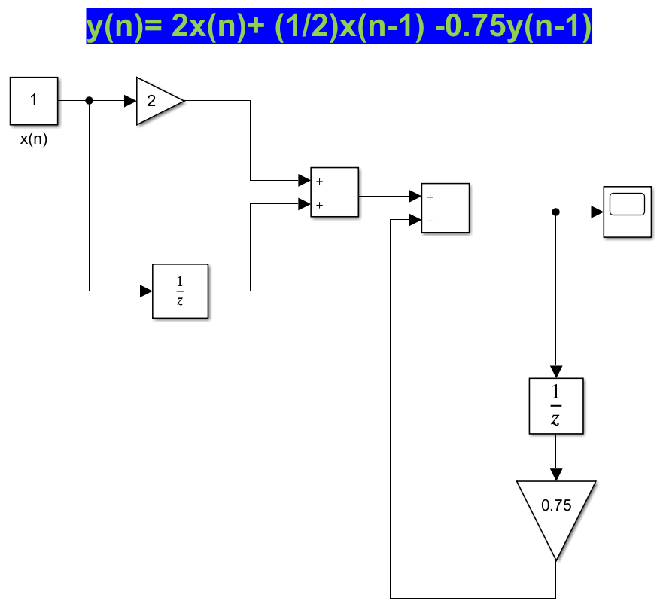

Fig: Difference Equation

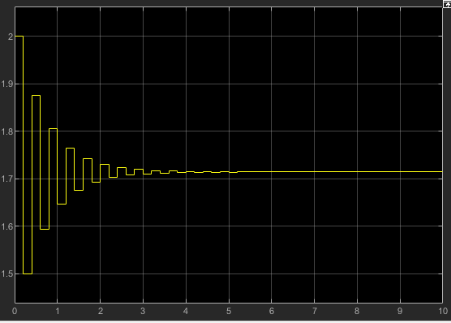

Fig: Difference Equation output

## 

## **ACTIVITY 3 – MATLAB ONRAMP**

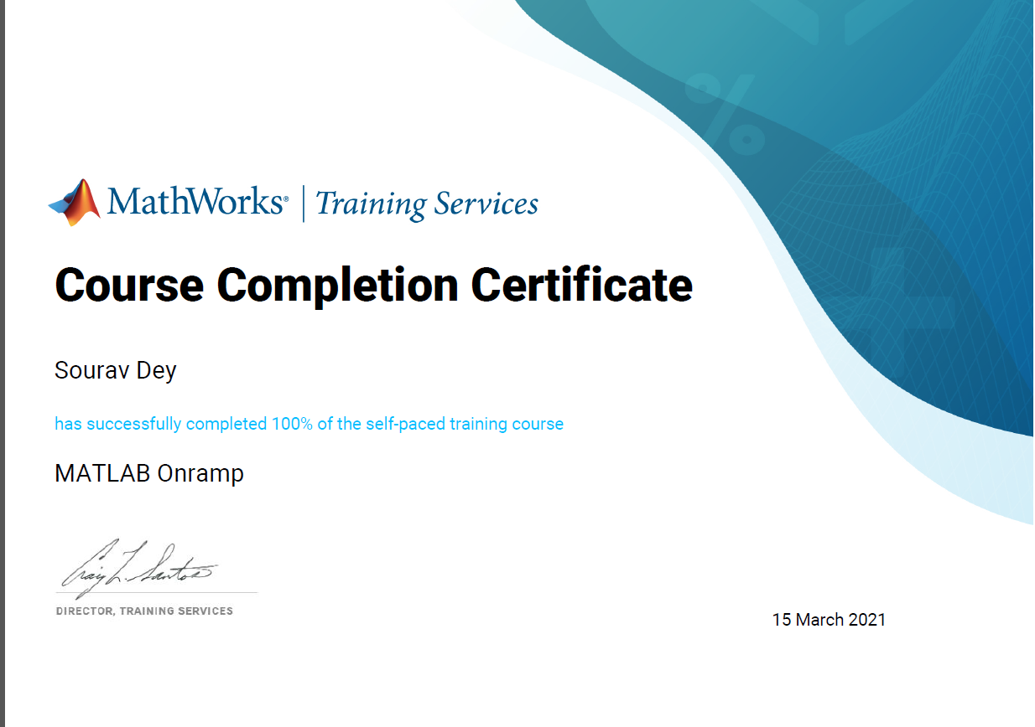

## **ACTIVITY 4 – COMPLETE SIMULINK ONRAMP**

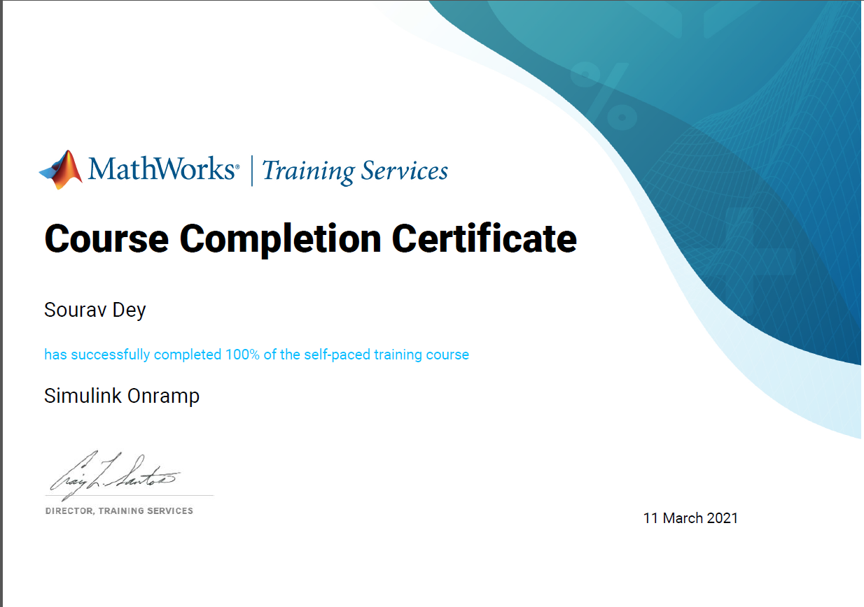

## **ACTIVITY 5 – STATEFLOW ONRAMP**

