1. CLASS DIAGRAM (STRUCTURAL)(HIGH LEVEL)

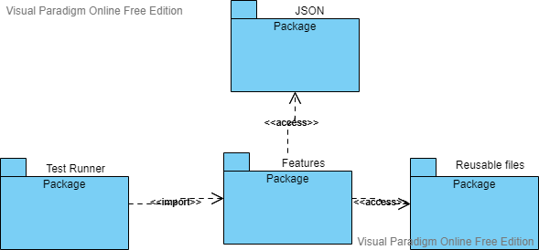

1. SEQUENCE DIAGRAM (BEHAVIOURAL)(HIGH LEVEL)

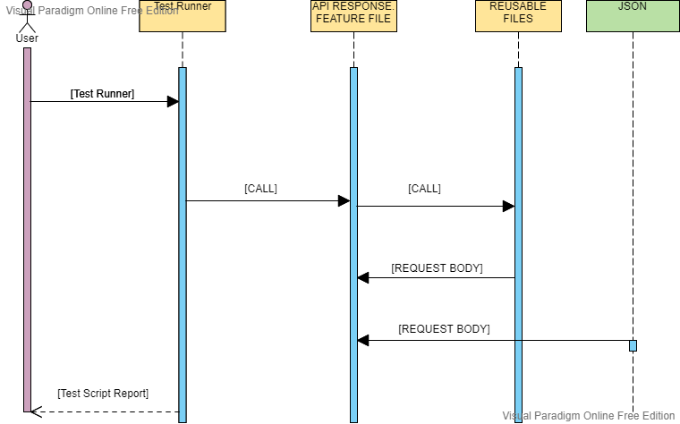

1. ACTIVITY DIAGRAM (BEHAVIOURAL)(LOW-LEVEL)

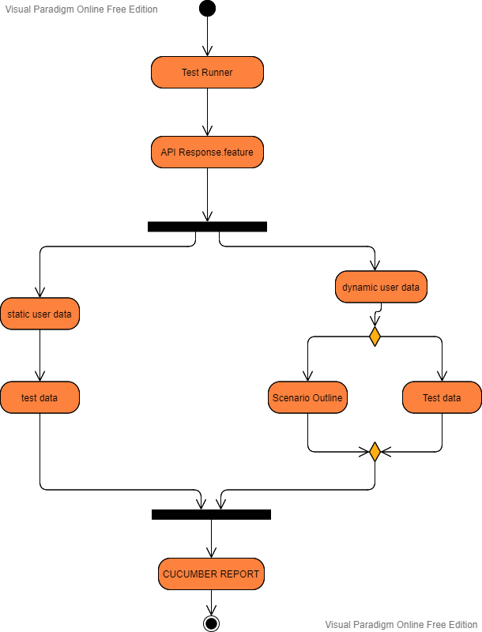

1. USECASE DIAGRAM (BEHAVIOURAL)(LOW-LEVEL)

