MATLAB HW

lab10

陳學銘

2018/07/11

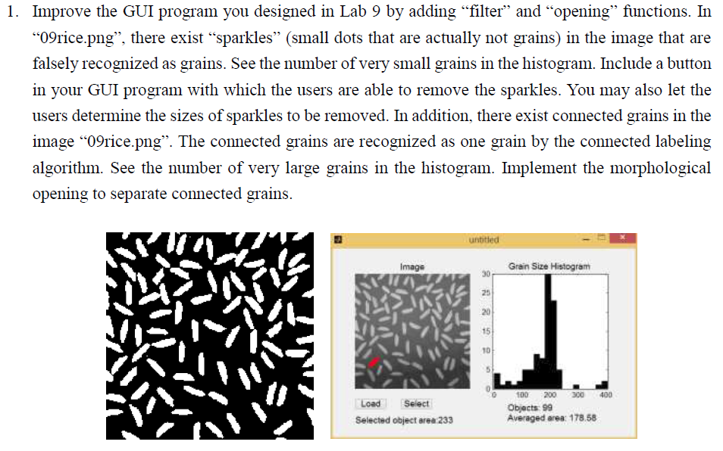

Result

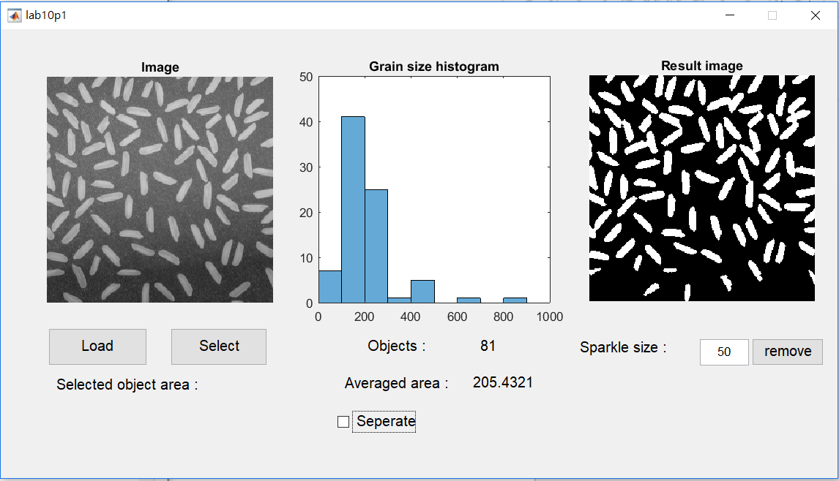

Conclusion

I haven’t done lab09 yet, so the selector can’t be used.

The histogram changes when a sparkle size is chosen, default sparkle size is 0.

function varargout = lab10p1(varargin)

% LAB10P1 MATLAB code for lab10p1.fig

% LAB10P1, by itself, creates a new LAB10P1 or raises the existing

% singleton*.

%

% H = LAB10P1 returns the handle to a new LAB10P1 or the handle to

% the existing singleton*.

%

% LAB10P1('CALLBACK',hObject,eventData,handles,...) calls the local

% function named CALLBACK in LAB10P1.M with the given input arguments.

%

% LAB10P1('Property','Value',...) creates a new LAB10P1 or raises the

% existing singleton*. Starting from the left, property value pairs are

% applied to the GUI before lab10p1_OpeningFcn gets called. An

% unrecognized property name or invalid value makes property application

% stop. All inputs are passed to lab10p1_OpeningFcn via varargin.

%

% *See GUI Options on GUIDE's Tools menu. Choose "GUI allows only one

% instance to run (singleton)".

%

% See also: GUIDE, GUIDATA, GUIHANDLES

% Edit the above text to modify the response to help lab10p1

% Last Modified by GUIDE v2.5 11-Jul-2018 08:01:58

% Begin initialization code - DO NOT EDIT

gui_Singleton = 1;

gui_State = struct('gui_Name', mfilename, ...

'gui_Singleton', gui_Singleton, ...

'gui_OpeningFcn', @lab10p1_OpeningFcn, ...

'gui_OutputFcn', @lab10p1_OutputFcn, ...

'gui_LayoutFcn', [] , ...

'gui_Callback', []);

if nargin && ischar(varargin{1})

gui_State.gui_Callback = str2func(varargin{1});

end

if nargout

[varargout{1:nargout}] = gui_mainfcn(gui_State, varargin{:});

else

gui_mainfcn(gui_State, varargin{:});

end

% End initialization code - DO NOT EDIT

% --- Executes just before lab10p1 is made visible.

function lab10p1_OpeningFcn(hObject, eventdata, handles, varargin)

% This function has no output args, see OutputFcn.

% hObject handle to figure

% eventdata reserved - to be defined in a future version of MATLAB

% handles structure with handles and user data (see GUIDATA)

% varargin command line arguments to lab10p1 (see VARARGIN)

% Choose default command line output for lab10p1

handles.output = hObject;

% Update handles structure

guidata(hObject, handles);

% UIWAIT makes lab10p1 wait for user response (see UIRESUME)

% uiwait(handles.figure1);

% --- Outputs from this function are returned to the command line.

function varargout = lab10p1_OutputFcn(hObject, eventdata, handles)

% varargout cell array for returning output args (see VARARGOUT);

% hObject handle to figure

% eventdata reserved - to be defined in a future version of MATLAB

% handles structure with handles and user data (see GUIDATA)

% Get default command line output from handles structure

varargout{1} = handles.output;

% --- Executes on button press in pushbutton1.

function pushbutton1_Callback(hObject, eventdata, handles)

% hObject handle to pushbutton1 (see GCBO)

% eventdata reserved - to be defined in a future version of MATLAB

% handles structure with handles and user data (see GUIDATA)

[File_Name, Path_Name] = uigetfile('*.png', 'Select Image');

I = imread([Path_Name,File_Name]);

axes(handles.axes1);

imshow(I);

title('Image')

bw = imbinarize(I);

J = imclose( bw, strel('disk',1,8));

J = imopen( J, strel('disk',1,8));

handles.img = J;

guidata(hObject, handles);

handles.Rimg = J;

guidata(hObject, handles);

L = bwlabel(J,4);

num = max(max(L));

area = zeros(num,1);

for k = 1:num

[r,c] = find(L == k);

area(k) = length(r);

end

handles.num = num;

guidata(hObject, handles);

handles.area = area;

guidata(hObject, handles);

axes(handles.axes2);

histogram(area)

title('Grain size histogram')

set(handles.text4,'string',num2str(num));

set(handles.text6,'string',num2str(mean(area)));

% --- Executes on button press in pushbutton2.

function pushbutton2_Callback(hObject, eventdata, handles)

% hObject handle to pushbutton2 (see GCBO)

% eventdata reserved - to be defined in a future version of MATLAB

% handles structure with handles and user data (see GUIDATA)

function edit1_Callback(hObject, eventdata, handles)

% hObject handle to edit1 (see GCBO)

% eventdata reserved - to be defined in a future version of MATLAB

% handles structure with handles and user data (see GUIDATA)

% Hints: get(hObject,'String') returns contents of edit1 as text

% str2double(get(hObject,'String')) returns contents of edit1 as a double

% --- Executes during object creation, after setting all properties.

function edit1_CreateFcn(hObject, eventdata, handles)

% hObject handle to edit1 (see GCBO)

% eventdata reserved - to be defined in a future version of MATLAB

% handles empty - handles not created until after all CreateFcns called

% Hint: edit controls usually have a white background on Windows.

% See ISPC and COMPUTER.

if ispc && isequal(get(hObject,'BackgroundColor'), get(0,'defaultUicontrolBackgroundColor'))

set(hObject,'BackgroundColor','white');

end

% --- Executes on button press in pushbutton3.

function pushbutton3_Callback(hObject, eventdata, handles)

% hObject handle to pushbutton3 (see GCBO)

% eventdata reserved - to be defined in a future version of MATLAB

% handles structure with handles and user data (see GUIDATA)

spsize = get(handles.edit1,'string')

sp = str2double(spsize);

J = handles.img;

K = bwareaopen(J, sp);

axes(handles.axes3);

imshow(K);

title('Result image')

handles.Rimg = K;

guidata(hObject, handles);

L = bwlabel(K,4);

num = max(max(L));

area = zeros(num,1);

for k = 1:num

[r,c] = find(L == k);

area(k) = length(r);

end

handles.num = num;

guidata(hObject, handles);

handles.area = area;

guidata(hObject, handles);

axes(handles.axes2);

histogram(area)

title('Grain size histogram')

set(handles.text4,'string',num2str(num));

set(handles.text6,'string',num2str(mean(area)));

% --- Executes on button press in checkbox1.

function checkbox1_Callback(hObject, eventdata, handles)

% hObject handle to checkbox1 (see GCBO)

% eventdata reserved - to be defined in a future version of MATLAB

% handles structure with handles and user data (see GUIDATA)

i = get(handles.checkbox1,'value');

M = handles.Rimg;

num = handles.num;

area = handles.area;

if i == 1

N = bwmorph(M,'thin',1);

J = imclose( N, strel('disk',2,8));

N = imopen( J, strel('disk',2,8));

L = bwlabel(N,4);

num2 = max(max(L));

avgar = sum(area)/num;

axes(handles.axes3);

imshow(N);

title('Result image')

set(handles.text4,'string',num2str(num2));

set(handles.text6,'string',num2str(avgar));

else

axes(handles.axes3);

imshow(M);

title('Result image')

set(handles.text4,'string',num2str(num));

set(handles.text6,'string',num2str(mean(area)));

end

% Hint: get(hObject,'Value') returns toggle state of checkbox1

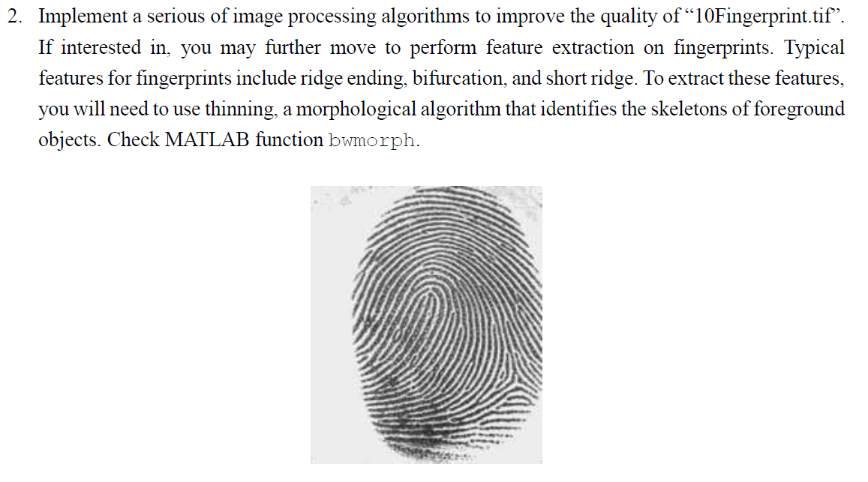

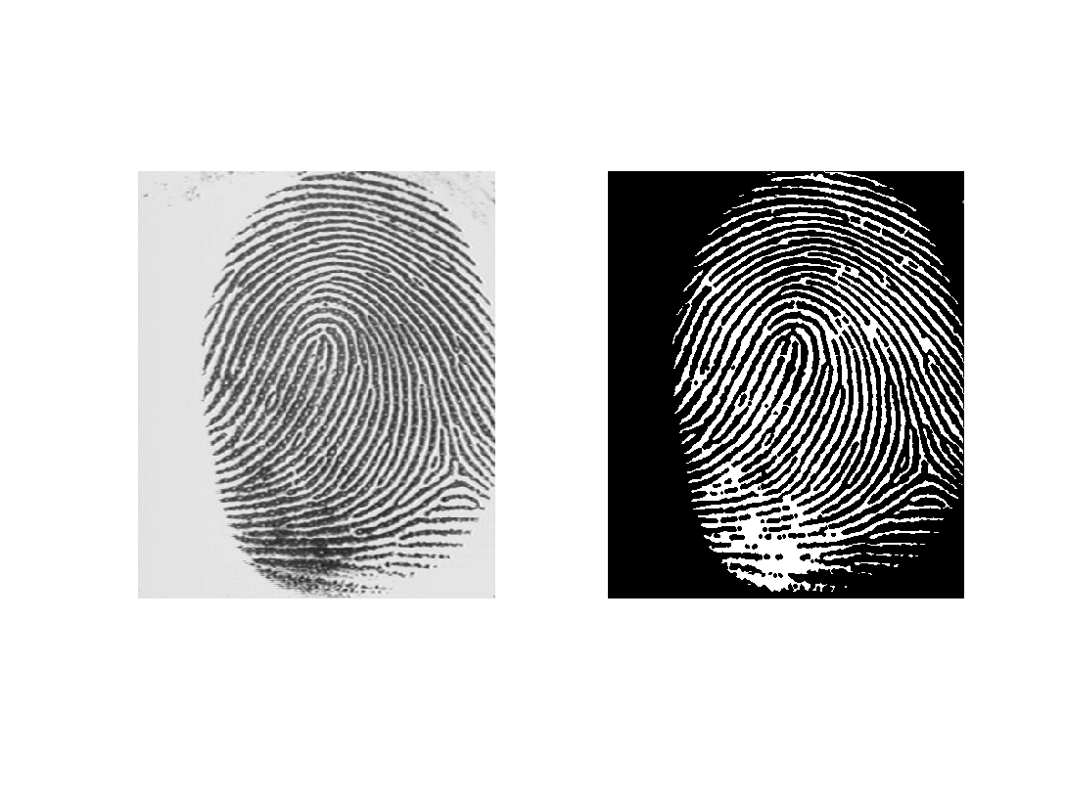Result

I = imread('10Fingerprint.tif');

bw=imbinarize(I);

subplot(121); imshow(I);

bw2 = ~bw;

J = imclose( bw2, strel('disk',1,8));

K = imopen( J, strel('disk',1,8));

K = ~K;

L = bwareaopen(K, 6);

L =~L;

N = bwmorph(L,'thin',1);

subplot(122); imshow(N);