**Assignment 4**

**DANDAN LIN**

**NUID:001093902**

**Question 1:**

The following plot is K-Fold validation for the SVM and K-Fold validation for the MLP model.

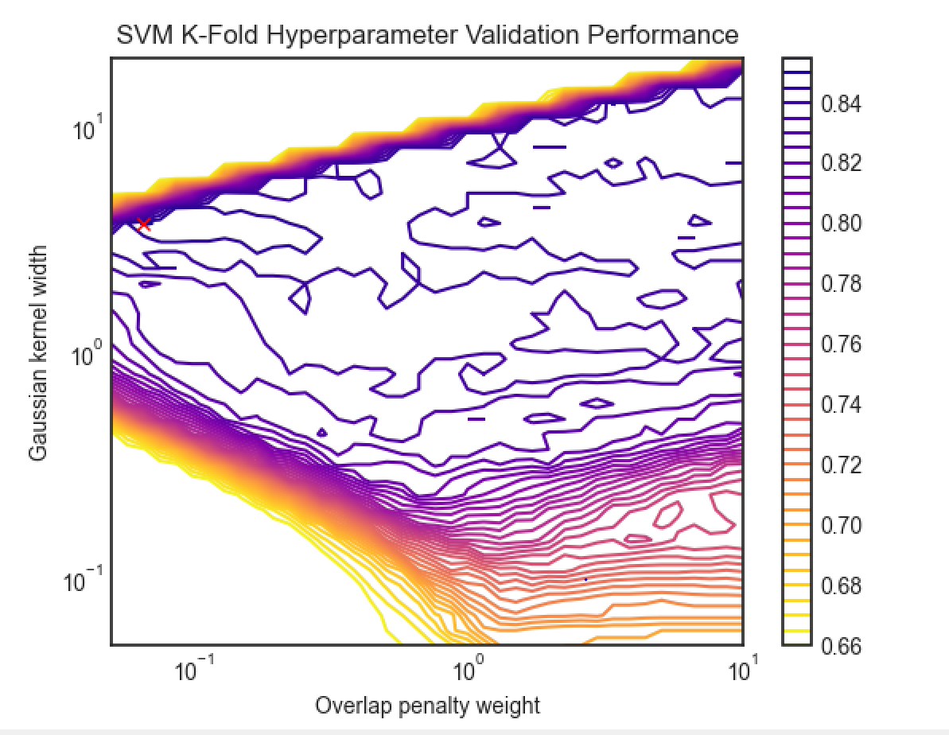

*Figure 1 K-Fold validation for SVM*

In figure 1,it tested 40 values of the overlap penalty weight and Gaussian kernel width in the ranges [0.5, 10] and [0.5, 20], respectively. The result of all accuracy is shown in the contour plot above.

The maximum achieved accuracy was marked as red “x” above.And we can know that the best SVM accuracy was 0.851.The best SVM accuracy was achieved with an overlap penalty weight of 0.066 and a Gaussian kernel width of 3.69.

The plot above has fairly flat plateaus, both on the lower and upper bounds of accuracy. Samples are essentially “too far” from each other to

produce meaningfully clustered groups with a low enough overlap penalty weight and kernel width.While with a low overlap penalty weight and large kernel width, samples become “too close” to each other and cannot be meaningfully separated. Because of this,it is possible to derive an appropriate decision boundary, but this boundary cannot correctly classify samples in the overlapping Gaussian distributions.

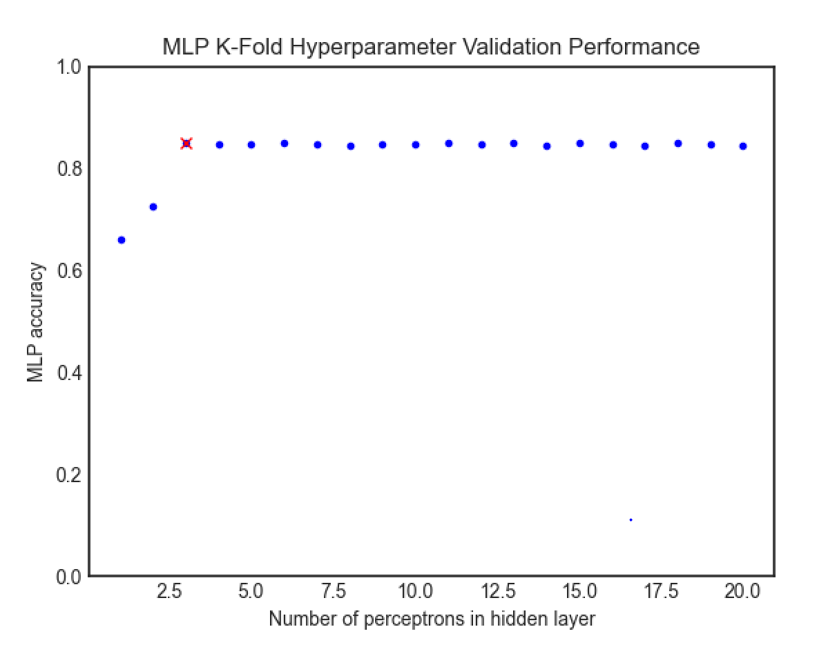

*Figure 2 K-Fold validation for MLP*

In the figure 2, up to 20 perceptrons were tested in the hidden layer. The accuracy achieved for each model is shown in the plot above.

The best MLP accuracy was achieved with 3 perceptrons in the hidden layer, which was marked with a red ‘x’ on the plot above.

The best MLP accuracy was 0.851.

The below figures were generated by training the optimal SVM model and optimal MLP model selected by K-Fold validation on the entire test dataset.

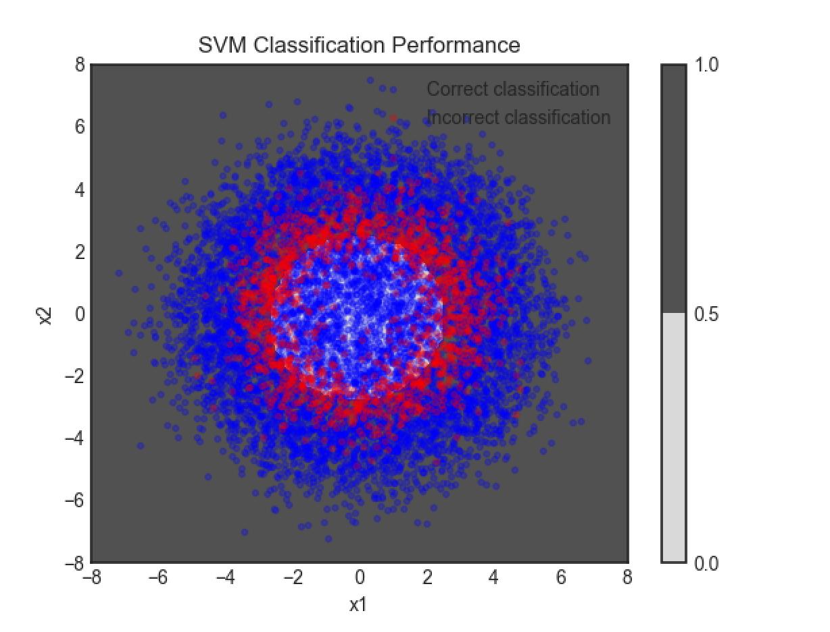

*Figure 3 SVM Classification Performance*

The test dataset was fit by the SVM model with an accuracy of 0.8406.

The test dataset was fit by the MLP model with an accuracy of 0.839.

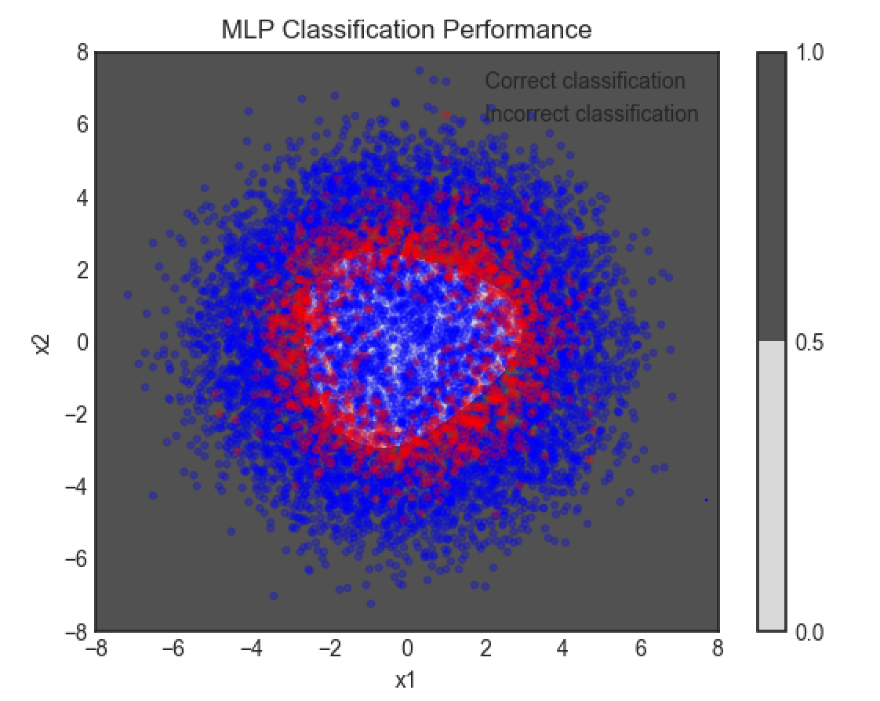

*Figure 4 MLP Classification Performance*

**Question 2:**

For this question, we need use GMM-based clustering to segment a color image. I pick color image “78004.jpg”,which is a boat from the dataset: https://www2.eecs.berkeley.edu/Research/Projects/CS/vision/grouping/segbench/BSDS300/html/dataset/images.html. As preprocessing, the following steps were performed: (1) append row index, column index, red value, green value, blue value for each pixel into a raw feature vector; (2) normalize each feature entry individually to the interval [0*,*1], so that all of the feature vectors representing every pixel in an image fit into the 5-dimensional unit-hypercube.

The GMM was used to segment the image into two parts to separate the foreground and the background. Then 10-fold cross-validation was used to identify the number of Gaussian components that produced the maximum average validation log-likelihood. After the estimated optimal number of Gaussian components was selected, a GMM with that number of components was fit to the image data. This new GMM model was then used to segment the image with the number of segments equal to the number of components in the GMM. The original image along with the segmented versions are shown in the following figure. For the boat image the segmented images include the segmented image for 2 GMMs which was specified in the problem and the number of GMMs that maximized the log likelihood as determined by cross-validation which is 6.

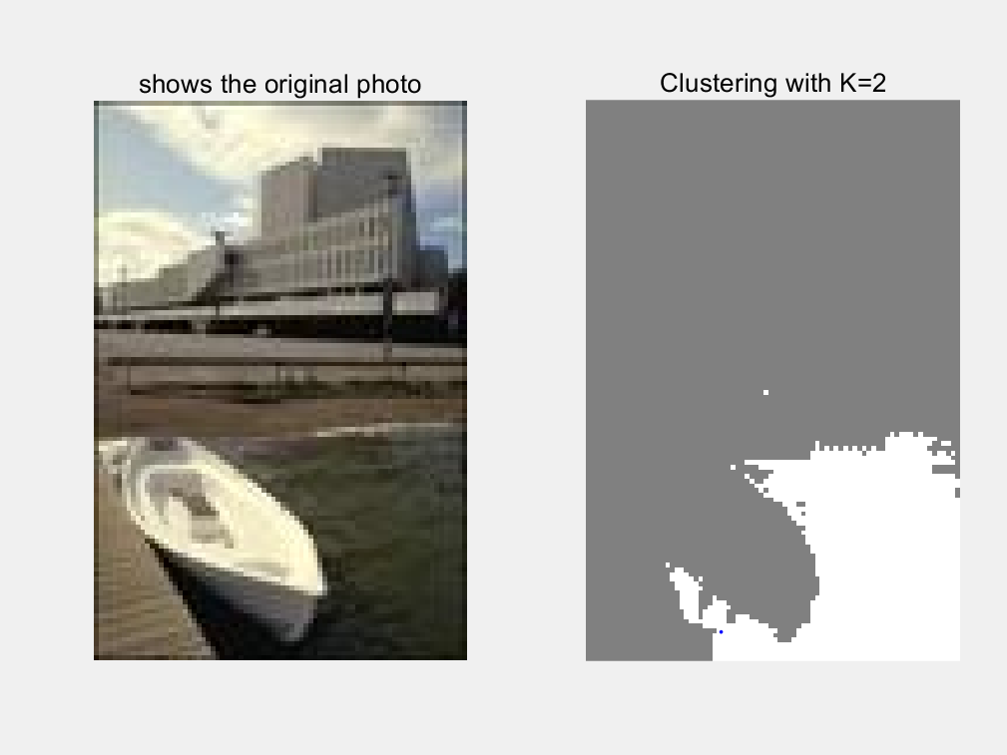

*Figure5 : Images and Segmentation Results*

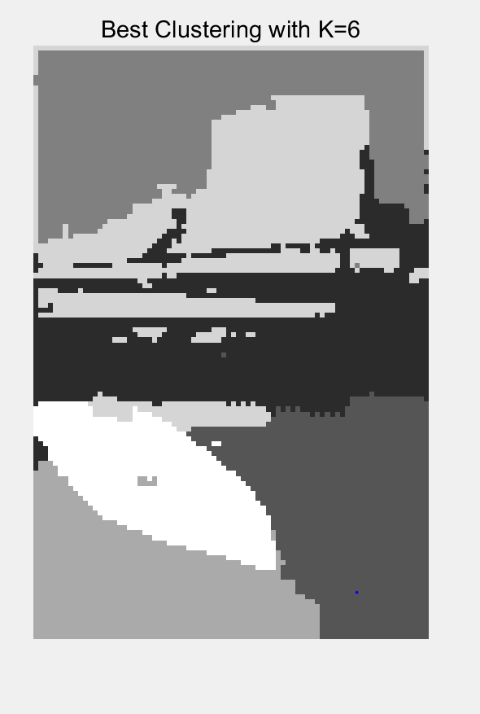

*Figure6 : Images and best Results*

The following figure shows the cross-validation results for the boat image. Though there is some data fluctuation,the average likelihood for this image was largest in the 6 GMMs and the loglikelihood decreased as additional GMMs were added.

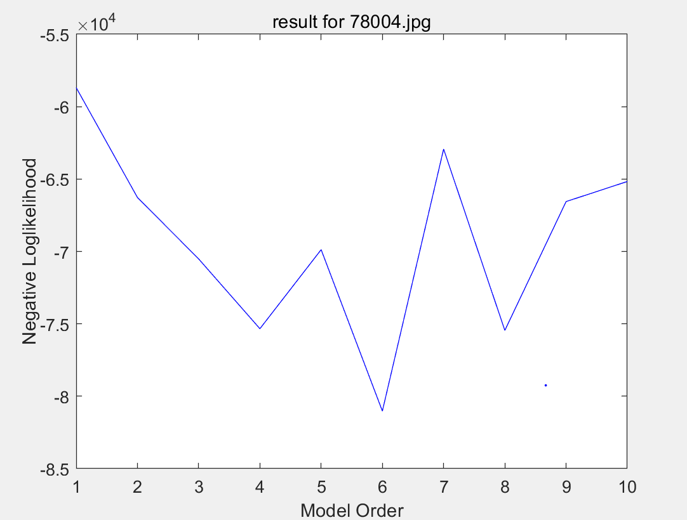

*Figure7 : Log Likelihood vs. Number of GMMs for the Boat Image*

**Appendix:**

Q1:

#code example help from prof. deniz

import numpy as np

import matplotlib.pyplot as plt

from sklearn.model_selection import StratifiedKFold

from sklearn.svm import SVC

import keras

from tensorflow.keras.models import Sequential

from tensorflow.keras.layers import Dense

from tensorflow.keras.optimizers import SGD

plotData = True

n = 2

Ntrain = 1000

Ntest = 10000

ClassPriors = [0.35, 0.65]

r0 = 2

r1 = 4

sigma = 1

def generate_data(N):

    data_labels = np.random.choice(2, N, replace=True, p=ClassPriors)

    ind0 = np.array((data_labels==0).nonzero())

    ind1 = np.array((data_labels==1).nonzero())

    N0 = np.shape(ind0)[1]

    N1 = np.shape(ind1)[1]

    theta0 = 2*np.pi*np.random.standard_normal(N0)

    theta1 = 2*np.pi*np.random.standard_normal(N1)

    x0 = sigma**2*np.random.standard_normal((N0,n)) + r0 * np.transpose([np.cos(theta0), np.sin(theta0)])

    x1 = sigma**2*np.random.standard_normal((N1,n)) + r1 * np.transpose([np.cos(theta1), np.sin(theta1)])

    data_features = np.zeros((N, 2))

    np.put_along_axis(data_features, np.transpose(ind0), x0, axis=0)

    np.put_along_axis(data_features, np.transpose(ind1), x1, axis=0)

    return (data_labels, data_features)

def plot_data(TrainingData_labels, TrainingData_features, TestingData_labels, TestingData_features):

    plt.subplot(1,2,1)

    plt.plot(TrainingData_features[np.array((TrainingData_labels==0).nonzero())][0,:,0],

            TrainingData_features[np.array((TrainingData_labels==0).nonzero())][0,:,1],

            'b.')

    plt.plot(TrainingData_features[np.array((TrainingData_labels==1).nonzero())][0,:,0],

            TrainingData_features[np.array((TrainingData_labels==1).nonzero())][0,:,1],

            'm.')

    plt.title('TrainingData')

    plt.subplot(1,2,2)

    plt.plot(TestingData_features[np.array((TestingData_labels==0).nonzero())][0,:,0],

            TestingData_features[np.array((TestingData_labels==0).nonzero())][0,:,1],

            'b.')

    plt.plot(TestingData_features[np.array((TestingData_labels==1).nonzero())][0,:,0],

            TestingData_features[np.array((TestingData_labels==1).nonzero())][0,:,1],

            'm.')

    plt.show()

# Uses K-Fold cross validation to find the best hyperparameters for an SVM model, and plots the results

def train_SVM_hyperparams(TrainingData_labels, TrainingData_features):

    hyperparam_candidates = np.meshgrid(np.geomspace(0.05, 10, 40), np.geomspace(0.05, 20, 40))

    hyperparam_performance = np.zeros((np.shape(hyperparam_candidates)[1] * np.shape(hyperparam_candidates)[2]))

    for (i, hyperparams) in enumerate(np.reshape(np.transpose(hyperparam_candidates), (-1, 2))):

        skf = StratifiedKFold(n_splits=K, shuffle=False)

        total_accuracy = 0

        for(k, (train, test)) in enumerate(skf.split(TrainingData_features, TrainingData_labels)):

            (_, accuracy) = SVM_accuracy(hyperparams, TrainingData_features[train], TrainingData_labels[train], TrainingData_features[test], TrainingData_labels[test])

            total_accuracy += accuracy

        accuracy = total_accuracy / K

        hyperparam_performance[i] = accuracy

        print(i, accuracy)

    plt.style.use('seaborn-white')

    ax = plt.gca()

    ax.set_xscale('log')

    ax.set_yscale('log')

    max_perf_index = np.argmax(hyperparam_performance)

    max_perf_x1 = max_perf_index % 40

    max_perf_x2 = max_perf_index // 40

    best_overlap_penalty = hyperparam_candidates[0][max_perf_x1][max_perf_x2]

    best_kernel_width = hyperparam_candidates[1][max_perf_x1][max_perf_x2]

    plt.contour(hyperparam_candidates[0], hyperparam_candidates[1], np.transpose(np.reshape(hyperparam_performance, (40, 40))), cmap='plasma_r', levels=40);

    plt.title("SVM K-Fold Hyperparameter Validation Performance")

    plt.xlabel("Overlap penalty weight")

    plt.ylabel("Gaussian kernel width")

    plt.plot(best_overlap_penalty, best_kernel_width, 'rx')

    plt.colorbar()

    print("The best SVM accuracy was " + str(hyperparam_performance[max_perf_index]) + ".")

    plt.show()

    return (best_overlap_penalty, best_kernel_width)

# Trains an SVM with the given hyperparameters on the train data, then validates its performance on the given test data.

# Returns the trained model and respective validation loss.

def SVM_accuracy(hyperparams, train_features, train_labels, test_features, test_labels):

    (overlap_penalty, kernel_width) = hyperparams

    model = SVC(C=overlap_penalty, kernel='rbf', gamma=1/(2*kernel_width**2))

    model.fit(train_features, train_labels)

    predictions = model.predict(test_features)

    num_correct = len(np.squeeze((predictions == test_labels).nonzero()))

    accuracy = num_correct / len(test_features)

    return (model, accuracy)

# Uses K-Fold cross validation to find the best hyperparameters for an MLP model, and plots the results

def train_MLP_hyperparams(TrainingData_labels, TrainingData_features):

    hyperparam_candidates = list(range(1, 21))

    hyperparam_performance = np.zeros(np.shape(hyperparam_candidates))

    for (i, hyperparams) in enumerate(hyperparam_candidates):

        skf = StratifiedKFold(n_splits=K, shuffle=False)

        total_accuracy = 0

        for(k, (train, test)) in enumerate(skf.split(TrainingData_features, TrainingData_labels)):

            accuracy = max(map(lambda _: MLP_accuracy(hyperparams, TrainingData_features[train], TrainingData_labels[train], TrainingData_features[test], TrainingData_labels[test])[1], range(4)))

            total_accuracy += accuracy

        accuracy = total_accuracy / K

        hyperparam_performance[i] = accuracy

        print(i, accuracy)

    plt.style.use('seaborn-white')

    max_perf_index = np.argmax(hyperparam_performance)

    best_num_perceptrons = hyperparam_candidates[max_perf_index]

    plt.plot(hyperparam_candidates, hyperparam_performance, 'b.')

    plt.title("MLP K-Fold Hyperparameter Validation Performance")

    plt.xlabel("Number of perceptrons in hidden layer")

    plt.ylabel("MLP accuracy")

    plt.ylim([0,1])

    plt.plot(hyperparam_candidates[max_perf_index], hyperparam_performance[max_perf_index], 'rx')

    print("The best MLP accuracy was " + str(hyperparam_performance[max_perf_index]) + ".")

    plt.show()

    return best_num_perceptrons

# Trains an MLP with the given number of perceptrons on the train data, then validates its performance on the given test data.

# Returns the trained model and respective validation loss.

def MLP_accuracy(num_perceptrons, train_features, train_labels, test_features, test_labels):

    sgd = SGD(lr=0.05, momentum=0.9)

    model = Sequential()

    model.add(Dense(num_perceptrons, activation='sigmoid', input_dim=2))

    model.add(Dense(1, activation='sigmoid'))

    model.compile(loss='binary_crossentropy', optimizer=sgd, metrics=['accuracy'])

    model.fit(train_features, train_labels, epochs=300, batch_size=100, verbose=0)

    (loss, accuracy) = model.evaluate(test_features, test_labels)

    return (model, accuracy)

# Creates a contour plot for a model, along with colored samples based on their classifications by the model.

def plot_trained_model(model_type, model, features, labels):

    predictions = np.squeeze(model.predict(features))

    correct = np.array(np.squeeze((np.round(predictions) == labels).nonzero()))

    incorrect = np.array(np.squeeze((np.round(predictions) != labels).nonzero()))

    plt.plot(features[correct][:,0],

            features[correct][:,1],

            'b.', alpha=0.25)

    plt.plot(features[incorrect][:,0],

            features[incorrect][:,1],

            'r.', alpha=0.25)

    plt.title(model_type + ' Classification Performance')

    plt.xlabel('x1')

    plt.ylabel('x2')

    plt.legend(['Correct classification', 'Incorrect classification'])

    gridpoints = np.meshgrid(np.linspace(-8, 8, 128), np.linspace(-8, 8, 128))

    contour_values = np.transpose(np.reshape(model.predict(np.reshape(np.transpose(gridpoints), (-1, 2))), (128, 128)))

    plt.contourf(gridpoints[0], gridpoints[1], contour_values, levels=1);

    plt.colorbar();

    plt.show()

K = 10

(TrainingData_labels, TrainingData_features) = generate_data(Ntrain)

(TestingData_labels, TestingData_features) = generate_data(Ntest)

if plotData:

    plot_data(TrainingData_labels, TrainingData_features, TestingData_labels, TestingData_features)

SVM_hyperparams = train_SVM_hyperparams(TrainingData_labels, TrainingData_features)

MLP_hyperparams = train_MLP_hyperparams(TrainingData_labels, TrainingData_features)

(overlap_penalty, kernel_width) = SVM_hyperparams

print("The best SVM accuracy was achieved with an overlap penalty weight of " + str(overlap_penalty) + " and a Gaussian kernel width of " + str(kernel_width) + ".")

print("The best MLP accuracy was achieved with " + str(MLP_hyperparams) + " perceptrons.")

(SVM_model, SVM_performance) = SVM_accuracy(SVM_hyperparams, TrainingData_features, TrainingData_labels, TestingData_features, TestingData_labels)

(MLP_model, MLP_performance) = max(map(lambda _: MLP_accuracy(MLP_hyperparams, TrainingData_features, TrainingData_labels, TestingData_features, TestingData_labels), range(5)), key=lambda r: r[1])

print("The test dataset was fit by the SVM model with an accuracy of " + str(SVM_performance) + ".")

print("The test dataset was fit by the MLP model with an accuracy of " + str(MLP_performance) + ".")

plot_trained_model('SVM', SVM_model, TestingData_features, TestingData_labels)

plot_trained_model('MLP', MLP_model, TestingData_features, TestingData_labels)

Q2:

clear all; close all;

f{1,1} = "78004.jpg";

K = 10;

M = 10;

n = size(f, 1);

imdata = imread(f{1,1});

figure(1), subplot(1, 2, 1*2-1),

imshow(imdata);

title("shows the original photo"); hold on;

[R,C,D] = size(imdata); N = R*C; imdata = double(imdata);

rowIndices = [1:R]'*ones(1,C); colIndices = ones(R,1)*[1:C];

features = [rowIndices(:)';colIndices(:)']; % initialize with row and column indices

for d = 1:D

imdatad = imdata(:,:,d); % pick one color at a time

features = [features;imdatad(:)'];

end

minf = min(features,[],2); maxf = max(features,[],2);

ranges = maxf-minf;

x = diag(ranges.^(-1))*(features-repmat(minf,1,N));

d = size(x,1);

model = 2;

gm = fitgmdist(x',model);

p = posterior(gm, x');

[~, l] = max(p,[], 2);

li = reshape(l, R, C);

figure(1), subplot(n, 2, 1*2)

imshow(uint8(li*255/model));

title(strcat("Clustering with K=", num2str(model)));

ab = zeros(1,M);

for model = 1:M

ab(1,model) = calcLikelihood(x, model, K);

end

[~, mini] = min(ab);

gm = fitgmdist(x', mini);

p = posterior(gm, x');

[~, l] = max(p,[], 2);

li = reshape(l, R, C);

figure(2), subplot(n,1,1),

imshow(uint8(li*255/mini));

title(strcat("Best Clustering with K=", num2str(mini)));

fig=figure(3);

subplot(1,n,1), plot(ab,'-b');

a = axes(fig, 'visible', 'off');

a.Title.Visible='on';

a.XLabel.Visible='on';

a.YLabel.Visible='on';

ylabel(a,'Negative Loglikelihood');

xlabel(a,'Model Order');

title(a,'result for 78004.jpg');

%% function

function negativeLoglikelihood = calcLikelihood(x, model, K)

N = size(x,2);

dummy = ceil(linspace(0, N, K+1));

negativeLoglikelihood = 0;

for k=1:K

indPartitionLimits(k,:) = [dummy(k) + 1, dummy(k+1)];

end

for k = 1:K

indValidate = [indPartitionLimits(k,1):indPartitionLimits(k,2)];

xv = x(:, indValidate); % Using folk k as validation set

if k == 1

indTrain = [indPartitionLimits(k,2)+1:N];

elseif k == K

indTrain = [1:indPartitionLimits(k,1)-1];

else

indTrain = [indPartitionLimits(k-1,2)+1:indPartitionLimits(k+1,1)-1];

end

xt = x(:, indTrain);

try

gm = fitgmdist(xt', model);

[~, nlogl] = posterior(gm, xv');

negativeLoglikelihood = negativeLoglikelihood + nlogl;

catch exception

end

end

end