**AOA Lab 1**

Name: Vivian Vijay Ludrick

Roll No: 9914

Branch: SE Comps A

Batch: C

**Bubble Sort:**

Code:

#include <iostream>

*// swaps a and b*

void swap(int &*a*, int &*b*) {

*// here a and b do not contain addresses but the references to the original paased values c doesn't have references like cpp so we use pointers there*

int temp = *a*;

*a* = *b*;

*b* = temp;

}

*// uses bubble sort to bubble up the lowest element to start*

void bubbleSort(int *arr*[], int *n*) {

for (int i = 0; i < *n* - 1; ++i) { *//n*

for (int j = i + 1; j < *n*; ++j) {

if (*arr*[j] < *arr*[i]) {

swap(*arr*[j], *arr*[i]);

}

}

}

}

*// Takes user input for the given array*

void getArray(int *arr*[], int *n*){

std::cout << "Enter the elements: ";

for (int i = 0; i < *n*; ++i) {

std::cin >> *arr*[i];

}

}

*// Prints the elements of the array to the standard out*

void printArray(int *arr*[], int *n*){

for (int i = 0; i < *n*; ++i) {

std::cout << *arr*[i] << " ";

}

}

int main() {

int n;

std::cout << "Enter the number of elements: ";

std::cin >> n;

int arr[n];

getArray(arr, n);

std::cout << "Unsorted array: ";

printArray(arr, n);

bubbleSort(arr, n);

std::cout << "Sorted array: ";

printArray(arr, n);

return 0;

}

OUTPUT:

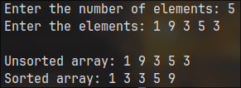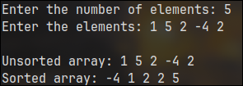

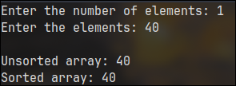

COMPLEXITY(worst case):

for first iteration:

No. of comparisons: n-1

No. of swaps: n -1

for second iteration:

No. of comparisons: n-2

No. of swaps: n -1

for last(n-1) iteration:

No. of comparison: 1

No. of swaps: 1

T(n) = (n - 1) + (n -2) + (n - 3) ….. + 2 + 1

= (n-1)(n-2)

2

= (N)(N-1)

2

T(n) = O(n2)

**Modified Bubble Sort:**

Code:

#include <iostream>

*// swaps a and b*

void swap(int &*a*, int &*b*) {

*// here a and b do not contain addresses but the references to the original*

*// paased values c doesn't have references like cpp so we use pointers there*

int temp = *a*;

*a* = *b*;

*b* = temp;

}

*// uses modified bubble sort to bubble up the highest element to end*

void modBubbleSort(int *arr*[], int *n*) {

for (int i = 0; i < *n* - 1; i++) {

int count = 0;

for (int j = 0; j < *n* - i - 1; j++) {

if (*arr*[j + 1] < *arr*[j]) {

swap(*arr*[j + 1], *arr*[j]);

count = 1;

}

}

if (count == 0)

break;

}

}

*// Takes user input for the given array*

void getArray(int *arr*[], int *n*) {

std::cout << "Enter the elements: ";

for (int i = 0; i < *n*; ++i) {

std::cin >> *arr*[i];

}

}

*// Prints the elements of the array to the standard out*

void printArray(int *arr*[], int *n*) {

for (int i = 0; i < *n*; ++i) {

std::cout << *arr*[i] << " ";

}

}

int main() {

int n;

std::cout << "Enter the number of elements: ";

std::cin >> n;

int arr[n];

getArray(arr, n);

std::cout << "\nUnsorted array: ";

printArray(arr, n);

modBubbleSort(arr, n);

std::cout << "\nSorted array: ";

printArray(arr, n);

return 0;

}

Output:

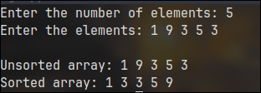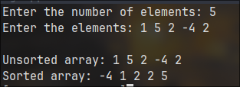

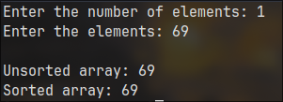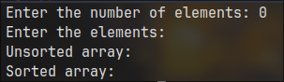

COMPLEXITY(worst case):

for first iteration:

No. of comparisons: n-1

No. of swaps: n -1

for second iteration:

No. of comparisons: n-2

No. of swaps: n -1

for last(n-1) iteration:

No. of comparison: 1

No. of swaps: 1

T(n) = (n - 1) + (n -2) + (n - 3) ….. + 2 + 1

= (n-1)(n-2)

2

= (N)(N-1)

2

T(n) = O(n2)

**Selection Sort:**

CODE:

#include <iostream>

*// swaps a and b*

void swap(int &*a*, int &*b*) {

*// here a and b do not contain addresses but the references to the original*

*// paased values c doesn't have references like cpp so we use pointers there*

int temp = *a*;

*a* = *b*;

*b* = temp;

}

*// Selection sort to select the smallest element and place it at the beginning*

void selectionSort(int *arr*[], int *n*) {

for (int i = 0; i < *n* - 1; ++i) {

int minIndex = i;

for (int j = i + 1; j < *n*; ++j) {

if (*arr*[j] < *arr*[minIndex]) {

minIndex = j;

}

}

swap(*arr*[i], *arr*[minIndex]);

}

}

*// Takes user input for the given array*

void getArray(int *arr*[], int *n*) {

std::cout << "Enter the elements: ";

for (int i = 0; i < *n*; ++i) {

std::cin >> *arr*[i];

}

}

*// Prints the elements of the array to the standard out*

void printArray(int *arr*[], int *n*) {

for (int i = 0; i < *n*; ++i) {

std::cout << *arr*[i] << " ";

}

}

int main() {

int n;

std::cout << "Enter the number of elements: ";

std::cin >> n;

int arr[n];

getArray(arr, n);

std::cout << "\nUnsorted array: ";

printArray(arr, n);

selectionSort(arr, n);

std::cout << "\nSorted array: ";

printArray(arr, n);

return 0;

}

OUTPUT:

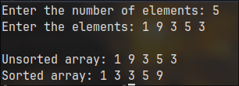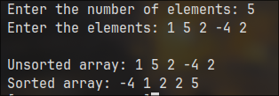

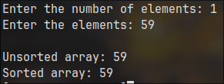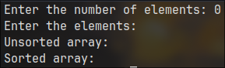

COMPLEXITY(worst case):

for first iteration:

No. of comparisons: n-1

for second iteration:

No. of comparisons: n-2

for last(n-1) iteration:

No. of comparison: 1

T(n) = (n - 1) + (n -2) + (n - 3) ….. + 2 + 1

= (n-1)(n-2)

2

= (N)(N-1)

2

T(n) = O(n2)

**Insertion Sort:**

CODE:

#include <iostream>

*// swaps a and b*

void swap(int &*a*, int &*b*) {

*// here a and b do not contain addresses but the references to the original*

*// paased values c doesn't have references like cpp so we use pointers there*

int temp = *a*;

*a* = *b*;

*b* = temp;

}

*// Insertion sort to insert elements in their correct positions*

void insertionSort(int *arr*[], int *n*) {

for (int i = 1; i < *n*; ++i) {

int key = *arr*[i];

int j = i - 1;

*// Move elements greater than key to one position ahead*

while (j >= 0 && *arr*[j] > key) {

*arr*[j + 1] = *arr*[j];

--j;

}

*// Insert key in its correct position*

*arr*[j + 1] = key;

}

}

*// Takes user input for the given array*

void getArray(int *arr*[], int *n*) {

std::cout << "Enter the elements: ";

for (int i = 0; i < *n*; ++i) {

std::cin >> *arr*[i];

}

}

*// Prints the elements of the array to the standard out*

void printArray(int *arr*[], int *n*) {

for (int i = 0; i < *n*; ++i) {

std::cout << *arr*[i] << " ";

}

}

int main() {

int n;

std::cout << "Enter the number of elements: ";

std::cin >> n;

int arr[n];

getArray(arr, n);

std::cout << "\nUnsorted array: ";

printArray(arr, n);

insertionSort(arr, n);

std::cout << "\nSorted array: ";

printArray(arr, n);

return 0;

}

OUTPUT:

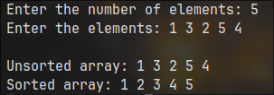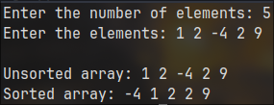

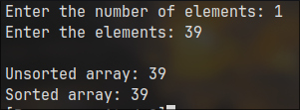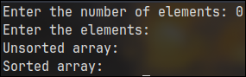

COMPLEXITY(worst case):

Total no of comparison = 1 + 2 + 3 + 4 + 5

= 1 + 2 + 3 + 4 … + (n -1) —------(Generalising the above equation)

= n (n - 1)

2

T(n) = O(n2)

**Counting Sort:**

CODE:

#include <iostream>

*// Counting sort to sort elements based on their count*

int getMax(int *arr*[], int *n*) {

int max = *arr*[0];

for (int i = 1; i < *n*; i++) {

if (*arr*[i] > max)

max = *arr*[i];

}

return max; *// maximum element from the array*

}

*// sorts the array based on the count of each element*

void countingSort(int *arr*[], int *n*) {

int output[*n* + 1];

int max = getMax(*arr*, *n*);

int count[max + 1]; *// create count array with size [max+1]*

for (int i = 0; i <= max; ++i) {

count[i] = 0; *// Initialize count array with all zeros*

}

for (int i = 0; i < *n*; i++) *// Store the count of each element*

{

count[*arr*[i]]++;

}

for (int i = 1; i <= max; i++)

count[i] += count[i - 1]; *// find cumulative frequency*

*/* This loop will find the index of each element of the original array in*

*count array, and place the elements in output array*/*

for (int i = *n* - 1; i >= 0; i--) {

output[count[*arr*[i]] - 1] = *arr*[i];

count[*arr*[i]]--; *// decrease count for same numbers*

}

for (int i = 0; i < *n*; i++) {

*arr*[i] = output[i]; *// store the sorted elements into main array*

}

}

*// Takes user input for the given array*

void getArray(int *arr*[], int *n*) {

std::cout << "Enter the elements: ";

for (int i = 0; i < *n*; ++i) {

std::cin >> *arr*[i];

}

}

*// Prints the elements of the array to the standard out*

void printArray(int *arr*[], int *n*) {

for (int i = 0; i < *n*; ++i) {

std::cout << *arr*[i] << " ";

}

}

int main() {

int n;

std::cout << "Enter the number of elements: ";

std::cin >> n;

int arr[n];

getArray(arr, n);

std::cout << "\nUnsorted array: ";

printArray(arr, n);

countingSort(arr, n);

std::cout << "\nSorted array: ";

printArray(arr, n);

return 0;

}

Complexity(worst case):

Function getMax = O(n)

Function countingSort = O(n)

Function getArray = O(n)

Function printArray = O(n)

Therefore the time complexity is O(n)

However if we take into consideration the time taken to create an array let say k, The time time complexity will increase as k is much larger in worst case hence we can’t ignore it

Therefore the time complexity is o(n + k)

OUTPUT:

