**CG LAB 7 : Shearing and Reflection**

Name: Vivian Vijay Ludrick

Branch : SE Comps A Batch C

Roll No : 9914

**SHEARING:**

Code:

#include <stdio.h>

#include <conio.h>

#include <graphics.h>

void **main**()

{

int gd = DETECT, gm;

int x = 100, y = 100, x1 = 100, y1 = 200, x2 = 200, y2 = 100, shear;

**initgraph**(&gd, &gm, "");

**printf**("ENTER THE SHAERING FACTOR: ");

**scanf**("%d", &shear);

**cleardevice**();

**line**(x, y, x1, y1);

**line**(x1, y1, x2, y2);

**line**(x2, y2, x, y);

**setcolor**(YELLOW);

x = x + y * shear;

x1 = x1 + y1 * shear;

x2 = x2 + y2 * shear;

**line**(x, y, x1, y1);

**line**(x1, y1, x2, y2);

**line**(x2, y2, x, y);

**printf**("ALONG Y-AXIS");

y = y + x * shear;

y1 = y1 + x1 * shear;

y2 = y2 + x2 * shear;

**line**(x, y, x1, y1);

**line**(x1, y1, x2, y2);

**line**(x2, y2, x, y);

**getch**();

**closegraph**();

}

OUTPUT:

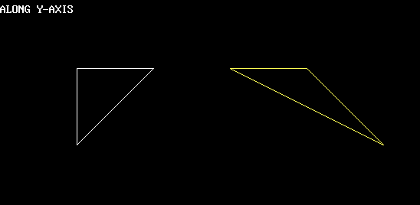

**REFLECTION:**

Code:

#include <stdio.h>

#include <conio.h>

#include <graphics.h>

void **main**()

{

int gm, gd = DETECT;

int ax, x1 = 100, x2 = 100, x3 = 200, y1 = 100, y2 = 200, y3 = 100;

**initgraph**(&gd, &gm, "");

**line**(**getmaxx**() / 2, 0, **getmaxx**() / 2, **getmaxy**());

**line**(0, **getmaxy**() / 2, **getmaxx**(), **getmaxy**() / 2);

**printf**("BEFORE REFLECTION IN 2 QUADRANT: ");

**setcolor**(15);

**line**(x1, y1, x2, y2);

**line**(x2, y2, x3, y3);

**line**(x3, y3, x1, y1);

**getch**();

**printf**("\nAFTER REFLECTION");

**printf**("AFTER REFLECTION ALONG ORIGIN: ");

**line**(**getmaxx**() - x1, **getmaxy**() - y1, **getmaxx**() - x2, **getmaxy**() - y2);

**line**(**getmaxx**() - x2, **getmaxy**() - y2, **getmaxx**() - x3, **getmaxy**() - y3);

**line**(**getmaxx**() - x3, **getmaxy**() - y3, **getmaxx**() - x1, **getmaxy**() - y1);

**getch**();

**printf**("AFTER REFLECTION ALONG Y-AXIS");

**line**(**getmaxx**() - x1, y1, **getmaxx**() - x2, y2);

**line**(**getmaxx**() - x2, y2, **getmaxx**() - x3, y3);

**line**(**getmaxx**() - x3, y3, **getmaxx**() - x1, y1);

**getch**();

**printf**("AFTER REFLECTION ALONG X-AXIS");

**line**(x1, **getmaxy**() - y1, x2, **getmaxy**() - y2);

**line**(x2, **getmaxy**() - y2, x3, **getmaxy**() - y3);

**line**(x3, **getmaxy**() - y3, x1, **getmaxy**() - y1);

**getch**();

**closegraph**();

}

OUTPUT:

