**CG LAB 9: Bezier Curve**

**Name:**Vivian Vijay Ludrick

**Branch:**SE Comps A Batch C

**Roll No:**9914

Code:

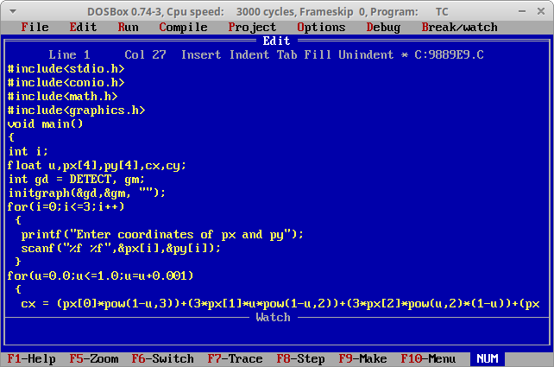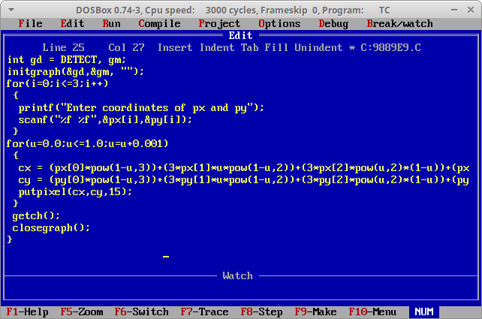

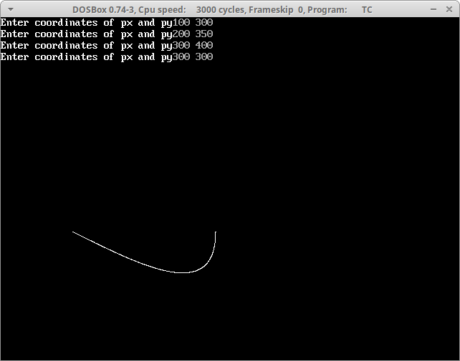

**OUTPUT:**