**DBMS: Assignment 1**

Name: Vivian Vijay Ludrick

Roll No: 9914

Branch: SE Comps A

Batch: C

Q. 1.A ⇒

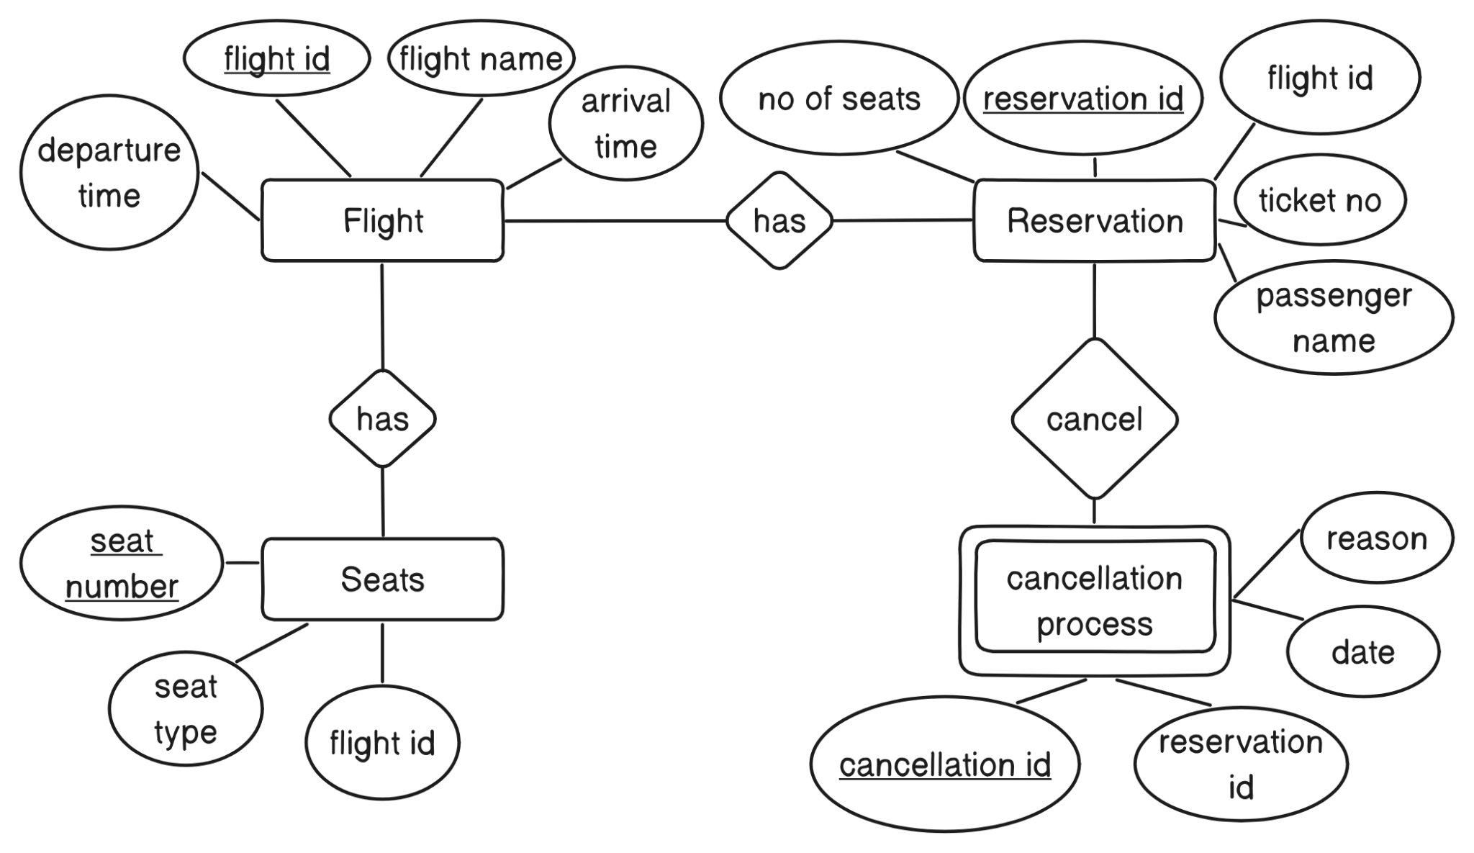

Assumptions:

1. Flights has unique ID
2. Seats have unique number for each flight
3. Reservation and Cancellation process have unique ids
4. Date attribute of the cancellation is the date when the particular reservation got cancelled

Q.1.B⇒

Flight:

* Flight id
* Flight name
* Arrival time
* Departure time

Seats:

* Seat number
* Seat type
* Flight id(foreign key)

Reservation:

* Reservation id
* Flight id
* Ticket number
* Passenger name/s
* Number of seats

Cancellation Process:

* Cancellation id
* Flight name
* Arrival time
* Departure time

Q.2

⇒ The given entities are:

1. Customer
2. Place
3. Location

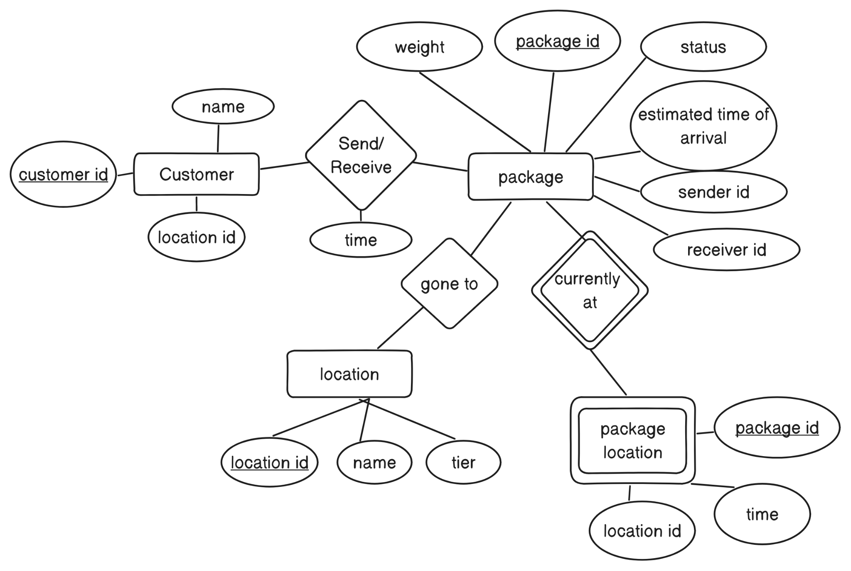

Relational Schemas:

1. Customer(customer_id: PK, name, location id: FK)
2. Package(package_id: PK, weight, status,estimated time of arrival, sender_id: FK, receiver_id: FK)
3. Location(location_id: PK, name, tier )
4. Package_Location(package_id: PK, location_id: PK, time)

Constraints:

Primary Key Constraints:

* + Customer: customer_id
  + Package: package_id
  + Location: location_id
  + Package_Location: (package_id, location id)

Foreign Key Constraints:

* + Package (sender_id): References Customer(customer_id)
  + Package (receiver_id): References Customer(customer_id)
  + Package_Location (package_id): References Package(package_id)
  + Package_Location (location_id): References Location(location_id)

Q.3. ⇒

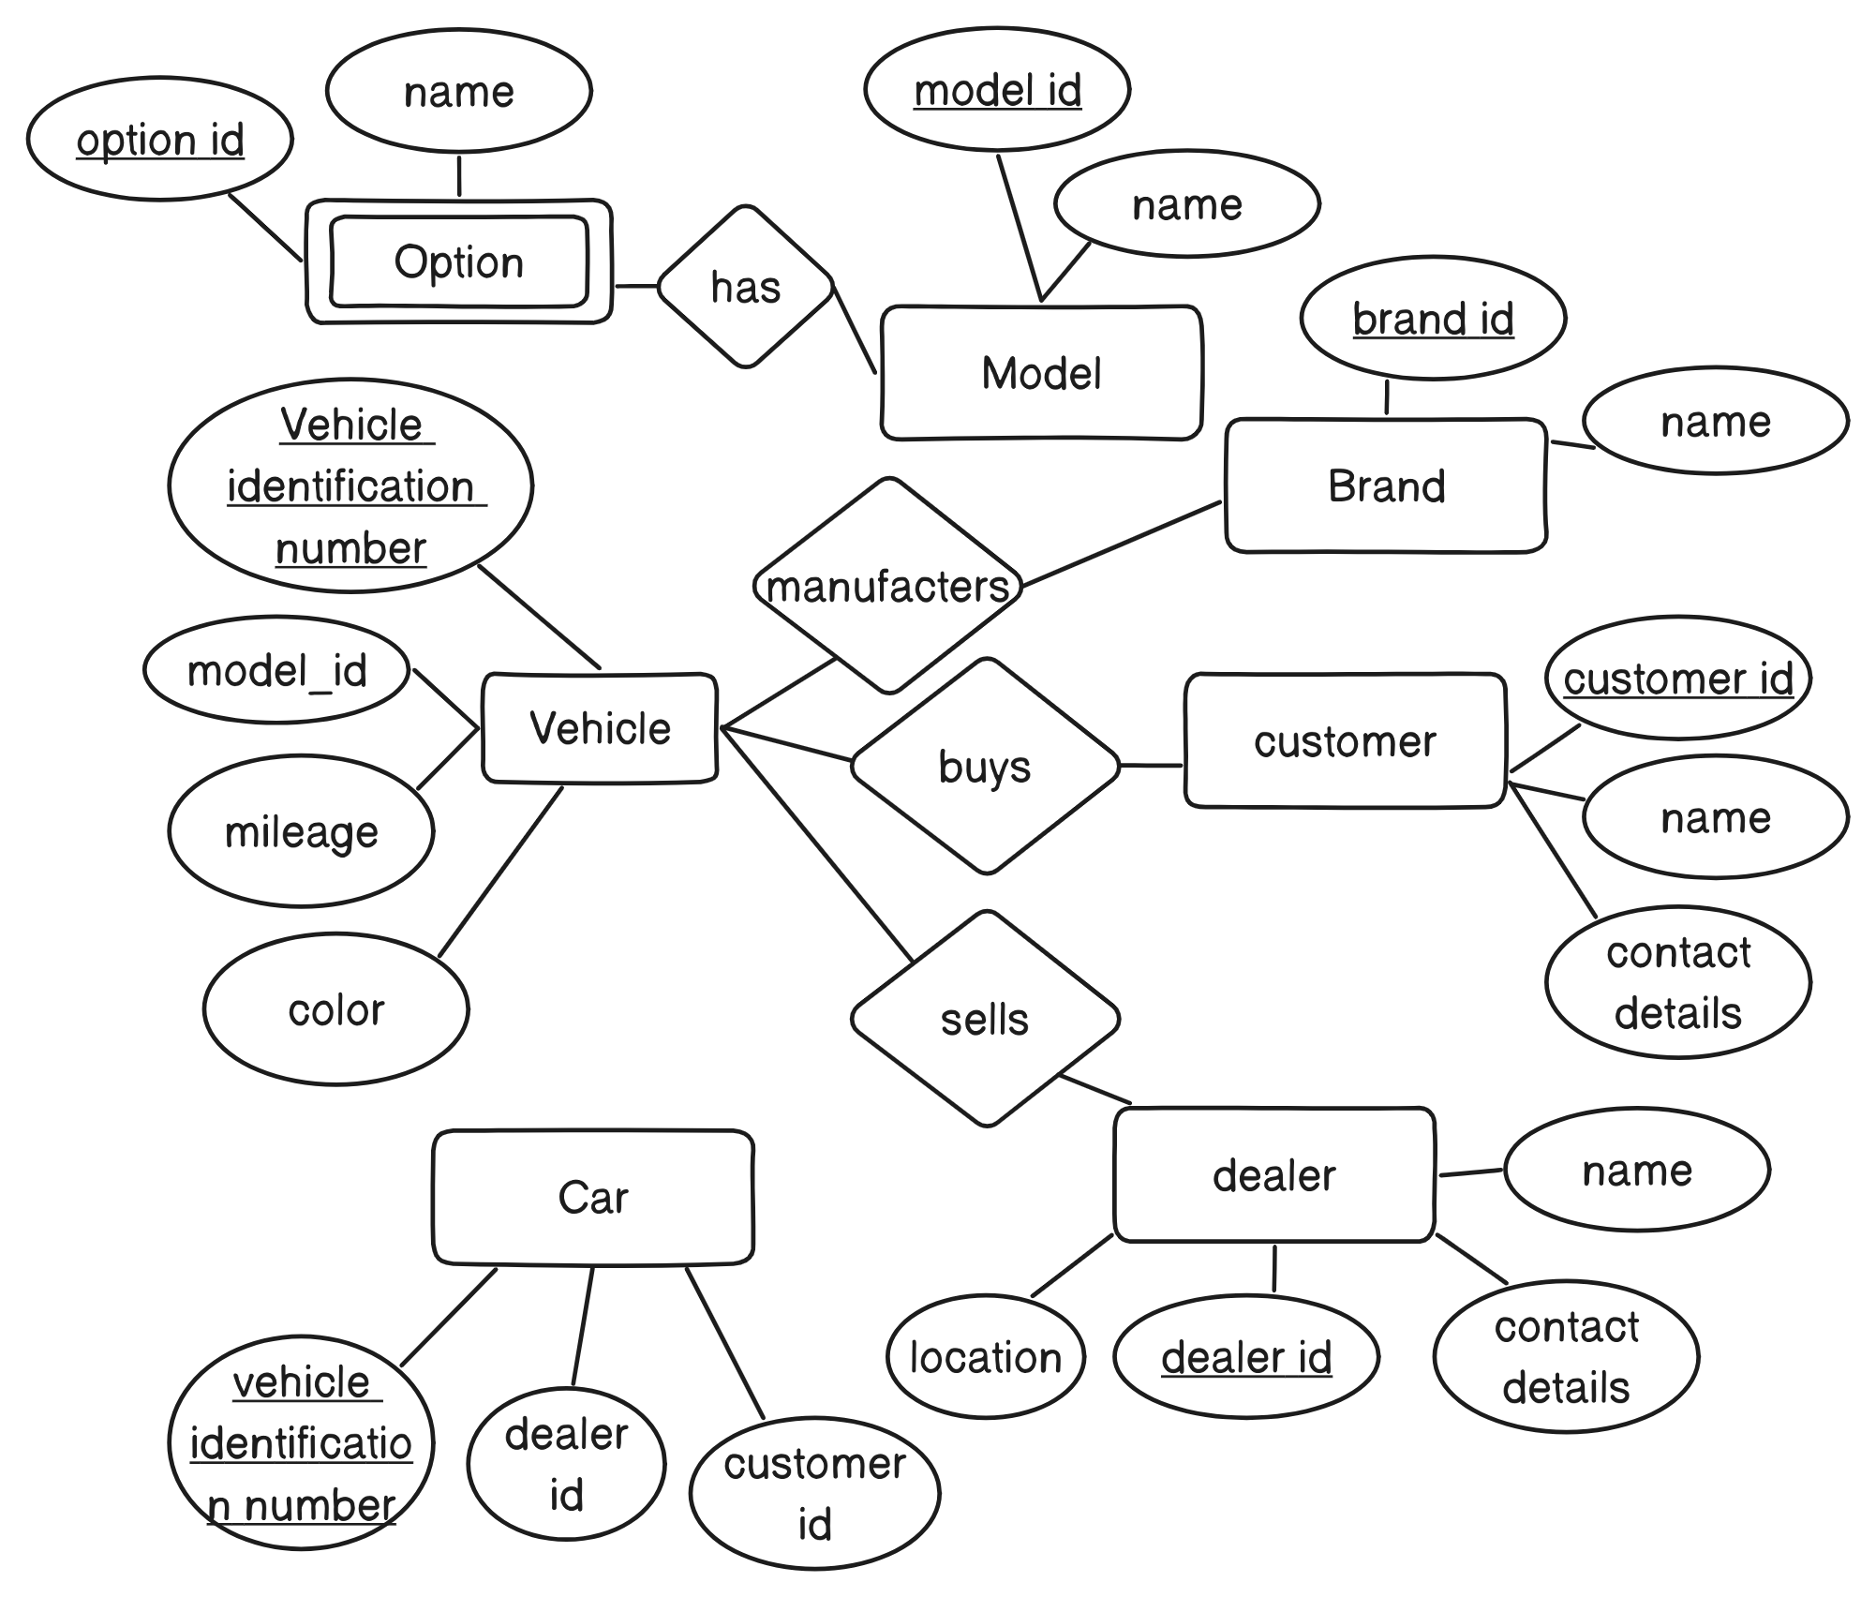

Relational Schemas:

* Vehicle(Vehicle identification number: PK, mileage, color, model_id: FK)
* Model(model_id: PK, name)
* Brand(brand_id: PK, name)
* Option(option_id: PK, name)
* Dealer(dealer_id: PK, name, location, contact details)
* Customer(customer_id: PK, name, contact details)
* Car(Vehicle identification number:PK, dealer id:FK, customer id:FK)

Constraints:

Primary Key Constraints:

* + Vehicle: VIN
  + Model: model_id
  + Brand: brand_id
  + Option: option_id
  + Dealer: dealer_id
  + Customer: customer_id
  + Car: VIN

Foreign Key Constraints:

* + Vehicle (model_id): References Model(model_id)
  + Car (dealer_id): References Dealer(dealer_id)
  + Car (customer_id): References Customer(customer_id)

Q.4.

1. ⇒

| **Entity** | **Primary Key** |
| --- | --- |
| Author | Name, address |
| Publisher | name |
| Shooping Basket | Basket id |
| Customer | Email |
| Book | ISBN |
| Warehouse | Code |

1. ⇒

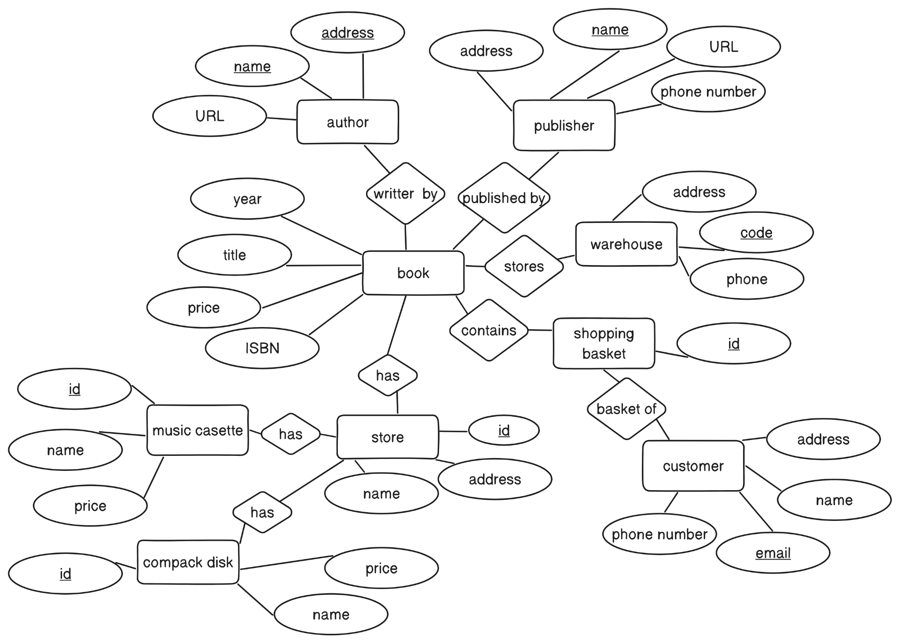

1. ⇒

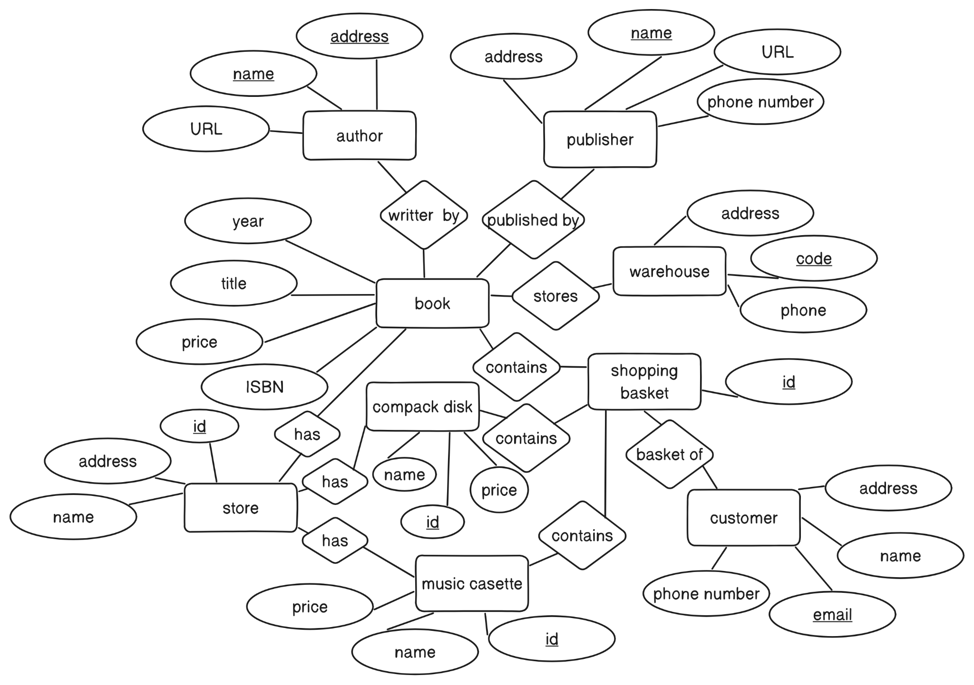

Q.5.

1. ⇒

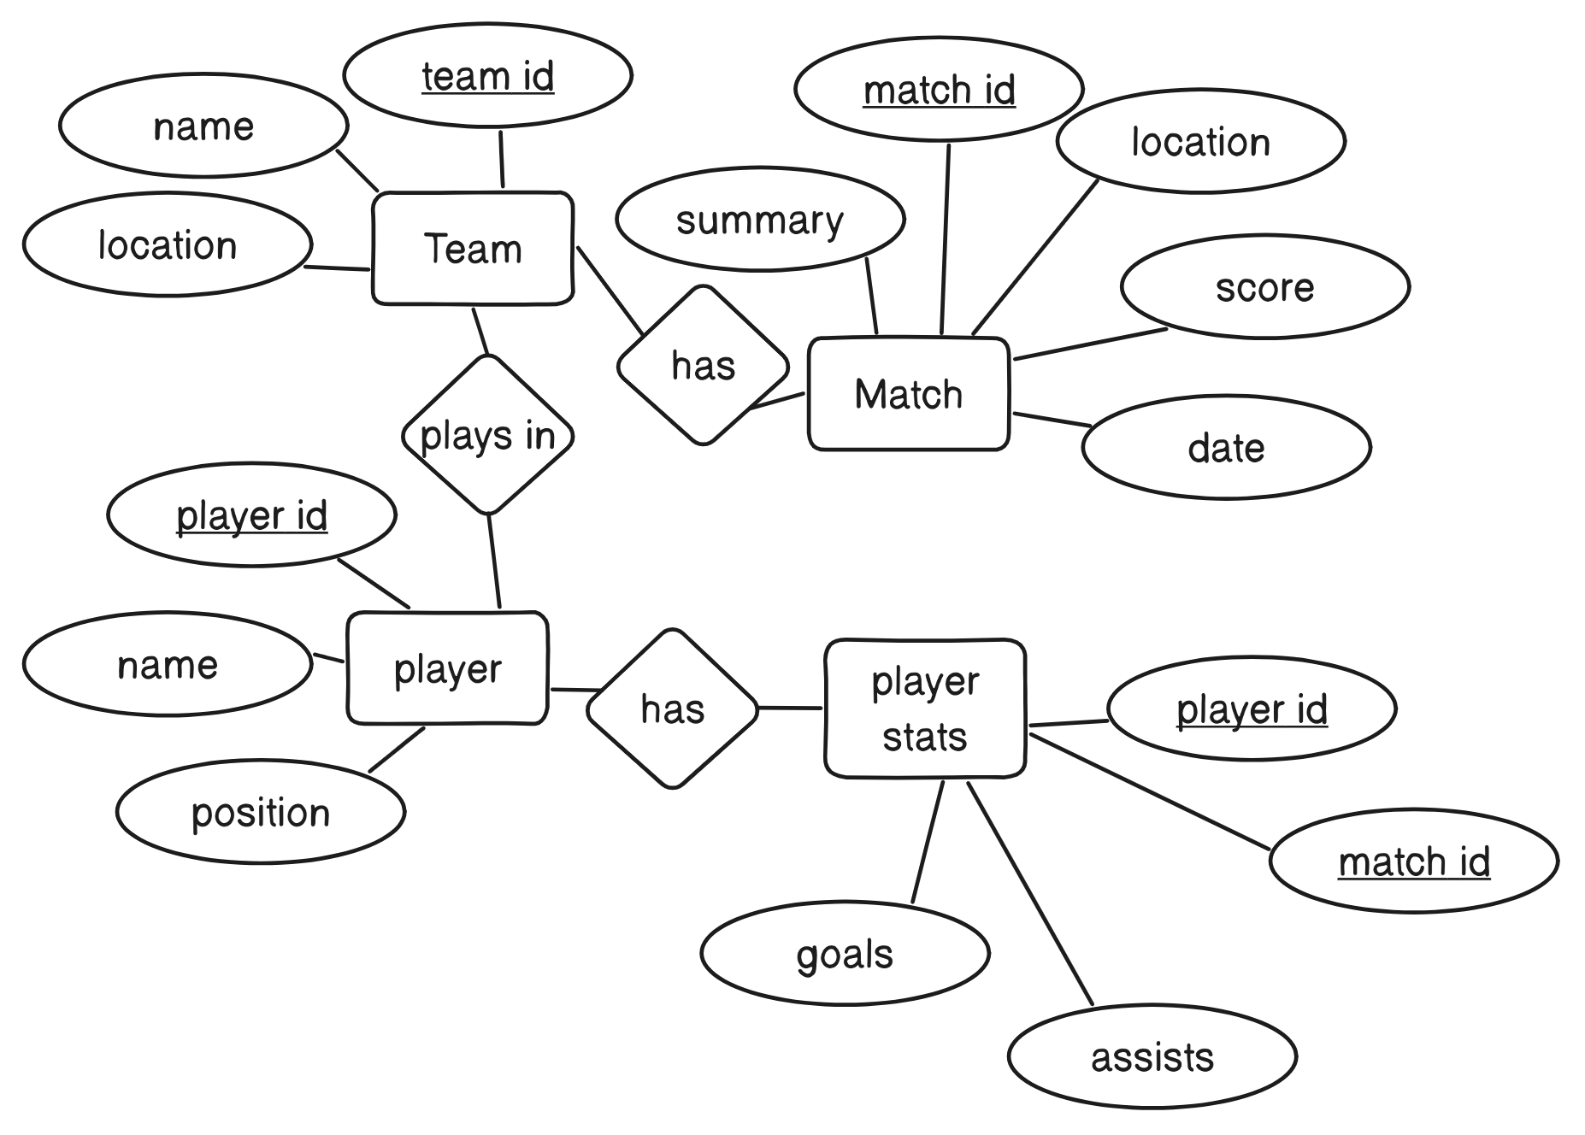

1. ⇒

Table 1:

| **Person** | | |
| --- | --- | --- |
| Drvier id(requierd) | Name | Address |

Table 2:

| **Car** | | |
| --- | --- | --- |
| License(required) | Model | Year |

Table 3:

| **Accident** | | | | | |
| --- | --- | --- | --- | --- | --- |
| Report Number(requierd) | Location | Date | Damage Amount | Car License(foreign key from car table) | Driver id(foreign key from person table) |

Q.6. ⇒

