| SE-Computer-Div-A Roll number : 9914 |
| --- |
| Experiment no. : 1 Date of Implementation : 23.01.2024 |
| Related Course outcome : At the end of the course, Students will be able to design ER model and develop relational model |
| **Rubrics for assessment of Experiment:**   | Indicator | Poor | Average | Good | | --- | --- | --- | --- | | Timeliness   * Maintains assignment deadline (3) | Assignment not done (0) | One or More than One week late (1-2) | Maintains deadline (3) | | Completeness and neatness   * Complete all parts of ER diagram(3) | N/A | < 80% complete (1-2) | 100% complete (3) | | Originality   * Extent of plagiarism(2) | Copied it from someone else(0) | At least few questions have been done without copying(1) | Assignment has been solved completely without copying (2) | | Knowledge   * In depth knowledge of the assignment(2) | Unable to answer 2 questions(0) | Unable to answer 1 question (1) | Able to answer 2 questions (2) | |
| **Assessment Marks :**   | Timeliness |  | | --- | --- | | Completeness and neatness |  | | Originality |  | | Knowledge |  | | Total |  | |
| **Total : (Out of 10)** |
| **Teacher's Sign :** |
|  |

| **Name Student** | Vivian Vijay Ludrick | **Roll No.** | 9914 |
| --- | --- | --- | --- |
| **Lab Experiment No.** | 1 | **Date** | 23.01.2024 |
| **Expt. Title** | Write Problem Definition and Draw ER /EER diagram | | |

**Aim** : Problem Definition and draw ER /EER diagram

**Objective of the Experiment:**

1. To design/draw ER/EER for the selected problem

**Theory:**

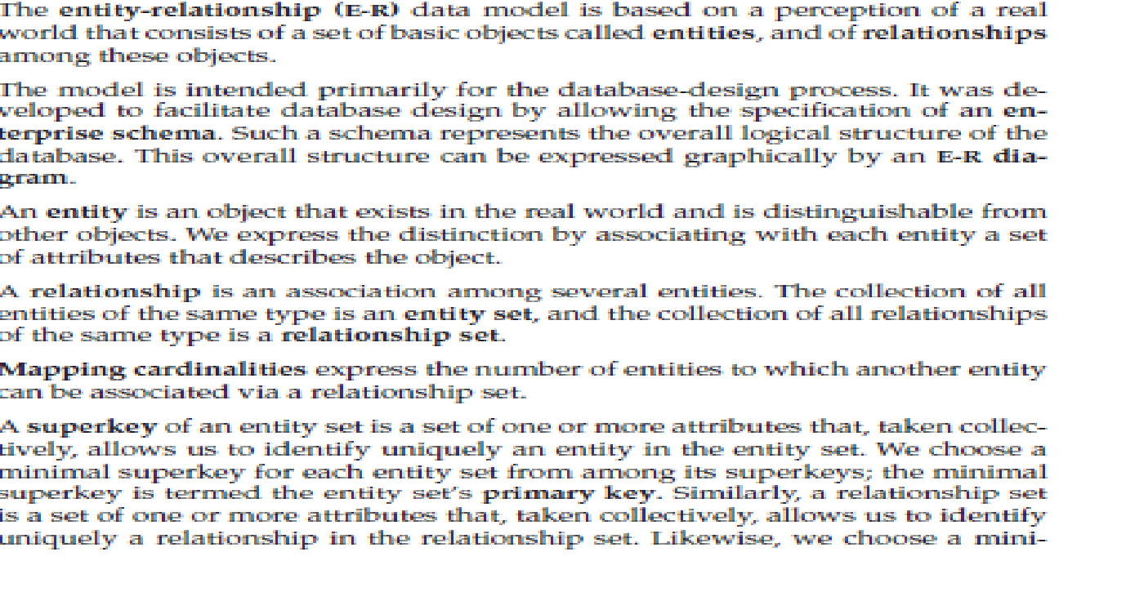

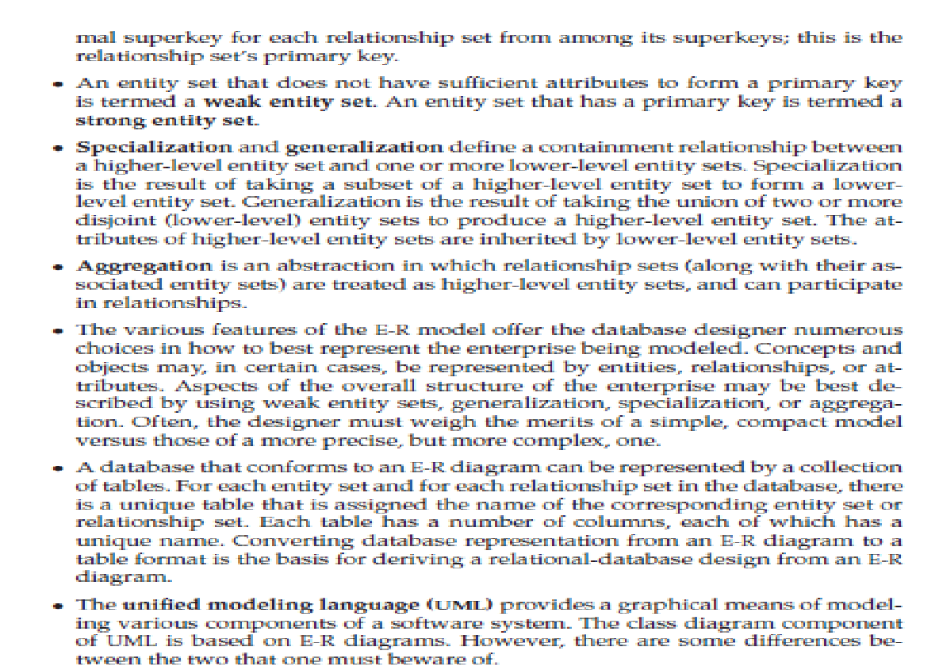

**(Sample Problem statement-BANKING)**

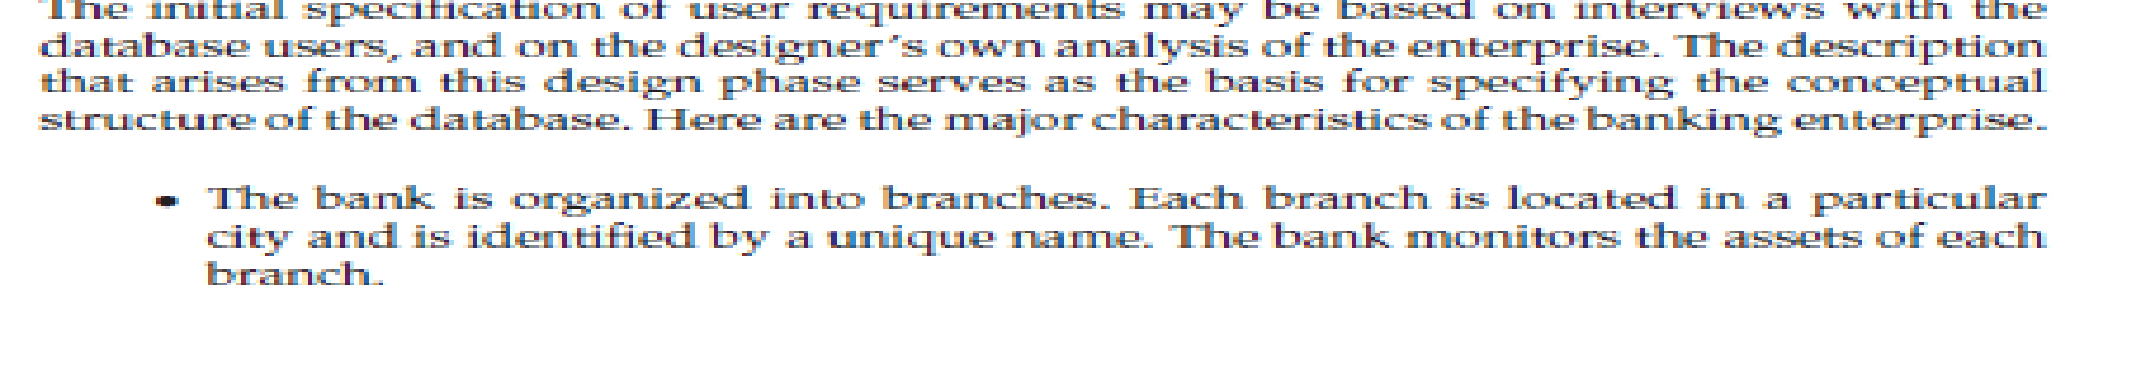

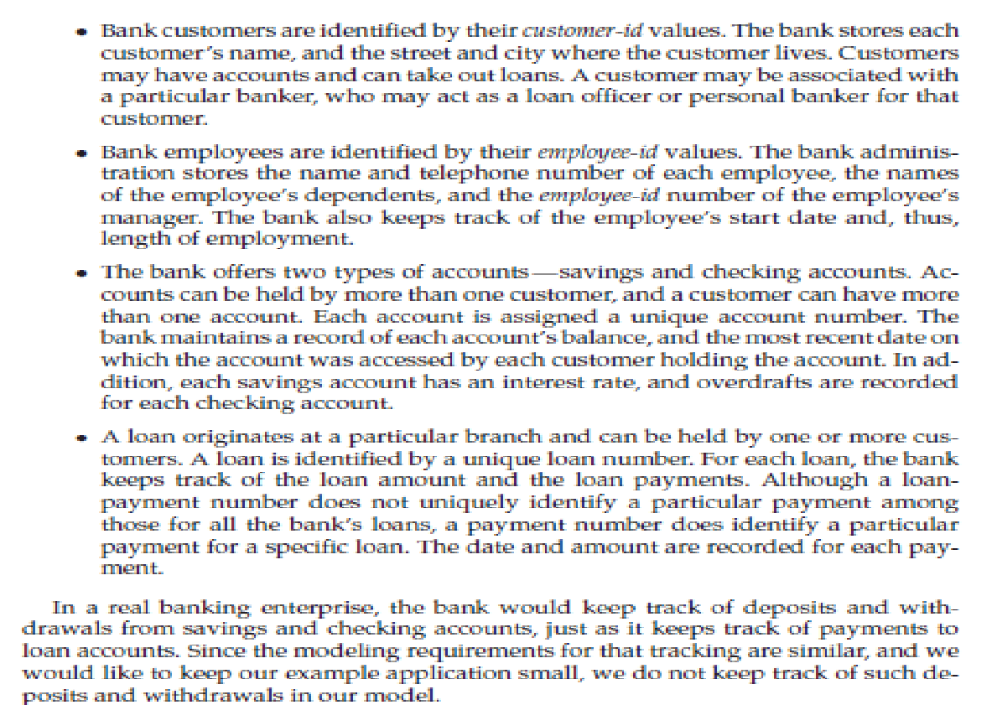

**Step 1- Identify entities of problem stmt**

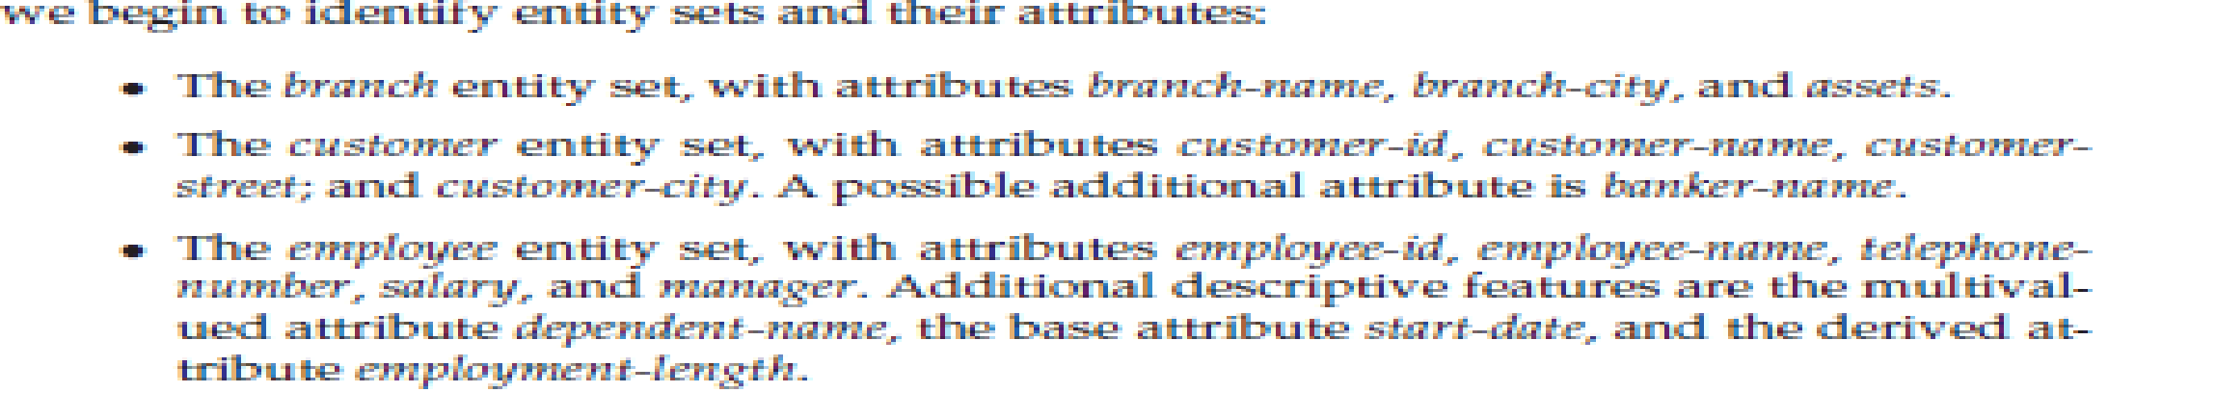

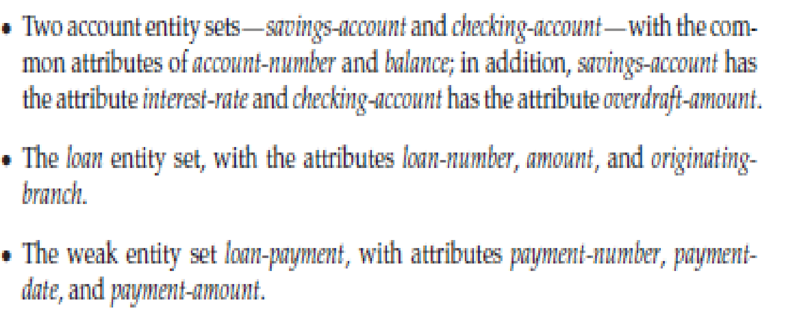

**Step-2 identify relationship with cardinality, type, and participation**

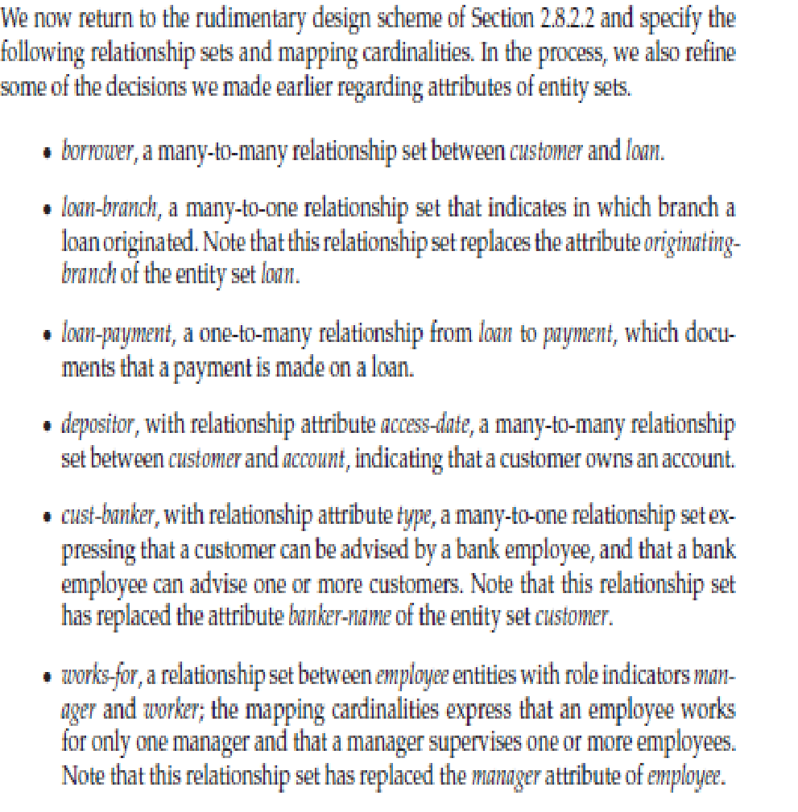

**Step-3 use symbols to draw ER/EER model -Old approach symbols-its representation in UML**

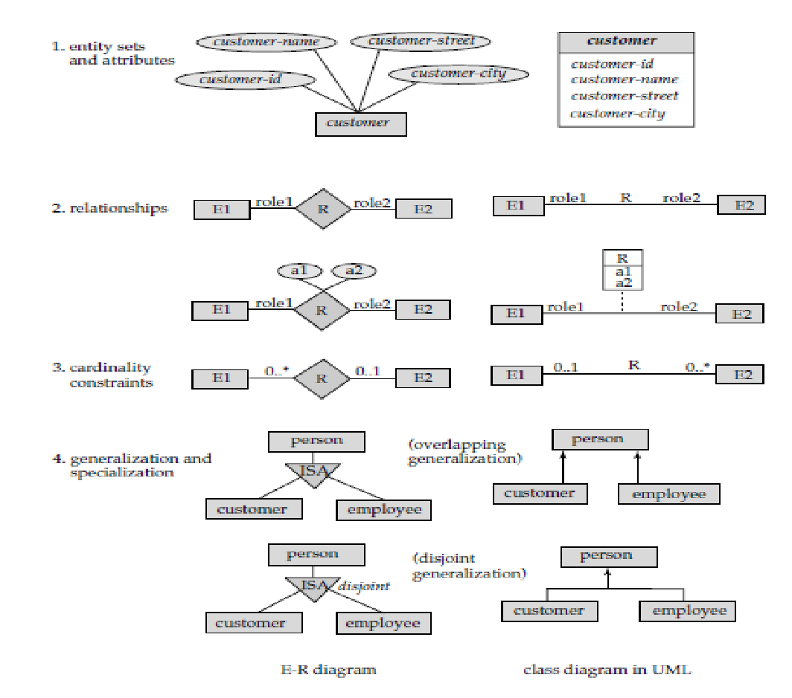

**New Approach notations-as per 6th edition of Korth**

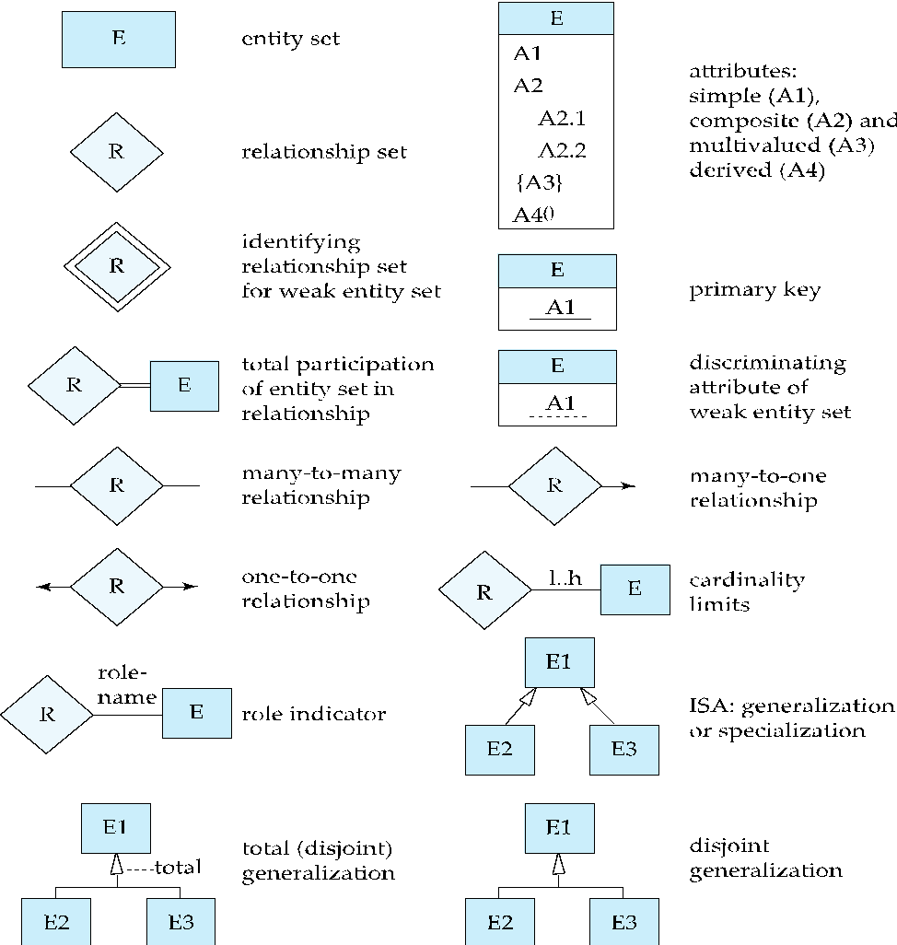 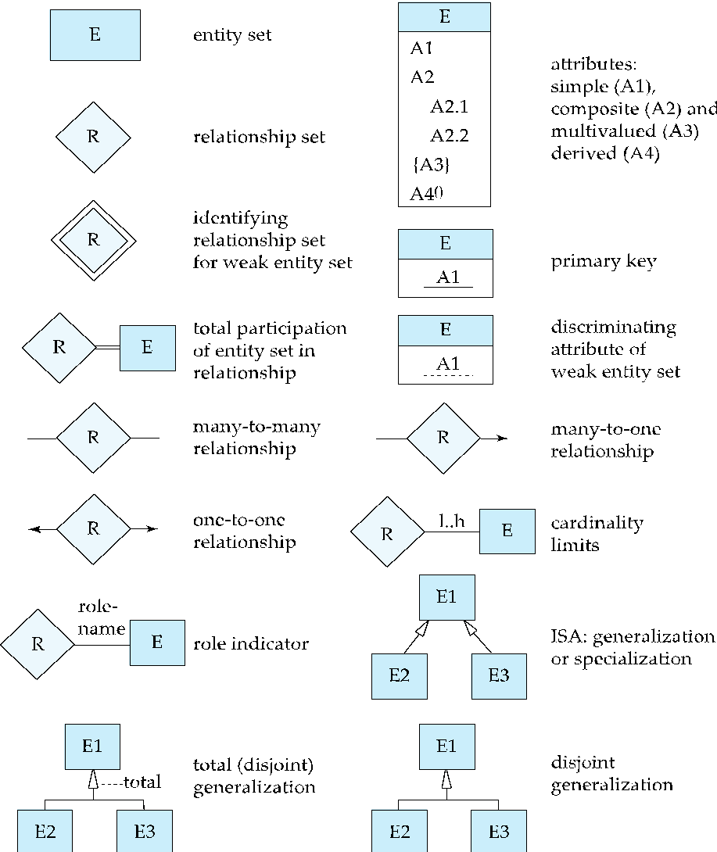

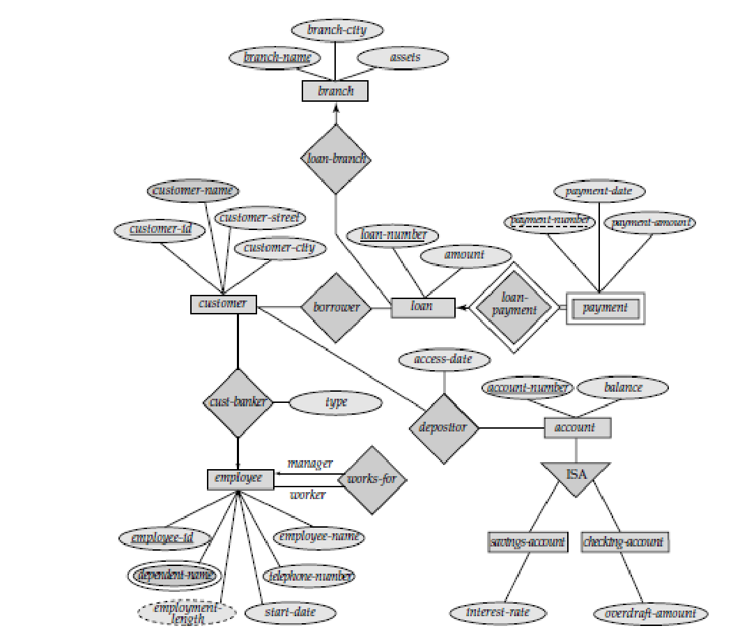

ER-Diagram banking example –Old approach

**Convert this using New approach**

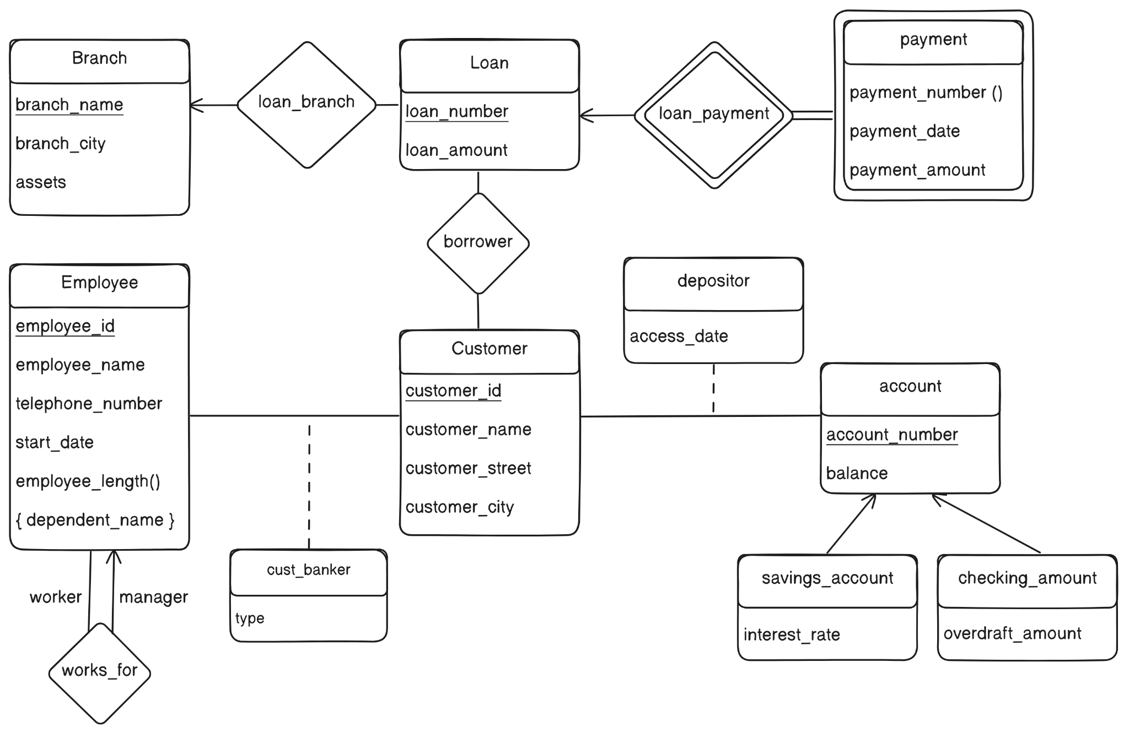

**Description of Problem Statement:-NAME OF CASE STUDY- DMART**

The ER diagram for DMart represents a database system for a retail store chain. The system stores information about customers, products, branches, invoices, and taxes.

The main entities in the ER diagram are:

* Customer: Customers are identified by their customer name.
* Branch: Branches are identified by their branch ID and have attribute branch name and address.
* Items: Items are identified by their item code and name. They also have a price, description, and tax information.
* Invoice: Invoices are identified by their invoice number and date. They contain information about the products purchased, the quantity purchased, the total amount, and the mode of payment.
* Taxes: Taxes are identified by their tax type and rate.

The relationships between the entities are:

* A customer can visit many branches.
* A branch can have many customers visit.
* A customer can buy many items.
* An items can be purchased by only one customer(unique product id)
* An item will always have an invoice.
* An invoice may contain several items.
* An product is associated with one branch.
* An invoice is associated with one customer.
* A product price will always have tax

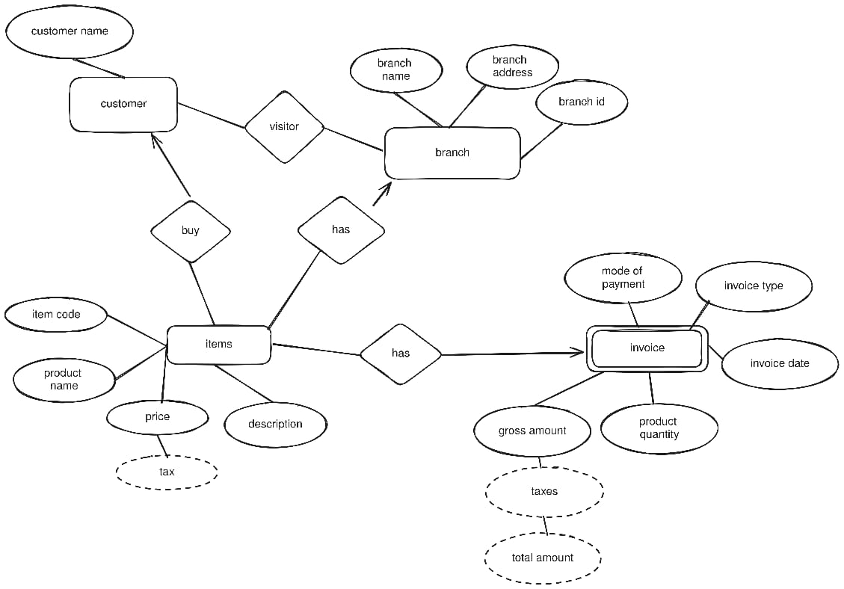

| **Post Lab Assignment:** |
| --- |
| 1. Describe various symbols used in E-R Diagram and EER diagram  | **SYMBOLS** | **Description** | | --- | --- | |  | Entities in ER model | |  | Weak entity | |  | Attribute of an entity | |  | Primary key(attribute) of an entity | |  | Dependent attribute | |  | Multivalued attribute | |  | Relationship between two entities | |  | Identity relationship | |  | Role 1 : Relation of entity 1 with respect to entity 2  Role 2: Relation of entity 2 with respect to entity 1 | |  | Connecting line(many to many) | |  | Connecting line(many to one) | |  | Connecting line(one to one) | |  | Total participation of one entity on another. | |

List of topics for ER diagram

1. Facebook system
2. Stock exchange syst
3. Wikipedia
4. Youtube
5. Traffic monitoring system
6. Dmart
7. Amazon
8. Twitter
9. Instagram
10. Olx.com
11. Hike
12. Whatsapp
13. Flipcart
14. Yahoo
15. Google search
16. Bio research
17. Bookmyshow
18. Election system- targeting the voters
19. Inventory management system
20. Library management system
21. College information management system
22. Banking system
23. Hospital management system
24. Airline reservation system
25. Railway reservation system
26. Ticket booking system
27. Hotel reservation system
28. Ola.
29. Other topics after the discussion and approval of subject teacher