| SE-Computer-A Roll number : 9914 |
| --- |
| Experiment no. : 2 Date of Implementation : |
| Related Course outcome : At the end of the course, Students will be able to design EER model and develop relational model |
| **Rubrics for assessment of Experiment:**   | Indicator | Poor | Average | Good | | --- | --- | --- | --- | | Timeliness   * Maintains assignment deadline (3) | Assignment not done (0) | One or More than One week late (1-2) | Maintains deadline (3) | | Completeness and neatness   * Complete all parts of ER diagram(3) | N/A | < 80% complete (1-2) | 100% complete (3) | | Originality   * Extent of plagiarism(2) | Copied it from someone else(0) | At least few questions have been done without copying(1) | Assignment has been solved completely without copying (2) | | Knowledge   * In depth knowledge of the assignment(2) | Unable to answer 2 questions(0) | Unable to answer 1 question (1) | Able to answer 2 questions (2) | |
| **Assessment Marks :**   | Timeliness |  | | --- | --- | | Completeness and neatness |  | | Originality |  | | Knowledge |  | | Total |  | |
| **Total : (Out of 10)** |
| **Teacher's Sign :** |

| **Name Student** | Vivian Vijay Ludrick | **Roll No.** | 9914 |
| --- | --- | --- | --- |
| **Lab Experiment No.** | 2 | **Date** | 12/02/2024 |
| **Expt. Title** | Mapping / Convert EER diagram to Relational Model of Problem | | |

**Aim** /objective: To map ER/EER diagram to relational model.

**Theory:**

* ER diagram is converted into the tables in relational model.
* This is because relational models can be easily implemented by RDBMS like MySQL, Oracle etc.

 ER diagrams mainly comprise of −

* Entity and its attributes
* Relationship, which is association among entities.

## 1)Mapping of ER model to Relational Model

## Mapping Entity

An entity is a real-world object with some attributes.

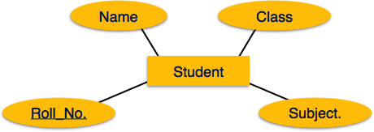

### Mapping Process (Algorithm)

* Create table for each entity set.
* Entity's attributes should become fields of tables with their respective data types.
* Declare primary key.

## Mapping Relationship

A relationship is an association among entities.

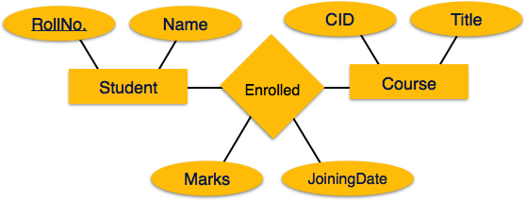

### Mapping Process

* Create table for a relationship.
* Add the primary keys of all participating Entities as fields of table with their respective data types.
* If relationship has any attribute, add each attribute as field of table.
* Declare a primary key composing all the primary keys of participating entities.
* Declare all foreign key constraints.

## Mapping Weak Entity Sets

A weak entity set is one which does not have any primary key associated with it.

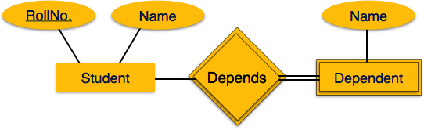

### Mapping Process

* Create table for weak entity set.
* Add all its attributes to table as field.
* Add the primary key of identifying entity set.
* Declare all foreign key constraints.

## Mapping Hierarchical Entities

ER specialization or generalization comes in the form of hierarchical entity sets.

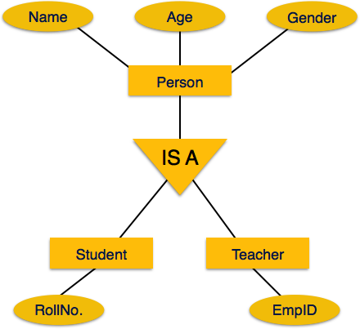

### Mapping Process

* Create tables for all higher-level entities.
* Create tables for lower-level entities.
* Add primary keys of higher-level entities in the table of lower-level entities.
* In lower-level tables, add all other attributes of lower-level entities.
* Declare primary key of higher-level table and the primary key for lower-level table.
* Declare foreign key constraints.

**Rules:**

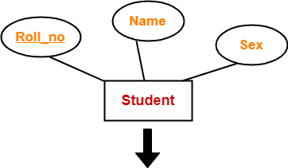

| **Roll_no** | **Name** | **Sex** |
| --- | --- | --- |
|  |  |  |

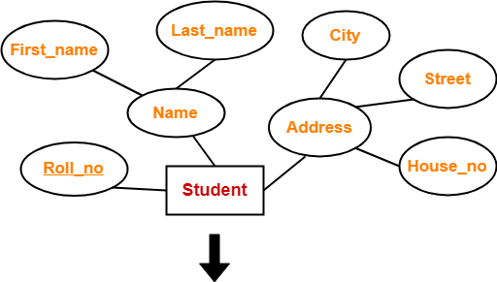

| **Roll_no** | **First_name** | **Last_name** | **House_no** | **Street** | **City** |
| --- | --- | --- | --- | --- | --- |
|  |  |  |  |  |  |

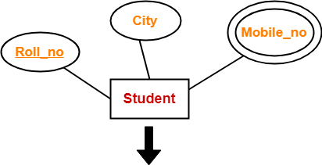

| **Roll_no** | **City** |
| --- | --- |
|  |  |

| **Roll_no** | **Mobile_no** |
| --- | --- |
|  |  |

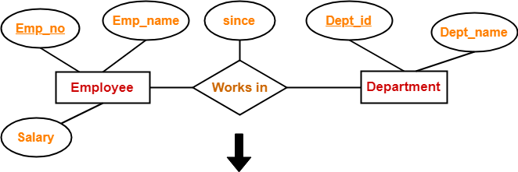

| **Emp_no** | **Dept_id** | **since** |
| --- | --- | --- |
|  |  |  |

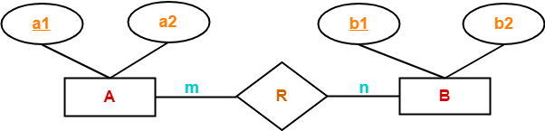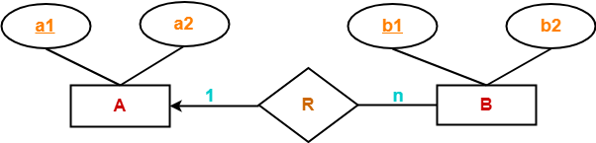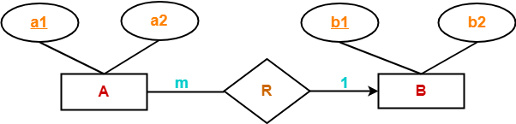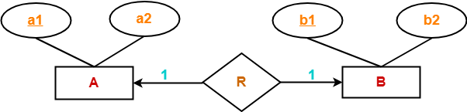

| **Thumb Rules to Remember**   While determining the minimum number of tables required for binary relationships with given cardinality ratios, following thumb rules must be kept in mind-   * For binary relationship with cardinality ration m : n , separate and individual tables will be drawn for each entity set and relationship. * For binary relationship with cardinality ratio either m : 1 or 1 : n , always remember “many side will consume the relationship” i.e. a combined table will be drawn for many side entity set and relationship set. * For binary relationship with cardinality ratio 1 : 1 , two tables will be required. You can combine the relationship set with any one of the entity sets. |
| --- |

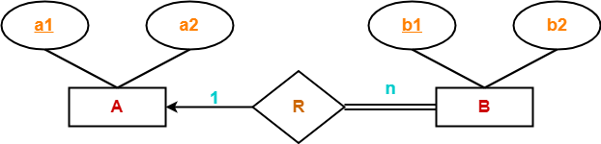

Because cardinality ratio = 1 : n , so we will combine the entity set B and relationship set R.

Then, two tables will be required-

1. A ( a1 , a2 )
2. BR ( a1 , b1 , b2 )

Because of total participation, foreign key a1 has acquired NOT NULL constraint, so it can’t be null now.

### **Case-02: For Binary Relationship With Cardinality Constraint and Total Participation Constraint From Both Sides-**

If there is a key constraint from both the sides of an entity set with total participation, then that binary relationship is represented using only single table.

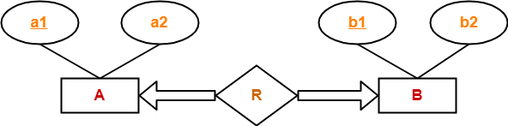

Here, Only one table is required.

* ARB ( a1 , a2 , b1 , b2 )

## **Rule-07: For Binary Relationship With Weak Entity Set-**

Weak entity set always appears in association with identifying relationship with total participation constraint.

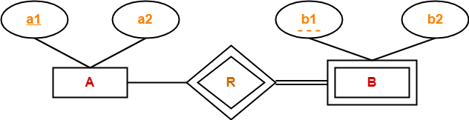

**Sample Example**

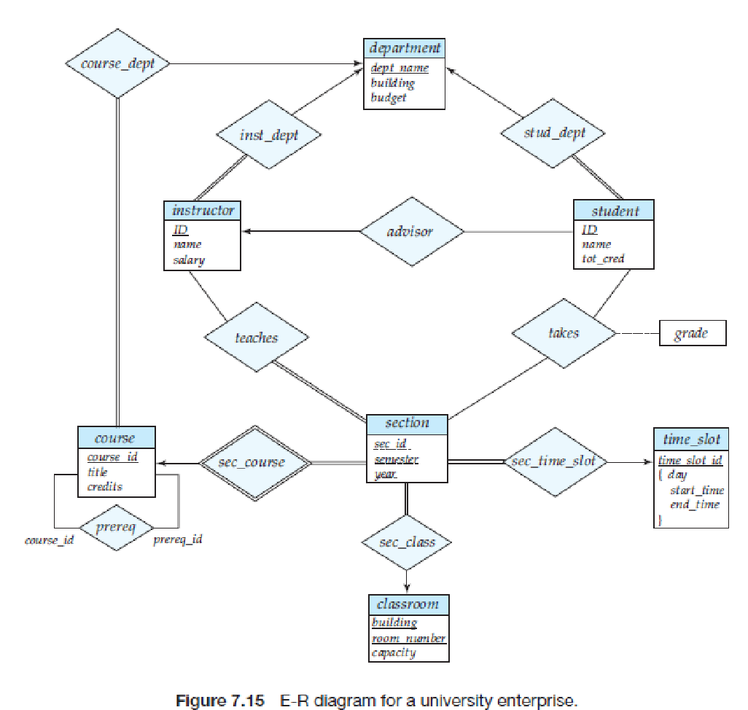

ER diagram of university database

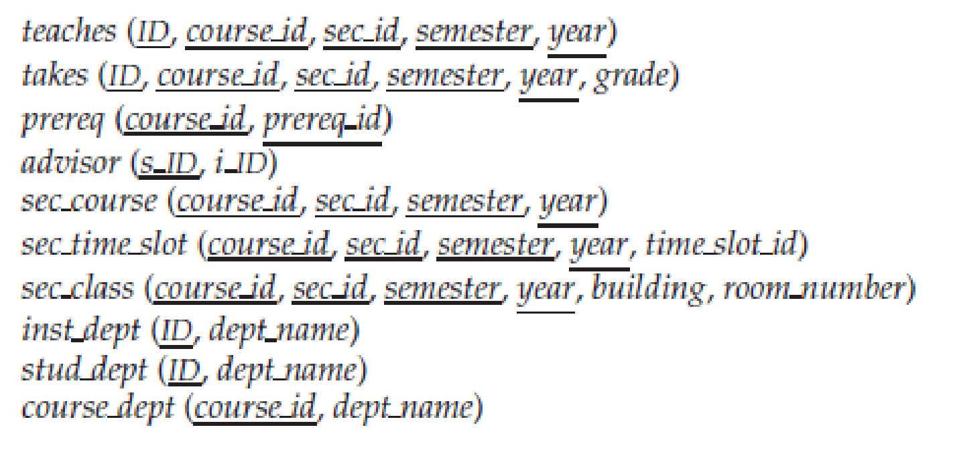

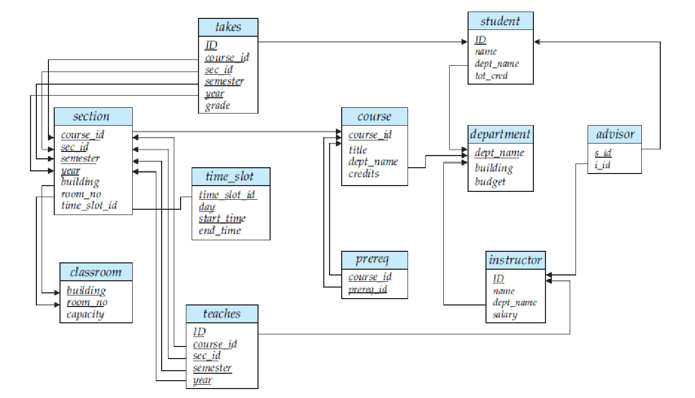**Schema diagram /relational model of University database**

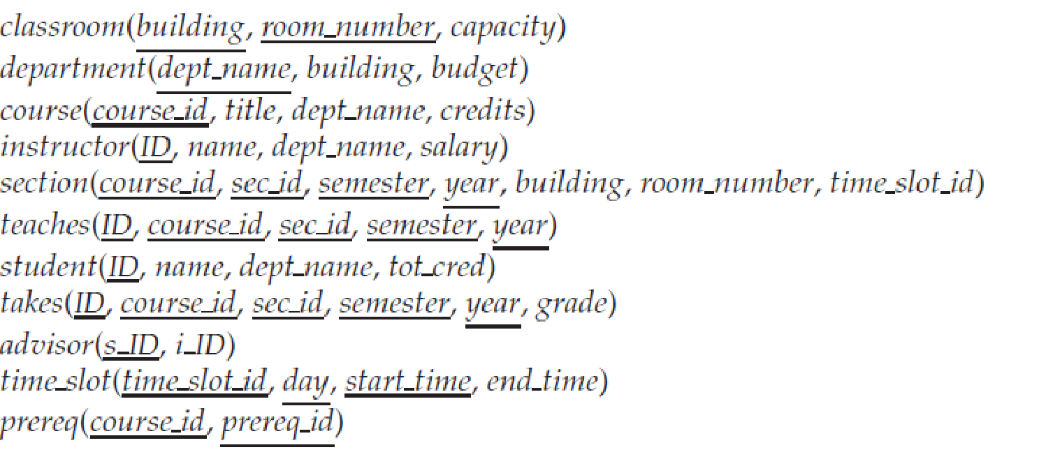

**2) Mapping of Specialization or Generalization**

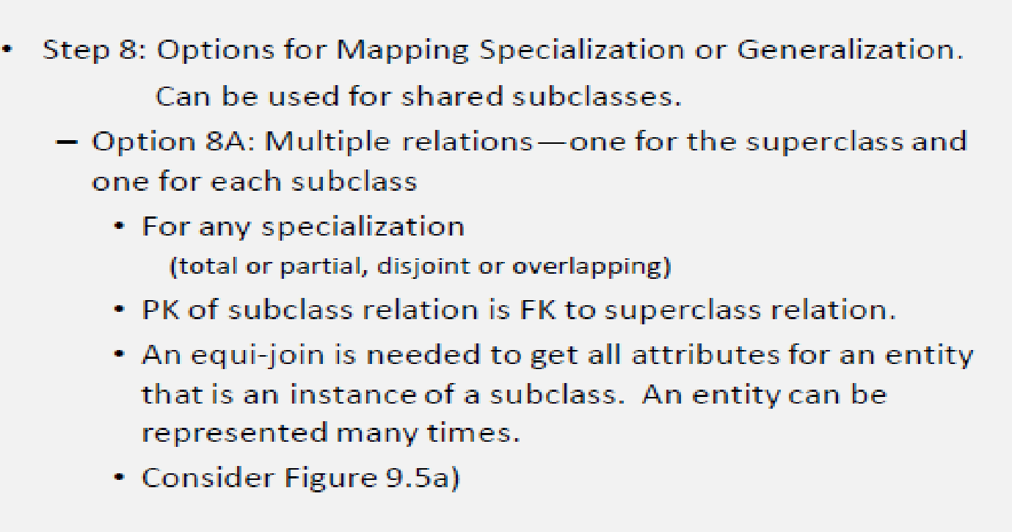

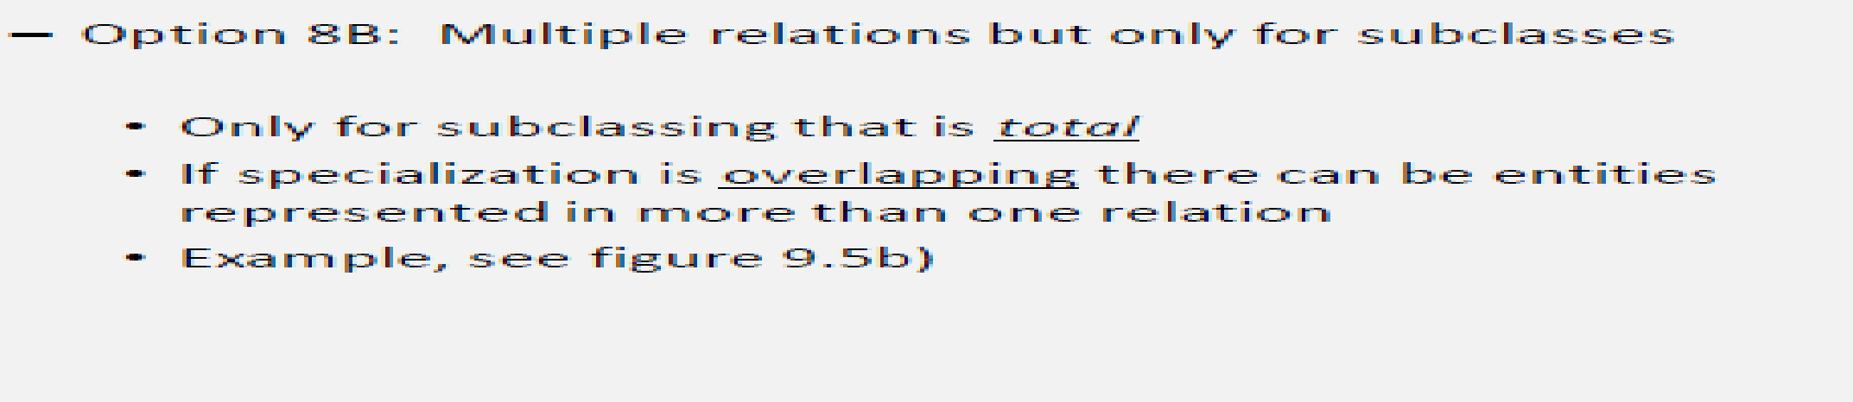

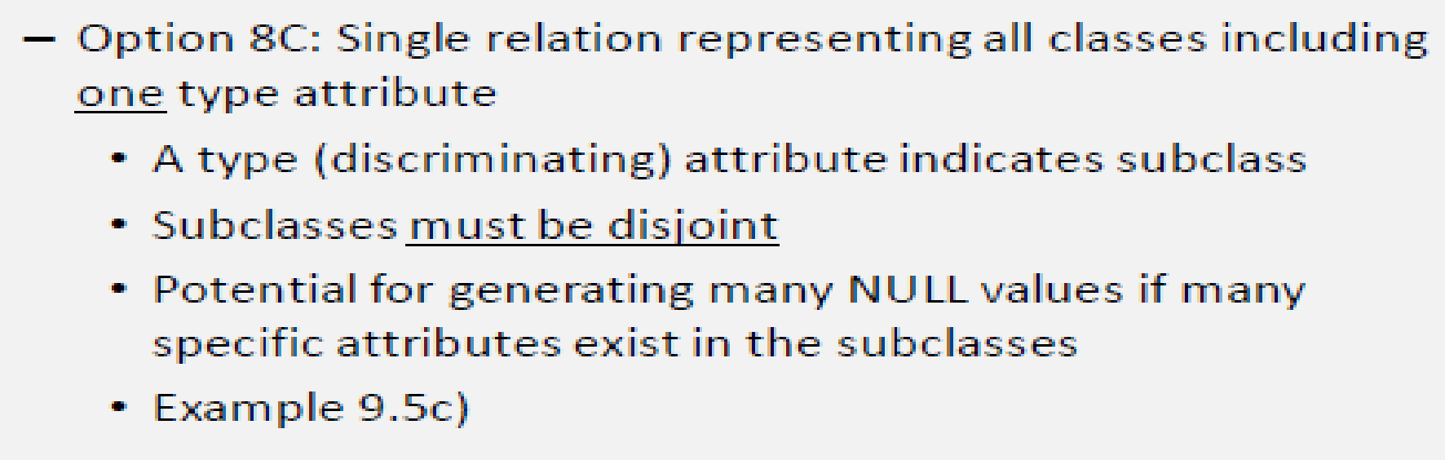

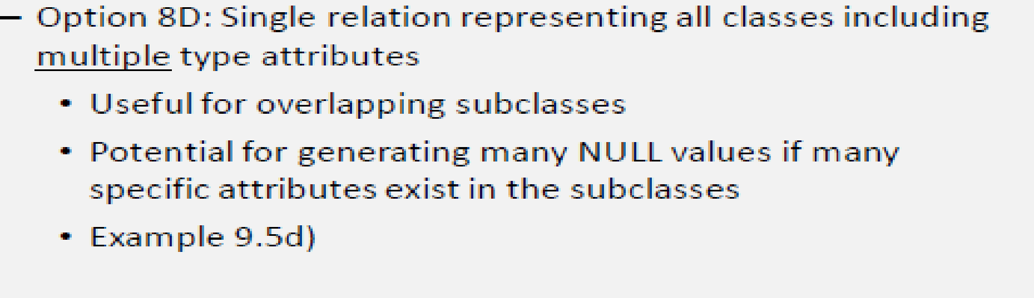

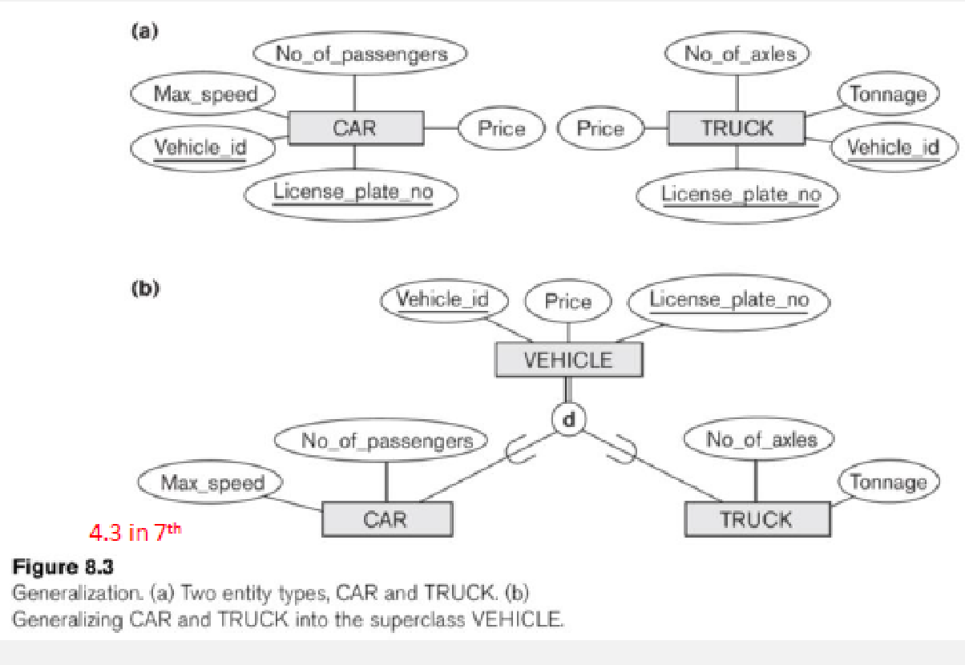 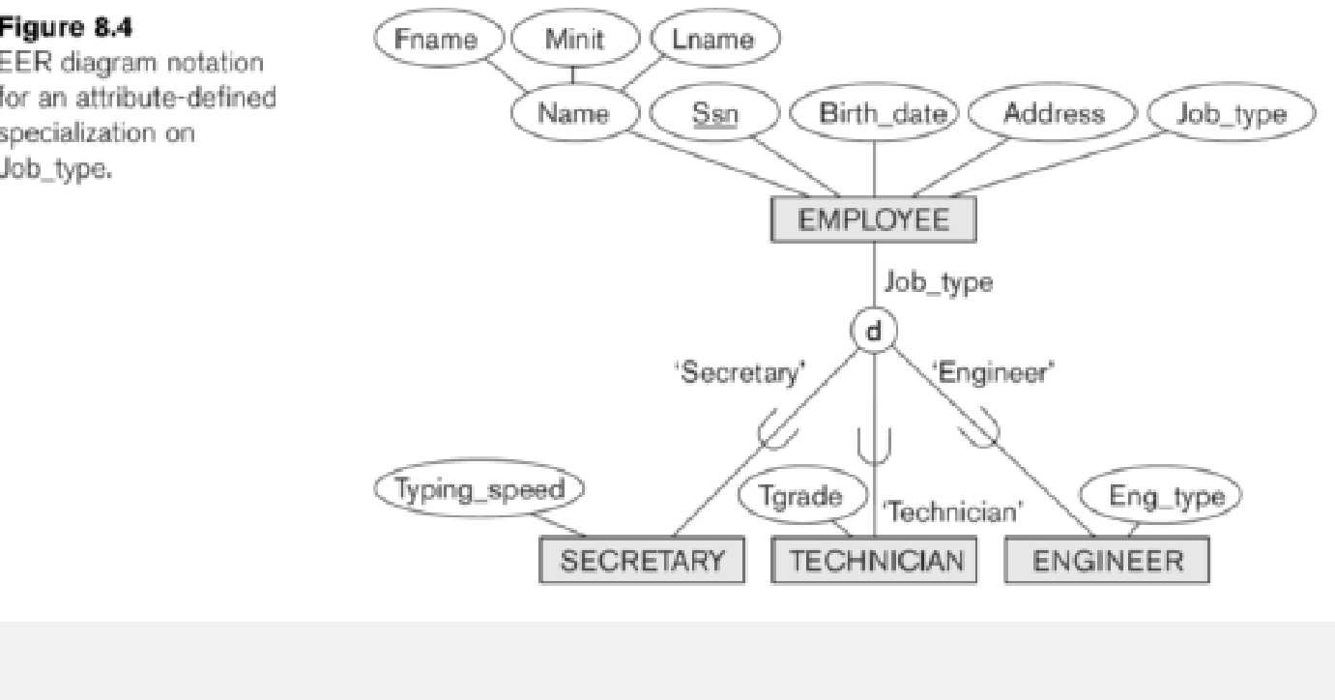

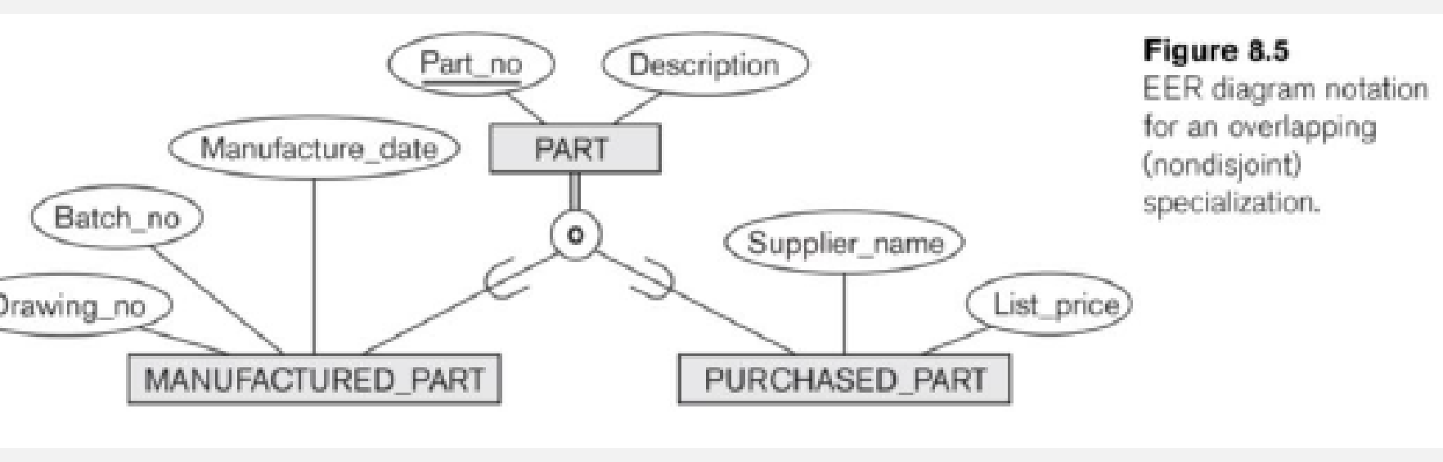

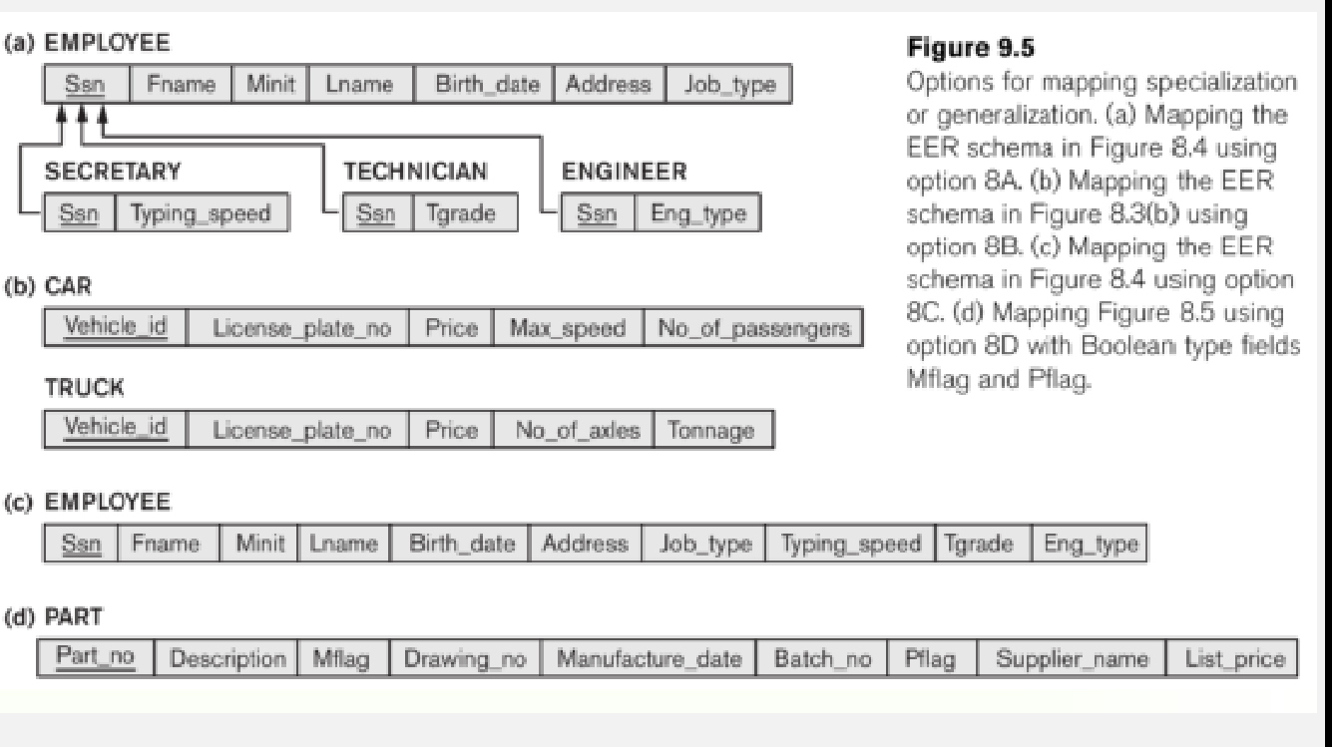

**EXAMPLE**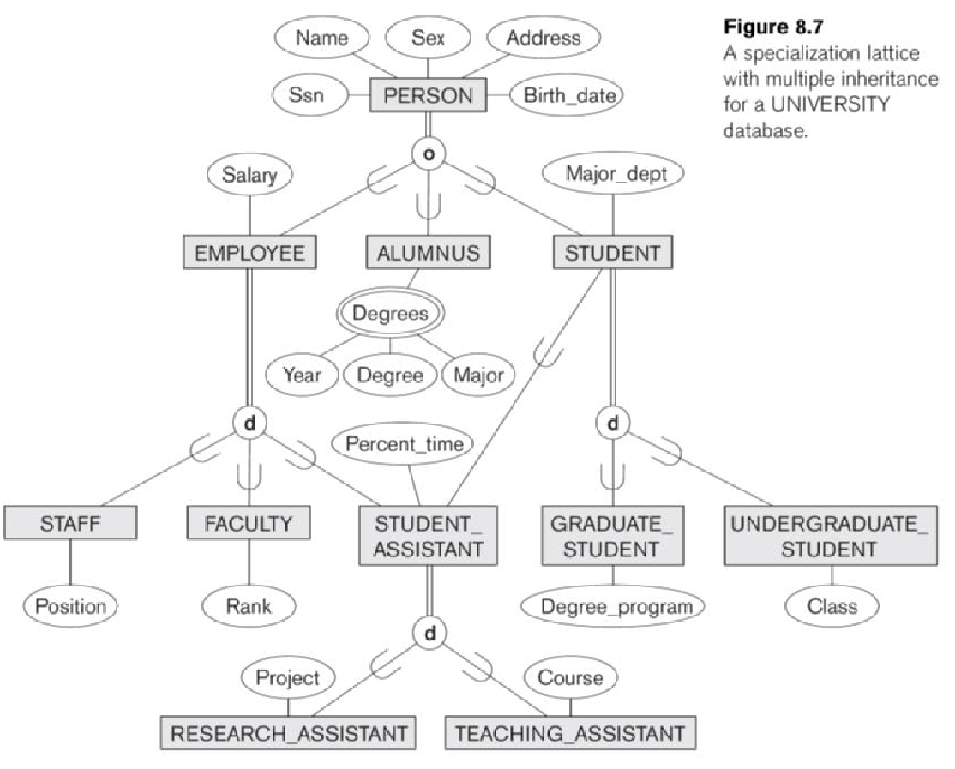

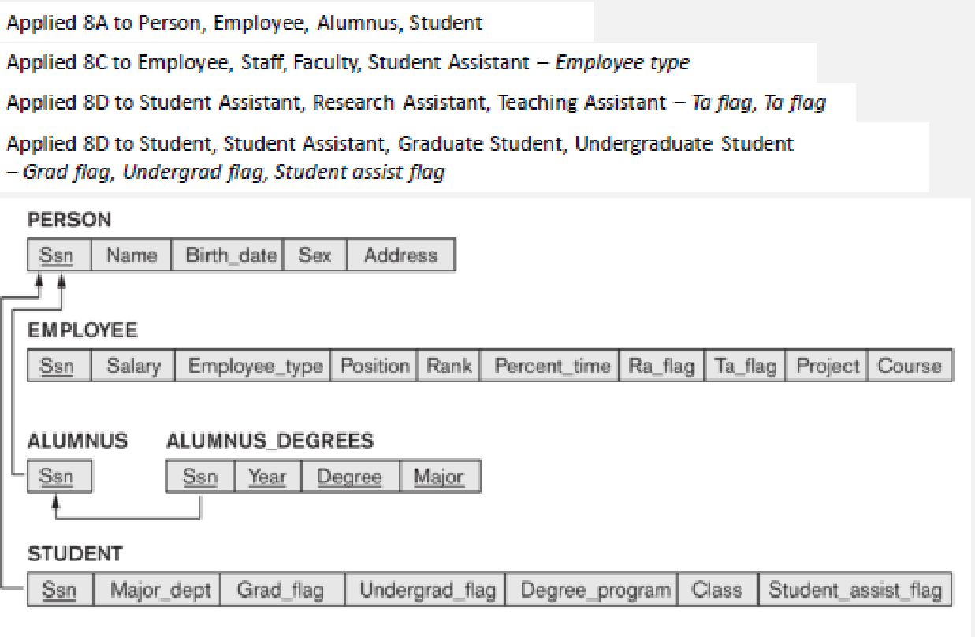

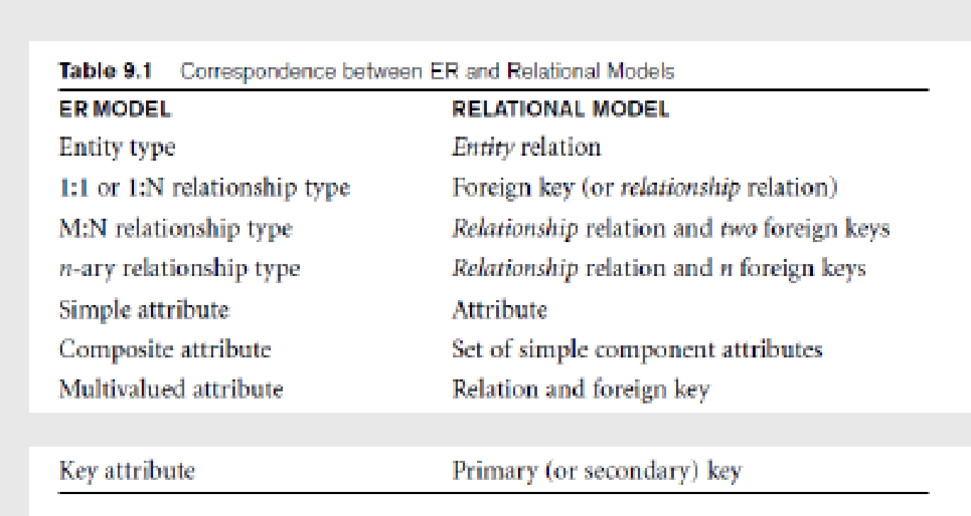

| **Relational Model of Problem** |
| --- |
|  |

| **Post Lab Assignment:** |
| --- |
| 1) Find the minimum number of tables required for the following ER diagram in relational model-    https://www.gatevidyalay.com/wp-content/uploads/2018/06/ER-Diagrams-to-Tables-Problem-01.png  ⇒ The number of tables required are:   1. P (P1, P2) 2. NR2 (N1, N2, P1) 3. MR1 (M1, M2, M3, P1)   2) Find the minimum number of tables required to represent the given ER diagram in relational model-    https://www.gatevidyalay.com/wp-content/uploads/2018/06/ER-Diagrams-to-Tables-Problem-02.png  ⇒ The number of tables required are:   1. C (C1, C2) 2. AR1R2 (A1, A2, C1, B1) 3. B (B1, B2) 4. R3 (B1, C1)   3) Find the minimum number of tables required to represent the given ER diagram in relational model-    https://www.gatevidyalay.com/wp-content/uploads/2018/06/ER-Diagrams-to-Tables-Problem-03.png  ⇒ The number of tables required are:   1. A (A1, A2) 2. BR1R4R5 (B1, B2,A1, C1, D1) 3. D (D1, D2) 4. CR3 (C1, C2, D1) 5. R2 (A1, C1) |