**FR. Conceicao Rodrigues College of Engineering**

**Department of Computer Engineering**

**11. Implement SIPO and PIPO shift register using 74194**

**1. Course, Subject & Experiment Details**

| **Academic Year** | **2023-24** | **Estimated Time** | **Experiment No. 11– 02 Hours** |
| --- | --- | --- | --- |
| **Course & Semester** | **S.E. (Computers) – Sem. III** | **Subject Name** | **Digital Logic & Computer Organization and Architecture** |
| **Chapter No.** | **3** | **Chapter Title** | **Processor Organization and Architecture** |
| **Experiment Type** | **Hardware** | **Subject Code** | **CSC304** |

**Rubrics**

| **Roll No.** | **Date of performance**  **16-10-2023** | **Timeline (2)** | **Practical Skill & Applied Knowledge**  **(4)** | **Output**  **(4)** | **Total (10)** |
| --- | --- | --- | --- | --- | --- |
| 9914 | Date of Submission |  |  |  |  |

**2. Aim & Objective of Experiment**

To study different modes of operation of universal shift register by using IC 74194

**3. Problem Statement**

Implement SISO & PISO using 74194

**4. Hardware Required**

1. Breadboard , Power Supply, Connecting wires.
2. Components: IC 74194,LEDs

**5**. **Brief Theoretical Description**

IC 74194 is an MSI 4 bit bidirectional parallel in parallel out shift register.

Its contents may be shifted in either of two directions. Left (QD to QA) or right ( QA to QD) depending on control input application

**FUNCTION TABLE (74194))**

| Function | Inputs | | Next state | | | | Clear |
| --- | --- | --- | --- | --- | --- | --- | --- |
| S1 | S0 | QA | QB | QC | QD |
| Hold | 0 | 0 | QA | QB | QC | QD | 1 |
| Shift right | 0 | 1 | Rin | QA | QB | QC | 1 |
| Shift left | 1 | 0 | QB | QC | QD | Lin | 1 |
| load | 1 | 1 | A | B | C | D | 1 |
| clear | X | X | 0 | 0 | 0 | 0 | 0 |

**IC 74194**

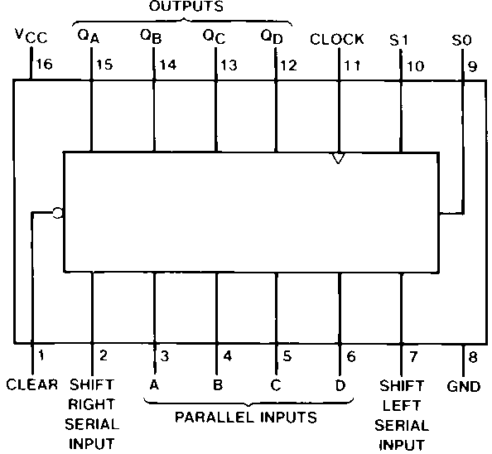

**6. Screenshots of Experiment :**

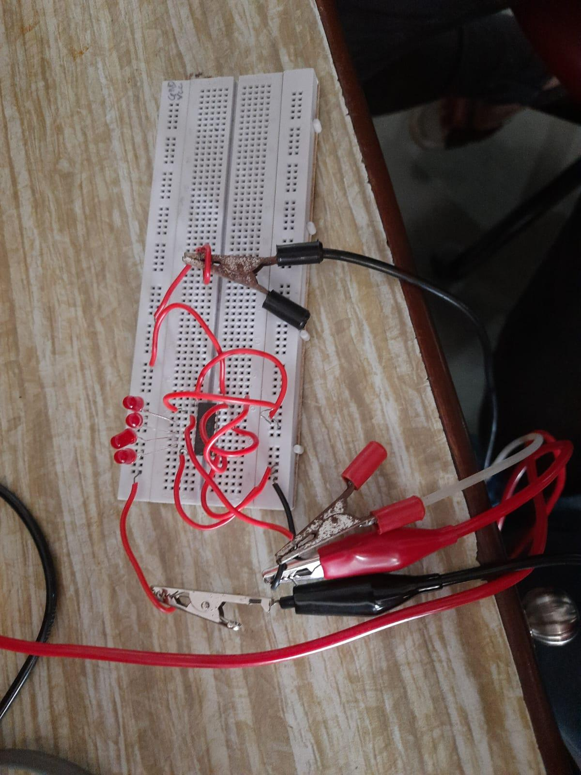

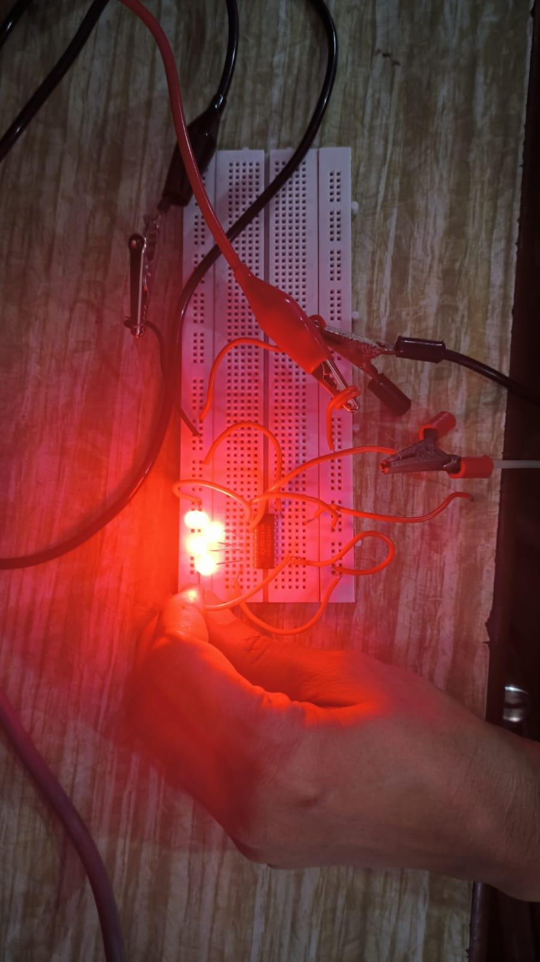

**7. Conclusion:**

In this experiment, we successfully implemented SISO and PISO shift registers using the IC 74194. The IC 74194 is a 4-bit bidirectional parallel in parallel out shift register, which allows us to shift its contents in either the left or right direction based on control input.