**FR. Conceicao Rodrigues College of Engineering**

**Department of Computer Engineering**

**5. Study of S-R, J-K, D, T Flip-Flops**

**1. Course, Subject & Experiment Details**

| **Academic Year** | **2023-24** | **Estimated Time** | **Experiment No. 5– 02 Hours** |
| --- | --- | --- | --- |
| **Course & Semester** | **S.E. (Computers) – Sem. III** | **Subject Name** | **Digital Logic & Computer Organization and Architecture** |
| **Chapter No.** | **3** | **Chapter Title** | **Processor Organization and Architecture** |
| **Experiment Type** | **Hardware** | **Subject Code** | **CSC304** |

**Rubrics**

| **Timeline (2)** | **Practical Skill & Applied Knowledge**  **(4)** | **Output**  **(4)** | **Total (10)** |
| --- | --- | --- | --- |
|  |  |  |  |

**2. Aim & Objective of Experiment**

* To learn and understand the working of various flip flops.

**3. Problem Statement**

Verify the truth table of S-R flipflop, MS J-K flipflop , D Flipflop, T Flipflop.

**4. Software Required**

1. Virtual Lab.

**5**. **Brief Theoretical Description**

The storage elements employed in clocked sequential circuits are called Flipflops. A flipflop is a binary cell capable of storing one bit of information. It has two outputs, one for normal value and one for the complement value of the bit store in it. A flipflop maintains a binary state until directed by a clock pulse to switch states. The difference among various types of flipflops is in the number of inputs they possess and in the manner in which the inputs affect the binary state(output).

**Types of Flip Flops**

1. **S-R flipflop:**

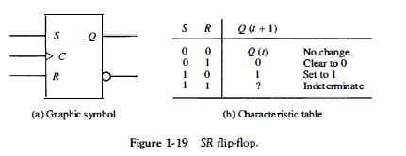

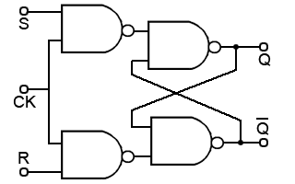

The symbol and truth table and logic diagram is shown in the figure.

1. **MS- JK Flipflop:**

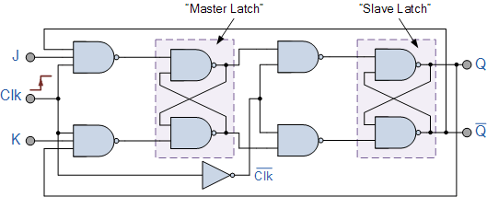

| **CLK** | **J** | **K** | **Q(t)** | **Q(t+1)** |
| --- | --- | --- | --- | --- |
| 1 | 0 | 0 | 0 | 0 |
| 1 | 0 | 0 | 1 | 1 |
| 1 | 0 | 1 | 0 | 0 |
| 1 | 0 | 1 | 1 | 0 |
| 1 | 1 | 0 | 0 | 1 |
| 1 | 1 | 0 | 1 | 1 |
| 1 | 1 | 1 | 0 | 1 (toggle) |
| 1 | 1 | 1 | 1 | 0 (toggle) |

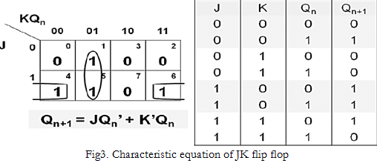

1. **D Flipflop:**

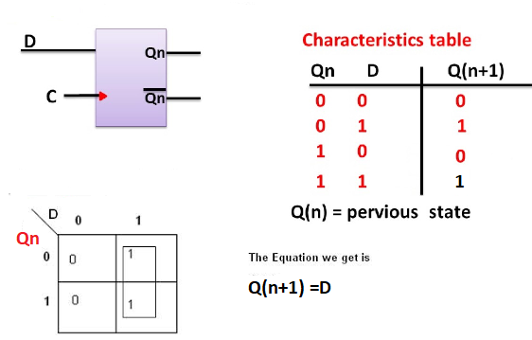

1. **T Flipflop:**

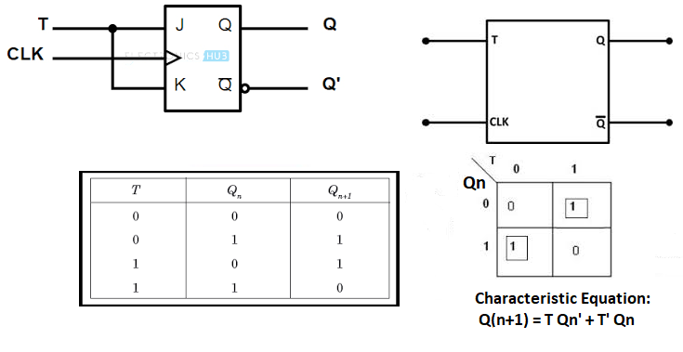



**6. Simulation**

**1- A** ***Virtual Lab:***

The virtual laboratory is an interactive environment for creating and conducting simulated experiments: a playground for experimentation. It consists of domain-dependent simulation programs, experimental units called objects that encompass data files, tools that operate on the objects.

The objective is to expose the students to various key aspects of Digital Logic and computer organization by enabling them to perform FPGA based prototyping of experiments with support of a virtual environment.

***Procedure to perform the experiments:***

1. Start the simulator as directed. This simulator supports 5-valued logic
2. To add the logic components to the editor or canvas (where you build the circuit) select any component and click on the position of the canvas where you want to add the component.( choose the required Gate)
3. The pin configuration is shown when you select the component and press the 'show pinconfig' button in the left toolbar or whenever the mouse is hovered on any canned component of palette
4. To connect any two components select the connection tool of palette, and then click on the source terminal and then click on the the target terminal
5. To move any component select the component using the selection tool and drag the component to the desired position
6. To give a toggle input to the circuit, use 'Bit Switch' which will toggle its value with a double click
7. Use 'Bit Display' component to see any single bit value. 'Digital Display' will show the output in digital format
8. undo/redo, delete, zoom in/zoom out, and other functionalities have been given in the top toolbar for ease of circuit building
9. Use start/stop clock pulse to start or stop the clock input of the circuit. Clock period can be set from the given 'set clock' button in the left toolbar
10. Users can save their circuits with .logic extension and reuse them
11. After building the circuit press the simulate button in the top toolbar to get the output.
12. Verify the truth table S-R, MS-JK,D,T flipflops.

**7*.* Attach the screen shots of the implemented circuits.**

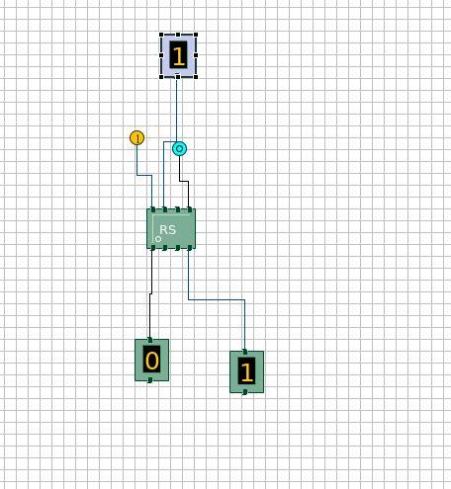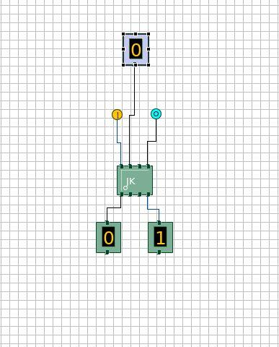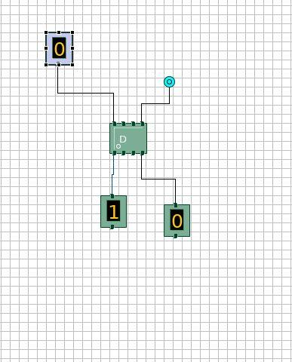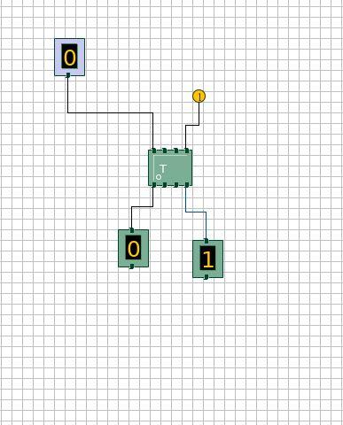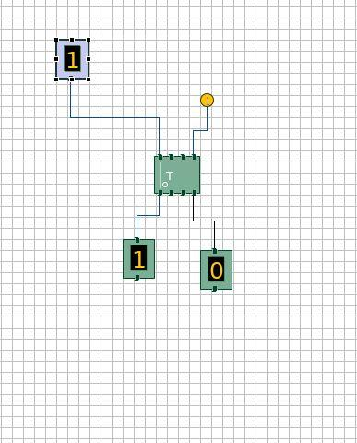

**8. Conclusion:**

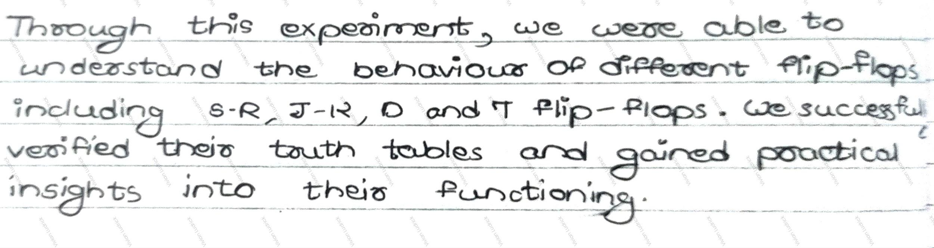

**9. Post-lab:**

Q1. Give the applications of D flipflop and T flipflop.

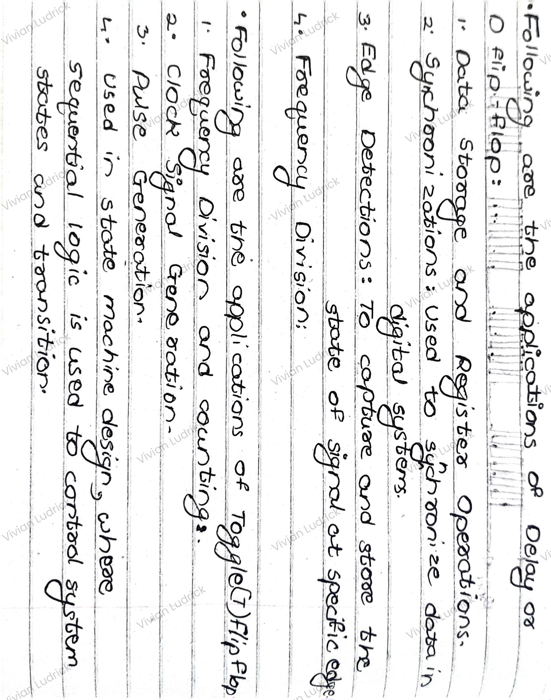

Q2. Explain race around condition in JK flipflop with the help of waveform.

