# **Experiment No 6**

**FR. Conceicao Rodrigues College of Engineering Department of Computer Engineering**

# **Course, Subject & Experiment Details**

| **Academic Year** | **2023-24** | **Estimated Time** | **Experiment No. 6– 02 Hours** |
| --- | --- | --- | --- |
| **Course &**  **Semester** | **S.E. (Computers) –**  **Sem. III** | **Subject Name** | **Digital Logic & Computer**  **Organization and Architecture** |
| **Chapter No.** | **2** | **Chapter Title** | **Processor Organization and Architecture** |
| **Experiment Type** | **Hardware** | **Subject Code** | **CSC304** |

**Rubrics**

| Roll NO | Date of Performance | Timeline (2) | Practical Skill & Applied Knowledge  **(4)** | Output (4) | Total (10) |
| --- | --- | --- | --- | --- | --- |
|  | Date of Submission |  |  |  |  |

# **Design a 4-bit and 16-bit arithmetic logic unit for given parameter**

1. **Aim & Objective of Experiment**

**Objective:** ∙ Understanding behaviour of arithmetic logic unit from working module and the module designed by the student as part of the experiment

* + Designing an 4-bit and 16-bit arithmetic logic unit for given parameter

# **Problem Statement**

Designing an 4-bit and 16-bit arithmetic logic unit for given parameter

# **Software Required**

A) Virtual Lab.

1. **Brief Theoretical Description**

ALU or Arithmetic Logical Unit is a digital circuit to do arithmetic operations like addition, subtraction,division, multiplication and logical oparations like and, or, xor, nand, nor etc. A simple block diagram of a 4 bit ALU for operations and,or,xor and Add is shown here :

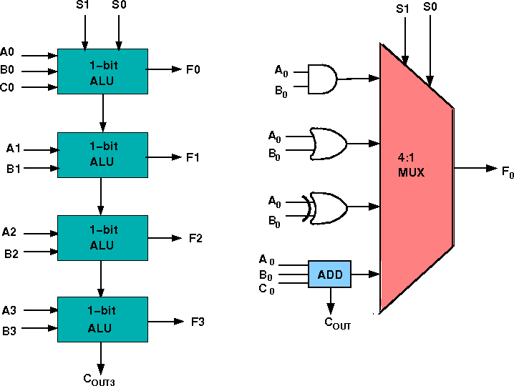

The 4-bit ALU block is combined using 4 1-bit ALU block

## **Design Issues :**

The circuit functionality of a 1 bit ALU is shown here, depending upon the control signal S1 and S0 the circuit operates as follows:

for Control signal **S1 = 0** , S0 = 0, the output is **A And B**, for Control signal **S1 = 0** , S0 = 1, the output is **A Or B**, for Control signal **S1 = 1** , S0 = 0, the output is **A Xor B**,

for Control signal **S1 = 1** , S0 = 1, the output is **A Add B**.

## **The truth table for 16-bit ALU with capabilities similar to 74181 is shown here:**

| Required functionality of ALU (inputs and outputs are active high) | | | | | |
| --- | --- | --- | --- | --- | --- |
| **Mode Select** | | | | **Fn for active HIGH operands** | |
|  | **Inputs** | |  | **Logic** | **Arithmetic (note 2)** |
| S3 | S2 | S1 | S0 | (M = H) | (M = L) **(Cn=L)** |
| L | L | L | L | A' | A |
| L | L | L | H | A'+B' | A+B |
| L | L | H | L | A'B | A+B' |
| L | L | H | H | Logic 0 | minus 1 |
| L | H | L | L | (AB)' | A plus AB' |
| L | H | L | H | B' | (A + B) plus AB' |
| L | H | H | L | A ⊕ B | A minus B minus 1 |
| L | H | H | H | AB' | AB minus 1 |
| H | L | L | L | A'+B | A plus AB |
| H | L | L | H | (A ⊕ B)' | A plus B |
| H | L | H | L | B | (A + B') plus AB |
| H | L | H | H | AB | AB minus 1 |
| H | H | L | L | Logic 1 | A plus A (Note 1) |
| H | H | L | H | A+B' | (A + B) plus A |
| H | H | H | L | A+B | (A + B') plus A |
| H | H | H | H | A | A minus 1 |

The L denotes the logic low and H denotes logic high

# **Simulation**

**A. *Virtual Lab:***

The virtual laboratory is an interactive environment for creating and conducting simulated experiments: a playground for experimentation. It consists of domain- dependent simulation programs, experimental units called objects that encompass data files, tools that operate on the objects.

The objective is to expose the students to various key aspects of Digital Logic and computer organization by enabling them to perform FPGA based prototyping of experiments with support of a virtual environment

## **Procedure to perform the experiment: Design of 4 bit ALU**

1. Start the simulator as directed.This simulator supports 5-valued logic.
2. To design the circuit we need 4 1-bit ALU, 11 Bit switch (to give input,which will toggle its value with a double click), 5 Bit displays (for seeing output), wires.
3. The pin configuration of a component is shown whenever the mouse is hovered on any canned component of the palette. Pin numbering starts from 1 and from the bottom left corner (indicating with the circle) and increases anticlockwise.
4. For 1-bit ALU input A0 is in pin-9,B0 is in pin-10, C0 is in pin-11 (this is input carry), for selection of operation, S0 is in pin-12, S1 is in pin-13, output F is in pin-8 and output carry is pin-7
5. Click on the 1-bit ALU component (in the Other Component drawer in the pallet) and then click on the position of the editor window where you want to add the component (no drag and drop, simple click will serve the purpose), likewise add 3 more 1-bit ALU (from the Other Component drawer in the pallet), 11 Bit switches and 5 Bit Displays (from Display and Input drawer of the pallet,if it is not seen scroll down in the drawer), 3 digital display and 1 bit Displays (from Display and Input drawer of the pallet,if it is not seen scroll down in the drawer)
6. To connect any two components select the Connection menu of Palette, and then click on the Source terminal and click on the target terminal. According to the circuit diagram connect all the components. Connect the Bit switches with the inputs and Bit displays component with the outputs. After the connection is over click the selection tool in the pallete.
7. See the output, in the screenshot diagram we have given the value of S1 S0=11 which will perform add operation and two number input as A0 A1 A2 A3=0010 and B0 B1 B2 B3=0100 so get output F0 F1 F2 F3=0110 as sum and 0 as carry which is indeed an add operation.you can also use many other combination of different values and check the result. The operations are implemented using the truth table for 4 bit ALU given in the theory

# **Attach the screen shots of the implemented circuits.**

**4-bit ALU using 1-bit ALU**

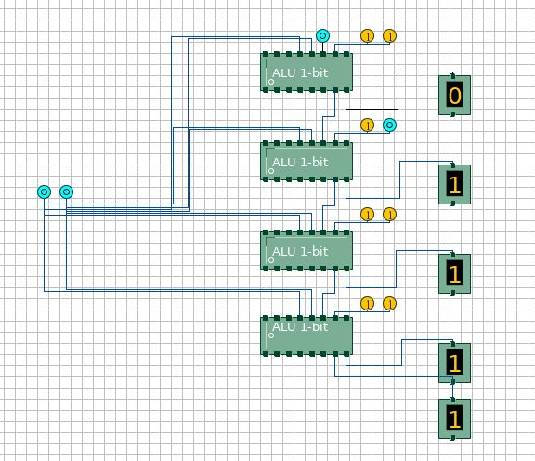

**4-bit ALU**

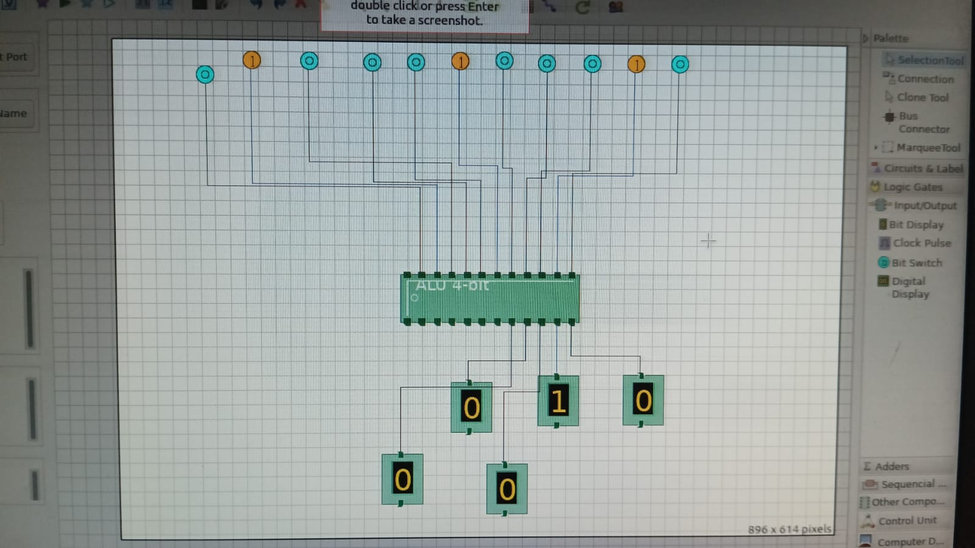

**1bit ALU using 4:1 mux**

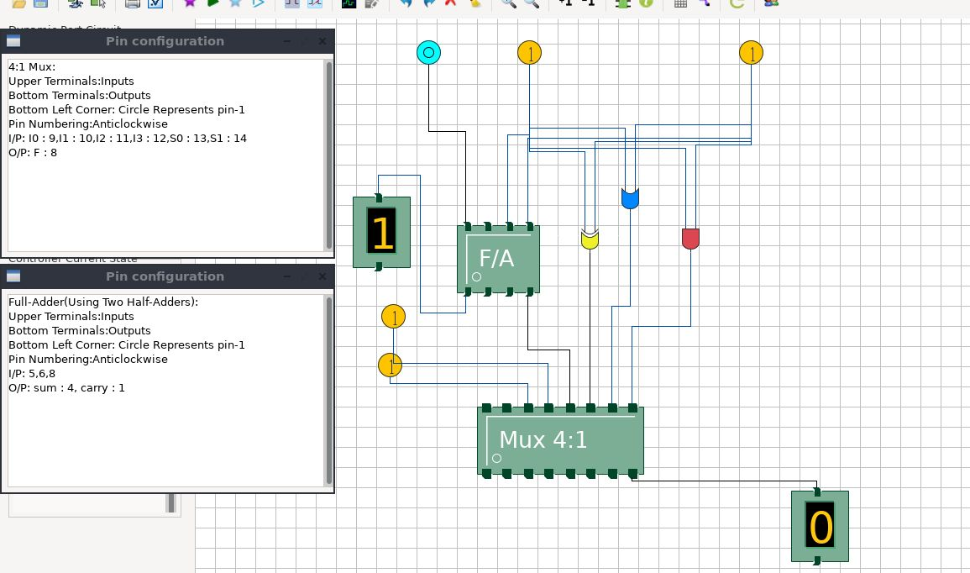

1. **Conclusion:**

The 4-bit and 16-bit ALUs were designed and implemented correctly in the virtual lab. We tested their functionality using various input values and confirmed their accuracy.