**FR. Conceicao Rodrigues College of Engineering**

**Department of Computer Engineering**

**7. DISPLAY A TO Z ON SCREEN**.

**1. Course, Subject & Experiment Details**

| **Academic Year** | **2023-24** | **Estimated Time** | **Experiment No. 7– 02 Hours** |
| --- | --- | --- | --- |
| **Course & Semester** | **S.E. (Comps)**  **– Sem. IV** | **Subject Name** | **Microprocessor** |
| **Chapter No.** | **2** | **Chapter Title** | **Instruction Set and Programming** |
| **Experiment Type** | **Software** | **Subject Code** | **CSC405** |

**Rubrics**

| **Timeline (2)** | **Practical Skill & Applied Knowledge**  **(2)** | **Output**  **(3)** | **Postlab**  **(3)** | **Total**  **(10)** | **Sign** |
| --- | --- | --- | --- | --- | --- |
|  |  |  |  |  |  |

**2. Aim & Objective of Experiment**

**7(A) DISPLAY A TO Z ON SCREEN**

**Objective :** To store A to Z Alphabets on an array and display them on user screen.

**3. Software Required**

TASM Assembler

**4** . **Brief Theoretical Description**

**Pre-Requisites:** 1. Knowledge of TASM directives.

2. Knowledge of DOS interrupts.

3. Knowledge of string instruction and MACRO

**5. Algorithm:**

1. Initialize the data segment.

2. Store all Alphabets in array.

3. Initialize counter to 1AH.

4. Load starting Address of array in to SI.

5. Get each character in DL.

6. Display Character on user screen.

7. Increment SI.

8. Decrement counter.

9. Repeat step 5 to 8 until count becomes Zero.

10. Stop

**CODE:**

.8086

.model small

.data

.code

start:

MOV AX, @data

MOV DS, AX

MOV CX, 1AH

MOV DL, 41H

display_keys:

MOV AH, 02H

INT 21H

INC DL

loop display_keys

MOV AH, 4CH

INT 21H

end start

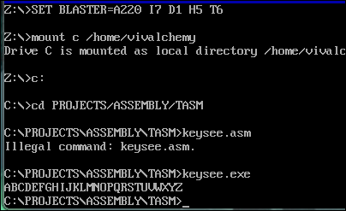

**7(B)**

**DISPLAY CHARACTER FROM KEYBOARD UNTIL 0 IS ENTERED.**

Objective: To Read Character from Keyboard and display on screen until 0 is pressed.

Theory: Instructions used in program are:

MOV AH,08H

INT 21H

Read Input From Keyboard without echo and store at AL.

**MOV AH,02H**

**INT 21H**

Display Character on screen. Character should be in DL register.

**Algorithm:**

1. Initialize the data segment.

2. Read input from keyboard.

3. Compare input with ASCII value of ZERO.

4. If result is 0, go to step 7.

5. Move content of AL to DL, to display it on screen.

6. Display character on screen.

7. Stop

**CODE:**

.8086

.model small

.data

.code

start:

MOV AX, @data

MOV DS, AX

MOV CX, 5H

up:

MOV AH, 08H

INT 21H

CMP AL, '0'

JZ end_program

MOV DL, AL

MOV AH, 02H

INT 21H

DEC CX

JNZ up

end_program:

MOV AH, 4CH

INT 21H

end start

