1. Write a Java program to create a string in the form of short_string + long_string + short_string from two strings. The strings must not have the same length.

Test Data:

Str1 = Python  
Str2 = Tutorial  
*Sample Output:*

PythonTutorialPython

CODE:

import java.util.Scanner;

public class CombineStrings {

public static void **main**(String[] *args*) {

Scanner scanner = new **Scanner**(System.in);

System.out.**print**("Enter the first string: ");

String str1 = scanner.**nextLine**();

System.out.**print**("Enter the second string: ");

String str2 = scanner.**nextLine**();

if (str1.**length**() == str2.**length**()) {

System.out.**println**("Strings must have different lengths.");

} else {

String result;

if (str1.**length**() < str2.**length**()) {

result = str1 + str2 + str1;

} else {

result = str2 + str1 + str2;

}

System.out.**println**("Combined String: " + result);

}

}

}

OUTPUT:

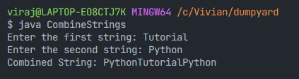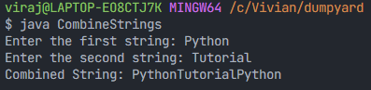

1. Write a Java program to convert a decimal number to a hexadecimal number.

Test Data:

***Input :****10****Output:****A*

***Input :****2545****Output:****9F1*

Code:

import java.util.Scanner;

public class DecimalToHexadecimal {

public static void **main**(String[] *args*) {

Scanner input = new **Scanner**(System.in);

System.out.**print**("Input a decimal number: ");

int decimal = input.**nextInt**();

String hex = "";

char[] hexDigits = {'0', '1', '2', '3', '4', '5', '6', '7', '8', '9', 'A', 'B', 'C', 'D', 'E', 'F'};

while (decimal > 0) {

int remainder = decimal % 16;*// get the last digit of hexadecimal*

hex = hexDigits[remainder] + hex;*// string concatenation*

decimal /= 16;

}

System.out.**println**("Hexadecimal number is: " + hex);

}

}

OUTPUT:

