Name : Vivian Ludrick

Branch: SE COMPS A BATCH C

ROLL NO: 9914

1. Write a Java program to compute the distance between two points on the earth's surface.

Distance between the two points [ (x1,y1) & (x2,y2)]  
d = radius * arccos(sin(x1) * sin(x2) + cos(x1) * cos(x2) * cos(y1 - y2))  
Radius of the earth r = 6371.01 Kilometers

*Test Data:*  
Input the latitude of coordinate 1: 25  
Input the longitude of coordinate 1: 35  
Input the latitude of coordinate 2: 52.5  
Input the longitude of coordinate 2: 35.5

*Expected Output*

The distance between those points is: 1480.0848451069087 km

CODE:

import java.util.Scanner;

public class DistanceCalculator {

public static void main(String[] args) {

Scanner input = new Scanner(System.in);

System.out.print("Input the latitude of coordinate 1: ");

double lat1 = input.nextDouble();

System.out.print("Input the longitude of coordinate 1: ");

double lon1 = input.nextDouble();

System.out.print("Input the latitude of coordinate 2: ");

double lat2 = input.nextDouble();

System.out.print("Input the longitude of coordinate 2: ");

double lon2 = input.nextDouble();

// Calculate and display the distance between the two coordinates

System.out.println("The distance between those points is: " + distance_Between_LatLong(lat1, lon1, lat2, lon2) + " km");

}

public static double distance_Between_LatLong(double lat1, double lon1, double lat2, double lon2) {

double RADIUS = 6371.01; // Radius of the Earth in kilometers

// Convert latitude and longitude from degrees to radians

lat1 = Math.toRadians(lat1);

lon1 = Math.toRadians(lon1);

lat2 = Math.toRadians(lat2);

lon2 = Math.toRadians(lon2);

// Calculate the distance

double temp = Math.sin(lat1) * Math.sin(lat2) + Math.cos(lat1) * Math.cos(lat2) * Math.cos(lon1 - lon2);

double distance = RADIUS * Math.acos(temp);

// Return the calculated distance

return distance;

}

}

OUTPUT:

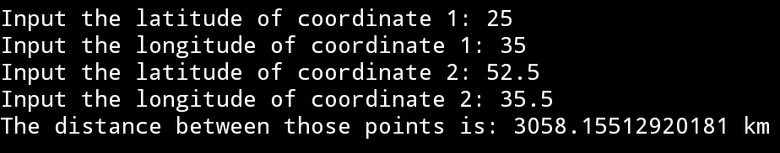

1. Write a Java program to find the updated length of a given sorted array where duplicate elements appear at most twice.  
   Original array: [1, 1, 2, 3, 3, 3, 4, 5, 6, 7, 7, 7, 7]  
   The length of the original array is: 13  
   After removing duplicates, the new length of the array is: 10

CODE:

import java.util.Arrays;

class Solution {

static int remove_Duplicates_twice(int[] nums) {

if (nums == null || nums.length == 0) {

return 0;

}

int index = 1;

for (int i = 2; i < nums.length; i++) {

if (nums[i] != nums[index] || (nums[i] == nums[index] && nums[i] != nums[index - 1])) {

index++;

nums[index] = nums[i];

}

}

return index + 1;

}

public static void main(String[] args) {

int[] nums = {1, 1, 2, 3, 3, 3, 4, 5, 6, 7, 7, 7, 7, 8};

System.out.println("Original array: " + Arrays.toString(nums));

System.out.println("The length of the original array is: " + nums.length);

Arrays.sort(nums);

System.out.println("After removing duplicates, the new length of the array is: " + remove_Duplicates_twice(nums));

}

}

OUTPUT:

