1. Write a Java program that reads a floating-point number. If the number is zero it prints "zero", otherwise, print "positive" or "negative". Add "small" if the absolute value of the number is less than 1, or "large" if it exceeds 1,000,000.

*Test Data*  
Input a number: -2534  
*Expected Output* :

Negative

CODE:

import java.util.Scanner;

public class FloatBasedOutput {

public static void **main**(String[] *args*) {

Scanner sc = new **Scanner**(System.in);

*// input the number*

System.out.**print**("Enter a floating point number :\t");

double input = sc.**nextDouble**();

*// display output based on condition*

if (input == 0) {

System.out.**print**("Zero ");

} else if (input > 0) {

System.out.**print**("Positive ");

if (input < 1) {

System.out.**print**("small");

} else if (input > 1000000) {

System.out.**print**("large ");

}

} else {

System.out.**print**("Negative ");

if (Math.**abs**(input) < 1) {

System.out.**print**("small ");

} else if (Math.**abs**(input) > 1000000) {

System.out.**print**("large ");

}

}

}

}

OUTPUT:

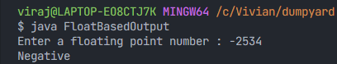

1. Write a program that accepts three numbers from the user and prints "increasing" if the numbers are in increasing order, "decreasing" if the numbers are in decreasing order, and "Neither increasing or decreasing order" otherwise.

CODE:

import java.util.Scanner;

public class IncreasingDecreasing {

public static void **main**(String[] *args*) {

Scanner sc = new **Scanner**(System.in);

System.out.**println**("Enter the first number");

int first = sc.**nextInt**();

System.out.**println**("Enter the second number");

int second = sc.**nextInt**();

System.out.**println**("Enter the third number");

int third = sc.**nextInt**();

if (first - second < 0 && second - third < 0) {

System.out.**println**("increasing");

} else if (first - second > 0 && second - third > 0) {

System.out.**println**("decreasing");

}else{

System.out.**println**("Neither increasing or decreasing");

}

}

}

OUTPUT:

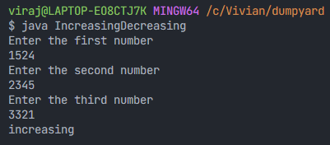

*Test Data*  
Input first number: 1524  
Input second number: 2345  
Input third number: 3321  
*Expected Output* :

Increasing order