**FR. CONCEICAO RODRIGUES COLLEGE OF ENGINEERIG**

**Department of Computer Engineering**

**Experiment 5- Based on Packages and object**

1. **Course Details:**

| **Academic Year** | **2023 - 24** | **Estimated Time** | **Experiment No. 5– 02 Hours** |
| --- | --- | --- | --- |
| **Course & Semester** | **S.E. (COMP) – Sem. III** | **Subject Name** | **Skill based lab Course-OOP with Java** |
| **Module No.** | **02** | **Chapter Title** | **Class, Object, Packages and Input/Output** |
| **Experiment Type** | **Software Performance** | **Subject Code** | **CSL304** |
|  |  |  |  |

| **Name of Student** | Vivian Vijay Ludrick | **Roll No.** | 9914 |
| --- | --- | --- | --- |
| **Date of**  **Performance:** |  | **Date of Submission:** |  |
| **CO Mapping** | **CSL304.2: Illustrate the concept of packages, classes, and objects** | | |

| **Timeline**  **(2)** | **Preparedness**  **(2)** | **Effort**  **(3)** | **Result**  **(3)** | **Total (10)** |
| --- | --- | --- | --- | --- |
|  |  |  |  |  |

**Problem statement:**

1. Write a class “Point” with members x and y.

* Write a default and parametrized constructor to set x n y.
* Write display function to display x and y

Write a class “Line” with members are 2 point objects.

* Write a method to find length of line and display it.

Write a class “Triangle” with members as 3 Line objects.

* Write a method to find perimeter of triangle and display it.

import java.util.Scanner;

*// class Point having x and y coordinates*

class Point {

private int x;

private int y;

*// non parameterised constructor*

public Point() {

this.x = 0;

this.y = 0;

}

*// parameterised constructor*

public Point(int *x*, int *y*) {

this.x = *x*;

this.y = *y*;

}

*// displays the coordinates of the point*

public void display() {

System.out.println("x: " + x + ", y: " + y);

}

*// returns the x value of the point*

public int getX() {

return x;

}

*// returns the y value of the point*

public int getY() {

return y;

}

}

*// class line*

class Line {

private Point p1;

private Point p2;

*// constructor for the endpoints of the line*

public Line(Point *p1*, Point *p2*) {

this.p1 = *p1*;

this.p2 = *p2*;

}

*// returns the length of the line*

public double length() {

return Math.sqrt(Math.pow(p2.getX() - p1.getX(), 2) + Math.pow(p2.getY() - p1.getY(), 2));

}

*// prints the length of the line*

public void displayLength() {

System.out.println("Length of line: " + length());

}

}

*// class triangle*

class Triangle {

private Line l1;

private Line l2;

private Line l3;

*// constructor to form a triangle*

public Triangle(Line *l1*, Line *l2*, Line *l3*) {

this.l1 = *l1*;

this.l2 = *l2*;

this.l3 = *l3*;

}

*// returns the perimeter of the circle*

public double perimeter() {

return l1.length() + l2.length() + l3.length();

}

*// displays the perimeter of the circle*

public void displayPerimeter() {

System.out.println("Perimeter of triangle: " + perimeter());

}

}

*// main class to run the program*

public class RunProgram {

public static void main(String[] *args*) {

Scanner scan = new Scanner(System.in);

final int SIZE = 3;*// to determine the no of points and the line*

*// puts the points in an array*

Point p[] = new Point[SIZE];

for (int i = 0; i < SIZE; i++) {

System.out.println("Enter x and y coordinates of point no. " + i);

int x = scan.nextInt();

int y = scan.nextInt();

p[i] = new Point(x, y);

p[i].display();

}

*// initialises the lines with two points*

Line l[] = new Line[SIZE];

for (int i = 0; i < SIZE; i++) {

l[i] = new Line(p[i], p[(i+1)%SIZE]);*// to make sure that the lines are connected*

l[i].displayLength();

}

*// initialises the triangle*

Triangle t1 = new Triangle(l[0], l[1], l[2]);

t1.displayPerimeter();

}

}

OUTPUT: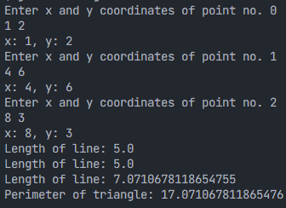

2) Write a program to input 2 strings and demonstrate the use of the following StringBuffer methods.

a. append() , b. insert() , c. replace() , d. delete() , e. reverse() , f. capacity() , g. ensureCapacity(), h. charAt(), i. length(), j. substring()

import java.util.Scanner;

public class StringBufferDemo {

public static void main(String[] *args*) {

Scanner scanner = new Scanner(System.in);

*// Input two strings*

System.out.print("Enter the first string: ");

String inputString1 = scanner.nextLine();

System.out.print("Enter the second string: ");

String inputString2 = scanner.nextLine();

*// Create StringBuffer objects from the input strings*

StringBuffer stringBuffer1 = new StringBuffer(inputString1);

StringBuffer stringBuffer2 = new StringBuffer(inputString2);

*// Demonstrate StringBuffer methods*

System.out.println("Original strings:");

System.out.println("String 1: " + stringBuffer1.toString());

System.out.println("String 2: " + stringBuffer2.toString());

*// a. append()*

stringBuffer1.append(" appended");

System.out.println("\nAfter appending:");

System.out.println("String 1: " + stringBuffer1.toString());

*// b. insert()*

stringBuffer2.insert(3, "inserted ");

System.out.println("\nAfter inserting at index 3:");

System.out.println("String 2: " + stringBuffer2.toString());

*// c. replace()*

stringBuffer1.replace(2, 10, "replaced");

System.out.println("\nAfter replacing a substring:");

System.out.println("String 1: " + stringBuffer1.toString());

*// d. delete()*

stringBuffer2.delete(2, 10);

System.out.println("\nAfter deleting a range of characters:");

System.out.println("String 2: " + stringBuffer2.toString());

*// e. reverse()*

stringBuffer1.reverse();

System.out.println("\nAfter reversing:");

System.out.println("String 1 (reversed): " + stringBuffer1.toString());

*// f. capacity()*

System.out.println("\nCapacity of String 1: " + stringBuffer1.capacity());

*// g. ensureCapacity()*

stringBuffer1.ensureCapacity(50);

System.out.println("Capacity of string 1 after ensuring capacity: " + stringBuffer1.capacity());

*// h. charAt()*

char charAtIndex5 = stringBuffer2.charAt(5);

System.out.println("\ncharacter at 5 in string 2: " + charAtIndex5);

*// i. length()*

int lengthOfString2 = stringBuffer2.length();

System.out.println("\nlength of string 2: " + lengthOfString2);

*// j. substring()*

String substringOfString1 = stringBuffer1.substring(2, 10);

System.out.println("\nsubstring of string 1 (index 2 to 10): " + substringOfString1);

scanner.close();

}

}

OUTPUT:

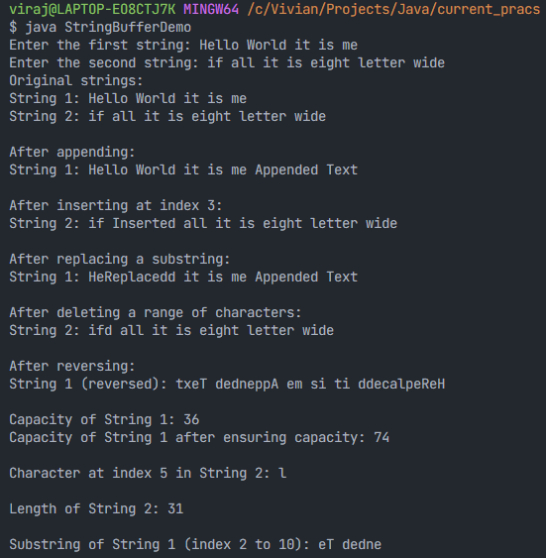

3) Write a class “UtoL” with method to convert string from upper case to lower case. Write another class “Array” with method to check if array is symmetric. Include both the classes in a package named “Utility”. Demonstrate how to use these classes in another package.

In the java file Utility/UtoL.java

package Utility;

*// convert the string to lowercase*

public class UtoL {

public static String convertFromUpperToLower(String *input*) {

return *input*.toLowerCase();

}

}

In the java file Utility/Array.java

package Utility;

*// class symmetry*

public class Array {

*// checks of the array is symmetric or not based on the *midpoint of the array*

static boolean is1DSymmetric(int[] *arr*) {

for (int i = 0; i < *arr*.length / 2; i++) {

if (*arr*[i] != *arr*[*arr*.length - i - 1]) {

return false;

}

}

return true;

}

*// checks if the matrix is symmetric or not*

*// public since by default the the function are private with respect to their package*

public static boolean isSymmetric(int *arr*[][]) {

if (*arr*.length == 0) {

return true; *// Empty array is symmetric.*

}

if (*arr*.length != *arr*[0].length) {

return false; *// If rows != column => not symmetric.*

}

for (int i = 0; i < *arr*.length; i++) {

*// since the matrix is a square matrix*

for (int j = 0; j < *arr*.length; j++) {

if (*arr*[i][j] != *arr*[j][i]) {

return false; *// If any element is different from its symmetric counterpart, it's not symmetric.*

}

}

}

return true; *.*

}

}

In the file Demo/Demo.java

package Demo;

import java.util.Scanner;

*// importing custom packages*

import Utility.UtoL;

import Utility.Array;

public class Demo {

public static void main(String[] *args*) {

final int SIZE = 3;

Scanner sc = new Scanner(System.in);

*// Demonstrate UtoL class*

*System.out.println("Enter the string:");*

String inputString = sc.nextLine();

String convertedString = UtoL.convertFromUpperToLower(inputString);

System.out.println("Converted string: " + convertedString);

*// Demonstrate Array class*

*System.out.println("Enter the 2D array to check symmetry");*

int[][] arr = new int[SIZE][SIZE];

for (int i = 0; i < SIZE; i++) {

for (int j = 0; j < SIZE; j++) {

arr[i][j] = sc.nextInt();

}

}

boolean isSymmetric = Array.isSymmetric(arr);

System.out.println("Is the given array symmetric? " + isSymmetric);

}

}

In the terminal :

javac Demo/Demo.java && java Demo.Demo

OUTPUT:

