Date : 16-10-2020

Name : Gude Balaji

Regno : 9919004097

**4. Write a program that creates a file containing TotalCount random integers (in**

**character format) in the range 0 to HighValue-1. Write PerLine integers per line.**

**Separate each integer with one space. End each line with the correct line**

**termination for your computer. The user is prompted for and enters HighValue,**

**which should be an integer larger than zero. Then the user is prompted for and**

**enters PerLine, which is an integer greater than zero, and TotalCount, which also is**

**an integer greater than zero. Finally the user is prompted for and enters the file**

**name.Use a BufferedWriter with a FileWriter for output. Construct a Random object**

**and use its method nextInt(int Top), which returns an int in the range 0..Top-1.**

**SOURCE CODE:**

import java.io.*;

import java.util.*;

public class Myclass {

public static void main(String args[])throws IOException{

int highvalue,perline,totalcount;

String filename = "D:/Randomnumber.txt";

String ss;

FileWriter fw = new FileWriter(filename);

Scanner sc = new Scanner(System.in);

System.out.println("enter value of highvalue");

highvalue = sc.nextInt();

System.out.println("enter value of perline");

perline=sc.nextInt();

System.out.println("enter value of totalcount");

totalcount=sc.nextInt();

Random r = new Random();

int num,wc=0;

for(int i=1;i<=totalcount;i++){

num = r.nextInt(highvalue);

ss = Integer.toString(num);

fw.write(ss);

fw.write(" ");

wc++;

if(wc == perline){

fw.write("\n");

wc=0;

}

}

fw.close();

FileReader fr = new FileReader(filename);

BufferedReader br = new BufferedReader(fr);

String s;

while((s=br.readLine())!=null){

System.out.println(s);

}

fr.close();

}

}

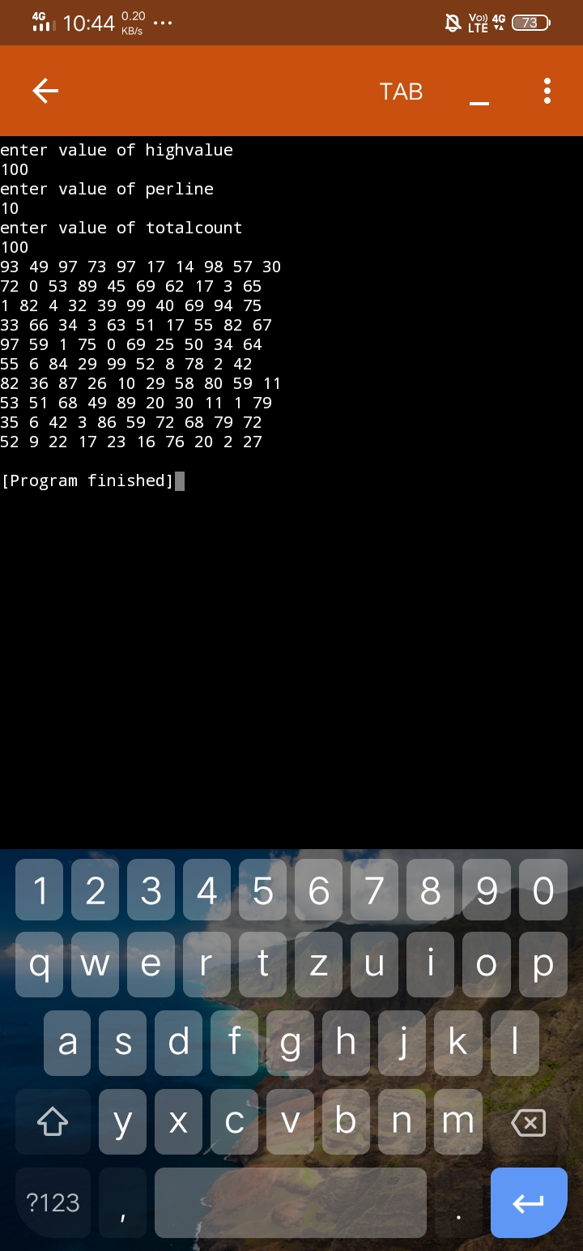

**5. Write a program that creates a new file by concatenating several files together. The**

**command line looks like this: java fileCat source0 source1 source2 ... newFile.**

**There can be one or more source files on the command line. Each source file must**

**exist (if not, write an error message and exit). The last file name on the**

**line, newFile, is the name of the file to be created, and must not already**

**exist.Create the new file by opening the source files one at a time, in order, reading**

**each file byte-by-byte and writing each byte to newFile. Close each file when it is**

**no longer needed. Use buffered input and buffered output.**

**SOURCE CODE:**

**import java.io.*;**

**import java.lang.*;**

**public class Myclass{**

**public static void main(String args[])throws IOException{**

**String src1 = "D:/Source1.txt";**

**String src2 = "D:/Source2.txt";**

**String src3 = "D:/Source3.txt";**

**FileWriter fw = new FileWriter(src1);**

**String str = "this is in file one";**

**fw.write(str);**

**fw.close();**

**fw = new FileWriter(src2);**

**str = "this is in file two";**

**fw.write(str);**

**fw.close();**

**fw = new FileWriter(src3);**

**str = "this is in file three";**

**fw.write(str);**

**fw.close();**

**int c;**

**fw = new FileWriter(args[args.length-1]);**

**FileReader fr;**

**for(int i=0;i<args.length-1;i++){**

**fr = new FileReader(args[i]);**

**while((c=fr.read())!=-1){**

**fw.write((char)c);**

**}**

**}**

**fw.write('\n')**

**fw.close();**

**fr = new FileReader(args[args.length-1]);**

**while((c=fr.read())!=-1){**

**System.out.println((char)c);**

**}**

**fr.close();**

**}**

**}**

**6. Write a program that compares two text files line by line. The command line looks**

**like this: java fileComp file1 file2 [limit]. Read in a line from each file. Compare the**

**two lines. If they are identical, continue with the next two lines. Otherwise, write out**

**the line number and the two lines, and continue.**

**SOURCE CODE:**

**import java.io.*;**

**public class MyClass {**

**public static void main(String args[]) throws IOException {**

**String srcl = "Sourcel.txt";**

**String src2 = "Source2.txt";**

**String src3 = "Source3.txt";**

**FileWriter fw = new FileWriter(srcl);**

**String str = " This is in file one";**

**fw.write(str);**

**fw.close();**

**fw = new FileWriter(src2);**

**str = "This is in file two";**

**fw.write(str);**

**fw.close();**

**fw = new FileWriter(src3);**

**str = "This is in file three";**

**fw.write(str);**

**fw.close();**

**fw = new FileWriter(args[args.length-1]);**

**FileReader fr; int c;**

**for (int i=0; i< args.length-1; i++)**

**{**

**fr = new FileReader(args[i]) ;**

**while ( (c = fr.read()) != -1)**

**fw.write((char)c);**

**fw.write('\n');**

**fr.close();**

**}**

**fw.close();**

**fr = new FileReader(args[args.length-1]);**

**while((c=fr.read()) != -1 )**

**System.out.print((char)c);**

**fr.close();**

**}**

**}**