**CMSC203**

**Assignment 0 Part 3 – Setup Junit Test**



**Setup Junit Test**

The purpose of this Assignment is to prepare you with the tools and software you need in order to be able to set the environment on your computer to successfully start working on your assignments. It is crucial that you complete this lab to save you time in order to focus on the course work and projects.

* Add JUnit to Eclipse Java Project

**Objectives**

* Create java project, compile and run using Eclipse
* Create JUnit Test and execute JUnit Test Example

**Step – Setup JUnit**

Source: <https://www.tutorialspoint.com/junit/junit_basic_usage.htm>

Eclipse supports both JUnit 4 and JUnit 5 (JUnit Jupiter). You don’t have to download JUnit JAR files as Eclipse is shipped with JUnit library.

1. Create New Java Project JUnitTestProject

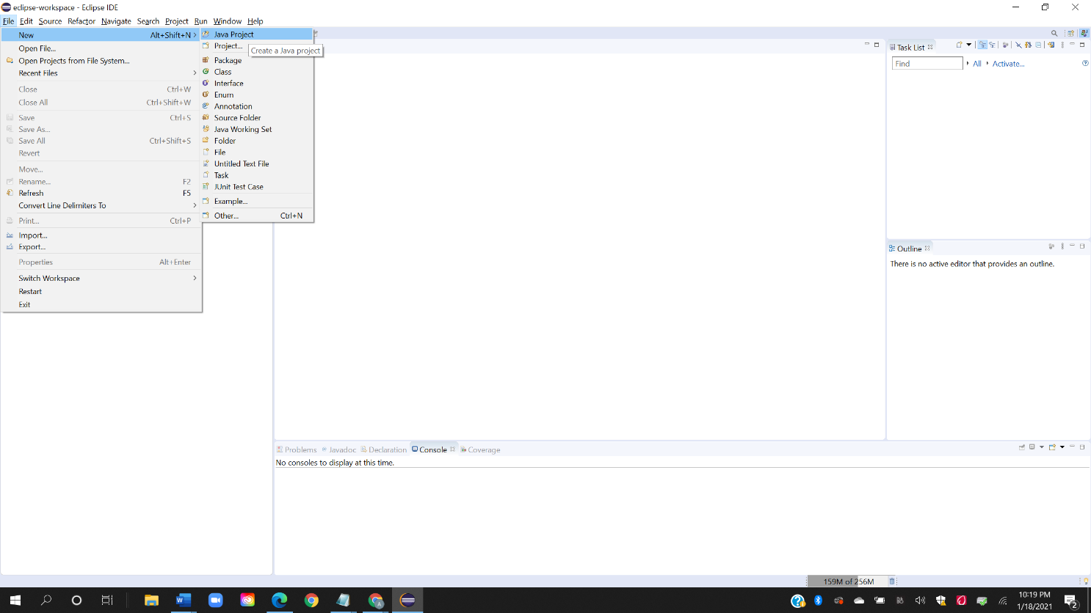

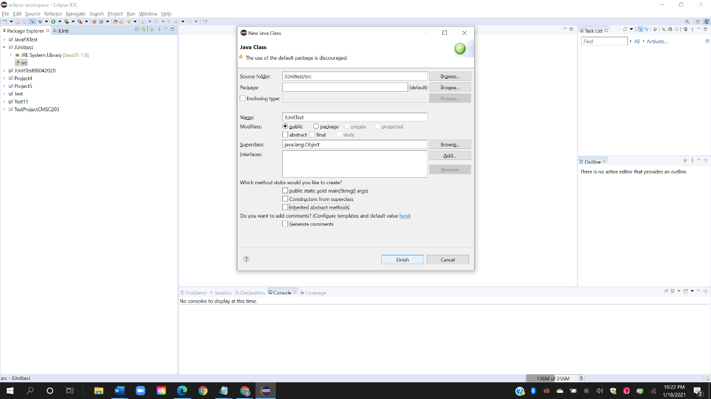

1. Add JUnitTest Library

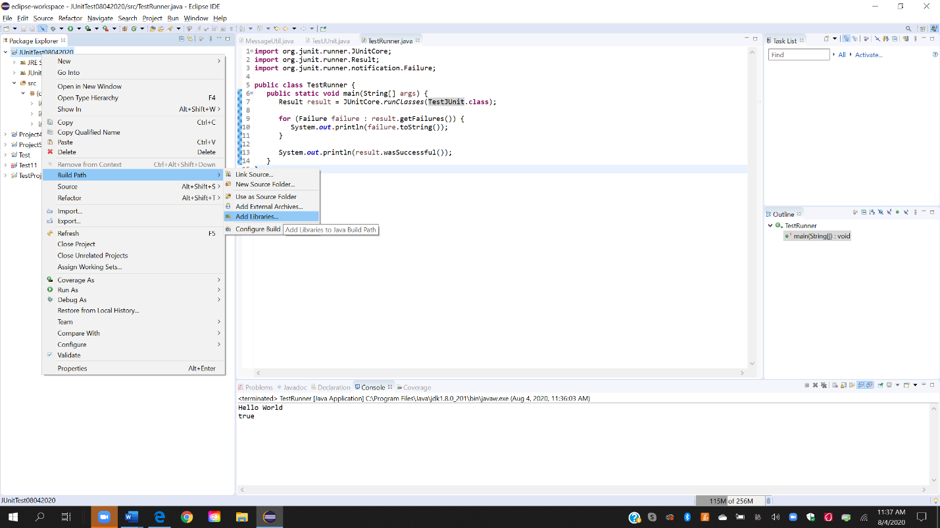

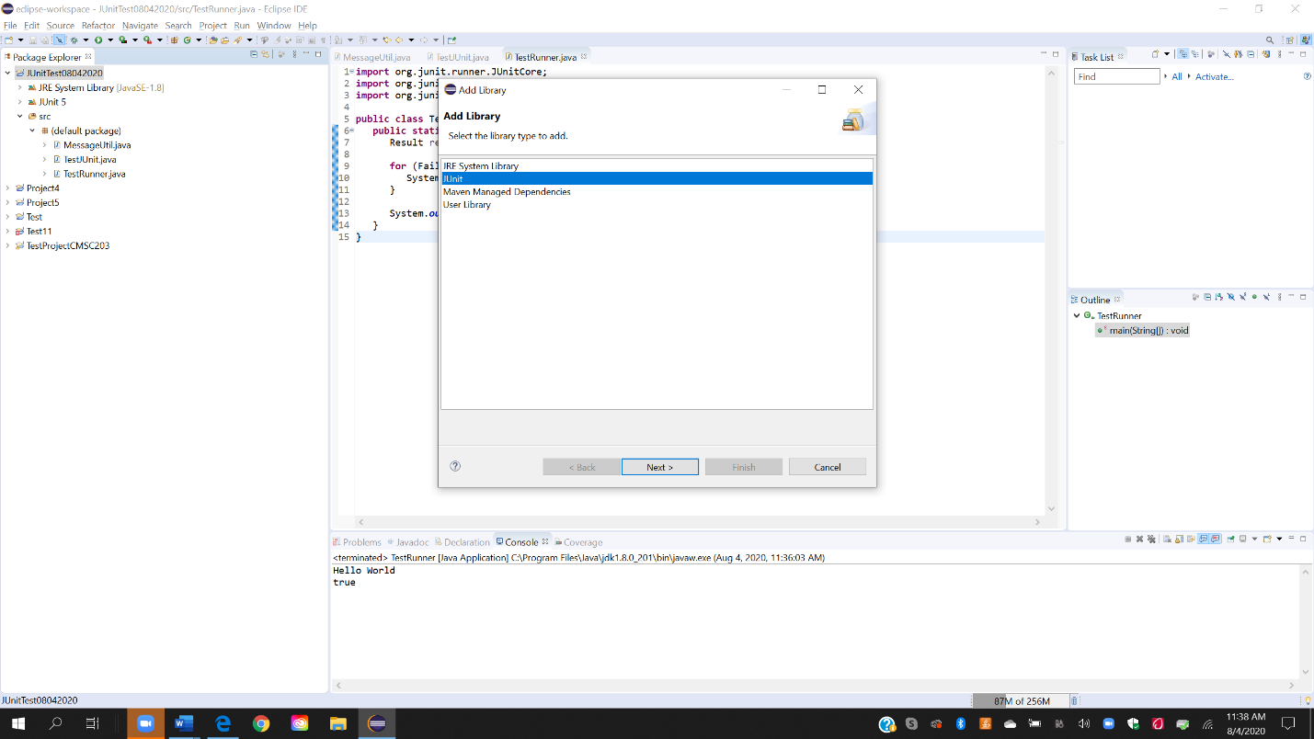

1. Create a java class to be tested MessageUtil.java

/*

* This class prints the given message on console.

*/

public class MessageUtil {

private String message;

//Constructor

//@param message to be printed

public MessageUtil(String message){

this.message = message;

}

// prints the message

public String printMessage(){

System.out.println(message);

return message;

}

}

1. **Create a Test Case class.**

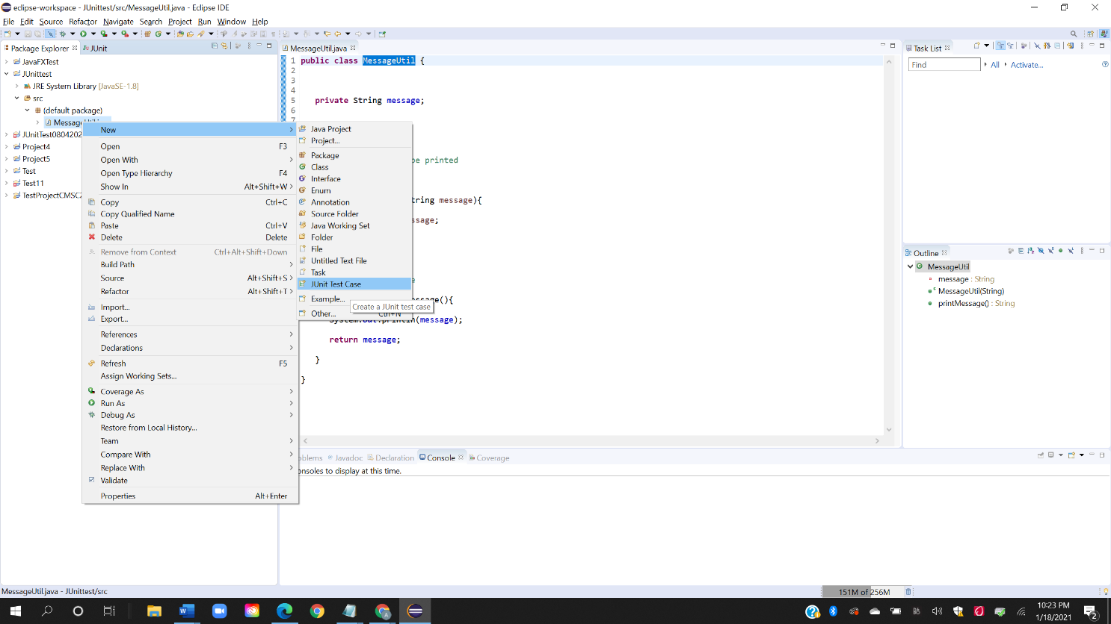

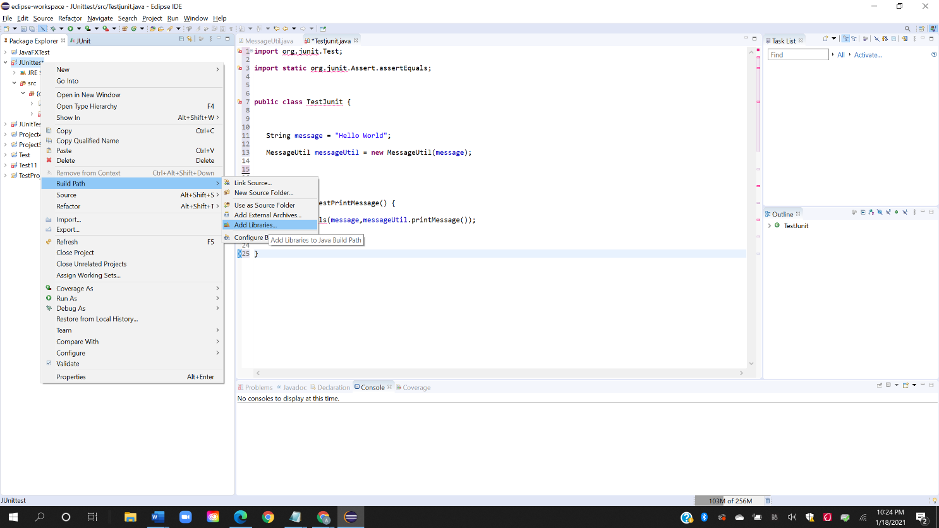

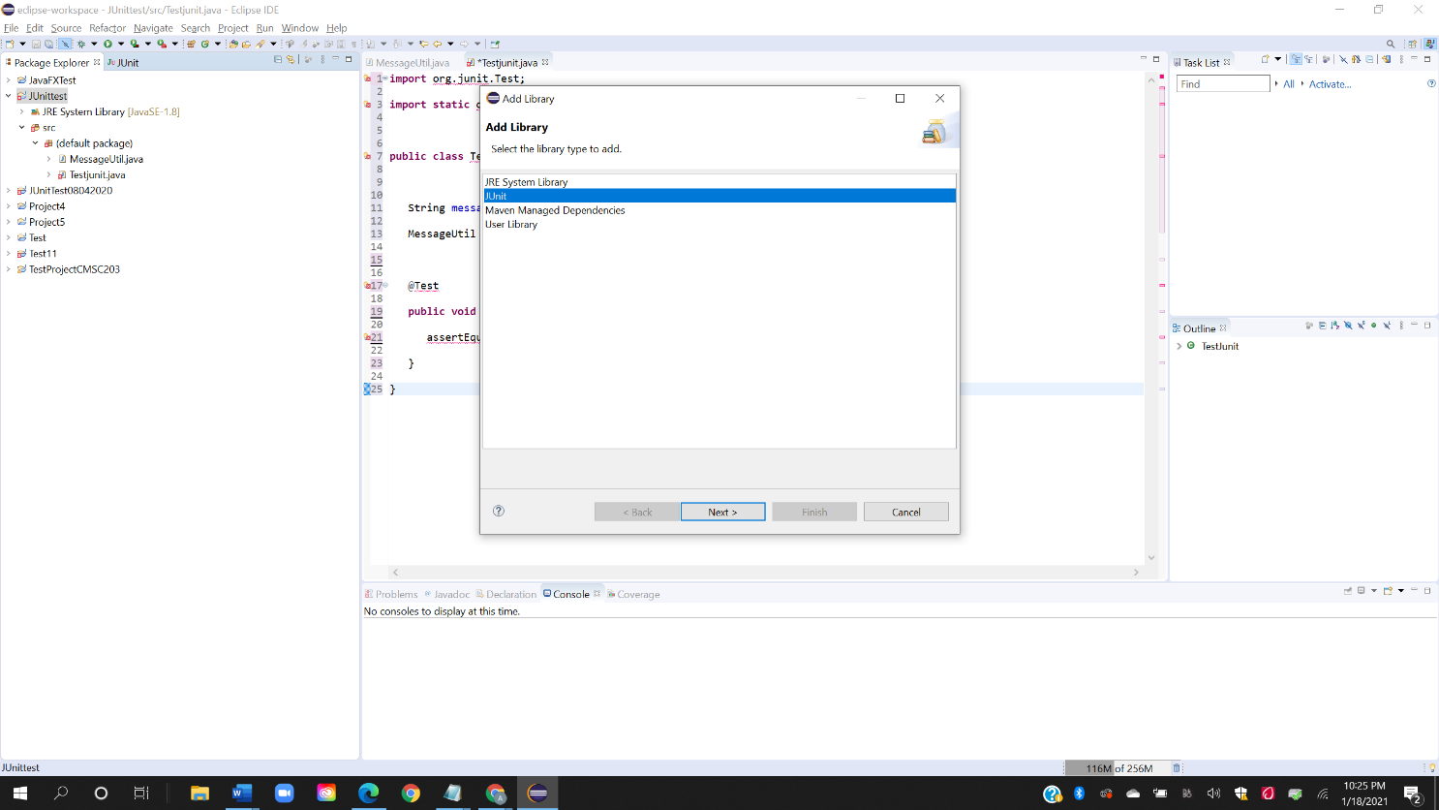

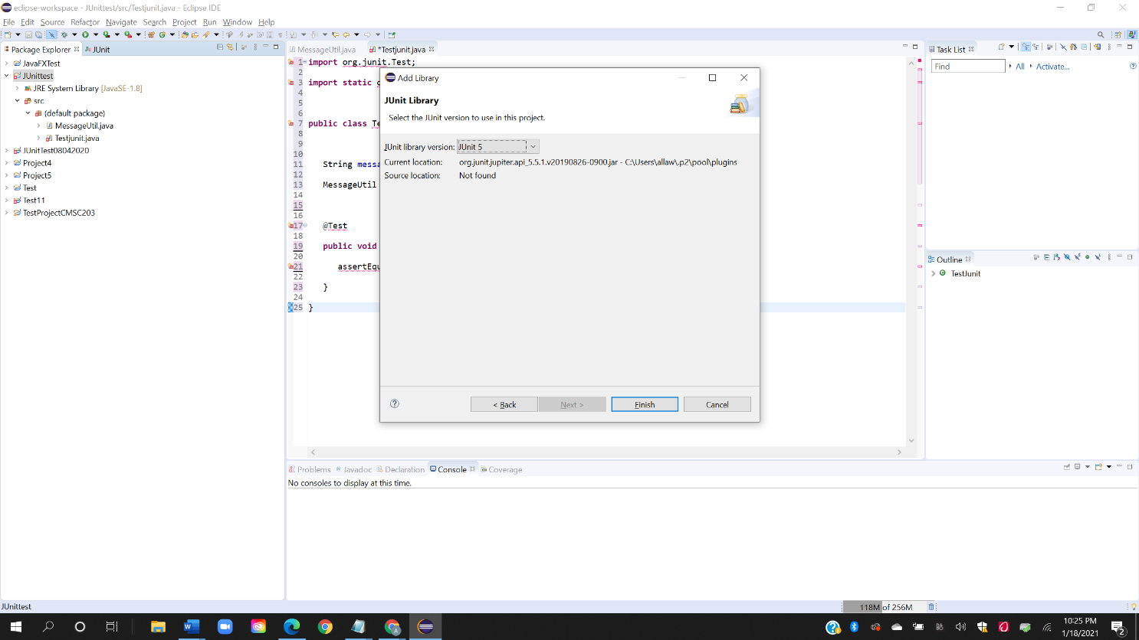

* Create a java test class, TestJunit.java.
* Add a test method testPrintMessage () to your test class.
* Add an Annotation @Test to method testPrintMessage ().
* Implement the test condition and check the condition using assertEquals API of JUnit.

import org.junit.Test;

import static org.junit.Assert.assertEquals;

public class TestJunit {

String message = "Hello World";

MessageUtil messageUtil = new MessageUtil(message);

@Test

public void testPrintMessage() {

assertEquals(message,messageUtil.printMessage());

}

}

1. **How to Run JUnit Test**

To run the test, do right-click on the TestJunit class on the left navigation menu and select Run As > JUnit Test)

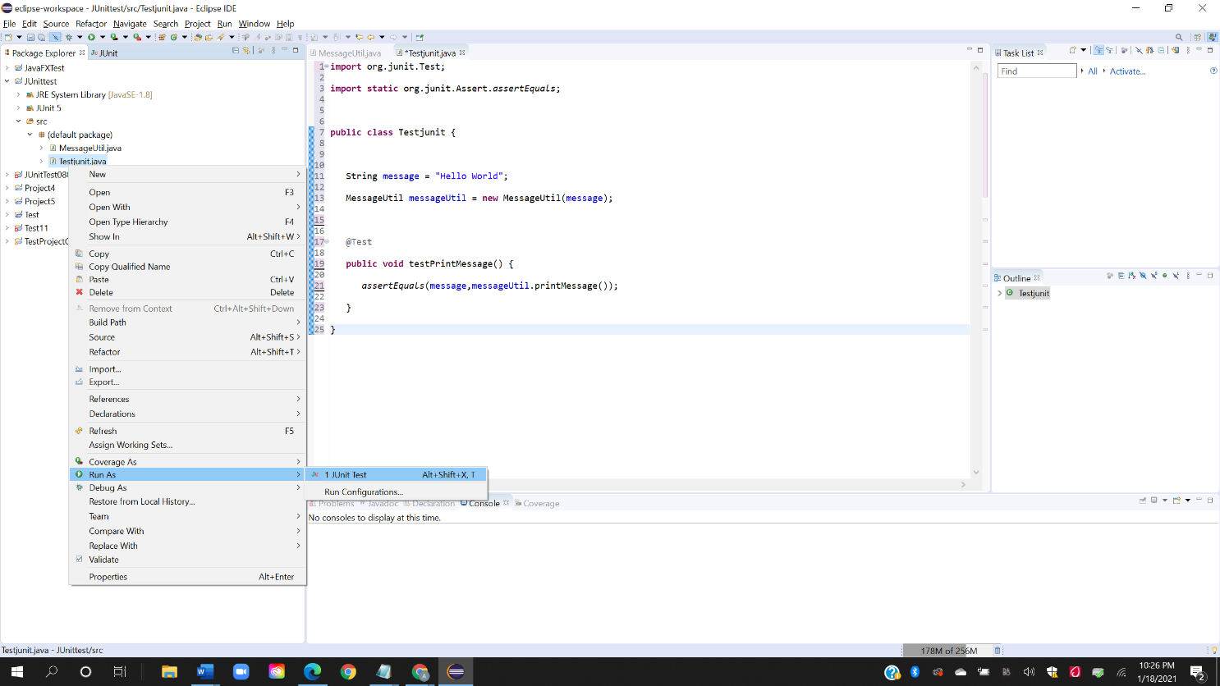

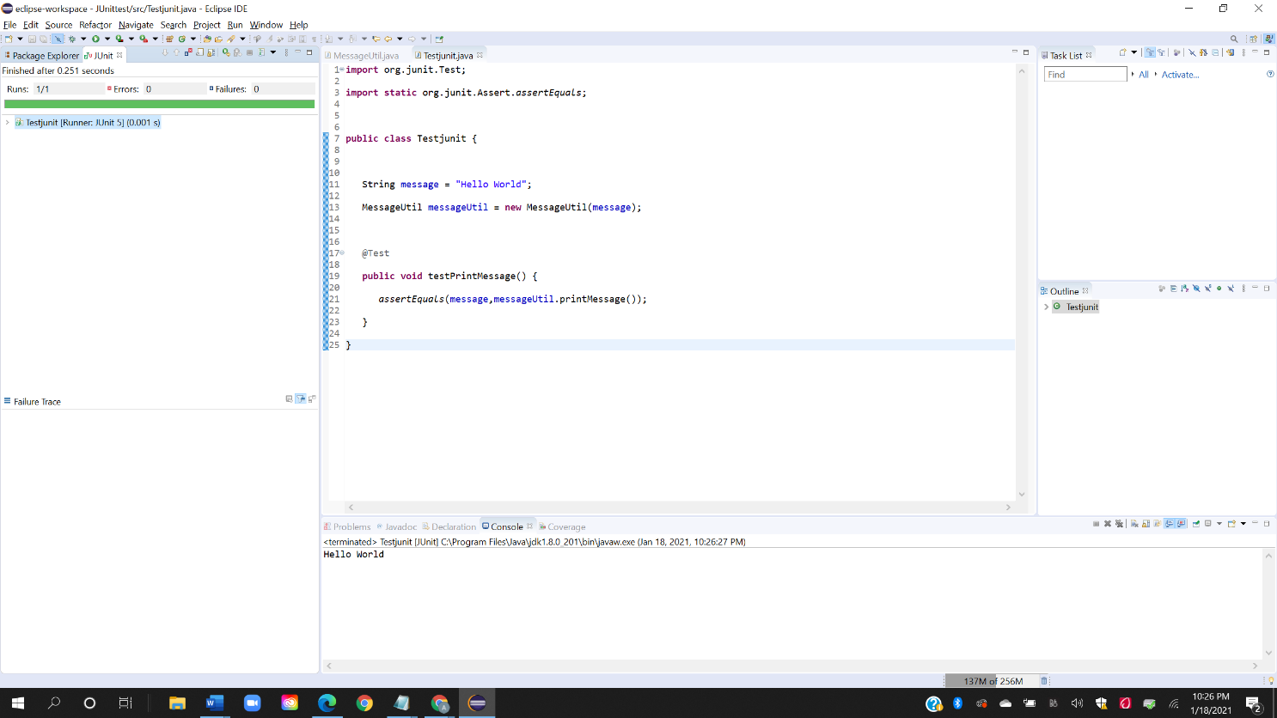

**Deliverables**

Upload the word document containing the screen shots from Step Setup JUnit to Blackboard Assignment 0.

**Submit :**

Screenshots showing:

Eclipse showing JUnit Test example working

* 1. Project screenshot

* 1. Running example screenshot

**References**

How to Download and Install JUnit in Eclipse. (n.d.). Retrieved from <https://www.guru99.com/download-installation-junit.html>

<https://www.codejava.net/testing/junit-tutorial-for-beginner-with-eclipse>