**FIN567 Financial Risk Management Homework 3**

Group name: SSVJ

Group members:

HOU Sunjie shou10

GADDA Veeraj gadda2

HONG Sungwook hong85

YOON Joonha joonhay2

Note:

We have also attached the data file we used in archive.

Solutions:

Question 1:

Part (a):

The covariance matrix is:

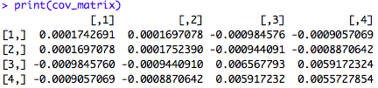

Part (b):

The annualized standard deviations are:



Question2:

The implied volatility of the four options is:



Question 3:

The 5% Value at Risk of the portfolio is:



Question 4:

The expected shortfall is:

