**FIN567 Financial Risk Management Homework 4**

Group name: SSVJ

Group members:

HOU Sunjie shou10

GADDA Veeraj gadda2

HONG Sungwook hong85

YOON Joonha joonhay2

Note:

We have also attached the data file we used in archive.

Solutions:

Question 1:

Mean excess loss e(u)-u graph:

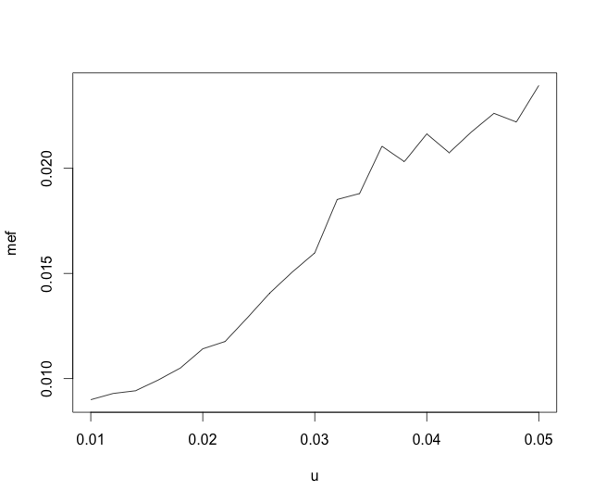

Question 2:

The number of losses that are greater than or equal to 0.022 is:



Question 3:

The estimated parameters are:



Question 4:

Conditional Density Graph:

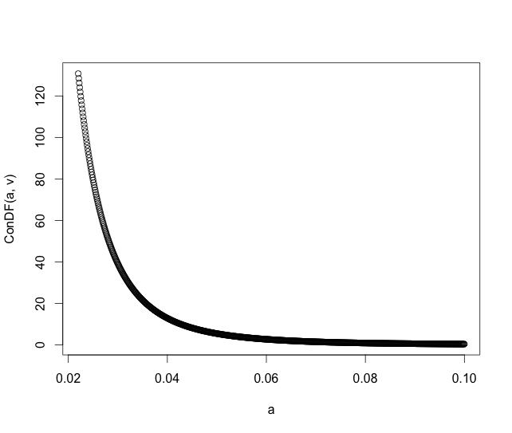

Question 5:

