**FIN567 Financial Risk Management Homework 7**

Group name: SSVJ

Group members:

HOU Sunjie shou10

GADDA Veeraj gadda2

HONG Sungwook hong85

YOON Joonha joonhay2

Solutions:

Q1:

The estimates of the realized variance and the average are:

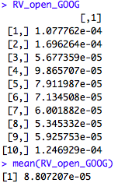

Q2:

(a):

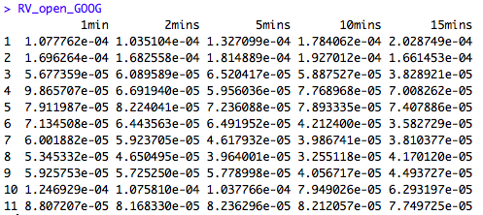

(b):

mean((RV_open_15_mins_GOOG[,1])) # 26 datapoints

7.749725e-5

mean(RV_open_15_mins_GOOG_b[,1]) #25 datapoints

6.935985e-5

If we do not apply adjustment factors, the result of lower numbers of data points tends to underestimate the realized variance. This has to be scaled based on not only the number of data point but also time interval. Thus, by multiplying the scale factor,

(1+(time_interval - 1) * ((max_data_points)/(min_data_points)))/time_interval,

we can effectively adjust the biased result.

The result is as the following:

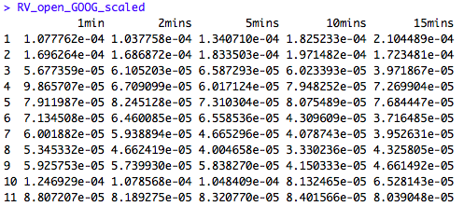

(c):

The estimates of the realized variance decrease as the return interval becomes longer. The ratios are:

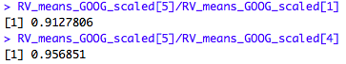

Q3:

(a):

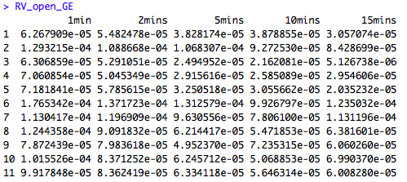

(b):

The estimates of the realized variance decrease as the return interval becomes longer. The ratios are:

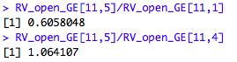

(c):

Since the change of realized variance with return interval are larger for GE than GOOG, the estimates are more dependent on return intervals for GE.

Q4:

Using the approach on slide 57, the estimates of RV are:



Using the approach on slide 58, the esimates are:

