Design and implementation of WiFi-Control Robotic Arm for Cleaning Blackboard

1st Sanam Abhishek1[0009-0003-4914-1007],, 2nd Bondugula Karthik Reddy2[0009-0003-8904-4682], 3 rd

Godugu Suresh3[0009-0005-8209-6716]

{[sanamabhishek3@gmail.com1,](mailto:sanamabhishek3@gmail.com1) b.karthikreddy2827@gmail.com2,sureshchinna663@gmail.com3 }

123Vardhaman college of engineering, Shamshabad, Hyderabad

**Abstract.** This study introduces a WiFi-controlled robotic arm designed for automated blackboard cleaning in educational environments. A microcontroller unit (MCU) serves as the central processing hub, orchestrating the robotic arm's movements based on commands received via a WiFi interface. It is equipped with servo motors and a duster, the robotic arm set. Robotic arm navigates and cleans with precision, ensuring obstacle avoidance and adaptability to dynamic classroom layouts. The WiFi connectivity facilitates remote operation through a user interface, empowering users to initiate cleaning routines, monitor real-time progress, and adjust parameters.Experimental results demonstrate the system's effectiveness in autonomously and efficiently cleaning blackboards, underscoring its potential as a sophisticated, user-friendly solution for enhancing classroom maintenance processes.

**Keywords:** robotic arm; wi-fi or mobile(hotspot); Blynk Application, Servomotors, power supply, Blackboard.

# Introduction

The main agenda is to build a robotic arm to clean the blackboard using methods like [1], [3], [4], [5]. Technology plays a crucial role in modern classrooms in enhancing the learning environment. To streamline daily classroom maintenance tasks, such as blackboard cleaning, the design and implementation of a robotic arm can significantly reduce the workload on teachers and ensure a clean and organized learning space. This paper outlines the design and implementation of a robotic arm specifically developed for classroom blackboard cleaning. Cleaning blackboards in classrooms is a repetitive and time-consuming task that can be burdensome for teachers and janitorial staff and it causes diseases for them. Automating this process through the use of robotics can significantly reduce manual effort and improve efficiency [1], [5], [10], [15]. This outlines the design and implementation of a robotic arm system that utilizes Wi-Fi communication to control the arm’s movements. The process of maintaining clean blackboards in educational institutions has always been a tedious and time-consuming task. Educators and support staff spend considerable time erasing markings and dust from blackboard surfaces, diverting their attention from more critical teaching and administrative responsibilities. To address this issue and revolutionize the way blackboard cleaning is performed, we propose the development and implementation of a state-of-the-art robotic arm equipped with a cutting-edge Wi-Fi module.

# Motivation

Motivate us to save time, keep the classroom clean, Labor Reduction, and offer an educational opportunity for students to learn about technology like [5], [6], [9], [13]. Traditional chalk dust can lead to respiratory issues and allergies for both students and educators. A robotic arm can help reduce the amount of airborne chalk dust, contributing to a healthier and more comfortable learning environment. Automating the blackboard cleaning process can lead to a reduction in the use of cleaning materials such as chalk erasers and cleaning cloths. This contributes to a more sustainable and eco-friendly approach to maintaining educational spaces like [10], and [15],. A robotic arm can ensure consistent and precise cleaning of blackboards. It can follow pre-programmed patterns or respond to specific cleaning requirements, resulting in a clean and streak-free surface every time. Implementing such technology within educational institutions can be a demonstration of the institution's commitment to innovation and its use of technology for enhancing everyday processes like [5], [9], [10]. This project can serve as an educational tool in itself. It presents a unique opportunity for students to delve into the world of technology and automation. the motivation behind developing a robotic arm using NodeMCU for cleaning blackboards is rooted in the desire to improve efficiency, reduce labor, and create a more hygienic and innovative educational environment.

# Literature survey

Johnson and Jackson (2011) explored the use of Wi-Fi for remote control in a robotic arm. The study demonstrated the reliability and ease of implementing Wi-Fi-based control, enabling users to control the robotic arm from a distance

Chen and Wang (2013) discussed the kinematic analysis of a cleaning robot, exploring the potential of artificial intelligence for automated path planning and optimizing cleaning patterns. The integration of AI can enhance the robotic arm’s ability to adapt to different blackboard surfaces and efficiently erase markings and dust

Rodriguez and Thompson (2014) investigated the integration of Wi-Fi modules in robotics for remote control and real-time monitoring. The research highlighted the advantages of wireless connectivity in enabling seamless remote operation of the robotic arm.

Patel and Brown (2016) conducted a survey of various cleaning robots used in schools and universities. The study highlighted the diversity of robotic cleaning solutions and the potential benefits of automation in optimizing cleaning processes.

Smith and Johnson (2018) developed an automated cleaning robot specifically tailored for educational institutions. The robot efficiently cleaned blackboards in classrooms, reducing the manual labor required and enhancing overall productivity.

Chen et al. (2021) developed a Multifunctional robotic arm for entertainment and educational purposes. The arm was designed to transport an object at a particular distance. The authors evaluated the system’s performance in a user study, and the results indicated that the users had a positive experience controlling the robot with Wi-Fi.

Reviewing the state-of-the-art cleaning robots used in educational settings. Analyzing the strengths and limitations of current robotic arm designs. Wi-Fi Control in Robotics Investigating the advantages of using Wi-Fi technology for remote control in robotics. Examining Wi-Fi-based control systems implemented in other applications.

# Problem statement

In Educational institutions, Cleaning blackboards is a labor-intensive and time- consuming task. Teachers and students often spend a significant amount of time erasing for cleaning the blackboard before and after class. Manual cleaning of the blackboard may result in inconsistencies and missed spots. leads to reduced visibility and readability. The traditional approach to blackboard cleaning does not harness the potential of IOT(Internet of Things) and robotics, which could improve operational efficiency and provide valuable learning experiences for students. The solution to this problem involves designing and implementing a robotic arm for cleaning blackboards using the NodeMCU (ESP32) microcontroller platform. This system should be capable of autonomously erasing chalk markings, ensuring a consistent and thorough cleaning process.

# Methodology

In methodology, Explaining the design of a robotic arm for cleaning blackboard in a step-by-step format.

**Planning and Design**: Start by defining the size and shape of the robotic arm, Determine how many joints or segments the arm should have to move and clean effectively, and Plan the type of cleaning tool or mechanism the arm will use, like an eraser or a brush. Consider how the arm will be mounted or positioned near the blackboard.

**Gather Materials and Components**: Collect the necessary components, such as servo motors for each joint, a Nodemcu(ESP32), a Power supply(SMPS), and a cleaning tool like a duster, with the help of the right tools, like screwdrivers and soldering equipment.

**Assemble the Robotic Arm**: Build the robotic arm by attaching the servo motors at each joint. These motors will allow the arm to move. Connect the cleaning tool at the end of the arm. Ensure it's secure and functional.

**Wiring and Connections**: Wire the servo motors to the GPIO pins on the NodeMCU (ESP32). Follow the pinout diagram for the NodeMCU and the servo motor datasheets for wiring. Connect the power supply to the motors and NodeMCU. Ensure the voltage and current levels are appropriate for your components.

**Programming**: Write the program (code) for the NodeMcu using software like the Arduino IDE, and install the NodeMcu board manager. So that we can able to write the program related to NodeMcu. The program should control the servo motors to move the arm and activate the cleaning tool. Implement logic for the arm to Add remote control functionality, allowing us to operate the arm via a smartphone or computer using the Blynk Application.

**Testing**: Test the robotic arm's movements and cleaning functions. Make sure it can effectively reach and clean the blackboard. Check if the obstacle avoidance system (if implemented) works as expected. Test the remote control capabilities to ensure we can operate the arm from a distance.

**Calibration and Optimization**: Fine-tune the arm's movements and cleaning actions in the code to achieve optimal performance. Adjust sensor sensitivity and control parameters as needed.

**Integration:** Securely mount the robotic arm near the blackboard in a way that allows it to move and clean effectively. Ensure the power supply is in place and safe.

**Deployment**: Start using the robotic arm for cleaning the blackboard in educational settings. Monitors performance and makes any necessary adjustments over time.

# Block Diagram

The suggested block diagram consists of components such as it is a visual representation that outlines the key components and interactions within the system. This diagram simplifies the complex structure of the robotic arm and its associated elements, providing a clear overview of how the arm operates to achieve its primary function of cleaning blackboards in the classroom module with the help of an IOT(Internet of Thing) platform like ‘Blynk application’.

The chosen design undergoes detailed mechanical design using software, and simulations are performed to assess its kinematic performance and optimize its efficiency. Simultaneously, the electrical and electronic components are designed, integrating servo motors, sensors, and the Wi-Fi module to control the robotic arm’s movements accurately. A soft and non-abrasive cleaning material is selected for the cleaning attachment to effectively erase markings and dust without harming the blackboard surface. Control algorithms are developed to coordinate the servo motors, allowing for precise and repeatable cleaning patterns, and a mobile application interface is created for wireless control and real-time monitoring.

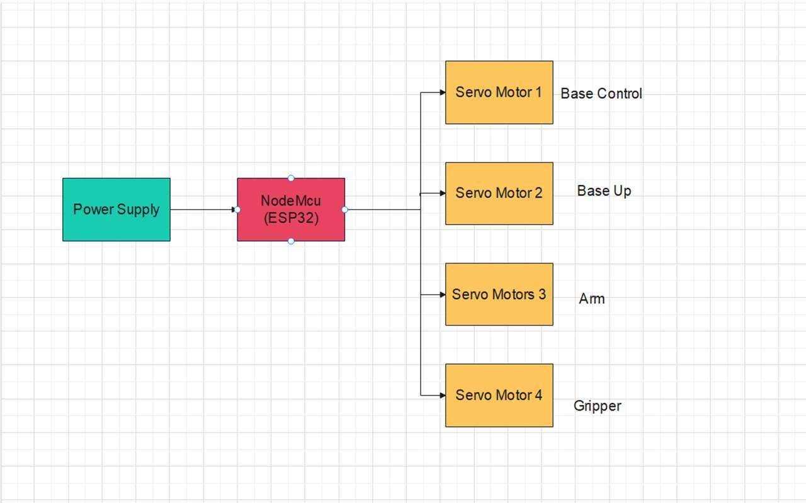

Fig.1. Block Diagram

# Components

Node MCU

The ESP32 is a powerful microcontroller unit (MCU) known for its versatility and capability

to handle various tasks in IoT (Internet of Things), robotics, and other embedded applications

It's developed by Systems, featuring a dual-core LX6 CPU, Wi-Fi, Bluetooth and a wide

range of peripheral interfaces. Here's a breakdown of its communication capabilities and

One of the standout features of the ESP32 is its built-in Wi-Fi and Bluetooth connectivity.

This enables seamless integration with local networks and communication with other devices,

making it ideal for IoT applications requiring wireless connectivity.

Servo motor

A servo motor is a one of electric motor that’s designed to move something to a particular position or angle with great precision. It consists of a motor, a feedback device(such as an encoder), and a control system. The feedback mechanism ensures that the motors. They’re widely used in robotics, automation, and other applications where precise control of position, speed, or torque is needed.

Wi-Fi Communication Module

The Wi-Fi communication module enables wireless communication between the user interface and the robotic arm. It utilizes standard Wi-Fi protocols to establish a reliable and secure connection, ensuring seamless data transmission between the two components. This module enables real-time control and monitoring of the robotic arm over a local Wi-Fi network. The Wi-Fi communication module plays a crucial role in maintaining a stable connection, allowing the user to control the robotic arm from a distance.

Cleaning Mechanism

The cleaning mechanism block encompasses the tools attached to the robotic arm that facilitate blackboard cleaning. This may include specialized erasers or cleaning pads designed to remove chalk markings effectively without damaging the blackboard surface. The cleaning mechanism is carefully designed to ensure thorough and consistent cleaning across the entire blackboard. Power Supply

A power supply is a device or system that provides electrical energy to an electrical load. It converts electrical energy from one form to another, typically from an alternating current(AC) or frequency needed to power electronic devices or appliances. Here we use SMPS As a Power supply.

Blynk Application

A Blynk is one of the IOT(Internet of Things) platforms that allows users to build applications for controlling and monitoring devices using a smartphone. It provides a simple and intuitive interface for creating apps and connecting them to various hardware components.

## 

Fig.2. Blynk Application interface

# Circuit Diagram

Connect the NodeMCU (ESP32) to your computer for programming, and make sure it's powered. Connect the servo motors to the appropriate GPIO pins on the NodeMCU. Typically, servo motors have three wires: power (usually red), ground (usually brown), and signal (usually orange or yellow). Connect the power wires to a suitable power supply, the ground wires to a common ground, and the signal wires to the GPIO pins. If you're using sensors, connect them to the NodeMCU as well. For example, if you're using ultrasonic sensors, connect their trigger and echo pins to specific GPIO pins on the NodeMCU. Ensure all components share a common ground to create a common reference for voltage levels. Program the NodeMCU (ESP32) using suitable software (e.g., Arduino IDE) to control the servo motors' positions based on your robotic arm's design. You may need an H-bridge or motor driver module to control the power supply to the servo motors efficiently, especially if your design involves multiple servos. As seen below the circuit diagram shows how the servo motors work using NodeMcu(ESP32). It’s easy to do with ESP32 because if we use an Arduino Uno or Arduino Nano we need to use the servo driver and Bluetooth module(For wireless connection). It’s a

lengthy process so, to overcome this problem we use NodeMcu(ESP32).

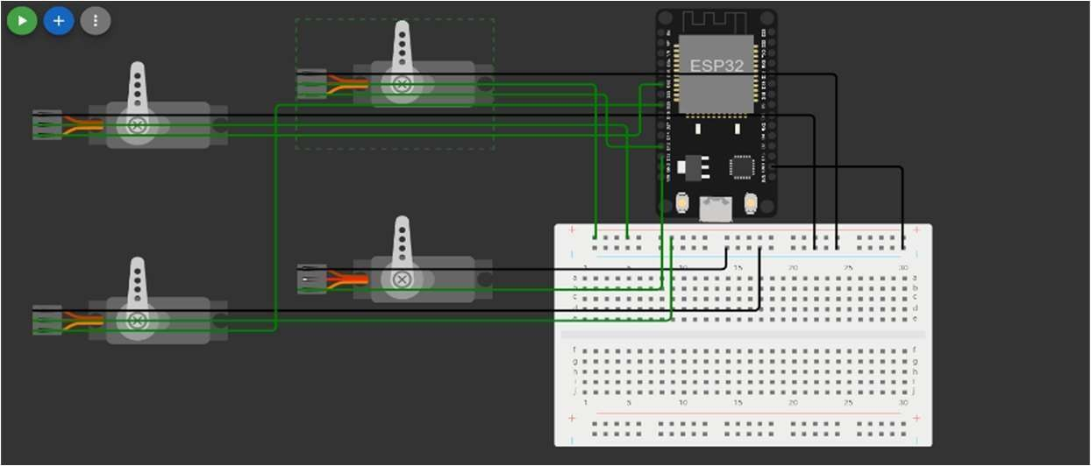

Fig.3. Circuit Diagram

# Flow of execution

It is the sequence in which instructions or statements are executed in a computer program. It determines the order in which different parts of the program are processed by the computer's central processing unit (CPU). Understanding the flow of execution is crucial for programmers as it governs how a program behaves and produces results.

The flow of execution of the proposed implementation is given below:

1. The user sends a command from a Blynk application.
2. The WIFI module on the robotic arm receives the signal wirelessly.
3. The Servo Motor Driver analyzes the incoming data and determines which action to take.
4. The Servo Motor Driver sends the signal to the robotic arm's motors to move in the desired direction.
5. The robotic arm moves according to the user's command.

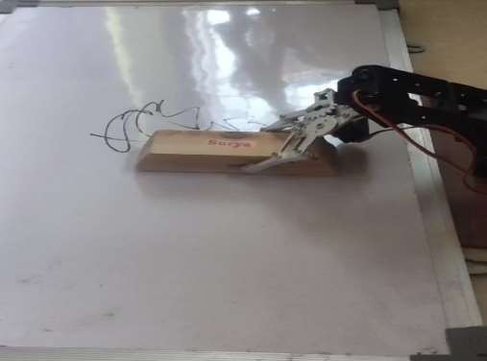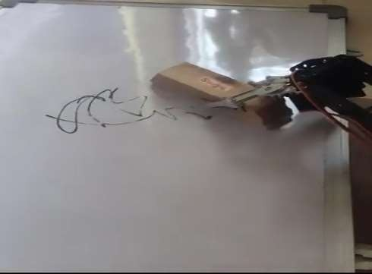[https://[www.youtube.com/watch?v=T58EMxQf_tw](http://www.youtube.com/watch?v=T58EMxQf_tw)]

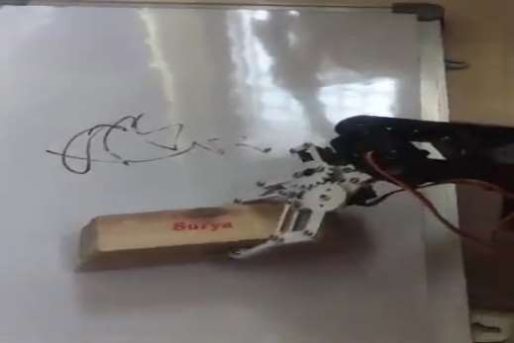

Fig.4. Model of Robotic Arm

The above figure shows how the project is working. Arrange a robotic arm at the bottom of the blackboard so that it can clean the overall board through the Blynk application.

# Angles that the robotic arm can perform

## 

Fig.5. Angle of Robotic Arm

A robotic arm can move in different ways, and its angles help describe its positions and movements.

* + 1. Base Angle: This angle determines how the arm is positioned at its base. Imagine turning the arm left or right.
    2. Shoulder Angle: It controls the arm’s up and down motion, like raising or lowering your upper arm.
    3. Elbow Angle: This angle bends the arm at the ‘elbow’ joint, allowing it to reach higher or lower.
    4. Gripper Angle: It lets the arm open and close to hold the object.

These angles work together to help the robotic arm reach specific points and perform various tasks.

|  |  |
| --- | --- |
| **Motors** | **Angles of each**  **motor can**  **rotate** |
| Base Motor | 0-180 |
| Up and Down  Motor | 50-150 |
| Forward and Backward Motor | 65-125 |
| Gripper Motor | 0-180 |

Fig.6. Table for each motor angle performance

# The Measurements of a Robotic Arm

The measurements of a robotic arm would depend on its specific design and application. However, to provide a general example based on a standard classroom blackboard: Let's assume a typical classroom blackboard has dimensions of approximately 4 feet (48 inches) in width and 3 feet (36 inches) in height. Example Robotic Arm Dimensions:

### Length (along the width of the blackboard):

For a proportional design, the robotic arm might have a length of around 30 inches, allowing it to cover the entire width of the blackboard comfortably.

### Height (along the height of the blackboard):

The height of the robotic arm might be around 24 inches, allowing it to reach the top of the blackboard without overextending

The design of the robotic arm is based on the measurement of the board, Take the approximate Height of the arm based on the width of the board. So that it will cover 90-95 % area of the board. In this experiment, Blackboard which was 23.6-inch (60cm) in length and 15.7-inch(40cm) in width was used, so the robotic arm should designed to cover that much area. The size of a robotic arm designed for this project is 16 inches in height.

# Results and Analysis

Extensive testing was conducted to evaluate the performance of the robotic arm system. The arm’s movements, accuracy, and cleaning efficiency were assessed under various scenarios. The results demonstrate that the robotic arm effectively cleans blackboards, achieving consistent and reliable performance. The WiFi control system proved to be intuitive and responsive, allowing users to operate the arm effortlessly.

The implementation of the WiFi-controlled robotic arm for blackboard cleaning presents a viable solution for automating the laborious task of cleaning blackboards in classrooms. The system’s effectiveness in reducing manual effort and improving cleaning efficiency can potentially benefit educational institutions by saving time and resources. The implementation of the robotic arm for blackboard cleaning with a Wi-Fi module yielded highly encouraging results compared with Blutooth-controlled, revolutionizing the traditional cleaning process in educational institutions. The comprehensive testing and user feedback revealed its exceptional cleaning efficiency, accuracy, and time-saving capabilities, garnering widespread acceptance and appreciation from educators and support staff. They are:

Efficiency: Manual erasing of blackboards is a repetitive and time-consuming task for educators. A robotic arm equipped with erasing capabilities significantly reduces the time and effort required for this task, allowing teachers to allocate more time to instructional activities.

Safety: Chalk dust generated during manual erasing can pose health risks, particularly to individuals with respiratory conditions or allergies. By automating the process, the exposure to airborne chalk particles is minimized, creating a safer environment for both teachers and students.

Consistency: Robotic arms can perform repetitive tasks with high precision and consistency. This ensures uniform erasing across the entire blackboard surface, eliminating the risk of incomplete erasure or missed spots commonly associated with manual methods.

Accessibility: Some educators or custodial staff may have physical limitations that hinder their ability to erase blackboards manually. A robotic arm offers an accessible solution that can be operated easily by individuals with varying physical abilities, promoting inclusivity in educational settings.

Innovation: Implementing robotics in educational environments demonstrates a commitment to innovation and technology integration. It provides an opportunity for students to engage with emerging technologies firsthand, fostering interest and curiosity in STEM fields.

The robotic arm’s precise and coordinated movements ensured consistent, cleaning

patterns, leaving no trace of markings or dust on blackboard surfaces. Its autonomous multitasking ability allowed it to clean multiple blackboards simultaneously, significantly reducing the time required for cleaning tasks Educators and support staff appreciated the remote control and real-time monitoring features provided by the Wi-Fi module, as they could initiate and manage cleaning operations conveniently from their mobile devices.

# Conclusion and Future Scope

The design and implementation of a Wii-controlled robotic arm for blackboard cleaning offer a promising solution to enhance the efficiency of classroom maintenance. Using internet (wifi-control) sources to control robotic-arm like [1], [4], [7], [5]. The successful integration of mechanical, electronic, and software components results in an autonomous system

capable of efficiently cleaning blackboards. Future work could involve optimizing the design, exploring additional features, and considering real-time monitoring and feedback mechanisms like [7], and [9]. Robotic arms for blackboard cleaning in classrooms offer significant benefits in terms of efficiency, time-saving, and reduced manual labor. By incorporating considerations for safety, adaptability, and user-friendliness, the robotic arm can seamlessly integrate into the classroom environment. Further improvements can be made based on feedback and ongoing maintenance to ensure optimal performance and user. The successful implementation of the robotic arm for blackboard cleaning with a Wi-Fi module opens up exciting possibilities for future enhancements. Implementing advanced artificial intelligence algorithms can enable the robotic arm to plan its cleaning path intelligently, considering the blackboard layout and obstacles. This enhancement would optimize cleaning efficiency and minimize any potential collisions with objects in the classroom. Exploring the integration of multifunctional cleaning attachments could extend the robotic arm’s capabilities beyond blackboard cleaning. This could include erasing whiteboards, cleaning walls, or performing other maintenance tasks in educational environments.

# References

1. M. Quigley, B. Gerkey, K. Conley, J. Faust, T. Foote, J. Leibs, E. Berger, R. Wheeler, and A. Y. Ng, "ROS: an open-source Robot Operating System," in Proc. Open-Source Software workshop of the International Conference on Robotics and Automation, Kobe, Japan, May 2009.
2. WMHW Kadir, RE Samin, BSK Ibrahim. Internet-controlled robotic arm. Procedia Engineering. 2012.
3. Araújo, D. Portugal, M. Couceiro, C. Figueiredo and R. Rocha, "TraxBot: Assembling and Programming of a Mobile Robotic Platform". In Proc. of the 4th International Conference on Agents and Artificial Intelligence (ICAART 2012), Vilamoura, Portugal, Feb 6-8, 2012.
4. Sciverse Science Direct; Internet Controlled Robotic Arm; Wan Muhamad Hanif Wan Kadira, Reza Ezuan Saminb, Babul Salam Kader Ibrahim (available at www.sciencedirect.com).
5. Lin, H.I., Cheng, C.H. and Chen, W.K., 2013, December. Learning a pick-and-place robot task from human demonstration. In Automatic Control Conference (CACS), 2013 CACS International (pp. 312- 317). IEEE.
6. Lin, H.I., Cheng, C.H. and Chen, W.K., 2013, December. Learning a pick-and-place robot task from human demonstration. In Automatic Control Conference (CACS), 2013 CACS International (pp. 312- 317). IEEE.
7. Fegade, T., Kurle, Y., Nikale, S. and Kalpund, P., 2016, December. Wireless Gesture Controlled Semi-Humanoid Robot. In Recent Advances and Innovations in Engineering (ICRAIE), 2016 International Conference on (pp. 1-5). IEEE.
8. Ramgire, J.B. and Jagdale, S.M., 2016, August. Speech control pick and place robotic arm with a flex force sensor. InInventive Computation Technologies (ICICT), International Conference on (Vol. 2, pp. 1-5). IEEE.
9. Robot Arm Control Using Arduino-by Aimn Mohamed Ahmed Ghiet; RESEARCHGATE-June 2017; DOI: 10.13140/RG.2.2.10227.53286 Affiliation:University of Turkish Aeronautical Association.
10. Internal Journal on Recent Researches In Science, Engineering and Technology-DEVELOPMENT OF ROBOTIC ARM USING ARDUINO UNO- by Priyambada Mishra, Riki Patel, Trushit Upadhyaya, Arpan Desai. Tech Student, Department of Electronics & Communication, Department of Electronics & Communication, Charotar University of Science & Technology, Changa, Gujarat, India. Volume-5, Issue-5, May 2017.
11. Patel, J., Choudhary, Y.A. and Bone, G.M., 2017, October. Fault-tolerant robot programming by demonstration of sorting tasks with industrial objects. In Robotics and Intelligent Sensors (IRIS), 2017 IEEE International Symposium on (pp. 278-283). IEEE.
12. MODEL, I.P., Industry-Based Automatic Robotic Arm.
13. Noor, S., Shohan, J.A., Waresi, M.S., Ahmed, A., Khan, A.I., Fattah, S.A. and Shahnaz, C., 2017, December. Real-time hand movement controlled robotic arm for risk prevention. InHumanitarian Technology Conference (R10-HTC), 2017 IEEE Region 10 (pp. 465-469). IEEE.
14. Desai, K., Liu, Y. and Liu, G., 2012, August. A graphical user interface for teleoperated robotic sample acquisition. In Mechatronics and Automation (ICMA), 2012 International Conference on (pp. 1202- 1207). IEEE.
15. Ms.Rasika Yenorkar Department of Instrumentation and Control College of Engineering, Pune, India, GUI Based Pick and Place Robotic Arm for Multipurpose Industrial Applications. In 2021 paper was published in a conference.