This file briefly describes the function of two code files, **NC2GeoTiff** and **PW-DRRS**. The former is a preprocessing tool that generates all-weather LST, converting WRF NC data into GeoTiff images, and the latter is a preprocessing tool that generates all-weather images.

**NC2GeoTiff (Convert WRF NC data into Geotiff images)**

**Step 1: Downloading/opening files**

1. Download all files as a.zip
2. Open the NC2GeoTiff.cpp file using software with a Qt5.8(C++) development environment (we use VS2019 as an example). And the Geospatial Data Abstraction Library (GDAL) needs to be imported into this development environment.

**Step 2: Run the code**

Steps:

1. Generate EXE format software

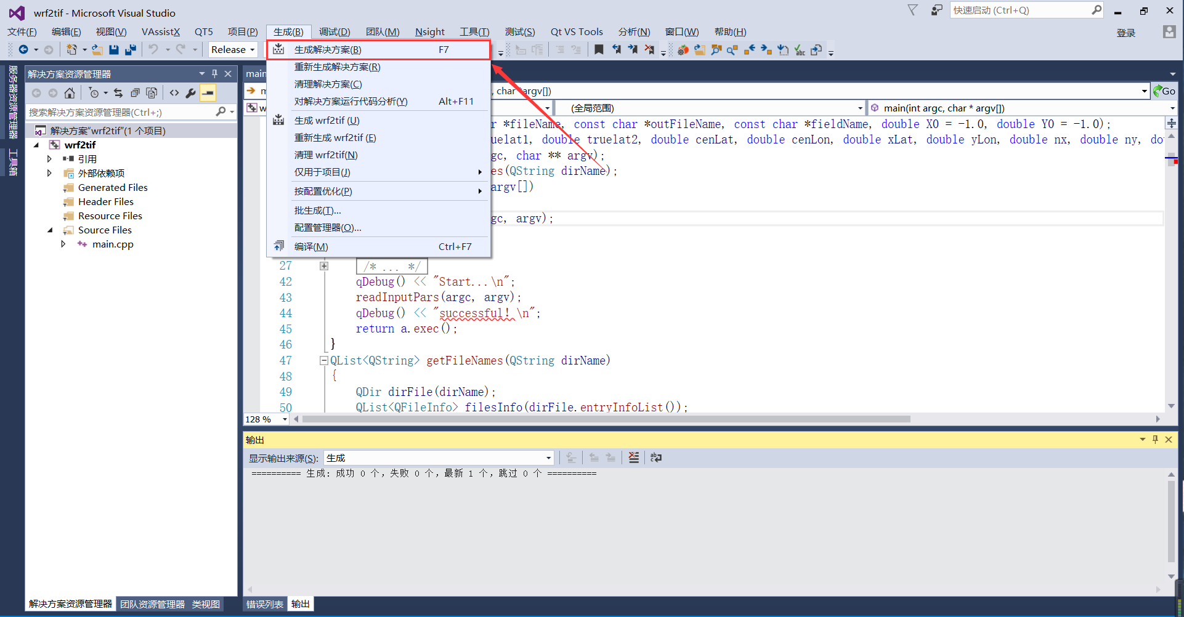

1. Open the generated EXE software with a terminal. Enter the following command, where F:\NC2Geotiff\wrfout is the input directory, F:\NC2Geotiff\result is the output directory, and TSK is the extracted field name, which is the name of the land surface temperature.

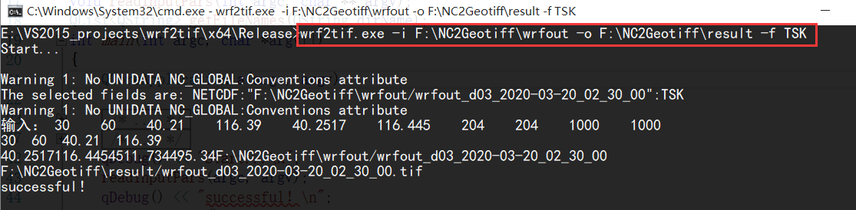

**PW-DRRS**

**Step 1: Downloading/opening files**

1. Download all files as a.zip
2. Open the PW-DRRS.py file using software with a Python3.7 development environment (we use PyCharm as an example).

**Step 2: Run the code**

Steps:

1. First, five variables need to be entered. Their meanings are as follows:

inXDirs: The name of the directory containing the independent variables

inYDir: The name of the directory containing the dependent variables

outResDir: The name of the directory outputting the all-weather LSTs

modelDir: The name of the directory outputting the RF models

errorFile: The name of the file outputting the daily LST error

cellValueDir: The name of the file outputting the MODIS clear sky pixels and the corresponding reconstructed all-weather pixels

ii) Run the function

