**Topics: Descriptive Statistics and Probability**

1. Look at the data given below. Plot the data, find the outliers and find out

|  | **Measure X** |
| --- | --- |
| Allied Signal | 24.23% |
| Bankers Trust | 25.53% |
| General Mills | 25.41% |
| ITT Industries | 24.14% |
| J.P.Morgan & Co. | 29.62% |
| Lehman Brothers | 28.25% |
| Marriott | 25.81% |
| MCI | 24.39% |
| Merrill Lynch | 40.26% |
| Microsoft | 32.95% |
| Morgan Stanley | 91.36% |
| Sun Microsystems | 25.99% |
| Travelers | 39.42% |
| US Airways | 26.71% |
| Warner-Lambert | 35.00% |

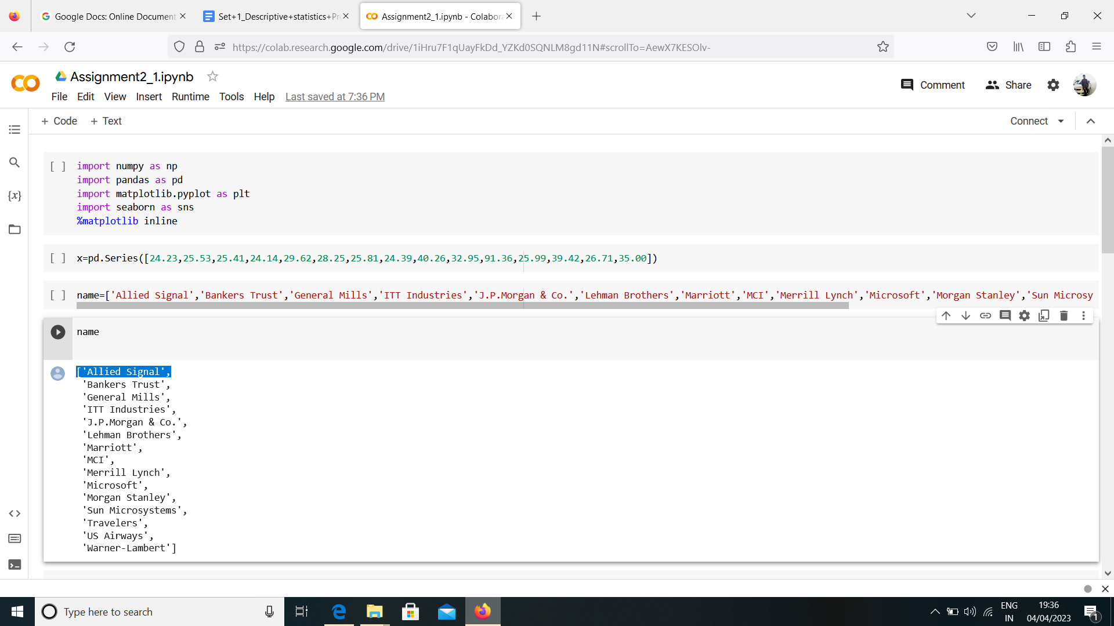

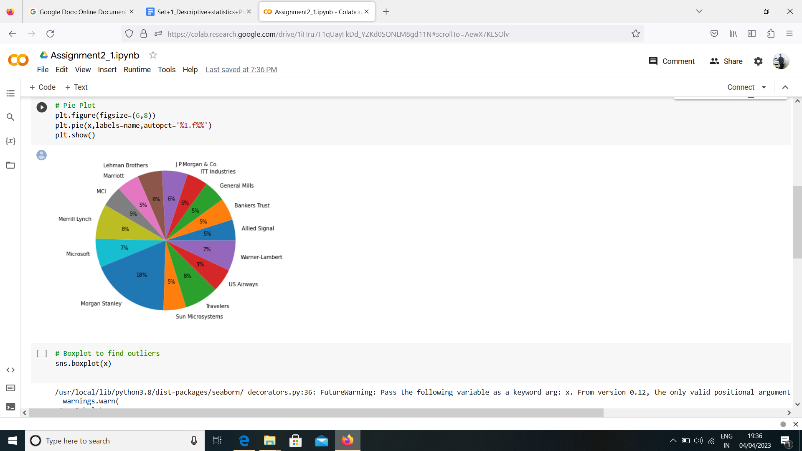

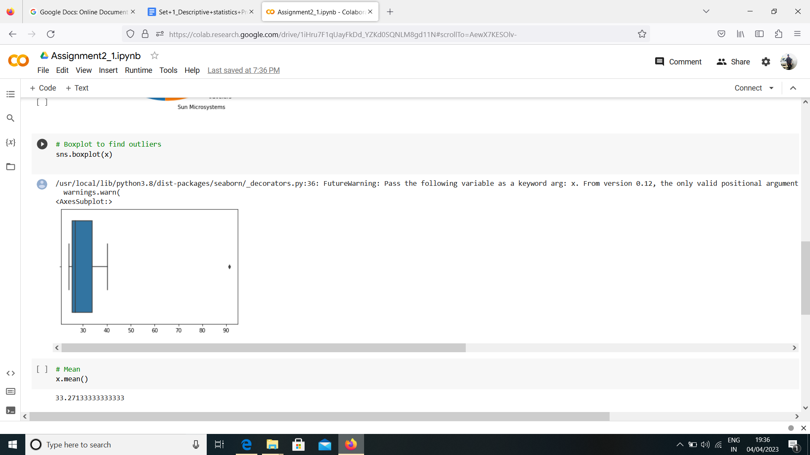

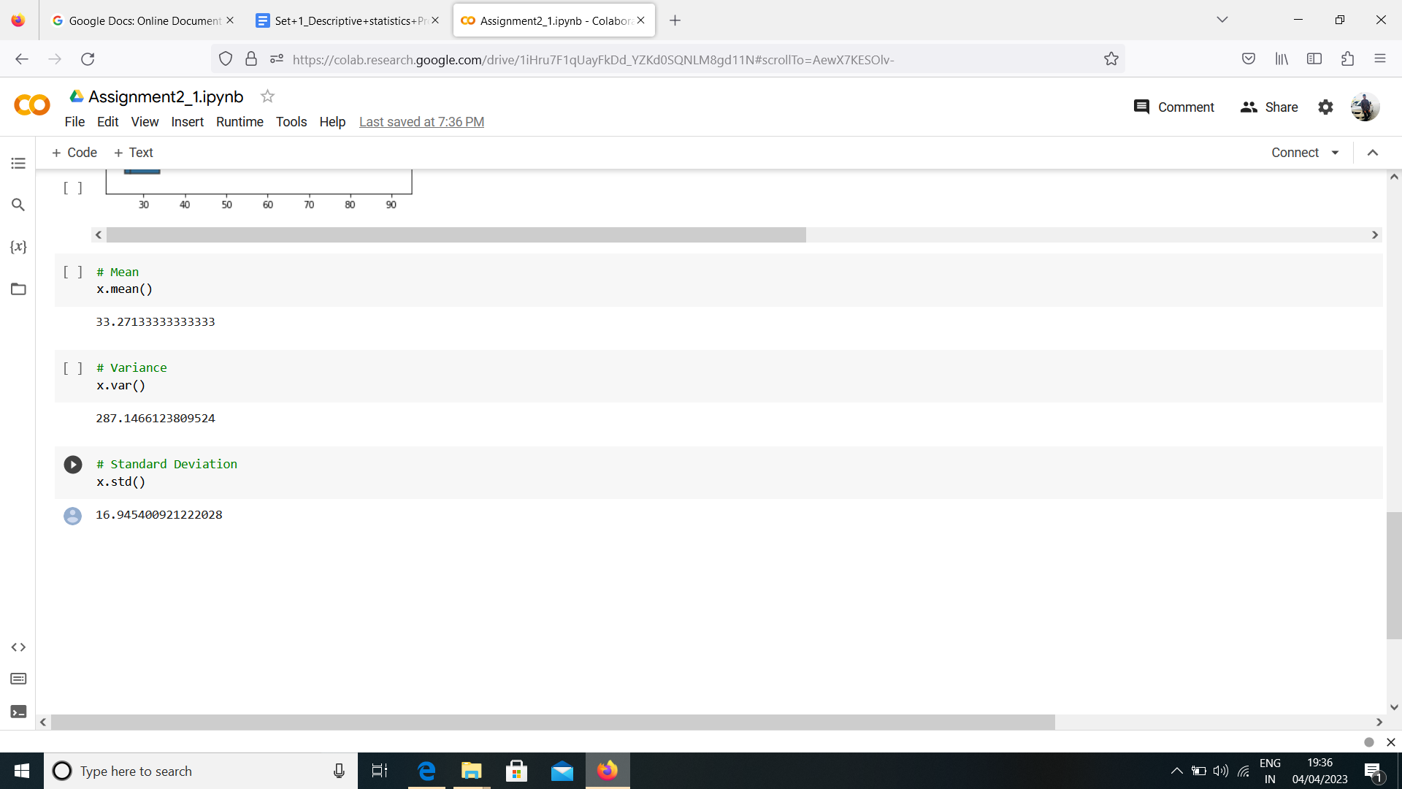

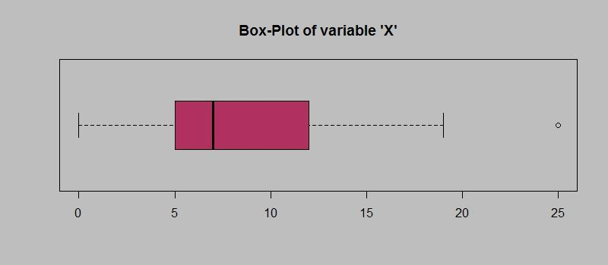

Answer the following three questions based on the box-plot above.

1. What is inter-quartile range of this dataset? (please approximate the numbers) In one line, explain what this value implies.

Answer: Approximately(First Quantile Range)Q1=5(Third Quantile Range)Q3=12,Meidan(Second Quartile Range)=7(Inter-Quartile Range) IQR=Q3-Q1 =12-5=7 Second Quartile Range is the median Value.

1. What can we say about the skewness of this dataset?

Answer: Right-Skewed median is towards the left side it is not normal distribution.

1. If it was found that the data point with the value 25 is actually 2.5, how would the new box-plot be affected?

Answer: In these case there would be no outliers on the given dataset because of the outliers the data had positive skewness it will reduce and the data will normal distributed.

3.

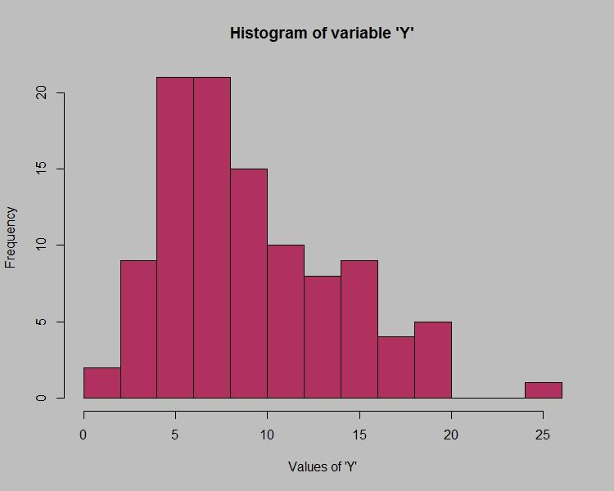

Answer the following three questions based on the histogram above.

1. Where would the mode of this dataset lie?

Answer: The mode of this data set lie between 5 to 10 and approximately between 4 to 8.

1. Comment on the skewness of the dataset.

Answer: Right – Skewed. Mean>Median>Mode.

1. Suppose that the above histogram and the box-plot in question 2 are plotted for the same dataset. Explain how these graphs complement each other in providing information about any dataset.

Answer: They both are right_skewed and both have outliers the meidan can be easily visualized in box plot where as in histogram mode is more visible.

1. AT&T was running commercials in 1990 aimed at luring back customers who had switched to one of the other long-distance phone service providers. One such commercial shows a businessman trying to reach Phoenix and mistakenly getting Fiji, where a half-naked native on a beach responds incomprehensibly in Polynesian. When asked about this advertisement, AT&T admitted that the portrayed incident did not actually take place but added that this was an enactment of something that “could happen.” Suppose that one in 200 long-distance telephone calls is misdirected. What is the probability that at least one in five attempted telephone calls reaches the wrong number? (Assume independence of attempts.)

Answer: Probability that at least one in 5 attempted call reaches the wrong number is 0.025.

Explanation:

Let us define an event

E: The call is misdirected

Then probability of the event E is

P(E) =1/200

Therefore,

P(E) =1-P(E) =1—1/200=199/200

Probabilty that at least one in 5 attempted call reaches the wrong number

=1-Probability that no attempted call reaches the wrong number.

=1-(199/200*199/200*199/200*199/200*199/200)

1=1-(199/200)^5

7920399001/200^5

0.025

1. Returns on a certain business venture, to the nearest $1,000, are known to follow the following probability distribution

| x | P(x) |
| --- | --- |
| -2,000 | 0.1 |
| -1,000 | 0.1 |
| 0 | 0.2 |
| 1000 | 0.2 |
| 2000 | 0.3 |
| 3000 | 0.1 |

1. What is the most likely monetary outcome of the business venture?

Answer: The most likely monetary outcome of the business venture is 2000$ As for 2000$ the probability is 0.3 which is maximum as compared to others.

1. Is the venture likely to be successful? Explain

Answer: Yes, the probability that the venture will make more than 0 or a profit p(x>0)+p(x>1000)+p(x>2000)+p(x=3000)=0.2+0.2+0.3+0.1=0.8 this states that there is a good 80% chances for this venture to be making a profit.

1. What is the long-term average earning of business ventures of this kind? Explain

Answer: The long-term average is Expected value=Sum(X*P(X))=800$ which means on an average the returns will be +800$.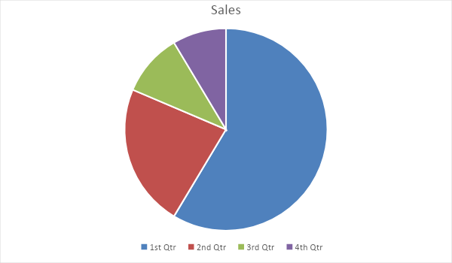

1. What is the good measure of the risk involved in a venture of this kind? Compute this measure

Answer: The good measures of the risk involved in a venture of this kind depends on the probability in the distribution.

Higher Variance means more chances of risk Var(X)=E(X^2)-(E(X))^2=2800000-800^2=2160000