SET 3

-----

1. Write a stored procedure that accepts the month and year as inputs and prints the ordernumber, orderdate and status of the orders placed in that month.

***Example***: call order_status(2005, 11);

⇒

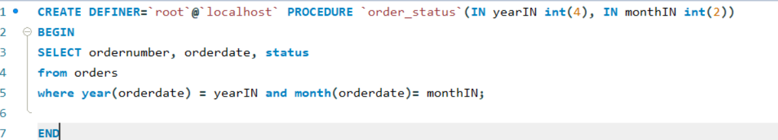

2. Write a stored procedure to insert a record into the cancellations table for all cancelled orders.

STEPS:

1. Create a table called cancellations with the following fields

id (primary key),

customernumber (foreign key - Table customers),

ordernumber (foreign key - Table Orders),

comments

All values except id should be taken from the order table.

1. Read through the orders table . If an order is cancelled, then put an entry in the cancellations table.

⇒

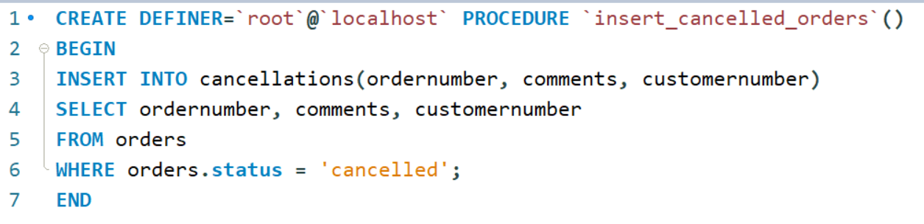

3. a. Write function that takes the customernumber as input and returns the purchase_status based on the following criteria . [table:Payments]

if the total purchase amount for the customer is < 25000 status = Silver, amount between 25000 and 50000, status = Gold

if amount > 50000 Platinum

⇒

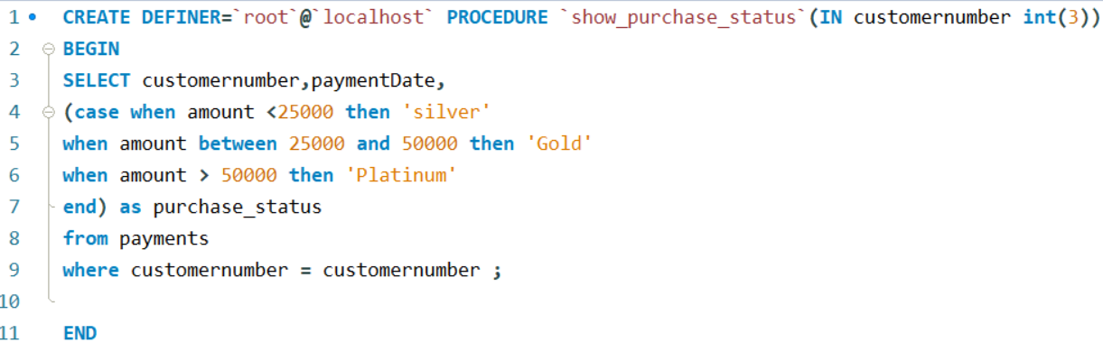

b. Write a query that displays customerNumber, customername and purchase_status from customers table.

⇒

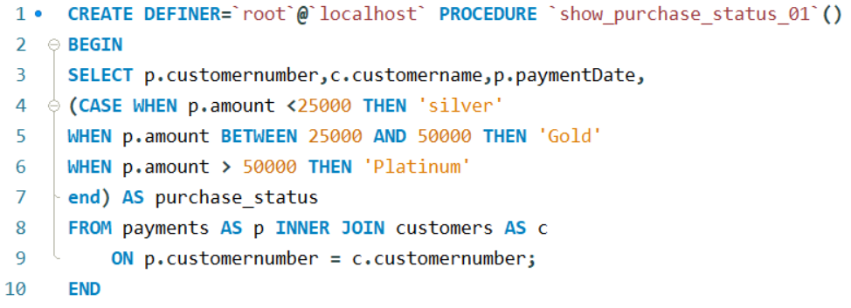

4. Replicate the functionality of 'on delete cascade' and 'on update cascade' using triggers on movies and rentals tables. Note: Both tables - movies and rentals - don't have primary or foreign keys. Use only triggers to implement the above.

⇒



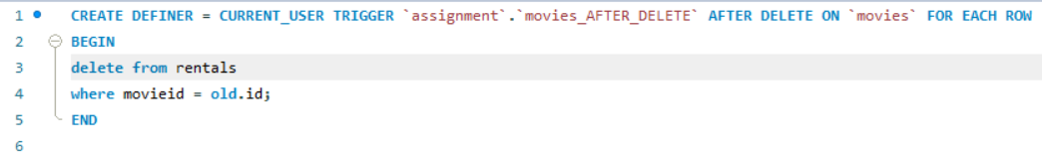

5. Select the first name of the employee who gets the third highest salary. [table: employee]

6. Assign a rank to each employee based on their salary. The person having the highest salary has rank 1. [table: employee]