1. Search for the grid project :- <https://github.homedepot.com/ose-automation-puppet>

For eg : thdgrid-mmhshdeintegration

1. Search for the latest rpm version

https://github.homedepot.com/ose-automation-puppet/thdgrid-mmhshdeintegration/blob/master/rpmversions/v1_1_17.yml

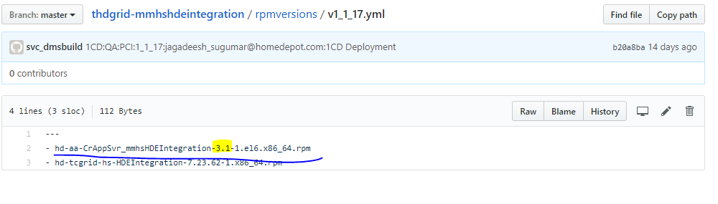

1. Go to http://puppetboard-np.homedepot.com/

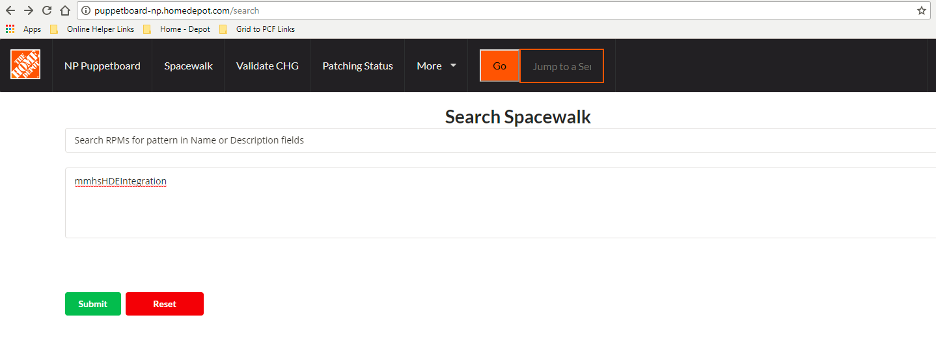

Checkout the version number which you found in the latest rpm version highlighted above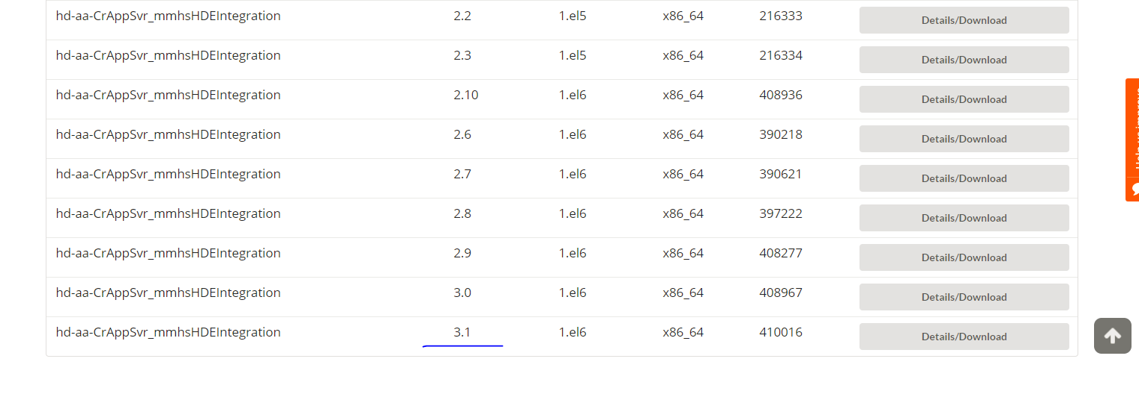

* Download the rpm file extract it will 7 zip and you will get .cpio file

hd-aa-CrAppSvr_mmhsHDEIntegration-3.1-1.el6.x86_64.cpio

* Open this file with notepad

Search for the JDBC Connection for QA. You will get the encrypted password like below

QA_username|IConXPCIUser

QA_password|sdfdsfdsfdsfdsfds3243245

QA_url|jdbc:sqlserver://WN29E4.homedepot.com\WN29E4:1433;databaseName=uatTraining

* Raise a ticket to app platform team to get the password to decrypt it.

https://portal.homedepot.com/sites/APSR/default.aspx